A/HRC/38/CRP.3
20 June 2018

English only
Human Rights Council
Thirty-eighth session
18 June - 6 July 2018
Agenda item 4
Human rights situations that require the Council’s attention
The siege and recapture of eastern Ghouta
Conference room paper of the Independent International Commission of Inquiry on the Syrian Arab Republic
Summary
Following five years of the longest running siege in modern history, between February and April pro-Government forces dramatically escalated their military campaign to recapture eastern Ghouta, decimating numerous homes, markets, and hospitals in bombardments amounting to the war crimes of launching indiscriminate attacks, and deliberately attacking protected objects. Aerial and ground offensives carried out by pro-Government forces on the besieged enclave claimed the lives of hundreds of Syrian men, women, and children. In an effort to avoid the bombardments, terrified civilians began relocating to makeshift basement shelters in February, where they subsisted for months underground in dire circumstances.
Through the widespread and systematic bombardments of civilian inhabited areas and objects, and the continued denial of food and medicine to besieged civilians during the period under review, pro-Government forces perpetrated the crime against humanity of inhumane acts causing serious mental and physical suffering.
Between February and April, besieged armed groups and terrorist organisations also relentlessly launched indiscriminate attacks against neighbouring Damascus city and nearby areas, amounting to war crimes which killed and maimed hundreds of Syrian civilians. As they gradually ceded territory to pro-Government forces, the frequency and gravity of their attacks correspondingly increased. Through the repeated, indiscriminate shelling of civilian inhabited areas, pro-Government forces, armed groups, and members of terrorist organisations alike committed the war crime of intending to spread terror among civilian populations living under the control of opposing sides.
By the time Government forces declared the enclave successfully recaptured on 14 April, some 140,000 individuals from eastern Ghouta had been displaced from their homes, tens of thousands of whom are being unlawfully interned by Government forces in managed sites throughout Rif Damascus. Pursuant to local truces and “evacuation agreements,” up to 50,000 civilians from eastern Ghouta were displaced to Idlib and Aleppo governorates. The cumulative physical and psychological harm wrought by the five-year siege continues to impact negatively hundreds of thousands of Syrian men, women, and children countrywide.

Contents
Page
I. Introduction 4
II. Methodology 4
III. Political context 5
IV. Military developments 6
V. Evolution of the siege 7
VI. Life in the enclave 10
VII. Unlawful attacks 11
A. Attacks against civilian infrastructure 11
B. Attacks against specially protected objects 12
C. Use of prohibited weapons 14
VIII. Attacks by armed groups and terrorist organisations 14
IX. Recapture of eastern Ghouta 16
A. Humanitarian corridors 16
B. Internally displaced persons 17
C. Evacuations 18
X. Findings 19
XI. Concluding remarks 20
Annexes
I. Map of the Syrian Arab Republic 21
II. Map of eastern Ghouta 22
III. UNITAR/UNOSAT Imagery analysis 23

I. Introduction
1. In the present report, submitted pursuant to Human Rights Council resolution A/HRC/37/1, the Independent International Commission of Inquiry on the Syrian Arab Republic presents its findings concerning the recent situation in eastern Ghouta and its environs.
2. In its resolution, the Human Rights Council requested the Commission to conduct urgently a comprehensive and independent inquiry into recent events in eastern Ghouta, and to provide an update followed by an interactive dialogue at its 38th session. Pursuant to its methodology, the Commission has always endeavoured to carry out its investigations in a comprehensive manner, investigating all credible allegations it receives, and reporting on all violations of international human rights and humanitarian law it is able to establish. For this report, the Commission interpreted its mandate to cover recent events which took place primarily between mid-February and April 2018, based on investigations conducted between 10 February 2018 and 10 June 2018.
II. Methodology
3. In conducting its work and employing its methodology, the Commission insists on investigating and reporting on violations perpetrated by all warring parties, eschewing political directions or considerations, and has at all times maintained its independence. The methodology employed by the Commission was based on standard practices of commissions of inquiry and human rights investigations. In so doing, the Commission relied primarily on first-hand accounts. The information contained herein is based on 140 interviews conducted in person in the region and from Geneva. Photographs, video recordings, satellite imagery, and medical records were collected and analysed. Reports from Governments and non-governmental sources, academic analyses, and United Nations reports were reviewed. The standard of proof was considered met when the Commission had reasonable grounds to believe that incidents occurred as described, and, where possible, that violations were committed by the warring party identified.
4. The Commission’s investigations remain curtailed by the denial of access to the Syrian Arab Republic. A besieged area where freedom of movement was routinely denied, the feasibility of conducting interviews in-person with residents inside eastern Ghouta was consequently challenging. Interviews conducted remotely, moreover, were regularly disrupted by on-going hostilities and other issues including a lack of telephone and internet lines and electricity disruptions. Protection concerns in relation to interviewees further impacted the Commission’s inquiry.
III. Political Context
5. Despite its designation as a de-escalation zone by the Russian Federation, Republic of Turkey, and Islamic Republic of Iran during Astana talks in May 2017, violence in eastern Ghouta gradually intensified, beginning with the first of three waves of attack in November 2017. Efforts made by the international community to resolve the escalation repeatedly failed, and the intensity of aerial and ground bombardments reached a new peak in February 2018 during a second wave of attack, heightening political tensions. A third wave of attack was carried out in March.
6. On the diplomatic front, a group of Security Council Member States began to push for a resolution on 20 February, which was intended to pave the way for a truce and enable aid deliveries and medical evacuations. After four days of consultations, on 24 February, the Security Council unanimously adopted resolution 2401, demanding a 30-day cessation of hostilities throughout the besieged enclave. All main anti-Government armed groups in eastern Ghouta formally declared their support for the resolution.
7. In March and April, attempts facilitated by the Russian Federation to implement humanitarian pauses and ceasefires with local armed groups continued in Harasta, Zamalka, Irbin, Ain Tarma, Jobar, and Douma. Despite these attempts, hostilities intensified, with armed groups gradually ceding territory. By 10 March, pro-Government ground forces advanced further into eastern Ghouta and split the enclave into three sectors: Harasta; Douma; and a “middle sector” in the south comprising Irbin, Zamalka, Jobar, and other areas.
8. At the time, Ahrar al-Sham (Free Men of the Levant) exerted control over Harasta, Jaysh al-Islam (the Army of Islam) dominated Douma, while Faylaq ar-Rahman (the Rahman Legion) controlled the middle sector. Elements of the terrorist group Hay’at Tahrir al-Sham (the Organisation for the Liberation of the Levant) further exercised shared control with Faylaq ar-Rahman over parts of the middle sector. By mid-March, pro-Government forces began implementing negotiated local truces and “evacuation agreements” with armed groups in each locale (paras. 68-70).
9. On 21 March, Ahrar al-Sham became the first armed group to reach an “evacuation agreement” with the Syrian Government, followed by Faylaq al-Rahman on 24 March. On 1 April, Jaysh al-Islam and the Syrian Government reached an agreement which allowed their fighters to leave Douma, hand over heavy and mid-sized weapons, and acknowledge the restoration of state sovereignty. The agreement collapsed on 5 April, however. Following a suspected chemical attack in Douma on 7 April (para. 52), members of Jaysh al-Islam surrendered. The Russian Federation, meanwhile, refuted allegations that Syrian Government forces had used chemical weapons in Douma, calling it a fabrication and provocation to justify subsequent foreign military action.
10. On 9 April, the United States referred to a possible military response to the suspected chemical attack, while France indicated it would join the United States if the use of chemical weapons were proven. Following a week of consultations among the allies who relied on their own investigations, the United States, United Kingdom, and France launched airstrikes in Syria on 13 April. The strikes hit the Barzah Research and Development Centre near Damascus and the Him Shinshar military installation near Homs. Reacting to the airstrikes, the Russian Federation called for an emergency Security Council meeting on 14 April, while the United Nations Secretary-General urged Member States to show restraint. On the same day, Government forces officially declared eastern Ghouta recaptured.
IV. Military developments
11. Throughout the reporting period, the military situation in eastern Ghouta was characterised primarily by the fortifications of armed and terrorist groups, and the firepower pro-Government forces used to overcome them. Besieged since April 2013, armed factions entrenched themselves behind fortifications they carved from urban terrain. Their experience gained over five years meant that pro-Government forces faced a complex mix of tunnels, trenches, ditches, firing positions, and depots. These helped armed groups overcome their lack of heavy weapons, including armoured vehicles and artillery.
12. In response, pro-Government forces redoubled their use of firepower between February and April. The most common weapons they employed were ground-based artillery guns and rocket launchers, as well as air-launched munitions. By early March, this enabled rapid advances against semi-urban villages in the east. The pace of conquest slowed in mid-March, however, as Government forces encircled denser urban terrain in Douma, Harasta, and Kafr Batna (middle sector).
13. Government forces used multiple-barrel rocket launchers (MBRL) which were either incapable of discriminating between civilian and military-targets in densely populated civilian areas, or deliberately employed to spread terror (para. 43). Rocket artillery included both inaccurate MBRL and makeshift imitations. In many cases, bombardments were disconnected from frontline clashes.
14. A number of Government forces participated in the offensive to recapture eastern Ghouta. By late February, Syrian Arab Army units including the 4th Armoured Division were facing Harasta and Douma from the northwest, and Republican Guard brigades were present on the southeast front (middle sector), from where they advanced north and west in March. Though bolstered by pro-Government militias, these mechanised units comprised the core of Government forces.
15. Throughout the campaign, pro-Government ground forces had an advantage in firepower, and carried out both direct and indirect attacks. They also relied on heavy bombardments to restrict the movement of armed group fighters. Weapons used by pro-Government ground forces to overcome the challenges presented by the fortified urban terrain in eastern Ghouta included indirect-fire artillery systems, such as guns, mortars, and rocket launchers. Pro-Government forces also took advantage of hills north of Damascus to fire into the enclave.
16. Airpower further played a key role in the recapture of eastern Ghouta. Throughout the period under review, the skies over eastern Ghouta were jointly controlled by the Syrian Arab Air Force and Russian Aerospace Forces, both of whom carried out aerial missions. The Syrian Arab Air Force fielded both the Su-22 and Su-24 ground attack aircraft, both of which carry similar armament, including unguided aerial bombs and cluster munitions. The Syrian Arab Air Force also used Mi-8 and Mi-17 helicopters to carry out “barrel bomb” attacks. Supporting the offensive, the Russian Air Force carried out airstrikes using Su-24 and Su-34 aircraft. Syrian forces do not use the Su-34.
17. Armed groups and terrorist organisations comprised several factions. Jaysh al-Islam was the largest, with an estimated 10,000 fighters based in Douma, and Faylaq al-Rahman the second largest, fielding an estimated 9,000 fighters who controlled territory in central, west, and southwest Ghouta (middle sector). Ahrar al-Sham fielded at least 1,500 fighters, mostly in Harasta. The terrorist group Hay’at Tahrir al-Sham contributed approximately 500 fighters spread throughout Jobar (middle sector), and near other positions held by Faylaq al-Rahman.
18. Providing cover and concealment, the urban terrain of eastern Ghouta protected these groups from the superior firepower of pro-Government forces. Armed groups also used trenches on the frontline and deep tunnels capable of accommodating vehicles. To deny Government forces mobility, they dug anti-tank ditches, which they sometimes flooded with water, and further relied on emplaced munitions to counter ground advances, including anti-personnel devices as well as anti-tank landmines and improvised explosive devices (IEDs).
19. Members of both Faylaq al-Rahman and Jaysh al-Islam were equipped with limited heavy weapons, as well as a modest quantity of light and heavy armour. Similarly, a small but important number of artillery guns were used to attack pro-Government forces on the frontlines. Nonetheless, the bulk of their indirect fire was limited to 82mm and 120mm mortars, and individual rockets and improvised rocket-assisted munitions (IRAMs). Members of Faylaq al-Rahman also used improvised “Omar” cannons, which are by their nature inherently indiscriminate.
V. Evolution of the siege
20. Administratively part of Rif Damascus governorate, the fertile agricultural landscape of eastern Ghouta surrounds the eastern and southern borders of Damascus city. Prior to the 2011 uprising, eastern Ghouta was home to 1.5 million residents. One of the first regions to actively participate in anti-Government demonstrations, armed groups found a sympathetic population in the rural enclave, and were able to seize control of the area by November 2012. In turn, Government forces and affiliated militias encircled eastern Ghouta in April 2013. Over the ensuing five years, pro-Government forces laid the longest running siege in modern history, steadily wearing down both fighters and civilians alike through a prolonged war of attrition.
21. Shortly after encircling eastern Ghouta, Government forces prevented fuel from entering the enclave, whereafter civilians began incinerating plastic to generate electricity. In early 2015, besieged civilians recounted how pro-Government forces had begun using heavy weaponry both on frontlines and throughout civilian inhabited areas, and, at the same time, cut access to water in Douma. Communities began digging underground wells, with some 600 wells dug and manual pumps installed to supply neighbourhoods with water. Children created seesaws on some pumps and played on them in an effort also to pump water (A/HRC/37/72, annex II, para. 3).
22. Between July 2014 and February 2017, residents of eastern Ghouta relied primarily on an elaborate network of manmade tunnels to smuggle in food and medicine. Depending on bribery, food and commodities were also occasionally smuggled through formal routes and sold in local markets at prohibitive prices. Upon their recapturing of municipalities in the eastern Damascus area, many tunnels were de facto closed by pro-Government forces in February 2017, while others were closed as part of local truces implemented between pro-Government forces and armed groups that May (e.g., Qaboun) (A/HRC/36/55, Annex III, para. 6).
23. In September 2017, Government forces closed the Wafidin crossing point near Douma, which had served as a major entry point for goods. In November, pro-Government forces markedly heightened aerial and ground operations on eastern Ghouta during the first of three waves of attack (para. 5). The closure of tunnels in February coupled with the closure of the Wafidin crossing led to an increase in cases of severe and acute malnutrition. By November, prices for basic commodities surged drastically, creating a debilitating captive market. By November 2017, many individuals throughout eastern Ghouta began subsisting on one modest meal of boiled corn or lentils a day.
24. Compounding the suffering of besieged civilians, Government forces and affiliated militias further deliberately denied the entry of humanitarian aid throughout the period under review, while international organisations, including the United Nations, were required to seek and obtain Government permission prior to aid deliveries—efforts which were routinely denied. In other cases, Government forces removed vital aid from convoys.
25. On 5 March, for example, an interagency convoy involving the United Nations, Syrian Arab Red Crescent (SARC), and International Committee of the Red Cross (ICRC) comprised of 46 trucks carrying humanitarian aid for 27,500 people attempted to enter Douma through a checkpoint controlled by Government forces, who stripped 70 per cent of medical supplies out of the convoy, including trauma and surgical kits. In other documented instances in late 2017, siege conditions pushed armed actors in eastern Ghouta to loot food and medical supplies from civil society organisations and aid warehouses.
26. By late January 2018, healthcare personnel in eastern Ghouta reported that over 700 patients were facing life-threatening conditions and required immediate evacuation, dozens of whom perished while awaiting evacuation clearance. Children throughout eastern Ghouta disproportionately suffered the effects of the siege, with several children having perished in late 2017 as a result of preventable illness such as organ failure exacerbated by malnutrition.
27. Between February and April 2018, tactics employed by pro-Government forces to recapture the enclave were largely unlawful in nature, aimed at punishing the inhabitants of eastern Ghouta and forcing the population, collectively, to surrender or starve. Such tactics included the war crimes of collective punishment, deliberately starving civilians by denying humanitarian aid, launching indiscriminate attacks with both conventional and prohibited weapons in densely populated civilian areas, and denying medical evacuations.
28. The battle to recapture eastern Ghouta, however, was characterised by pervasive war crimes committed by all sides. Members of armed groups and terrorist organisations also regularly carried out indiscriminate reprisal attacks on adjacent, Government held Damascus city and Rif Damascus, killing and injuring hundreds of civilians (paras. 53-57). Armed groups further regularly arbitrarily arrested civilians in Douma, committing the war crimes of cruel treatment and torture, and outrages upon personal dignity (para. 58).
29. At least 265,000 individuals subsisted in the enclave during the reporting period, comprising the vast majority of all Syrian men, women, and children living under siege at the time. Nearly 13,000 individuals fled eastern Ghouta on 16 March through humanitarian corridors established by the Russian Federation, during the largest single-day exodus of the conflict. By mid-April, when pro-Government forces declared a decisive victory and the besieged enclave fully recaptured, approximately 95,000 individuals had risked their lives amidst continuous bombardments to leave eastern Ghouta through the corridors (paras. 59-62).
30. Approximately 31,000 of those displaced are currently subsisting in Rif Damascus, spread across eight severely overcrowded and/or underserved sites for internally displaced persons, where the majority are being unlawfully interned by Government forces (para. 67). About 64,000 have been cleared for vetting and were able to leave the sites. Additionally, at least 50,000 civilians were displaced to Idlib and Aleppo governorates via organised evacuations carried out between March and April, none of whom were provided with basic humanitarian aid or relocation assistance by the Government (para. 74). Approximately 120,000 civilians are estimated to have remained in eastern Ghouta after its recapture on 14 April.
VI. Life in the enclave
31. Due to the escalation in aerial and ground attacks by pro-Government forces during the second wave of attack in early February (para. 5), families throughout eastern Ghouta relocated to fortified, overcrowded shelters underground. Often connected via manmade tunnels, unfurnished basements were occupied by besieged civilians between February and April, and housed dozens to hundreds of men, women, and children. By March in Ain Tarma (middle sector), one shelter became the makeshift home of up to 2,000 desperate civilians living in fear. By mid-February, residents in Douma recounted how aerial and ground bombardments affected cable lines, generators, and access to electricity in the majority of basements. When bombardments occasionally calmed, civilians in Douma described rushing upstairs for air and to reconnect generators or adjust solar panels and refill water tanks. The majority of those residing in underground shelters throughout eastern Ghouta described life in the basements as unbearable, with one mother from Saqba (middle sector) remembering “praying everyday expecting it would be our last.”
32. Despite dismal living conditions, life in basement shelters between February and April engendered a deepened sense of community among residents of eastern Ghouta. In the majority of cases documented by the Commission, dozens of strangers huddled together, often in the dark, hanging bedsheets for privacy. One resident in Irbin (middle sector) noted the intimacy by recalling the lack of hygiene underground, and how those subsisting in basements were unable to bathe or change clothes for one and a half months.
33. Physicians in Irbin (middle sector) took turns travelling from one underground shelter to another to visit patients and check on the needs of the general population. In rarer instances, doctors treated emergency cases brought to them in shelters. Other civilians – namely men and boys – functioned as runners, and, when the pace of bombardments slowed, ventured upstairs in an effort to find food or water for their families still underground. In Irbin, young men collected money to buy food for sheltered residents, while members of the local council and those of relief organisations risked their lives to distribute stored food and aid to underground shelters.
34. By the time pro-Government ground troops split eastern Ghouta into three sectors on 10 March (para. 7), life in the basements posed considerable challenges to finding or preparing food. In Mesraba (middle sector), residents in one shelter had established a makeshift kitchen with a small wooden stove on which they cooked rice for one another and distributed it among families in an organised fashion. By March, however, rice had become unavailable. In order to cook, residents in Douma described using wood from household furniture or incinerating plastic. Without adequate ventilation in the basements, one resident recalled cooking as “risky”. In March, numerous sheltered residents throughout the enclave began subsisting on one meal per day, often comprised of bread only. Shops throughout eastern Ghouta were mostly closed by March.
35. Those in basement shelters were further often made to share one toilet, and, in numerous cases, recounted waiting hours for their turn. Children unable to restrain themselves were prioritised. Mothers began offering their children reduced quantities of unpotable water in order to limit their need to use the toilet. Some of those sheltered underground in Douma resorted to using plastic bags to relieve themselves. In Saqba (middle sector), one mother decided to dig a hole in her basement so that her children could use it, recalling how the nearest toilet was only “six steps away.” The fear of aerial bombardment, however, prevented her and her family from going up those six stairs.
36. Beyond the lack of access to adequate food and sanitation, others, primarily mothers, noted how supplies in dire need included diapers for infants. Residents in Beit Sawa (middle sector), for example, recalled how children who spent more than a month and a half in basements were constantly crying due to hunger and lack of access to milk. Due to stress, one mother in Saqba described being unable to produce breastmilk, and the consequent hunger pangs of her infant child. Moreover, due to the relentless nature of bombardments, the majority of schools throughout eastern Ghouta were shut down by early February or relocated to the underground shelters, though most remained unused as residents sheltered themselves in the makeshift schools. One witness in Saqba, for example, explained how a kindergarten had been set up underground, but was later used as a shelter by local inhabitants.
37. The fortification of basements, however, was not enough to avoid aerial bombardments. Though underground, numerous residents feared turning on lights in case it attracted an attack. Absent a valid military objective, the Commission documented one instance on 7 March in which an attack carried out by pro-Government forces hit a shelter in Saqba (middle sector), near Jadat ibn Salam. The shelter was housing up to 35 civilians, including women and children. Pro-Government forces launched the attack between 6:30 and 7:00 p.m., killing six family members, including a two-year-old boy and a male infant, and wounding at least seven other civilians. One witness to the attack recalled being unable to evacuate wounded family members due to lack of access to telephone signals underground and continuous shelling, which increased preventable deaths. Weeks later, shortly before its evacuation in late March (paras. 68-70), another resident in Saqba noted how she feared planes that “were shooting at anything that moved.” Indeed, pro-Government forces drastically heightened a campaign of launching attacks against civilian and protected objects, documented previously, during the reporting period.
VII. Unlawful attacks
A. Attacks against civilian infrastructure
38. By April, numerous densely populated residential areas, civil defence centres, markets, schools, and hospitals had been all but razed to the ground. Initial reports indicated that, between 18 February and 11 March, attacks by pro-Government forces killed over 1,100 civilians and injured over 4,000 others, mainly due to aerial bombardments. Within the same period, shelling on Damascus city by armed groups and terrorist organisations killed and injured hundreds of civilians (paras. 53-58). On 26 February, in his remarks to the Human Rights Council, United Nations Secretary-General Antonio Guterres described the rapidly deteriorating situation in eastern Goutha as “hell on earth.”
39. On 19 and 20 February, for example, pro-Government forces launched a series of airstrikes which impacted four temporary shelters in Beit Sawa (middle sector). Owing to cultural norms, shelters were often segregated with men on one side and women and children on the other, which led to spikes in victims of one or the other group. Of the incidents assessed by the Commission, one of the gravest involved a two-storey residential building which partly collapsed after being struck on 20 February between 1:00 and 2:00 a.m. At least 42 civilians hiding underground were killed, including 41 women and children, and one man. Rescue workers struggled to reach victims, as streets had become completely blocked by the debris of collapsed buildings.
40. On 16 March, at approximately 11:45 a.m., pro-Government forces launched an airstrike which impacted a civilian area in Kafra Batna (middle sector), killing at least 70 civilians, including men, women, and children, and injuring up to 200 others. The area accommodated an informal marketplace, attended by numerous civilians who – for the first time in days – had dared to come up from underground shelters due to messages received that a ceasefire was announced by the Russian Federation. The considerable number of civilian casualties is explained by the information about a ceasefire and the attendant spike in civilian presence, coupled with the fact that fuel sold in the market was ignited due to the airstrike, which in turn burned numerous victims alive.
41. Three days later, on 19 March, pro-Government forces launched an airstrike which hit the former Dar as-Salam School number 3, located in al-Sarout in Irbin (middle sector). The school was being used as an underground shelter at the time, mainly hosting women and children, while men slept in a nearby underground shelter. At approximately 6:30 p.m., a missile penetrated several floors before exploding in the basement. The attack killed at least 17 children, four women, and one man, and injured at least 20 other civilians, primarily women.
42. A few days later, on 22 March, at approximately 9:30 p.m., pro-Government forces launched an airstrike using incendiary weapons which hit the Abdul Rahman educational centre in the al-Duwar area of Irbin (middle sector). Witnesses described an explosion which blocked the shelter entrance, with civilians trapped inside burning to death. The attack killed at least 10 women, 13 men, and 15 children belonging to the same family, incinerating the bodies of victims. Witnesses further recounted seeing smoke, and noted that the weapons used left fires burning for days. Statements as well as documentary material analysed by the Commission depict how at least one body reignited when being moved by rescuers.
43. There are reasonable grounds to believe that each of the foregoing incidents amounts to the war crime of launching indiscriminate attacks, as well as violations of the right to life, liberty, and security of person. Through the repeated, indiscriminate shelling of eastern Ghouta, there are also reasonable grounds to believe that pro-Government forces intended to terrorise besieged civilians in an effort to accelerate the recapture of the enclave and compel surrender.
B. Attacks against specially protected objects
44. A rise in attacks against official and makeshift hospitals throughout eastern Ghouta also markedly increased during the period under review. As hostilities escalated in February, reports emerged that 28 health facilities had been attacked, destroying vital lifesaving equipment. Near constant bombardment often rendered the transport of victims impossible, which compounded their suffering, and, in some cases, led to preventable deaths.
45. Between 19 and 21 February, pro-Government forces launched daily attacks, including against hospitals. Beginning on 19 February, in the early evening, pro-Government forces carried out an airstrike which hit the main hospital in Maraj (middle sector), impacting its emergency section and yard. The attack killed one male medical worker, aged 28 years, and wounded three male staff aged 25, 26, and 35 years. Due to the ensuing chaos, one woman in her early twenties undergoing an operation at the time also perished.
46. The following day, on 20 February, between approximately 4:00 and 5:00 p.m., pro-Government forces carried out an airstrike against the main hospital in Irbin (middle sector). First, a missile penetrated the hospital without exploding. Minutes later, a second missile hit the same spot, which led to both missiles discharging, partially destroying the hospital. As treatment facilities had previously been moved to a fortified basement, no casualties were sustained.
47. In the early afternoon the next day, 21 February, pro-Government forces attacked the Saqba surgical hospital – supported by Médecins Sans Frontières (MSF) – with two missiles, killing a male nurse and wounding at least nine civilians, including a child, and two women. A rocket had struck the entrance of the emergency section, further damaging operating theatres and destroying medical equipment.
48. By March, capacities of the few remaining entities capable of providing healthcare in Douma, Harasta, and the middle sector were either severely diminished, or completely eroded, yet some still remained the object of attack. On 12 March, the Syrian American Medical Society (SAMS) and 11 other humanitarian organisations operating inside Syria shared the coordinates of 60 health facilities with the United Nations Office for the Coordination of Humanitarian Affairs (OCHA), who in turn forwarded them to warring parties. Despite this, on 20 March, pro-Government forces launched another airstrike against the main hospital of Irbin, even though its coordinates had been shared. At approximately 9:00 p.m., a missile penetrated several floors and entered an underground treatment room. A male patient in his late twenties, present in the room, died under the rubble.
49. These attacks had a devastating effect on healthcare delivery for the few remaining providers. By late March, remaining doctors, nurses, first responders, and other medical staff were forced to carry out their functions with primitive and inadequate means, if at all. Common treatments such as diabetic care or diarrhoea management had become mostly unattainable. Blood stores were entirely unavailable, while lifesaving medications including antibiotics were available in extremely limited supply. With the continued denial and removal of medical supplies from humanitarian aid deliveries over the reporting period (paras. 24-25), the perilous medical situation in eastern Ghouta further deteriorated.
50. In all of the foregoing incidents, victims and medical staff stated there were no military installations within the hospitals attacked. While the Commission cannot discount that wounded fighters may have been receiving medical treatment in the same hospitals as civilians, their treatment would not render a hospital a valid military objective. Moreover, no warnings were issued by pro-Government forces prior to the attacks, as required by international humanitarian law. The frequency of attacks on medical facilities in eastern Ghouta appears indicative of a policy on the part of pro-Government forces intended to erode the viability of health services in an opposition-held area. As previously noted by the Commission, this pattern of attack strongly suggests that pro-Government forces systematically targeted medical facilities, repeatedly committing the war crime of deliberately attacking protected objects, and intentionally attacking medical personnel.
C. Use of Prohibited weapons
1. February/March
51. Evidence on the possible use of weaponised chlorine was received in relation to three incidents, the first having occurred in al-Shayfouniya (middle sector) on 25 February at approximately 6:30 p.m. The attack killed an infant and a four-year-old child, and injured another 18 civilians. A similar incident occurred on 7 March at approximately 10:00 p.m., in an area between Saqba and Hammouriyeh (middle sector). The latter attack injured at least 27 individuals. In both incidents, victims and witnesses including treating medical staff described symptoms similar to those suffered due to chlorine exposure, as well as similar treatment methods (e.g., the use of salbutamol). Witnesses recognised the smell of chlorine. In both cases, however, the Commission was unable to obtain sufficient material evidence to conclusively identify the weapons delivery systems.
2. April
52. Following the collapse of ceasefire negotiations between Jaysh al-Islam and the Russian Federation to evacuate Douma in early April, pro-Government forces launched a series of attacks on the last remaining opposition redoubt on 5 April, and continued launching a series of attacks on Douma into 6 and 7 April. Over the course of the day on 7 April, numerous aerial attacks were carried out in Douma, striking various residential areas. In one residential building, the Commission received information on the deaths of at least 49 individuals, and the injuries of up to 650 others following aerial bombardments. The Commission of Inquiry has been investigating this incident. The available evidence is largely consistent with the use of chlorine, but this in and of itself does not explain other reported symptoms, which are more consistent with the use of another chemical agent, most likely a nerve gas. The Commission’s investigations are on-going.
VIII. Attacks by armed groups and terrorist organisations
53. The foregoing attacks were regularly met with brutal acts of reprisal perpetrated by besieged armed groups. Coinciding with the first of three renewed waves of attack by pro-Government forces in late November 2017 (para. 5), residents in Damascus city recounted a heightened counteroffensive emanating from eastern Ghouta. At the time, armed groups began to rely increasingly on indirect fire artillery systems, including improvised, locally manufactured rockets which could reach mid- and long-range positions in Damascus city and Rif Damascus governorate. Their weapons were incapable of accurate targeting, however, and most often launched absent any legitimate military objective.
54. In response to the escalated campaign on eastern Ghouta by pro-Government forces on 20 February (paras. 39 and 46), members of Faylaq al-Rahman and/or HTS in Jobar (middle sector) launched reprisal attacks into Damascus city that day, killing at least 13 civilians, including women and children. The first mortar, launched at approximately 10:30 a.m., killed a male taxi driver and a female passenger near the Dama Rose Hotel on Shoukry al-Qouwatly Street. A half an hour later, a second mortar injured four girls near Umayyad Square, immediately followed by a third which struck the Tal’at al-Jamarik gate, killing three males. Nearly three hours later, at approximately 1:50 p.m., the Damascus Opera House – also on Umayyad Square – was struck in an attack which killed its female programme manager. Over 100 others were injured, many of whom were left in critical condition
55. Also on 20 February, members of Faylaq al-Rahman and/or HTS based in Ayn Tarma (middle sector) launched mortars at approximately 8:25 p.m., striking a real estate and car agency located on Qousor Street opposite Jaramana Surgical Hospital (Damascus city). Three men were killed after having succumbed to shrapnel injuries, including two Druze students aged 20 and 24, and another young male. Another man and a 16-year-old boy were injured.
56. In a particularly egregious attack on 20 March, at approximately 6:00 p.m., members of Faylaq ar-Rahman and/or HTS in southern Ghouta launched a mortar which struck the Kashkol neighborhood of Damascus city, located on the edge of Jaramana district. At least 44 civilians were killed, including women and children, and hundreds more injured. The rocket landed in a food market where hundreds of civilians were shopping on Mother’s Day. Witnesses described an explosion “unlike we had ever heard before,” and how windows in nearby homes were shattered. The mortar landed in front of the Badawi sweet shop and a stationary/bookshop. The incident signified one of the largest death tolls in a single attack targeting Damascus during the Syrian conflict. Similar attacks against Damascus city continued up until the recapture of eastern Ghouta.
57. Through the use of unguided mortars, the abovementioned attacks carried out by Jaysh al-Islam, Ahrar al-Sham, Faylaq ar-Rahman, and/or Hay’at Tahrir al-Sham killed and maimed hundreds of civilians, amounting in each documented instance to the war crime of launching indiscriminate attacks. The attacks seriously contravened the most basic human rights of persons, including the right to life, liberty and security of person. As with attacks by pro-Government forces, there are reasonable grounds to believe that the repeated, indiscriminate shelling of Damascus city and Rif Damascus by these groups amounted to the war crime of intending to spread terror among civilians residing in Government-held areas. Moreover, even if carried out with the purpose of inducing Government forces to cease their unlawful attacks, armed and terrorist groups did not have the right to resort to countermeasures against persons not taking a direct part in hostilities.
58. Through the entire duration of the siege (2013-2018), armed groups also regularly arbitrarily arrested and tortured civilians in Douma, including members of religious minority groups, repeatedly committing the war crimes of crimes of cruel treatment and torture, and outrages upon personal dignity. Interviewees arrested in 2016 and 2017 and released from prisons in Douma were evacuated to Idlib in March and April (para. 69). One man aged 30 years who was released by Jaysh al-Islam fighters on 1 April described how he had been taken to Prison 28 in Douma, in an area known as the “Security Quarters,” and was held in isolation for four months. The witness further described having been tortured repeatedly during interrogation, including by being hung from a ceiling by his arms, beaten with tools, starved, and electrocuted. Similarly, a 24-year-old man released by Jaysh al-Islam on 9 March recounted having been tortured for three and a half months while interrogated.
IX. Recapture of eastern Ghouta
- Humanitarian corridors
59. Beginning with the first wave of attack in November 2017 (para. 5), the marked upsurge in hostilities throughout eastern Ghouta rendered civilian life in the enclave increasingly uninhabitable. Recognising the need to provide safe passage to besieged civilians, the Russian Federation announced on 23 January its intent to establish nine humanitarian corridors. Around the same time, residents in Douma recalled seeing airplanes dropping leaflets, informing them that safe passage was available via the nearby Wafidin checkpoint. The checkpoint, however, was initially re-opened only to facilitate the evacuation of sick and injured civilians, and later opened to the general population in February. Other humanitarian corridors were implemented on 27 February, during which time the majority of civilians in eastern Ghouta were enduring in underground shelters (paras. 31-37).
60. During the third wave of attack by pro-Government forces in March (para. 5), in an effort to facilitate safe passage, the Russian Federation sought the cooperation of armed groups in Douma, Harasta, and the middle sector to implement five-hour humanitarian pauses and temporary ceasefires. Despite these attempts, civilians consistently echoed how heightened aerial and ground bombardments continued to intensify as they tried to reach the corridors, leading to a chaotic situation on the ground. Many civilians suffered from a lack of information about the military situation, pauses, and corridor processes – not knowing whether to attempt to leave or where to go.
61. Aside from hostilities, numerous civilians expressed fears of arrest or forced conscription by pro-Government forces. When Government forces advanced into Saqba in March, for example, a mother in the town recalled hearing screams coming from the street. She rushed out of an underground shelter to find men who were shouting “Don’t stay in your basements, run away!” Similar fears were shared by civilians in Hammouriyeh, where relatives advised one another to flee through the corridor before Government forces could advance to find them underground. Other civilians affiliated with humanitarian organisations were afraid of retaliation. One woman in Douma, for example, noted how she and others did not want to leave eastern Ghouta because they “did not trust” the Government. As hostilities raged on and the humanitarian situation continued to deteriorate, however, she recalled up to 400 people rushing to the Wafidin crossing-point in March to escape at any cost. Though some interviewees spoke of Government forces arresting or executing civilians who fled through the Hammouriyeh corridor, the Commission was unable to confirm the allegations.
62. All civilians spoken to by the Commission denied that members of armed groups interfered with their ability to leave eastern Ghouta through the humanitarian corridors. In Saqba, for example, civilians recalled how armed group members were focused on preventing the advance of Government forces at the frontline, and had no ability to control the civilian population even if they had wanted to. In some instances, however, men of fighting age in Douma were encouraged not to attempt to flee by members of Jaysh al-Islam, who warned them that they may be arrested by pro-Government forces if they tried. The advance of Government ground troops and affiliated militias in early March triggered the mass displacement of Syrian men, women, and children from the enclave. Overall, approximately 95,000 individuals fled eastern through the humanitarian corridors Ghouta between February and April.
B. Internally displaced persons
63. Government forces rounded up the tens of thousands of civilians who fled through humanitarian corridors and transported them in buses to eight collective shelters scattered across Rif Damascus. In total, approximately 95,000 individuals were taken to these sites. At the time of writing, some 31,000 internally displaced persons (IDPs) remain in the sites, while approximately 64,000 have been released. The Commission is unaware of any individuals who fled through humanitarian corridors between February and April who were not taken to the shelters.
64. Beginning in February, the Syrian Arab Red Crescent (SARC) and international humanitarian organisations including the United Nations supported the eight IDP sites by providing food, water, shelter, medical services, and protection. The collective shelters are severely overcrowded, however, and some interviewees recalled being forced to live in dire conditions. Those able to leave the shelters revealed how the situation varied considerably across sites: some individuals were forced to reside in caravans, and others in camps or old factories. Certain shelters moreover lack basic services and facilities, and fail to offer privacy which has resulted in protection risks, particularly for women and children. One young female, for example, recalled feeling unsafe after having been harassed by a Government soldier. At some sites, the assistance of humanitarian organisations coupled with the steady release of IDPs has contributed to a more stable environment.
65. Government forces are currently not allowing the vast majority of the approximately 31,000 individuals subsisting in the foregoing IDP sites to leave, unless they successfully undergo a screening process and provide evidence of a sponsor residing in a Government-held area. Since late February, over 64,000 displaced individuals have successfully undergone screening, had been guaranteed sponsors, and were therefore granted freedom of movement by Government forces. By 29 May, nearly 13,000 displaced persons returned to their homes in eastern Ghouta, while numerous women and children successfully screened have chosen to return to the shelters, despite living conditions, only to reunite with their husbands/fathers who were denied permission to leave.
66. As with women and girls, the process of needing to secure a sponsor in Government-held areas applies to boys below 15 years of age and above 55 years, as well as only sons exempt from military service. Interviewees further confirmed that males aged 16 years and above are being held separately from their families, and that fighting-aged males were sometimes sent directly to frontlines. The Commission notes with concern that some medical staff from eastern Ghouta are being held separately from the general population. Processes, in particular the sponsorship system, lack transparency and consistent application across these sites. In order to leave, interlocutors confided that civilians were commonly forced to bribe Government forces to expedite their screening and/or sponsorship, with one interviewee indicating that the cost ranged between 300 to 2,000 USD for an expedited release.
67. Internment, or administrative detention, for the purposes of vetting civilians believed to pose a security threat may be justified only when absolutely necessary to address “imperative reasons of security,” though a case-by-case evaluation must take place in relation to each individual prior to detaining him or her, which was not the case for the approximately 95,000 individuals collectively forced into the foregoing camps. The burden of proof lies with the Syrian Government to show that each interned individual poses a threat which cannot be addressed by alternative measures, a burden which increases with the length of the detention. The blanket internment of all civilians who fled eastern Ghouta through humanitarian corridors, including women and children, cannot be justified by Syrian Government forces. In many instances, the on-going internment of these individuals amounts to arbitrary deprivation of liberty, and therefore the unlawful confinement of tens of thousands of individuals.
C. Evacuations
68. Between mid-March and April, at least 50,000 Syrian men, women, and children unwilling or unable to leave eastern Ghouta through the humanitarian corridors were evacuated on buses to Idlib and northern Aleppo governorates. By the time pro-Government ground forces split eastern Ghouta into three pockets (para. 5), both Government forces and the Russian Federation began negotiating local truces with armed groups in control of the three sectors. On 17 March, Government forces and representatives of Ahrar al-Sham had reached a ceasefire agreement regarding Harasta and, on 21 March, further reached an agreement to evacuate fighters and civilians who sought to leave. Ahrar al-Sham fighters along with over 5,000 civilians from Harasta were evacuated to Idlib on 23 and 24 March.
69. Similarly, on 22 March, the Russian Federation and Faylaq al-Rahman reached a ceasefire agreement, and an “evacuation agreement” on 24 March. The following day, on 25 March, evacuations from Irbin (middle sector) to Idlib and Aleppo governorates began, continuing until 31 March. Overall, nearly 41,000 civilians were evacuated from Irbin. Following the suspected chemical weapons attack in Douma on 7 April, Government forces reached a local truce agreement with Jaysh al-Islam the following day. Between 9 and 11 April, over 8,800 individuals, including fighters, were “evacuated” from Douma to Aleppo.
70. The Commission has previously documented how in some instances the evacuations of civilians from besieged areas throughout the Syrian Arab Republic have amounted to the war crime of forced displacement. Civilians unable to remain in eastern Ghouta included humanitarian workers, medical staff, media activists, fighting-aged males, and others who feared human rights violations by Government forces. For each civilian in eastern Ghouta unable to decide freely on his or her movement or destination, there are reasonable grounds to believe that the agreement to evacuate him or her constitutes the war crime of forced displacement.
X. Findings
71. Between February and April, the heightened campaign by pro-Government forces to recapture eastern Ghouta was marked by pervasive war crimes committed by all sides. On the part of pro-Government forces, the nature of the weapons employed in densely populated civilian areas terrorised besieged residents, amounting to the war crime of launching indiscriminate attacks, and violations of the right to life, liberty, and security of person. As previously noted by the Commission, pro-Government forces moreover continued a pattern of attacks against hospitals and medical facilities, systematically targeting them and repeatedly committing the war crime of deliberately attacking protected objects, and intentionally attacking medical personnel. Through the repeated, indiscriminate shelling of eastern Ghouta, and in an effort to accelerate the recapture of the enclave and compel surrender, there are reasonable grounds to believe that pro-Government forces committed the war crime of intending to spread terror among the besieged civilian population.
72. Through the widespread and systematic bombardments of civilian inhabited areas and objects in eastern Ghouta, and continued denial of food and medicine to besieged civilians during the period under review, there are reasonable grounds to believe that pro-Government forces further perpetrated the crime against humanity of inhumane acts causing serious mental and physical suffering.
73. Concertedly launching unguided mortars, members of Jaysh al-Islam, Ahrar al-Sham, Faylaq ar-Rahman, and/or Hay’at Tahrir al-Sham carried out reprisal attacks during the same period, killing and maiming hundreds of civilians, amounting in each documented instance to the war crime of launching indiscriminate attacks. The attacks further seriously contravened the most basic human rights of persons, including the right to life, liberty and security of person. As with attacks by pro-Government forces, there are reasonable grounds to believe that the repeated, indiscriminate shelling of Damascus city and Rif Damascus by members of these groups was carried out with the intent to spread terror among civilians residing in Government-held areas. Through the entire duration of the siege, armed groups also regularly arbitrarily arrested and tortured civilians in Douma, including members of religious minority groups, repeatedly committing the war crimes of cruel treatment and torture, and outrages upon personal dignity.
74. Some 95,000 civilians fled through humanitarian corridors between February and March, over 30,000 of whom are displaced persons subsisting in eight severely overcrowded and/or underserved camps in Rif Damascus. The majority are being unlawfully interned by Government forces. At least 50,000 civilians were displaced to Idlib and Aleppo governorates via organised evacuations carried out between March and April, none of whom were provided with basic humanitarian aid or relocation assistance by the Government. For each civilian in eastern Ghouta unable to decide freely on his or her movement or destination, there are reasonable grounds to believe that the agreement to evacuate him or her constitutes the war crime of forced displacement.
XI. Concluding remarks
75. In the context of sieges, the Commission has consistently found in all of its public reports how parties to the Syrian conflict commit a wide range of war crimes, violations of international humanitarian law, and violations and abuses of human rights law. In the present report, we conclude further that certain acts perpetrated by pro-Government forces during the siege laid to eastern Ghouta, including the deliberate starvation of the civilian population as a method of warfare, amount to the crime against humanity of inhumane acts causing serious mental and physical suffering.
76. Under international law, the laying of sieges must comport with certain rules, including allowing for vital foodstuffs and other essential supplies to be delivered to the besieged civilian population, and granting civilians freedom of movement. Moreover, objects used for humanitarian relief operations such as humanitarian aid convoys must be respected and protected. Sieges throughout the Syrian Arab Republic, however, have been regularly used as a form of collective punishment – intentionally laid to erode the viability of civilian life, to turn the besieged civilian population against the warring party “governing” them, to compel surrender, and to forcibly displace dissident civilians. Throughout the ongoing conflict in Syria hundreds of thousands of Syrian women, men and children countrywide have suffered for too long the perverse and long-lasting effects of this medieval form of warfare.
77. Through speaking with hundreds of Syrians victims and interlocutors, the cumulative knowledge gained by the Commission in just seven years clearly demonstrates that civilians besieged in urban areas remain the primary victims and object of attack. Moreover, the array of violations perpetrated by warring parties on besieged communities does not always render safe passage of civilians a viable alternative, as numerous civilians have echoed to the Commission how, even when given the option, they do not trust the besieging party enough to leave. Others have had no such choice, rather having been used as human shields and denied freedom of movement by the party under siege. While cognisant that, under international humanitarian law, sieges as a military tactic are considered lawful when their purpose is to achieve a military objective, the Commission is of the view that sieges, as they have been conducted in Syria, are unlawful.

Annex I
Map of the Syrian Arab Republic
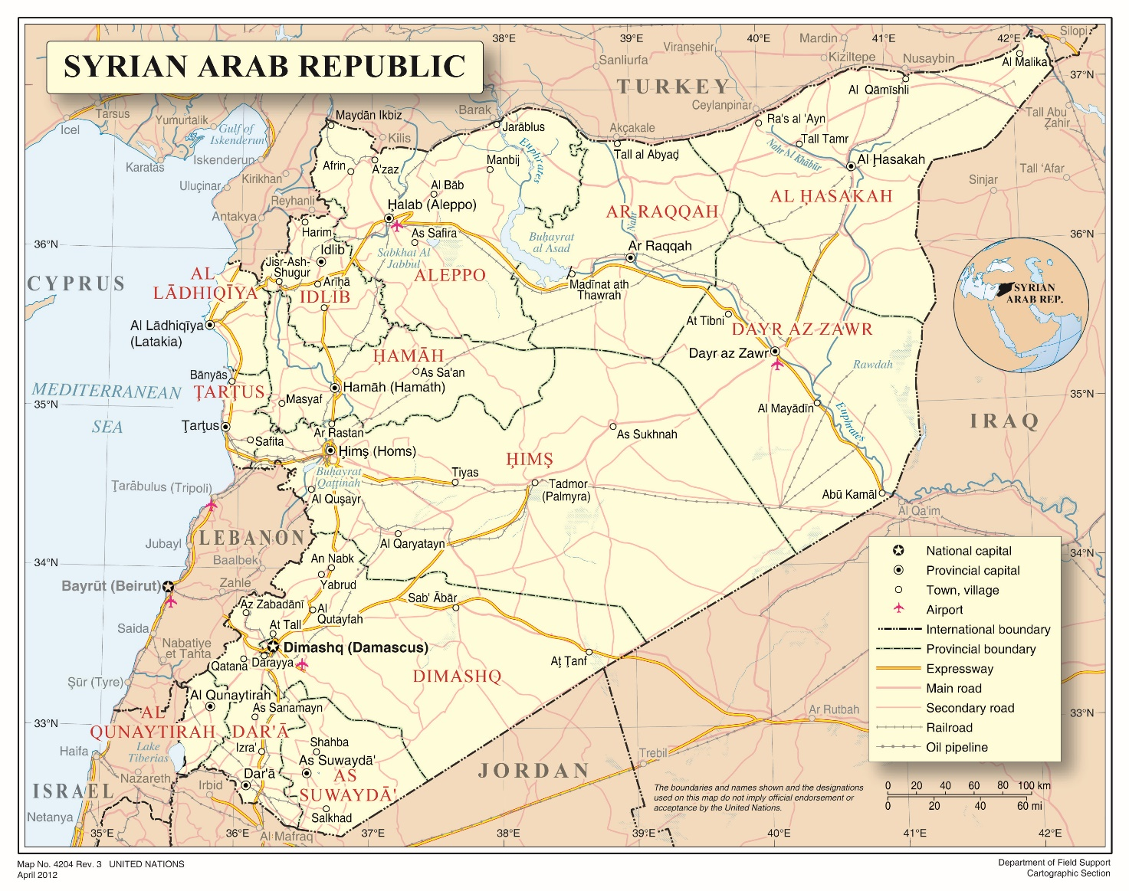

Annex II
Map of eastern Ghouta

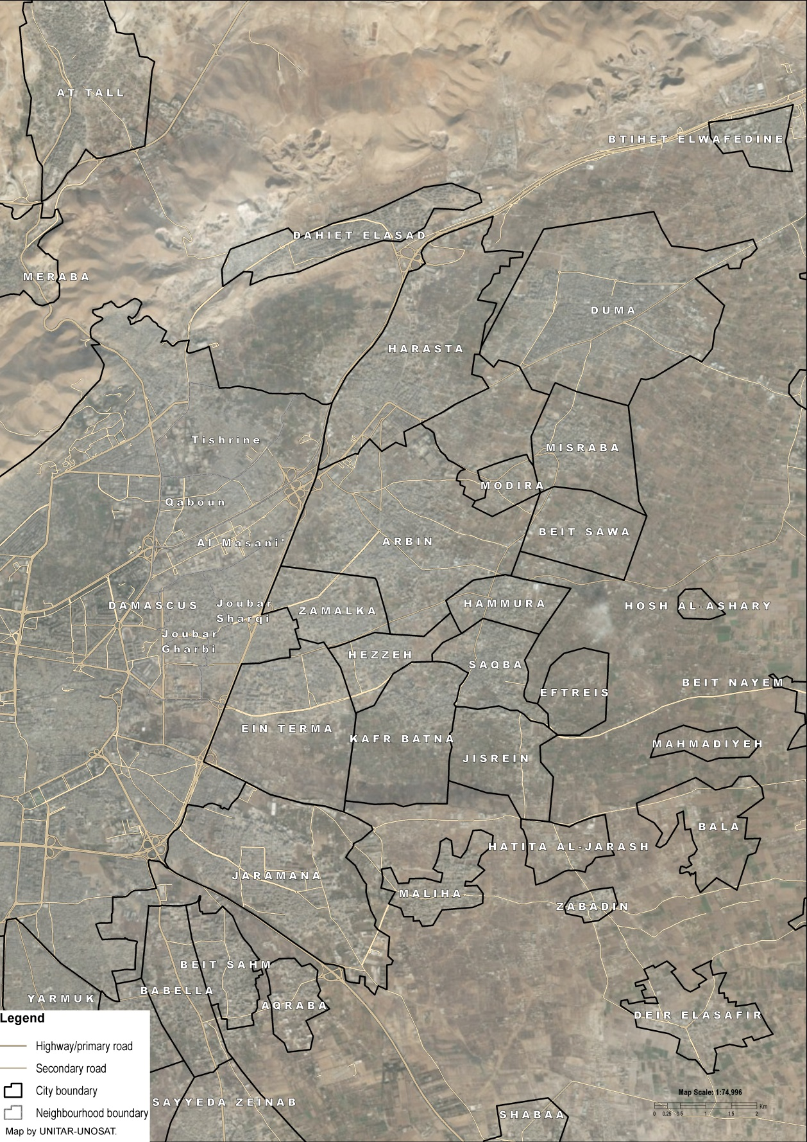
Annex III
UNITAR/UNOSAT Imagery analysis: Eastern Ghouta area / Damascus Governorate, 27 March 2018
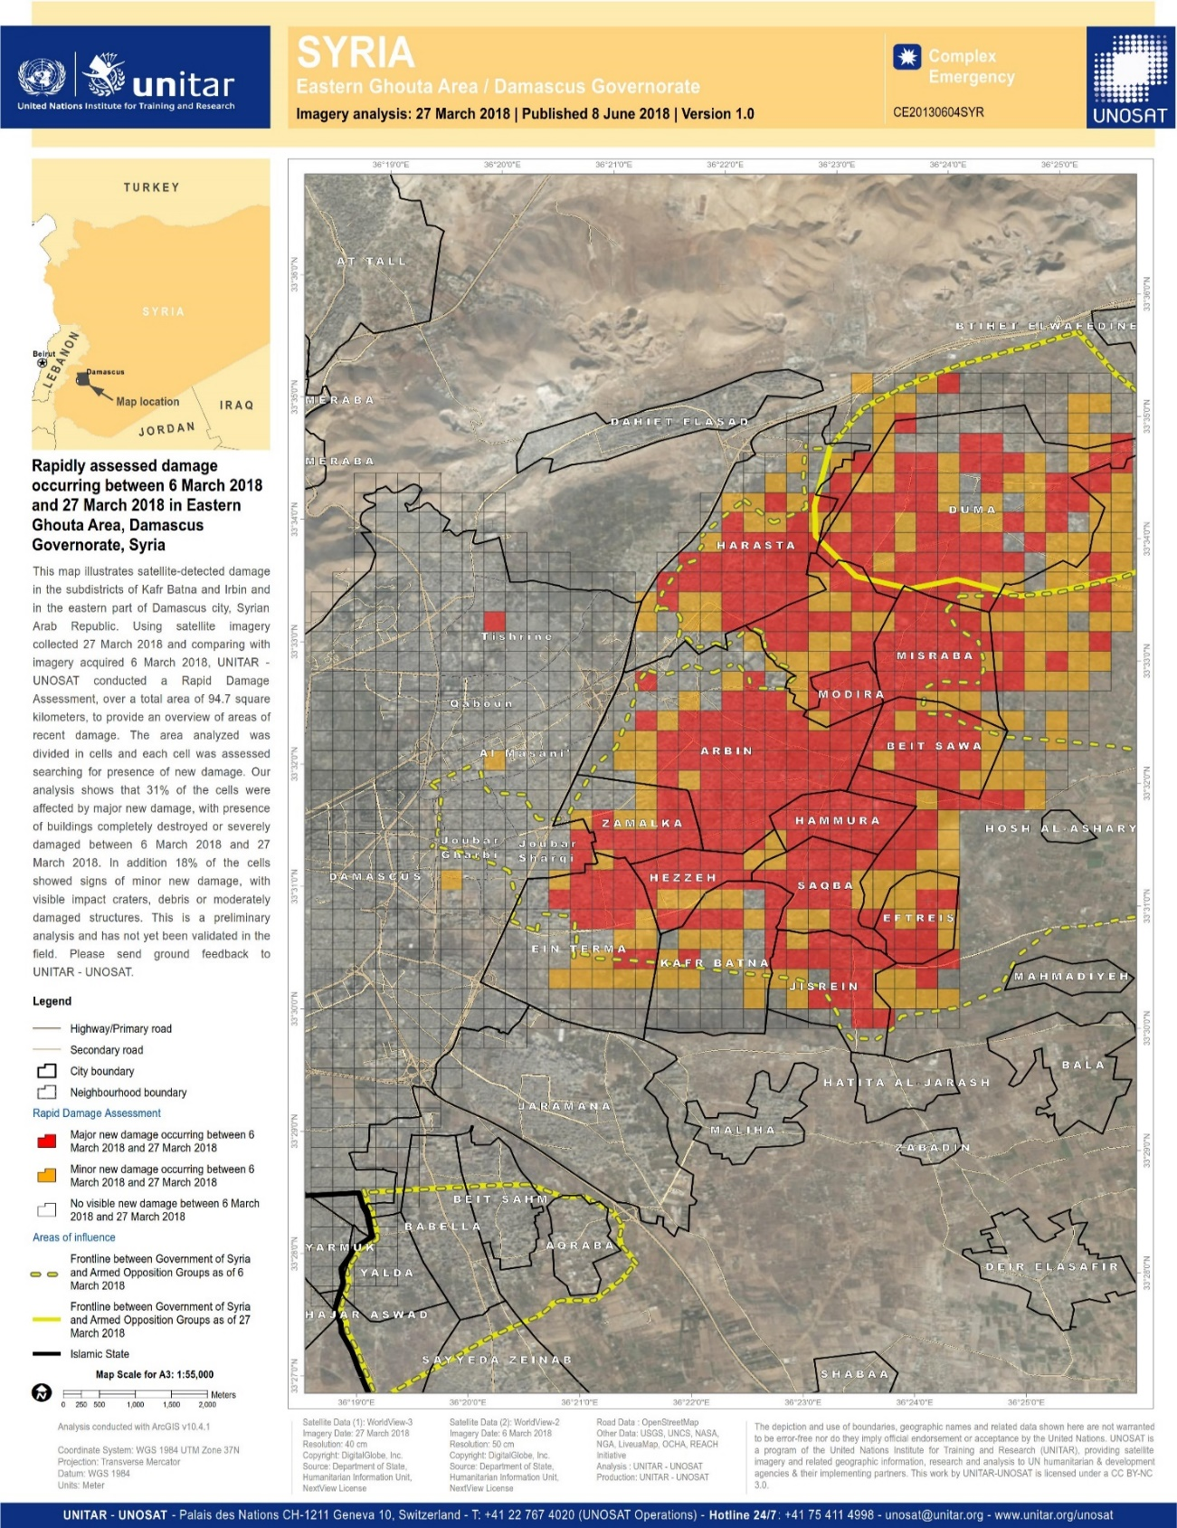

Resolution adopted by the Human Rights Council on 5 March 2018, 37/1. The deteriorating situation of human rights in Eastern Ghouta, in the Syrian Arab Republic, available at http://www.ohchr.org/EN/HRBodies/HRC/RegularSessions/Session37/Documents/A_HRC_RES_37_1_EN.docx. The commissioners are Paulo Sérgio Pinheiro (Chair), Karen Koning AbuZayd, and Hanny Megally.
The Government of the Syrian Arab Republic periodically addresses Identical Letters to the Secretary General, the President of the Security Council, and others in relation to situations of concern it faces. As with other sources consulted, and for purposes of this report, the Commission analysed 39 such letters published by the Syrian Government between February and April.
Notwithstanding its change in name from “Jabhat al-Nusra” to “Jabhat Fatah al-Sham” in July 2016, the group continues to be regarded as a terrorist entity as designated by Security Council resolution 2170 (2014). After the first round of Astana talks, the terrorist group united with a number of extremist factions under the umbrella coalition of “Hay’at Tahrir al Sham” on 28 January 2017.
This included a relatively recent series of over-calibre design known as the “Golan” series which was most frequently used by the 4th Armoured Division. Different systems within this series fire different calibres and sizes of improvised rocket-assisted munitions (IRAMs).
See, generally, the rapid assessment on damage for the period 6 to 27 March (Annex III). Satellite detected damage indicates major as well as minor new damage in eastern Ghouta as assessed by UNITAR – UNOSAT.
In the northwest, the 4th Armoured Division was reinforced by Liwa al-Quds (Jerusalem Brigade), a pro-Palestinian militia group. Other militia fighters included members of the elite Qawat Al-Nimr (Tiger Forces) and Arab Nationalist Guard, the latter comprised of volunteers. Other, smaller groups such as the al-Aqsa Shield Forces also took part in the offensive.
Government forces relied on large volumes of high explosive munitions to provide close-support. Heavy armour including main battle tanks (MBTs) were the most relied upon due to their heavy cannons (100-125mm) and armoured mobility. Light armour played a smaller, supporting role. Anti-aircraft vehicles were also employed against ground targets. Armour tended to be operated by regular military units, particularly the 4th Armoured Division and the Republican Guard.
All incidents of aerial attacks referenced in this report were carried out by either the the Syrian Air Force or Russian Aerospace Forces. In instances where specific attribution to a party was not possible, the aerial attack is attributed to either one party or the other under the designation of “pro-Government forces.”
Such as Soviet FAB and OFAB models.
Such as Soviet RBK series models.
The numbers for opposition group and HTS strengths are estimates arrived at by comparing a number of primary and secondary sources. See also, generally, Identical letter dated 20 March 2018 from the Government of the Syrian Arab Republic to the United Nations (S/2018/246).
The Commission relies on the definition of siege as defined by the United Nations Office for the Coordination of Humanitarian Affairs (OCHA), which notes that an area is besieged when it is “surrounded by armed actors with the sustained effect that humanitarian assistance cannot regularly enter, and civilians, the sick and wounded cannot regularly exit.”
International Committee of the Red Cross (ICRC), Customary International Humanitarian Law, 2005, Volume I: Rules [hereinafter “ICRC Rule”], at Rules 103 and 156.
See A/HRC/37/72, Annex II, para. 32. The Commission notes that the deliberate starvation of civilians is a war crime in non-international armed conflict. See ICRC Rules 53 and 156. The Security Council has expressed grave concern at the “the use of starvation of civilians as a method of combat, including by the besiegement of populated areas” in Resolution 2258 (2015), and further recalled “that starvation of civilians as a method of combat is prohibited by international humanitarian law” in Resolution 2401 (2018).
ICRC Rule 156.
ICRCs Rule 90 and 156.
Though the precise figure remains unknown, this estimate is based on discussions with interlocutors and data published by OCHA. See, e.g., https://reliefweb.int/report/syrian-arab-republic/syrian-arab-republic-response-east-ghouta-crisis-rural-damascus-2.
UNHCR, Syria Situation Report for the Eastern Ghouta and Afrin, Humanitarian Emergencies, as of 29 May 2018, available at https://reliefweb.int/sites/reliefweb.int/files/resources/UNHCR%20Flash%20Update%20for%20Eastern%20Ghouta%20%26%20Afrin%20-%2029MAY18.pdf
Syrian Arab Republic: Response to the East Ghouta Crisis in Rural Damascus Situation Report No. 5 (19 April – 1 May 2018), available at https://reliefweb.int/report/syrian-arab-republic/syrian-arab-republic-response-east-ghouta-crisis-rural-damascus-2.
See OCHA, Syria Crises: East Ghouta – Situation Report 4, available at https://reliefweb.int/report/syrian-arab-republic/syria-east-ghouta-situation-report-no-4-1-february-13-march-2018-enar.
See Secretary-General’s remarks to Human Rights Council [as delivered], 26 February 2018, available at https://www.un.org/sg/en/content/sg/statement/2018-02-26/secretary-generals-remarks-human-rights-council-delivered.
International Criminal Tribunal for the former Yugoslavia (ICTY), Prosecutor v. Stanislov Galić, IT-98-29-A, 30 November 2006, at paras. 99-109
Since the inception of the Syrian conflict, attacks against hospitals, medical points, ambulances, and medical personnel have been a persistent and devastating warring strategy. While such attacks are regularly carried out by most parties to the conflict, the Commission has previously documented how pro-Government forces systematically target healthcare infrastructure to deprive both civilians and belligerents of medical treatment. As elsewhere throughout Syria, and in an effort to avoid exposure to attack, hospitals and medical points in eastern Ghouta began relocating underground already at the end of 2013. In other cases, medical personnel removed identifying insignia used to indicate the presence of medical facilities, in an effort of camouflage their existence from attack.
See OCHA, Syria Crises, East Ghouta: Situation Report No. 4, (1 February – 13 March 2018), available at https://www.humanitarianresponse.info/en/operations/whole-of-syria/document/syria-crisis-east-ghouta-situation-report-no-4-1-february-%E2%80%93-13.
See A/HRC/27/60, paras. 109-111; A/HRC/33/55, paras. 42-65; A/HRC/34/64, paras. 30-40. On 3 May 2016, moreover, the United Nations Security Council adopted Resolution 2286, condemning attacks on medical facilities and personnel in conflict.
Among multiple sources consulted by the Commission concerning incidents investigated on 20 February, identical letters sent by the Government of the Syrian Arab Republic to the United Nations were taken into account, including S/2018/135 and S/2018/148.
See A/HRC/31/68, para. 105, A/HRC/36/55, paras. 46-48, and A/HRC/34/CRP.3, para. 70.
The whereabouts and fate of countless others, including for example human rights activists Razan Zaitouneh, Samira Khalil, Nazem Hamadi and Wa’el Hamada who were abducted by armed groups in Douma in December 2013, remains unknown.
The eight shelters in Rif Damascus are: Dweir, Fayhaa Alsham, Akram Abu al-Naser, Adra School Shelter, Nashabiyeh, Najha, Harjelleh, and Adra Electricity Complex.
According to figures from 15 May 2018, published by the Syrian Ministry of Local Administration and Environment (MoLA).
See Under-Secretary-General For Humanitarian Affairs And Emergency Relief Coordinator, Mark Lowcock; Briefing to the Security Council on the humanitarian situation in Syria 29 May 2018, available at https://reliefweb.int/sites/reliefweb.int/files/resources/ERC_USG%20Mark%20Lowcock%20Statement%20to%20the%20SecCo%20on%20Syria%20-%2029May2018%20-%20FINAL.pdf. Moreover, since recapturing eastern Ghouta on 14 April, Government forces have granted access only once for UN agencies to provide humanitarian aid to the approximately 70,000 civilians who remained in the enclave. Notably, the United Nations has received authorisation to visit eastern Ghouta only once since mid-March, namely to Kafr Batna and Saqba on 14 May. While the Syrian Arab Republic noted in an identical letter (S/2018/231) sent on 16 March they were providing aid to those displaced through humanitarian corridors, victims, witnesses, and interlocutors interviewed by the Commission insisted aid was being provided by humanitarian organisations.
Figures by SARC as of 27 May.
The Commission notes that medical personnel and healthcare providers have become a primary target for providing assistance to armed groups including during sieges. Laws 19, 20, and 21of the Syrian Arab Republic criminalising this conduct contravene the customary international humanitarian law rule that under no circumstances shall any person be punished “for performing medical duties compatible with medical ethics”, regardless of the person benefiting therefrom. See A/HRC/24/CRP.2, para. 21; see also ICRC Rule 26.
The Commission concurs with the International Committee of the Red Cross that “both customary and treaty international humanitarian law contain an inherent power to intern”, and considers “imperative reasons of security” the permissible grounds standard applicable to situations of non-international armed conflict. See, e.g., International Committee of the Red Cross, Commentary of 2016, Article 3: Conflicts Not of an International Character, at para. 728, available at https://ihl-databases.icrc.org/applic/ihl/ihl.nsf/Comment.xsp.
Human Rights Committee, General comment no. 35, Article 9 (Liberty and security of person), at para. 15
Primarily to Azaz and al-Bab (Aleppo).
See, e.g., A/HRC/34/64, at para. 93, and A/HRC/36/55, at para. 35; See also, generally, Sieges as a Weapon of War: Encircle, starve, surrender, evacuate., Independent International Commission of Inquiry on the Syrian Arab Republic, 29 May 2018, available at http://www.ohchr.org/Documents/HRBodies/HRCouncil/CoISyria/PolicyPaperSieges_29May2018.pdf.

