|  |  |  |  |
| --- | --- | --- | --- |
|  | United Nations | A/HRC/28/18 | |
| _unlogo | **General Assembly** | | Distr.: General  27 March 2015  Original: English |

**Human Rights Council**

**Twenty-eighth session**

Agenda item 2

**Annual report of the United Nations High Commissioner  
for Human Rights and reports of the Office of the  
High Commissioner and the Secretary-General**

Report of the Office of the United Nations High Commissioner for Human Rights on the human rights situation in Iraq in the light of abuses committed by the so-called Islamic State in Iraq and the Levant and associated groups[[1]](#footnote-2)\* [[2]](#footnote-3)\*\*

|  |
| --- |
| *Summary* |
| The present report has been prepared by the Office of the United Nations High Commissioner for Human Rights pursuant to Human Rights Council resolution S-22/1, in which the Council requested the High Commissioner to dispatch a mission to Iraq to investigate alleged violations and abuses of international human rights law committed by the so-called Islamic State in Iraq and the Levant (ISIL) and associated terrorist groups, and to establish the facts and circumstances of such abuses and violations, with a view to avoiding impunity and ensuring full accountability. The report provides an overview of the situation from June 2014 to February 2015, as requested in resolution S-22/1. |
|  |

****Contents

*Paragraphs Page*

I. Introduction 1–15 3

A. Context 1–6 3

B. Mandate and terms of reference 7–8 4

C. Methods of work 9–11 4

D. Legal framework 13–15 5

II. Patterns of violations 16–71 5

A. Violations perpetrated by ISIL 16–49 5

B. Violations perpetrated by other parties to the conflict 50–69 12

C. Mass graves 70–71 14

III. Legal responsibility 72–76 15

A. States’ legal responsibility 72–75 15

B. Individual criminal responsibility 76 15

IV. Conclusions and recommendations 77–79 16

Annex

Notes verbales 18

I. Introduction

A. Context

1. Iraq has endured decades of authoritarianism, followed by a difficult transition that was marked by an international presence, unrest and continuous violence, resulting in thousands of civilian casualties. Despite positive steps towards building a constitutional republic, this period has witnessed a wide range of human rights violations. They include enforced disappearances, arbitrary detention, reprisal killings, shortcomings in fair trial and due process standards, lack of accountability and failure to deliver many basic services. Since 2003, thousands of suicide attacks, carried out by terrorist groups, have killed thousands of civilians.
2. The so-called Islamic State in Iraq and the Levant (ISIL)[[3]](#footnote-4) surfaced in this unstable and violent environment. A lack of inclusive participatory processes and a failure to promote and protect political, civil, economic, social and cultural rights amidst regional turmoil paved the way for ISIL and other radical groups to advance into northern Iraq, exploiting the frustration of local tribes and, shortly after, cracking down on many with the utmost brutality and cruelty.
3. In April 2013, the Iraqi Security Forces (ISF) used force to end a demonstration in the town of Hawija in Kirkuk governorate and a number of demonstrators died. Rallies and sit-ins followed in the provinces of Anbar, Ninewa, Salah ad-Din and Diyala. The Government’s crackdown on these protests exacerbated a sense of exclusion among the sizeable Sunni population.
4. In January 2014, the city of Fallujah in Anbar province fell into the hands of ISIL. In April, Anbar was a battleground. By May, 500,000 civilians had been internally displaced. While ISF scored some victories against ISIL in Anbar, the latter stormed the cities of Mosul and Tikrit in a blitz offensive in June, taking control of large swathes of the northern provinces. ISIL carried out massacres at Badush prison and Camp Speicher and besieged the town of Amerli in Diyala province.
5. In August 2014, ISIL seized the districts of Sinjar, Tel Afar and the Ninewa Plains. Allegations began to surface of serious human rights abuses perpetrated by ISIL and associated armed groups, including the intentional and systematic targeting of members of ethnic and religious communities in areas seized. This led to a mass exodus of Yezidis, Christians and members of other ethnic and religious groups from the Ninewa Plains. Operations in Mosul and Sinjar triggered the displacement of a further 1.5 million people. By the time Mosul fell to ISIL, ISF were in disarray. The Government of Iraq turned to other armed actors, alongside ISF, to halt ISIL advances and reverse its territorial gains. Many young Iraqis volunteered to fight ISIL as part of the “Popular Mobilization Movement”.[[4]](#footnote-5)
6. Throughout the summer of 2014, the Popular Mobilization Movement ‘volunteers’ and Shia militia moved from their southern heartlands towards ISIL-controlled areas in central and northern Iraq. While their military campaign against the group gained ground, the militias seemed to operate with total impunity, leaving a trail of death and destruction in their wake.

B. Mandate and terms of reference

1. A special session of the Human Rights Council was requested inter alia by Iraq and convened in the light of increasing violations and abuses of human rights and violations of international humanitarian law, including unlawful killings, deliberate targeting of civilians, forced conversions, targeted persecution of groups and individuals on the basis of their religion or belief, acts of violence against members of ethnic and religious groups, as well as destruction of places of worship and cultural heritage sites.. The United Nations High Commissioner for Human Rights dispatched a mission to Iraq pursuant to Council resolution S-22/1, adopted on 1 September 2014 without a vote. In that resolution, the Council requested the Office of the United Nations High Commissioner for Human Rights to dispatch a mission to Iraq to investigate alleged violations and abuses of international human rights law committed by ISIL and associated terrorists groups, and to establish the facts and circumstances of such abuses and violations, with a view to avoiding impunity and ensuring full accountability.
2. Also in resolution S/22-1, the Council requested the High Commissioner to provide an oral update on the implementation of the resolution at an interactive dialogue during its twenty-eighth session. The present report, submitted pursuant to this request, covers events linked to the armed conflict involving ISIL which took place in Iraq between June 2014 and February 2015. All the information it contains is based on rigorous human rights investigations carried out in Iraq between December 2014 and February 2015. The Office of the United Nations High Commissioner for Human Rights also verified information received on human rights violations and abuses, and violations of international humanitarian law that have been perpetrated by other parties to the conflict and documents them herein.[[5]](#footnote-6)

C. Methods of work

1. The mission reviewed all available information, including testimony from witnesses and victims and documentation from the Government of Iraq,[[6]](#footnote-7) Member States and relevant United Nations and non-governmental organizations. It followed up on reports of violations of international human rights and humanitarian law in Iraq to verify their veracity and establish further facts. The mission conducted investigations in Chamchamal, Dohuk, Erbil, Kalar, Suleimaniyah and Zakho, and camps for internally displaced persons in those areas.
2. Owing to insecurity and heightened conflict in some areas of the country, and logistical constraints, the mission could not conduct investigations in many areas of Iraq where serious human rights abuses and violations had allegedly taken place, such as Kirkuk governorate and Mosul, Tel Afar and Zummar in Ninewa governorate. For areas that were physically inaccessible, the mission undertook telephone interviews or, when possible, met victims and witnesses in more secure locations.
3. The findings outlined in the present report are based on an analysis of first-hand information obtained through in-depth interviews conducted with over 100 victims and witnesses. The credibility of information was assessed on the basis of consistency among witness accounts and the existence of other corroborative information. The factual certainty of the findings is not uniform; for each of its findings, the mission specifies the degree to which it is confident that the incident occurred.
4. OHCHR thanks the Government of Iraq for extending full cooperation to the investigation mission and facilitating access to various parts of the country.

D. Legal framework

1. Human rights law and international humanitarian law are applicable to Iraq. The events described in resolution S-22/1 amount to an armed conflict of a non-international character involving ISIL and other affiliated armed groups, on one side, and ISF and other armed forces which support them, on the other. The mission therefore relied on international humanitarian law applicable in armed conflicts of a non-international character as its specialized legal framework alongside international human rights law.
2. Iraq is a party to core international human rights treaties and a number of treaties containing rules applicable in non-international armed conflict. All parties to the conflict in Iraq are bound by applicable rules of international humanitarian law, including customary rules. The Government has faced tremendous challenges in ensuring law and order within its territory. Nevertheless, it must abide by its obligations under international law. This duty is explicitly recognized in the Constitution of Iraq (art. 8).
3. In resolution S-22/1, the member States stressed the need for those responsible for violations of international humanitarian law or serious violations and abuses of international human rights law to be held to account through appropriate mechanisms and called upon the Government of Iraq to ensure that all perpetrators were brought to justice, with a view to avoiding impunity and ensuring full accountability. In the light of those requirements, the mission focused on acts that would possibly constitute genocide, crimes against humanity or war crimes.

II. Patterns of violations

A. Violations perpetrated by ISIL

1. Attacks against religious and ethnic groups

1. The mission gathered reliable information about acts of violence perpetrated against civilians because of their affiliation or perceived affiliation to an ethnic or religious group. It is reasonable to conclude, in the light of the information gathered overall, that some of those incidents may constitute genocide. Other incidents may amount to crimes against humanity or war crimes. Ethnic and religious groups targeted by ISIL include Yezidis, Christians, Turkmen, Sabea-Mandeans, Kaka’e, Kurds and Shia.

**(a) Attacks against Yezidis**

1. Based on interviews conducted with victims and witnesses, corroborated by other sources, the mission collected information regarding the killing of members of the Yezidi community and acts that caused serious bodily or mental harm to members of that group. The information also pointed to the intent of ISIL to destroy the Yezidi as a group when perpetrating those acts and to the existence of a manifest pattern of attacks against that community, whose identity is based on its religious beliefs. If confirmed, such conduct may amount to genocide. Numerous Yezidi witnesses provided credible and consistent accounts of separate incidents and attacks, detailing how they were forced to convert to Islam or face death.
2. At the beginning of August 2014, a series of systematic and widespread attacks took place against a backdrop of ISIL incursions into the Ninewa plains and Yezidi-populated cities and villages. Interviews with numerous victims and witnesses from Al-Adnaniya, Al-Qahtaniyah, Barah, Bazwaya, Dogore, Gogjali, Hardan, Khanasor, Kocho, Qani, Sharaf ad-Din, Sinjar city, Solagh, Tel Banat, Tel Qasab and Zummar point to a pattern whereby members of ISIL systematically separated the men from the women and young children; the men were subsequently taken away to nearby ditches and summarily executed. Some victims and witnesses added that they had been asked to convert to Islam and that the men who refused were killed, while in other instances even the men who converted were summarily executed. Men who managed to survive such executions, largely through being shielded by the bodies of other victims, relayed their accounts to the investigation team. Women and children who were held captive near execution sites also witnessed some executions. In some instances, villages were entirely emptied of their Yezidi population.
3. For instance, on 3 August, in Qani village (Sinjar) at least 80 men were killed in a single incident. The mission interviewed survivors. One of them recounted how they were rounded up and taken to a nearby ditch, where ISIL fighters opened fire on them. He added that at least 50 members of his extended family had been killed. In Kocho, at least 700 men were killed in August. A survivor of one of the several Kocho village (Sinjar) massacres recounted how, around 11 August, Yezidi men who refused to convert were separated from the women and then taken to a farm. An ISIL fighter told them “you will see now what will happen to you, you pagans and peacock worshippers”. Although the villagers were initially given assurances that they would be freed once they handed over their possessions, ISIL divided the men in four groups of 15. The Yezidi men were ordered to lie face down on the ground; they were filmed by ISIL fighters before being shot several times. Survivors informed the mission that some residents from surrounding areas assisted ISIL in perpetrating those killings. Witnesses consistently reported that ISIL fighters had acted upon direct orders they received via telephone.
4. ISIL fighters abducted Yezidis on a mass scale and detained many for months. For instance, a group of 196 disabled Yezidis, including elderly and ill persons and children, were held captive in Mosul and Tel Afar and only released in January 2015. Many victims were forced to convert to Islam during their captivity. Around 3,000 persons, mainly Yezidis, allegedly remain in ISIL captivity. Further investigation is needed to establish the precise number of those who continue to be held by ISIL and the numbers killed, estimated to be in the thousands.[[7]](#footnote-8)

**(b) Attacks against Christians**

1. Although perceived as the “People of the Book”,[[8]](#footnote-9) a classification that grants them a certain protection in comparison with other ethnic and religious groups, Christians suffered forced displacement and deprivation of property. By 6 August, an estimated 200,000 Christians and members of other ethnic and religious groups had fled from Al-Hamdaniya, Bashiqa, Bartella, Tel Keif and other towns and villages in the Ninewa plains before they were taken over by ISIL. Among them were 50,000 persons previously displaced from Mosul, mostly Christians, who had fled in mid-June in fear of ISIL threats when they were given the choice to pay a tax, convert or leave. Houses and property of Christians in Mosul have been seized by ISIL.
2. On or around 6 August, ISIL stormed the city of Al-Hamdaniya (also referred to as Qaraqosh). Many witnesses stated that ISIL fighters pillaged and destroyed buildings in the city, including historic Christian cathedrals and churches. Approximately 150 families were unable to flee. Before expelling them, members of ISIL took possession of all their valuables and identity documents. Witnesses also reported that, during the attack, grenades, mortars and rockets landed in areas still occupied by civilians.

**(c) Attacks against Shia**

1. Interviews conducted with victims and witnesses, corroborated by reliable sources, make it reasonable to conclude that attacks were perpetrated against Turkmen, Shabak and other Shia groups.
2. Victims and witnesses from Amerli (Salah ad-Din), Barawjali, Bashir, Jerdghali and Qaranaz in Diyala governorate, as well as Bashiqa, Bazwaya, Gogjali and Omar Kan in Ninewa governorate consistently reported the same pattern of events. ISIL surrounded the village, killed the inhabitants who could not escape, burned and destroyed houses and businesses, destroyed Shia places of worship, and pillaged private and public properties.
3. On 17 June 2014, for instance, ISIL attacked the predominantly Shia Turkmen villages of Barawjali, Jerdghali and Qaranaz, north of Amerli, allegedly burning and destroying houses and property, as well as at least two Shia religious places known as Husseiniyas. Several people were killed defending the village, and at least eight were summarily executed by being shot in the head. Also on 17 June, the Shia Turkmen village of Bashir, Kirkuk, was attacked by ISIL. More than 60 people were killed, including women, children and the elderly.
4. In late June and early July, in the Ba’shika, Bazwaya, Gogjali and Omar Kan villages, Ninewa, ISIL members allegedly summarily executed a number of men and abducted numerous Shabak community members. At the end of February 2015, their whereabouts remained unknown. One woman reported that, on 20 June 2014, her son and brother-in-law disappeared after being stopped at an ISIL checkpoint. Three days later, they were found dead in a cemetery — her son beheaded and her brother-in-law shot several times.
5. ISIL also laid siege to Amerli, Salah ad-Din governorate, starting on 11 or 12 June 2014. Twenty days into the siege, ISIL members cut off the water and electricity supplies to the town. At least 15,000 people allegedly suffered from a lack of power, food, drinking water, medical services and medicine. Residents were forced to drink contaminated water, which caused many to fall ill, especially children and the elderly. A woman and her newborn baby died due to lack of medical services. The city was shelled daily with mortar rounds. One child, four men and a woman allegedly died from the shelling. The siege was broken on 1 September 2014 by ISF and affiliated armed groups.
6. Based on interviews with survivors, the mission received reliable information that, on 10 June 2014, more than 600 inmates of Badush prison, Ninewa governorate, were summarily executed by members of ISIL. Early in the morning, the prison, which housed over 3,000 inmates, was taken over by ISIL. Prisons guards had allegedly fled before the attack. The prisoners were separated into groups according to their ethnic or religious affiliation. Sunnis were freed, while others, mainly Shia, were loaded on trucks, driven to a nearby ravine and shot. Some survivors said they immediately rolled into the ravine and were saved by other bodies landing on top of them. ISIL fighters kept shooting into the ravine at any moving body, including men who were screaming in pain.

2. Politically motivated attacks

1. Interviews with victims and witnesses, corroborated by reliable sources, have led the mission to reasonably conclude that there has been a pattern of attacks by members of ISIL against those it perceives to be affiliated with the Government. Targets include police officers, members of the Iraqi armed forces, the Awakening Movement,[[9]](#footnote-10) public servants, members of parliament, tribal and religious leaders, candidates in parliamentary and legislative elections and those who had publicly criticized, or were perceived to be opposed to, ISIL. Those violations were not based on perceived ethnic or religious identity but targeted Iraqis, usually Sunnis, deemed to be linked to the Government, or who refused to pledge allegiance to ISIL.
2. The mission interviewed men and women from the Al-Jebouri, Albu Hishma and Albu Nimr tribes who had fled their homes in Diyala, Salah ad-Din and Anbar governorates. ISIL fighters are reported to have relied on lists of targets to conduct house-to-house and checkpoint searches. Numerous men allegedly disappeared after being taken by ISIL from their homes or workplace or at checkpoints. Several relatives who witnessed those arrests stated that the victims were forced to “repent” by ISIL.[[10]](#footnote-11)
3. The mission received information about several politically motivated killings. At least 602 members of the Albu Nimr tribe were allegedly killed in six separate incidents between September 2014 and January 2015 in Anbar province. Witnesses reported that, on 28 October 2014, 48 people — including seven children aged between 13 and 18 — were summarily executed in Hit in Anbar governorate and that, on 29 October, 213 tribesmen were allegedly summarily executed in Al-Furat. A police officer from Mosul who managed to escape recounted how “on 10 June, my two brothers were stopped and shot at an ISIL checkpoint at al-Karama district in Mosul”. A former police officer recounted that in mid-June 2014, in Tikrit, “ISIL fighters asked me for my police ID card; when I showed them, one of them took a knife and cut the throat of my father, my five-year-old boy and my five-month-old daughter. I begged them to kill me instead, but they told me: “we want to make you suffer, we want you to feel it burns inside your heart”.
4. Based on interviews with survivors, the United Nations Assistance Mission for Iraq reported that approximately 1,500 to 1,700 members of the Iraqi armed forces from Camp Speicher in Salah ad-Din governorate were summarily executed on 12 June 2014 by ISIL, allegedly after being captured or having surrendered. The mission interviewed people who went to Camp Speicher after the massacre and had seen numerous dead bodies in the streets around the military base and in some parts of Tikrit. The results of a government investigation into that incident are yet to be made public.
5. Numerous reports of ISIL looting, burning and destroying houses were received. As a woman from Yathrib, Salah ad-Din governorate, lamented: “In August, after the fall of Yathrib, ISIL fighters forced me out of my home with my children and made me watch the destruction of my house. Years of my life have gone. We Sunni Arabs have nowhere to go, we are targeted by everybody.” Similar accounts were provided by numerous other victims who fled ISIL violence.
6. Survivors of the Badush prison massacre of 10 June 2014 consistently reported that some Sunni detainees were asked whether they were ISF or Awakening Council representatives. Reportedly, those Sunni prisoners listed as defending their cellmates or defined as “apostates” were reportedly made to line up with Shia and other prisoners, and were then summarily executed.

3. Sexual and gender-based violence

1. The mission gathered corroborated witness statements indicating clear patterns of sexual and gender-based violence against Yezidi women. When attacking Yezidi villages, ISIL reportedly engaged in the systematic and widespread killing of men, including boys over the age of 14. Women and children were subjected to different violations. Accounts indicate that ISIL views captured women and children as spoils of war which it owns. Numerous interviews conducted with Yezidi women and girls who fled ISIL captivity between November 2014 and January 2015 provided reliable information on killings, widespread and systematic enslavement, including selling of women, rape, and sexual slavery, the forced transfer of women and children, and inhuman and degrading treatment. Many of the women interviewed were able to identify the origins of their ISIL captors, who were from a wide range of countries.
2. Following the systematic separation of men, women and young children, Yezidi women were further divided into three groups: married women with children, married women without children, and unmarried women and young girls. Each of those groups was transferred to different locations in ISIL-controlled territory. Some victims were transferred to more than 10 different locations during a four-month period. These repeated displacements were apparently intended to reinforce ISIL control over the victims by instilling in them feelings of fear, insecurity and disorientation.
3. Girls and unmarried women who escaped from ISIL captivity consistently recounted the process by which they were raped and sexually enslaved. ISIL members numbered them or recorded their names on lists, and inspected them to evaluate their beauty. While some were given as “gifts”, others were sold to local or foreign ISIL fighters. Some victims were privy to price negotiations between “vendors” and “buyers.” An “emir”[[11]](#footnote-12) would instruct ISIL fighters to inspect and choose girls for “marriage”. Girls would then be prepared for “marriage” (rape), involving, in some cases, full body searches. Mission investigators met with victims as young as 11 years of age.[[12]](#footnote-13) A 30-year-old woman described how young girls were prepared for sale at a house in Mosul. They were ordered to stand and remove their headscarves to be inspected. Then they were forced to smile while ISIL fighters took photographs.
4. A victim witnessed similar cruel and inhuman treatment following her transfer to Adnaani, a 15-minute drive from Baaj, Ninewa governorate. She recounted that an “emir” wrote the names of 14 girls on small pieces of paper and called two ISIL fighters, who each picked one piece of paper. The “emir” asked the ISIL fighters to call out the name written on the paper. The 15- and 18-year-old girls whose names were called were forcibly taken by the two fighters into another room. The “emir” and a so-called “imam” who was in the room laughed when they heard the two girls screaming. After around 20 minutes, the two girls were brought back into the room. The witness said both girls were in shock and had blood on their trousers. Both confirmed to the witness that they had been “married” (raped).
5. A 19-year-old pregnant married woman explained that she was repeatedly raped by an ISIL “doctor” for two and a half months in Hawija district, Kirkuk governorate.[[13]](#footnote-14) There were visible lacerations on her breast, indicating that she may have been tortured. According to the woman, the “doctor” sat on her stomach, aiming to kill her unborn child, saying, “this baby should die because it is an infidel; I can make a Muslim baby”.[[14]](#footnote-15)
6. The mission obtained credible reports about the rape of young girls, including a 9-year-old and 6-year-old. The former was raped for three days by an ISIL fighter in Tel Qaseb, Ninewa governorate. A witness stated that she could clearly hear the girl being assaulted and screaming out her name for help. The girl told the witness that she was blindfolded, handcuffed, beaten and repeatedly raped. Eventually, her “owner” sold her to another ISIL fighter from the Syrian Arab Republic. In the same house, a 6-year-old girl was raped by another ISIL fighter. A witness heard the child screaming.She was reportedly sold to an ISIL fighter in the Syrian Arab Republic.
7. Witnesses reported that a doctor conducted abortions on two women in a school in Ba’aj, Ninewa; they were two and three months pregnant, respectively. Prior to the abortion, one witness reportedly heard an ISIL fighter stating: “we do not want more Yezidis to be born”. Both women received an injection and were made to take pills. A week after the abortions, both women were sold.
8. Women who escaped ISIL custody recounted how they were forcibly transferred multiple times to different locations in Iraq, including Adnaani, Al-Nufus, Baaj, Fallujah, Gayara, Hawija, Khaini, Kirkuk, Kocho, Mosul,[[15]](#footnote-16) Rambosi, Sheba, Solagh, Tel Afar,[[16]](#footnote-17) Tel Qaseb, Tel Banat and Wardya. Other women and children were transferred to Al-Hassakeh, Al-Shadadiyah, Deir-ez-Zoor, Ghazna, Membij, Raqqa and Tel Abyad in the Syrian Arab Republic.
9. Many survivors of sexual violence experienced the loss of loved ones killed by ISIL. Some witnessed those attacks and are severely traumatized. Suicides and attempted suicides have sharply risen amongst those women and girls. Many survivors interviewed displayed visible signs of trauma and depression. The mission investigators spoke to men who were desperate and felt helpless after being separated from their wives and children. One said: “losing my wife and children to ISIL is the worst nightmare that could happen to a man”.

4. Recruitment and use of children

1. Based on information provided by victims and witnesses, it is reasonable to conclude that ISIL used, conscripted or enlisted children between the ages of 8 and 18 to participate in the armed conflict, in breach of international human rights law,[[17]](#footnote-18) international criminal law[[18]](#footnote-19) and customary international humanitarian law.
2. The mission investigators interviewed Yezidi children who had escaped ISIL captivity. In August 2014, following the abduction of thousands of Yezidis by ISIL fighters, children aged between 8 and 15 were separated from their mothers and transferred to different locations in Iraq and the Syrian Arab Republic, including a school in Tel Afar and a school on the outskirts of Raqqa, Syrian Arab Republic. Children recounted how they had received religious and military training following their forced conversion. Training lasted from 13 days to 3 weeks and included how to load and unload guns, shoot using live bullets and launch small and medium-sized rockets. Boys reported being forced to watch videos of beheadings several times. When they refused, they were severely beaten. A child was told: “this is your initiation into jihad, you have to be strong, because you will do this when you will go to jihad for the Islamic State; you are an Islamic State boy now”.
3. Numerous other incidents reported by reliable sources require further investigation. For instance, residents of Fallujah, Anbar governorate, and Mosul, Ninewa governorate, reported that children in their late teens man checkpoints for ISIL. Other allegations indicate that children as young as 12 or 13 undergo military training with ISIL in Mosul. In areas it controls in Iraq and the Syrian Arab Republic, ISIL has allegedly established centres for military and religious training of children in an effort to indoctrinate them and build a new generation of fighters. An ISIL video portrays one such camp near Mosul, referring to the children as the “cubs of the caliphate”. Children are shown exercising and reciting the Holy Koran, while an instructor explains that they are being trained to fight “hate-filled Shia”. It is unclear how many children have received such training and how many are actively engaged in hostilities.

5. Use of prohibited weapons

1. Allegations of the use of chlorine gas by members of ISIL were reported. The use of chlorine gas as a chemical weapon is prohibited in all circumstances. It was alleged that a chemical agent, likely chlorine, was used on 22 September 2014 when ISIL attacked and killed 300 Iraqi soldiers in Anbar. Officials from Balad and Dulu’iya in Salah ad-Din governorate have alleged that ISIL used bombs with chlorine-filled cylinders during clashes in late September 2014. Those allegations require further investigation.

6. Other human rights violations in ISIL-controlled areas

1. The mission documented other serious human rights violations committed by ISIL in areas under its de facto control. They include unfair trials, torture, cruel and inhuman treatment and extrajudicial killings.
2. ISIL-established sharia courts in Mosul allegedly sentence people to such cruel, inhuman and degrading treatment as stoning and amputation. Two men accused of homosexuality were convicted by an ISIL “court” and thrown from the top of a tall building. Four physicians were reportedly executed after refusing to treat ISIL fighters. Thirteen teenage boys were sentenced to death for watching a football match. In January 2015, a document attributed to ISIL showed two men being “crucified” after they were accused of banditry. Other documents attributed to ISIL revealed that in Al-Qaim, Anbar governorate, an ISIL soldier’s hand was cut off for theft. Owing to lack of access to ISIL-controlled areas, and the complete breakdown of telecommunications in Mosul, it was not possible for the mission to follow up those cases.

B. Violations perpetrated by other parties to the conflict

1. The mission gathered information from multiple credible sources highlighting alleged violations of international humanitarian and violations and abuses of human rights law by ISF and associated armed groups in their counter-terrorism efforts to defeat ISIL. It is reasonable to conclude that those forces carried out extrajudicial killings, torture and abductions and forcibly displaced a large number of people, often with impunity.
2. Since the fall of Mosul, various armed groups have become an integral component of the Government’s response to ISIL, with the line between regular and irregular pro-Government forces, and particularly between Popular Mobilization volunteers and militia becoming increasingly blurred. As a result, the mission was not always able to clearly determine which group was directly involved in reported incidents or identify the chain of command. A number of victims interviewed by the mission stressed that militia groups are in de facto command over regular forces. Such claims could not be independently verified. Additional information is needed to establish the link between some militia forces and the Government. The Government, however, has the obligation to exercise due diligence in protecting persons under its jurisdiction.

1. Extrajudicial killings, abductions and torture

1. Between June and August 2014, a series of attacks occurred in the Diyala governorate when militia, at times jointly with ISF, waged a retaliatory campaign against members of the Sunni community. Numerous victims and witnesses described a number of incidents in the villages of Baquba, Imam Weis and Sinsil, which, they alleged, all specifically targeted Sunnis. In mid-June, fleeing armed forces allegedly set fire to an army base in Sinsil where 53 Sunnis were being held. Witnesses discovered their bodies: some were charred beyond recognition; others were only partially burnt, revealing gunshot wounds, severe bruises and broken limbs.[[19]](#footnote-20)
2. On 16 June, at least 43 prisoners from the Al-Wahda police station in Baquba were allegedly summarily executed by gunshots to the head. Some victims had broken limbs, suggesting torture.[[20]](#footnote-21)
3. On 22 August, militia members and Iraqi police allegedly carried out two consecutive attacks against the Musab Ibn Umair mosque in Imam Weis village, killing 34 civilians, including a woman and a 17-year-old boy, who were attending Friday prayers. An investigation has been launched; the findings are yet to be made public.
4. The mission received multiple allegations that members of militia and ISF executed at least 70 Sunni civilians in different locations in Barwana, Diyala governorate, on 26 January 2015. The bodies were reportedly removed to an unknown location and the victims’ families were unable to retrieve them. Other civilians arrested on the same day allegedly remain unaccounted for. The Government has announced an investigation.
5. Attacks allegedly perpetrated by militia affiliated to ISF were reported in Baghdad, Baquba, Kirkuk, Mosul, Samarra and Tel Afar, allegedly in revenge for attacks by ISIL. The mission could not independently verify those incidents, which require further investigation.
6. Against the background of attacks against Sunni villages in Salah ad-Din and Diyala governorates, numerous witnesses reported incidents involving illegal arrests and the taking of hostages. They allegedly occurred in Al-Hatimiya, Baquba, Dujail, Tuz Khormato and Yathrib. Some families said that they had secured the release of loved ones by paying ransoms.
7. In August and September 2014, as ISF and affiliated militia moved against ISIL in Yathrib, Salah ad-Din governorate, Sunni men from the area were allegedly systematically arrested in the village of Jami’iya and at checkpoints in Al-Hatimiya and Dujail. Victims provided consistent accounts of being ordered to hand over mobile phones, valuables and identity documents. They were blindfolded, handcuffed and taken to the Al-Bakr (Balad) airbase in Salah ad-Din governorate, where they were tortured or ill-treated for several days while being interrogated about ISIL forces and their positions in the region.
8. On the night of 8 to 9 August 2014, a militia stationed at the Youth Sports Club in Tuz Khormato town in Salah ad-Din governorate abducted up to seven Sunnis from their houses. One Sunni was brutally beaten, tortured and killed,[[21]](#footnote-22) while the fate of the others remains unknown. The mission received multiple reports that militia groups are running detention facilities at Al-Bakr airbase, Salah ad-Din, where torture is allegedly undertaken routinely. On 25 October 2014, for example, two Sunnis were taken from the Brigade 17 checkpoint in Dujail to Al-Bakr airbase. They were handcuffed, blindfolded and tortured for five days by beatings, kicks and electric shocks. Up to 40 men allegedly shared a cell with them and suffered the same treatment. One of their captors allegedly urged them daily to convert to Shia Islam. On 11 December, a Sunni man was abducted at the Al-Hatimiya checkpoint by fighters[[22]](#footnote-23) and was taken to the Al-Bakr airbase, where he was held and tortured for four days. He was released once his family had paid 6,000 United States dollars in ransom.
9. The mission gathered information from a number of victims and witnesses about an attack on 25 January 2015 against Sunni Arabs in the villages Al-Sibaya and Al-Jeri, north of Sinjar. Based on evidence gathered, it may be reasonable to conclude that the attack was perpetrated by a Yezidi armed group. Twenty-two people were allegedly shot dead, including women, children and the elderly; several others were injured. The bodies of at least six people were burnt in their homes after they had been shot. Several houses were allegedly burnt, properties were looted and villagers were allegedly ordered to hand over valuables. Witnesses reported that 17 people were abducted; their whereabouts remain unknown. Inhabitants of both villages were displaced.
10. These allegations could not be thoroughly investigated by the mission and warrant further investigation.

2. Forced displacement and preventing access to safe areas

1. Multiple accounts indicate that militia conducted operations targeting Sunni in Salah ad-Din and Diyala that resulted in forced displacement. Witnesses reported that during an operation in Al-Jami’iya, Salah ad-Din in September 2014, militia members forced Sunni civilians from their homes at gunpoint, beat them and shouted “you are all ISIL, you are against Islam”. One victim recounted that militiamen entered his house, smashed furniture and stole large amounts of money and gold. He was told to leave and never return; his home and car were torched. The mission received similar reports of the destruction and burning of houses in villages in Yathrib, Salah ad-Din governorate. Victims told the mission that militia had prevented Sunnis from returning to their villages.
2. The mission also interviewed victims from dozens of Sunni villages in Amerli and Suleiman Bek, Salah ad-Din governorate, who reported a similar pattern of looting and destruction after the siege of Amerli was broken. As one witness recounted, “we hoped for the best when the Iraqi army and the ‘volunteers’ liberated the area from ISIL. Instead, once the ‘volunteers’ took control, they pillaged, burnt and blew up houses, claiming that all villagers are part of ISIL. This is not true; we are just ordinary poor people.”
3. While more information is needed on the link between the militia and the Government, such incidents point, at the very least, to a failure by the Government to protect persons under its jurisdiction.
4. On the basis of interviews conducted with victims and witnesses, it is reasonable to conclude that Iraqis were deprived of their fundamental rights to safety and security. In November 2014, members of the Sunni community leaving villages taken over by ISIL in Yathrib, Salah ad-Din governorate, were allegedly blocked for several days at the Makthab Khalid checkpoint in Kirkuk governorate. The checkpoint, manned by forces under the control of the Kurdistan Regional Government (KRG), was the main entry point for those who wanted to reach safety in Kirkuk city or Suleimaniyah governorate. Some interviewees waited at the checkpoint for 15 days, sleeping in the street in the bitter cold. Many witnessed children dying of cold while their families waited to be allowed through.
5. Numerous other incidents reported by reliable sources could not be verified by the mission and require further investigation. For instance, it was reported that Shia Turkmen who fled the conflict in Tel Afar were stranded at checkpoints operated by armed forces under the control of KRG.

3. Indiscriminate attacks

1. The mission received a number of reports alleging indiscriminate attacks against civilians. While it was unable to determine the intended target of these attacks, it established that they often caused civilian deaths and injuries, raising the possibility of a lack of precautionary measures to protect civilians.
2. On 29 November 2014, for example, in Zour, Salah ad-Din governorate, two rockets fired from a helicopter hit a car, killing one person and injuring seven. On the same day, fire from another Iraqi helicopter hit a house in the same area, killing at least 17 people, including five children.
3. Numerous other incidents reported by reliable sources could not be independently verified by the mission and require further investigation. For instance, the use of barrel bombs by ISF was widely alleged. The use of this low-accuracy weapon in residential areas would likely amount to indiscriminate attacks.

C. Mass graves

1. As State forces have retaken some ISIL-controlled areas, mass graves have been discovered. The KRG Committee on Mass Graves informed the mission that seven mass graves had been discovered in Hardan, Khanasor, Sinone and Zummar. Four mass graves were also discovered in Khanaqin, Diyala. A further 12 mass graves are reportedly located in areas that remain under ISIL control.
2. Although some measures have been put in place to protect mass graves and prevent attempts to exhume the bodies, more needs to be done in order to make sure that the dead can be identified and the cause of death determined.

III. Legal responsibility

A. States’ legal responsibility

1. Information gathered by the mission strongly suggests that international crimes may have been perpetrated and continue to be perpetrated in Iraq by ISIL. The primary legal responsibility for addressing those international crimes lies with the State of Iraq whose duty it is to protect persons under its jurisdiction and ensure accountability.
2. All States are required to determine how to implement their obligations to ensure respect for international humanitarian law, especially in the framework of their obligation to investigate and prosecute allegations of war crimes and genocide. The Government of Iraq has a duty to investigate all allegations which concern ISIL, ISF and affiliated armed groups, as well as other armed militias, and to prosecute perpetrators, including the responsible commanders and other superiors.
3. Information gathered by the mission suggests that some militia groups may enjoy de facto command over regular forces. If that is true, it is the Government’s responsibility to ensure that all organized armed forces, groups and units are placed under a command responsible for the conduct of its subordinates.
4. In light of the violations perpetrated by parties to the armed conflict in Iraq, other States who lend support to the various parties to the conflict need to determine whether such support is compatible with their obligations under international law.

B. Individual criminal responsibility

1. The following crimes may have been committed.

* Genocide, by killing, causing serious bodily or mental harm and forced transfer of children, as part of a manifest pattern of similar conduct aimed at the destruction of a particular group. Information gathered strongly suggests that ISIL may have perpetrated those crimes against the Yezidi population.
* Crimes against humanity, such as murder, enslavement, deportation or forcible transfer of population, imprisonment or other severe deprivation of physical liberty, torture, rape, sexual slavery, sexual violence and persecution, committed as part of widespread and systematic attacks directed against civilian populations pursuant to, or in furtherance of, an organizational policy to commit such attacks. Information provided strongly suggests that ISIL has perpetrated some of those crimes against Christian, Shia and Yezidi communities.
* War crimes of murder, mutilation, cruel treatment and torture, outrages upon personal dignity, the passing of sentences and the carrying out of executions without previous judgement pronounced by a regularly constituted court, directing attacks against the civilian population, directing attacks against buildings dedicated to religion, historic monuments, pillaging a town or place, committing rape, sexual slavery and any other form of sexual violence, conscripting or enlisting children or using them to participate actively in hostilities, ordering the displacement of the civilian population, destroying or seizing the property of an adversary. Information gathered points to ISIL having perpetrated such crimes.
* Information gathered demonstrates that ISF and affiliated militia may have committed some war crimes.

IV. Conclusions and recommendations

1. **The High Commissioner is impressed by the vast number of credible witnesses and victims who, despite severe trauma and in some cases at considerable risk to their personal safety and security, bravely spoke out about the violations perpetrated to ensure that they are documented with the aim that the perpetrators will be brought to justice. He salutes their courage.**
2. **Subject to a determination by an independent and competent court, the mission concludes that:**

* **Members of ISIL may have perpetrated genocide against the Yezidi community by killing, causing serious bodily or mental harm and forcibly transferring members of the group, including children, in the context of a manifest pattern of conduct aimed at the destruction of the group.**
* **Members of ISIL may have committed crimes against humanity by perpetrating murder, enslavement, deportation or forcible transfer of population, severe deprivation of physical liberty, torture, rape, sexual slavery, sexual violence and persecution, committed as part of widespread or systematic attacks directed against civilian populations pursuant to or in furtherance of an organizational policy to commit such attacks.**
* **Members of ISIL may have committed war crimes by perpetrating murder, mutilation, cruel treatment and torture, outrages upon personal dignity, taking of hostages, the passing of sentences and the carrying out of executions without previous judgement pronounced by a regularly constituted court, directing attacks against the civilian population, directing attacks against buildings dedicated to religion or against historic monuments, pillaging a town or place, committing rape, sexual slavery and other forms of sexual violence, conscripting or enlisting children under the age of 15 years or using them to participate actively in hostilities, ordering the displacement of the civilian population or destroying or seizing the property of an adversary.**
* **ISIL is perpetrating serious human rights violations in areas which are under its de facto control; including torture, cruel and inhuman treatment, and extrajudicial killings.**
* **While more information is needed on the link between the militia and the Government, some incidents addressed in the report point, at the very least, to a failure on part of the Government to exercise due diligence as regards its obligation to protect persons under its jurisdiction.** **Members of ISF and affiliated armed groups may have committed war crimes by perpetrating murder, cruel treatment and torture, taking hostages, directing attacks against the civilian population, pillaging a town or place, ordering the displacement of the civilian population or destroying or seizing the property of an adversary.**

1. **In order to ensure justice for all victims in Iraq of violations of international humanitarian law and human rights, and in the light of the ongoing armed conflict, The High Commissioner recommends that:**

The Government of Iraq:

* **Ensure that all alleged crimes are investigated in line with international human rights standards, and perpetrators are brought to justice.**
* **Take the necessary steps for Iraq to become a party to the Rome Statute of the International Criminal Court and ensure that the international crimes defined in the Rome Statute are criminalized under domestic law; and in the meantime, accept the Court’s jurisdiction over the current situation, under article 12, paragraph 3 of the Rome Statute.**
* **Ensure that the findings of all Government-initiated investigations into violations of international humanitarian and human rights law are made public and lead to effective remedies for victims.**
* **Engage in a rights-based, inclusive and meaningful political dialogue to bring the current crisis to an end; and foster a national reconciliation process that represents the legitimate interests and grievances of all Iraqis.**
* **Ensure that all Iraqis currently displaced have access to essential services and fundamental rights, such as access to adequate health care and education; establish non-discriminatory procedures for access to safe zones, taking into consideration the humanitarian imperative; and ensure durable solutions for all displaced populations, recognizing their right to return and their right as Iraqi citizens to reside in any part of the country.**
* **Ensure that victims of the international crimes documented in the present report, particularly survivors of sexual abuse and sexual slavery, receive adequate support, including psychosocial support and medical care.**
* **Ensure the protection of mass graves and that with measures are taken to identify the dead and launch an efficient investigation to determine the circumstances under which death occurred.**
* **Investigate allegations that ISF and armed groups acting under its control failed to protect communities persecuted by ISIL.**
* **Invite the special procedures of the Human Rights Council, in particular the Special Rapporteurs on extrajudicial, summary or arbitrary executions and on torture and other cruel, inhuman or degrading treatment or punishment, as well as the Working Group on Arbitrary Detention, to visit Iraq to monitor and report on the human rights situation.**

The Human Rights Council:

* **Ensure that the situation of human rights in Iraq remains on the agenda of the Council by continuing to closely follow the situation in Iraq with a view to ensuring that perpetrators of violations of international humanitarian law and violations and abuses of human rights law are held accountable through the establishment of appropriate monitoring and investigating mechanisms.**
* **Urge the Security Council to remain seized of and to address, in the strongest terms, information that points to genocide, crimes against humanity and war crimes, and call on the Security Council to consider referring the situation in Iraq to the International Criminal Court.**

Annex

Notes verbales

[Arabic/English only]

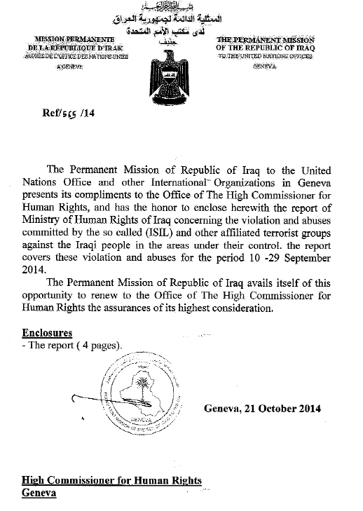

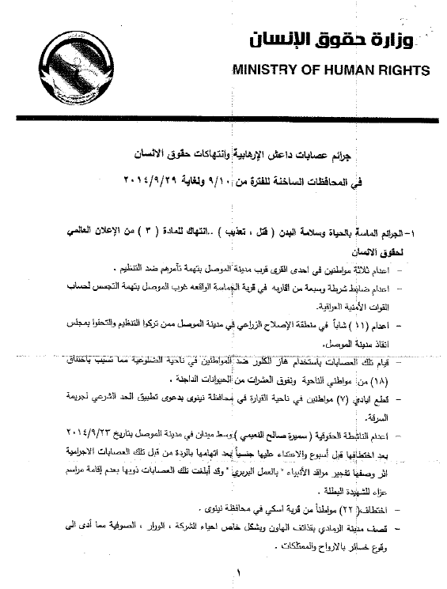

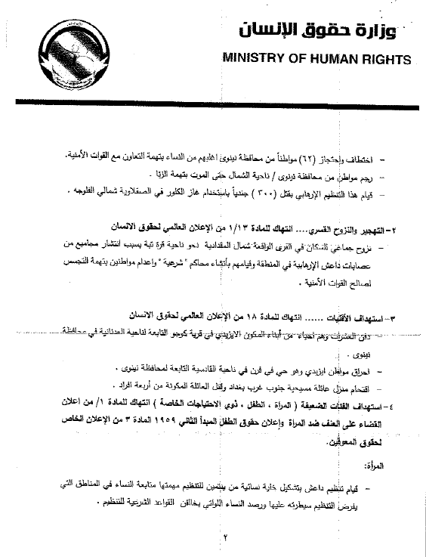

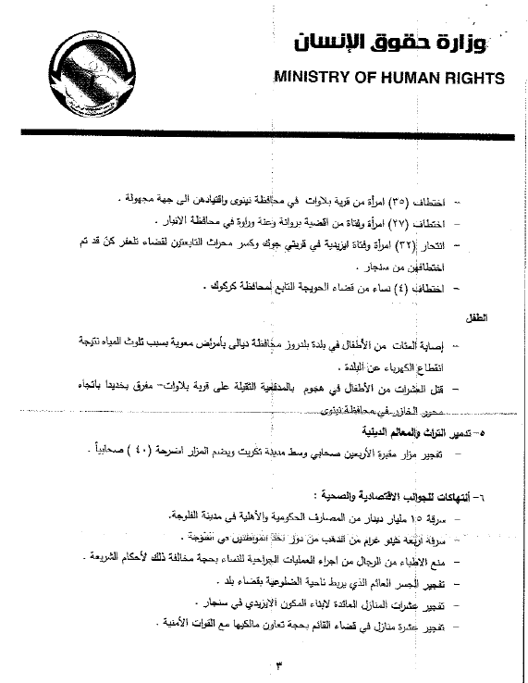

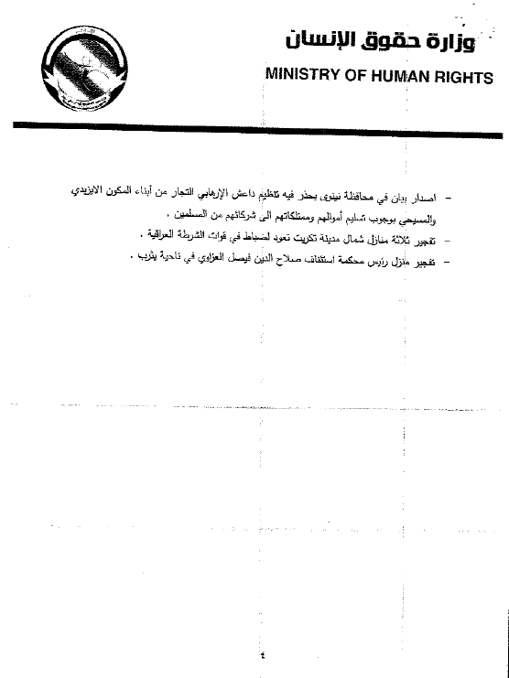

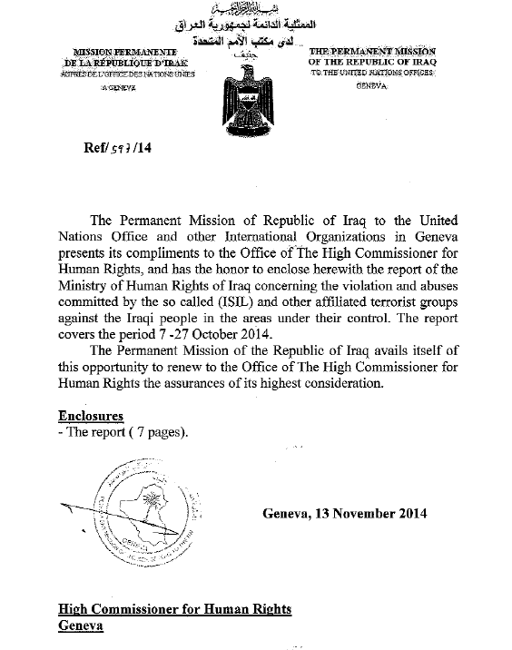

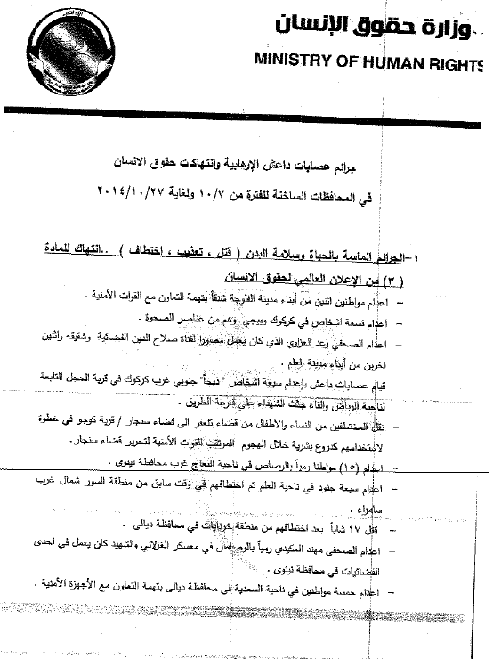

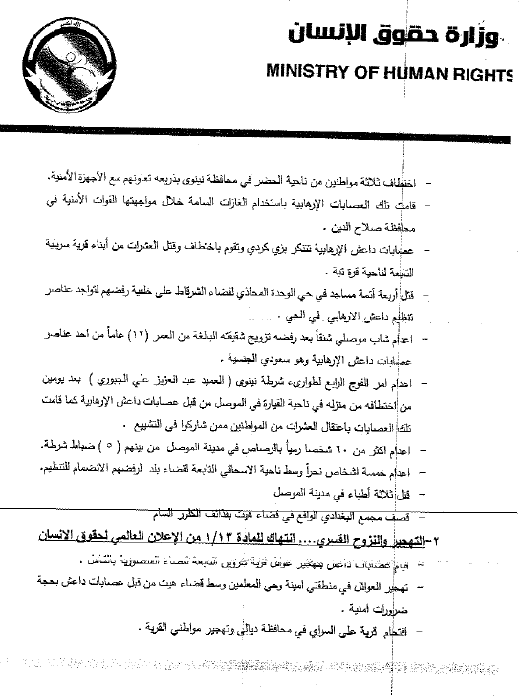

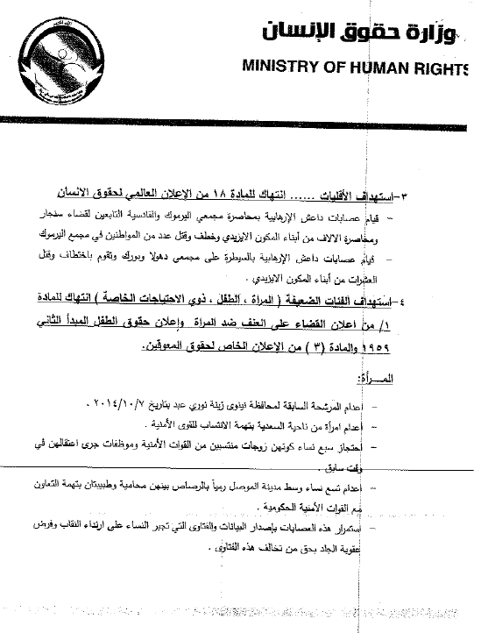

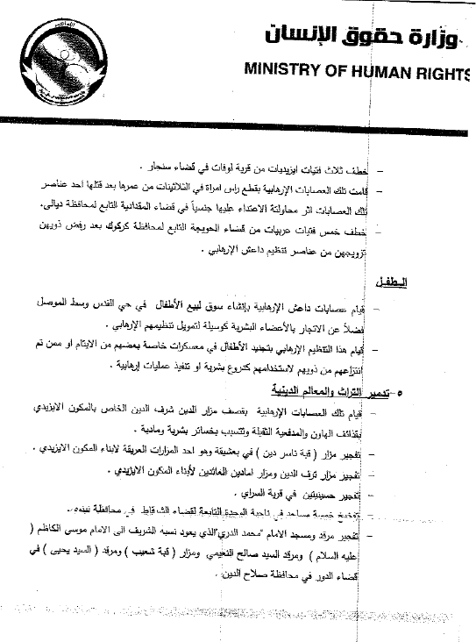

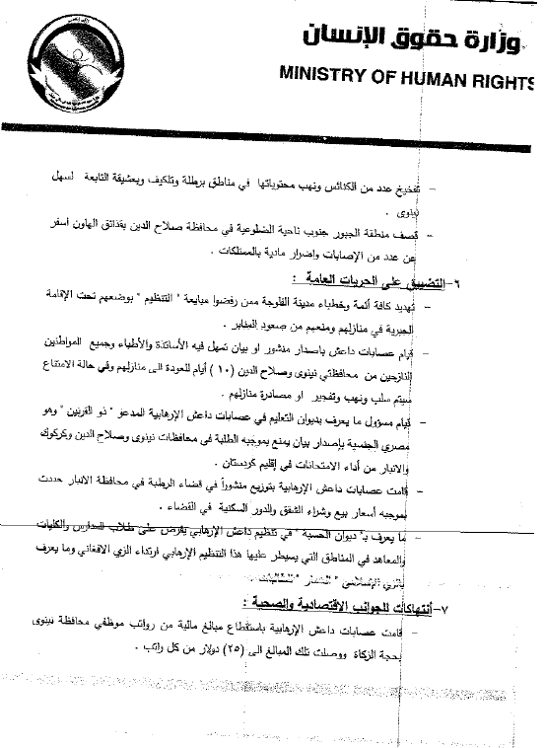

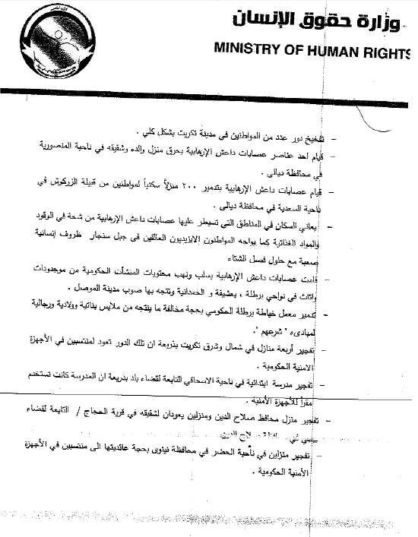

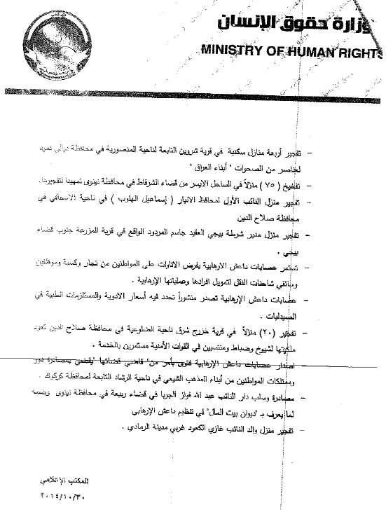

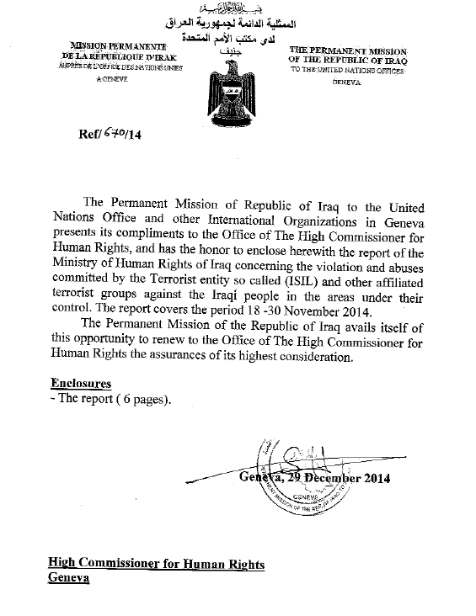

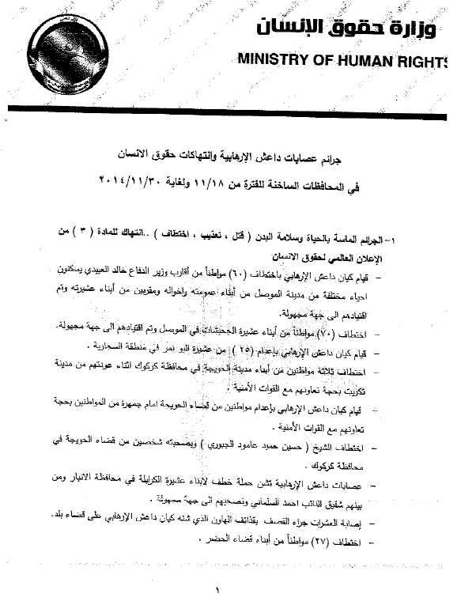

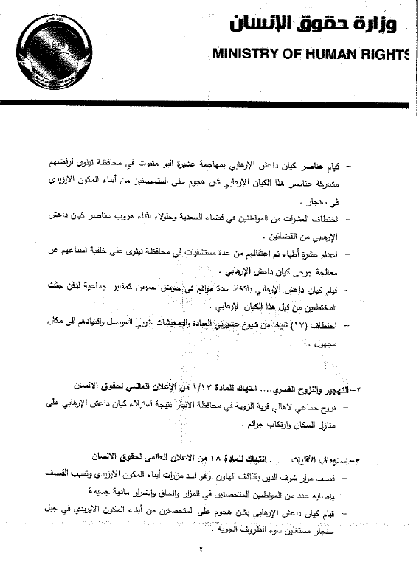

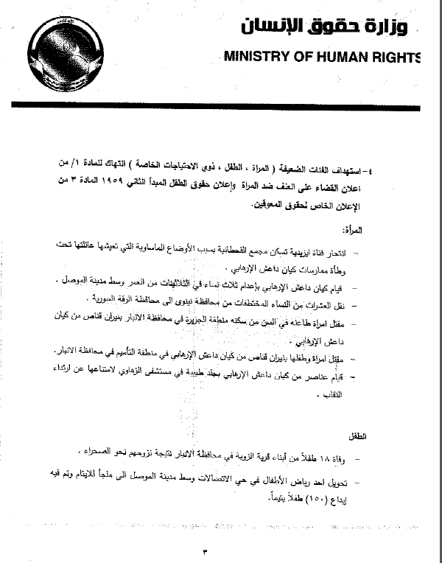

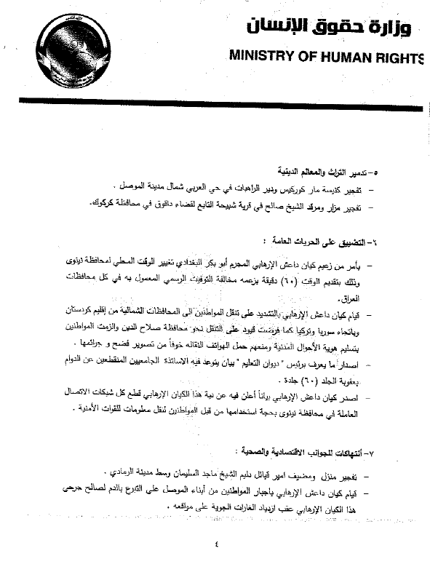

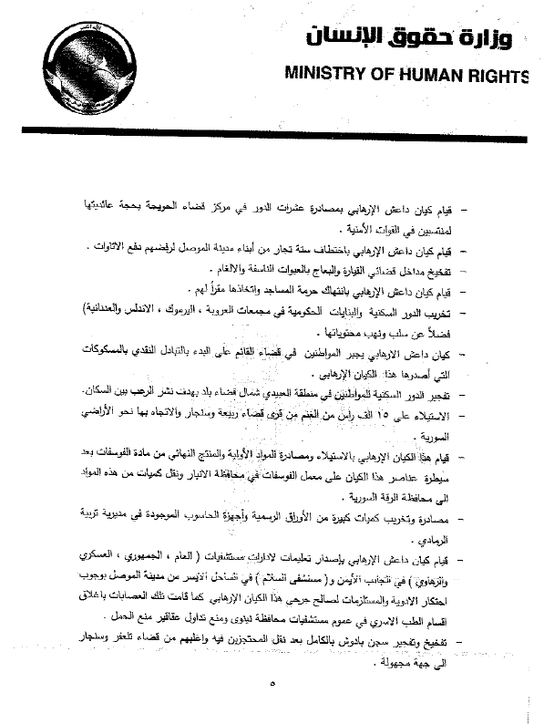

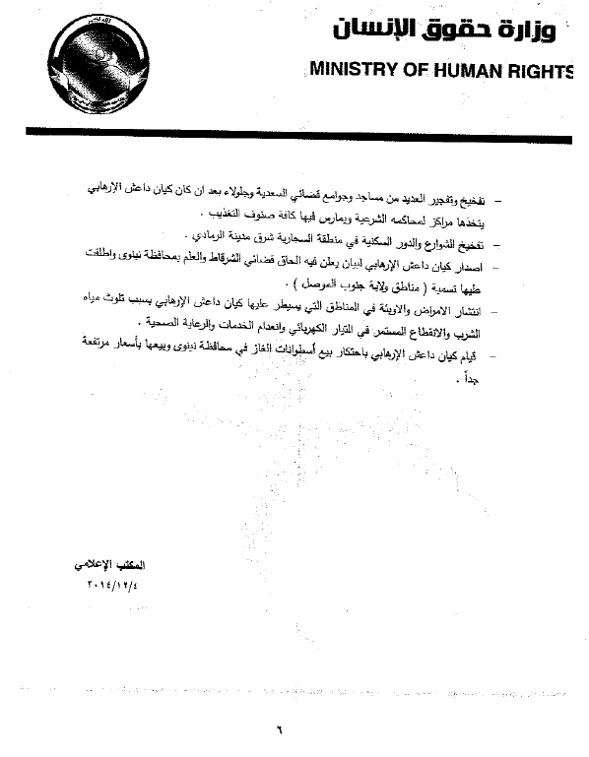

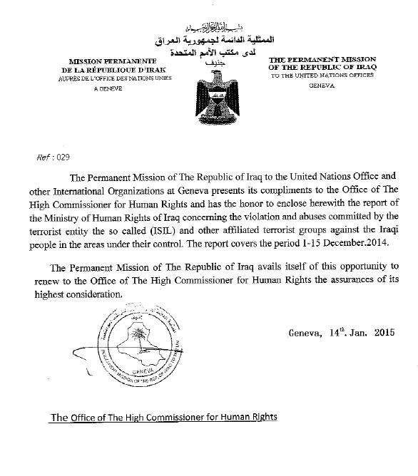

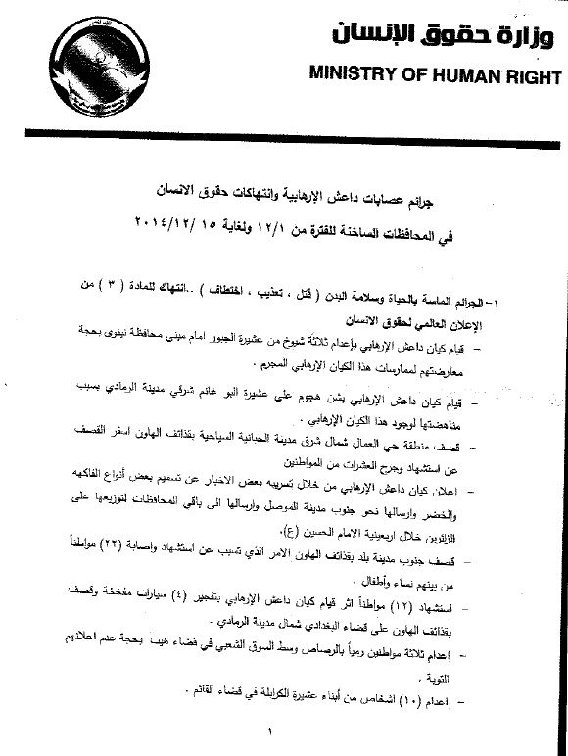

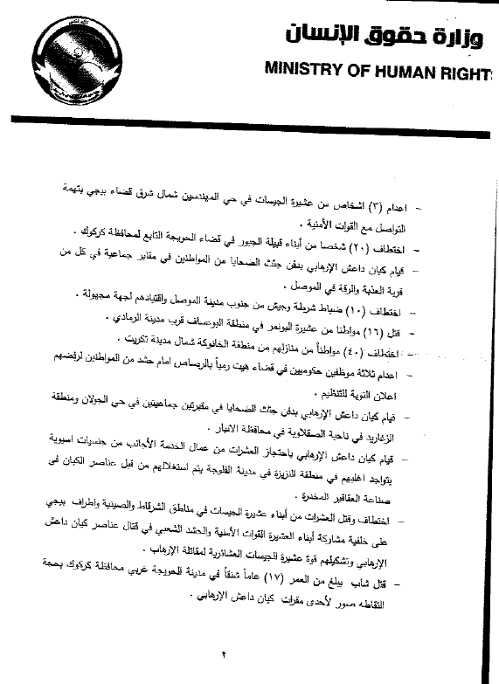

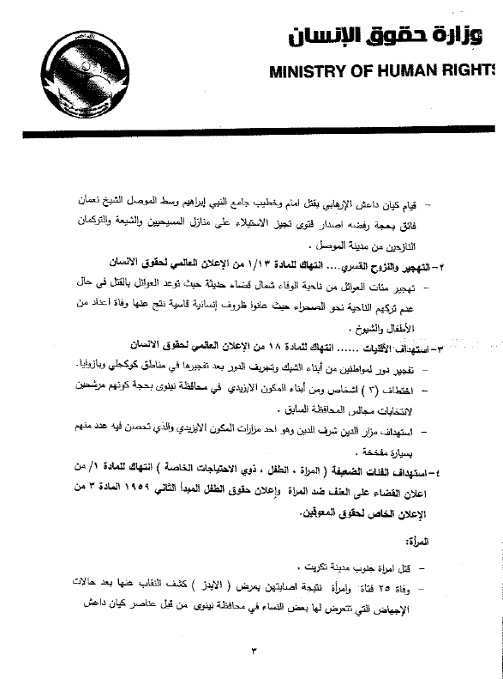

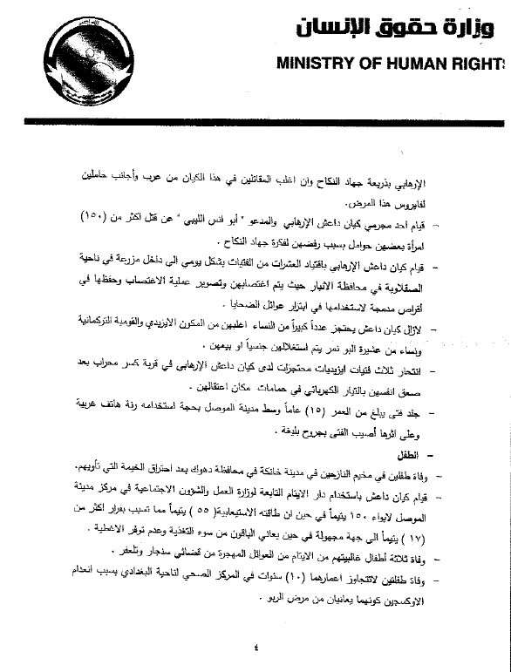

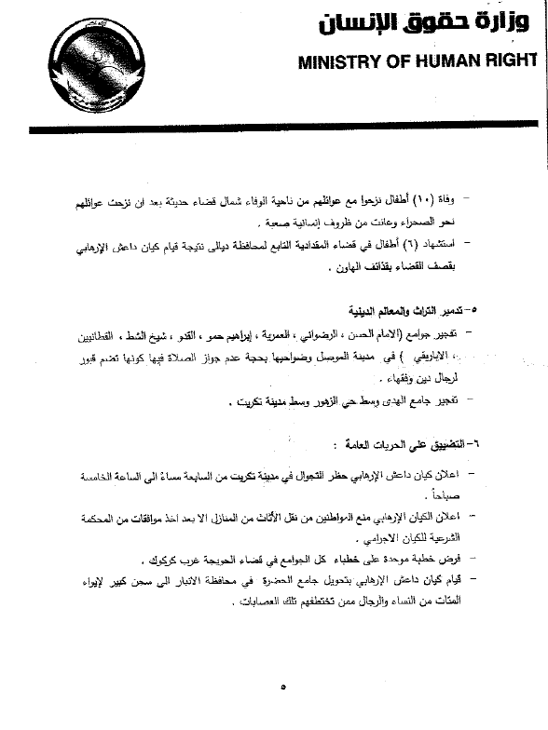

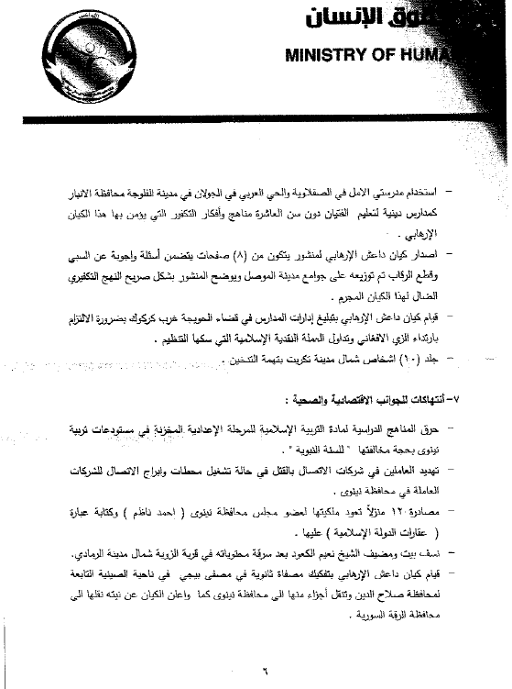

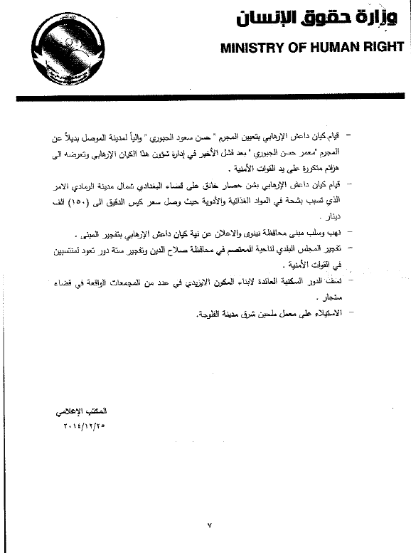

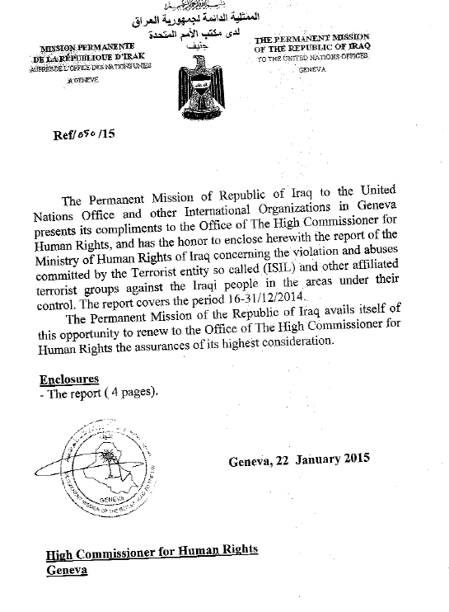

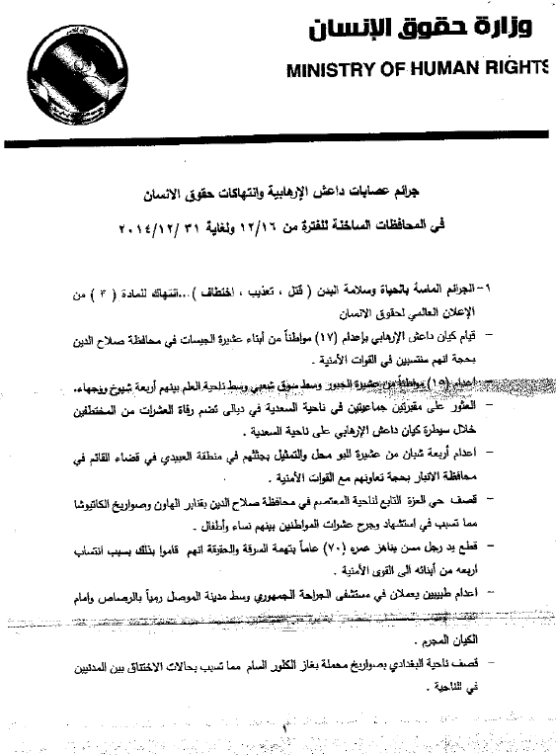

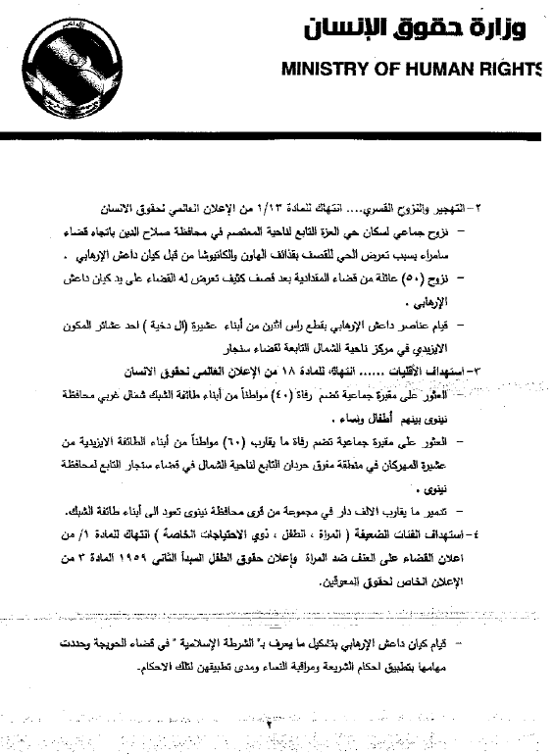

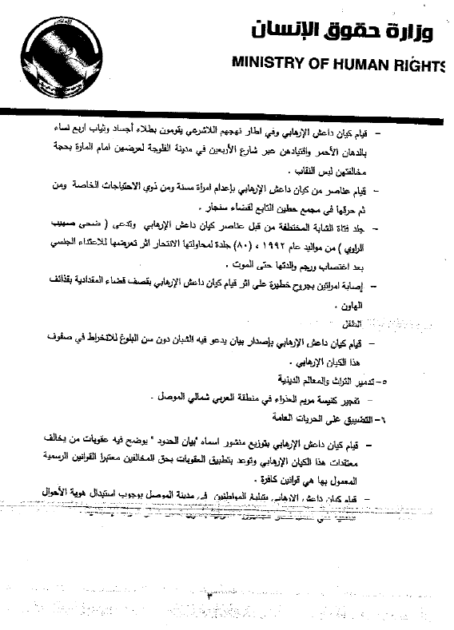

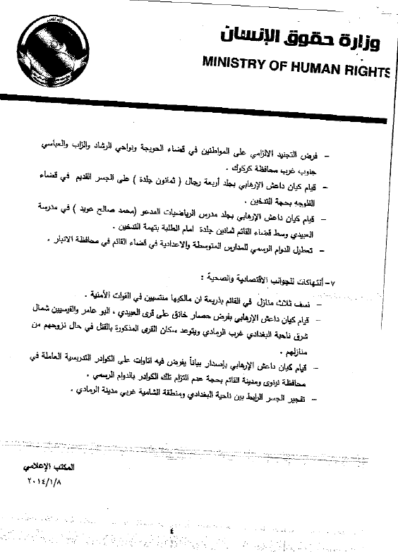

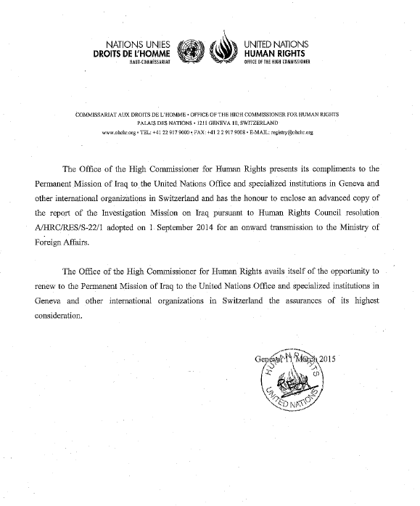

1. \* Late submission. [↑](#footnote-ref-2)
2. \*\* The annex is circulated as received in the languages of submission only. [↑](#footnote-ref-3)
3. ISIL is on the Al-Qaida Sanctions List established pursuant to Security Council resolutions 1267 (1999) and 1989 (2011), which impose financial sanctions, an arms embargo and a travel ban on the members of the groups on the list. [↑](#footnote-ref-4)
4. The Popular Mobilization Movement was established following the seizure of territories by ISIL in June 2014 when Grand Ayatollah Ali al-Sistani called on volunteers to defend their homeland. On 30 September 2014, the Cabinet passed a resolution calling on Prime Minister al-Abadi to ensure the provision of the Movement with weapons, logistics, training and salaries. [↑](#footnote-ref-5)
5. Pursuant to General Assembly resolution 48/141. [↑](#footnote-ref-6)
6. See notes verbales in the annex to the present document. [↑](#footnote-ref-7)
7. It is difficult to determine the exact number, particularly given that many of those who are listed as missing were killed. Civil society organizations shared lists containing the names of thousands of alleged victims with the investigation mission. [↑](#footnote-ref-8)
8. Ahl al-Kitab in Islam includes Christians, Jews and Sabea-Mandeans. [↑](#footnote-ref-9)
9. The Awakening Councils (Sahwa) consist of tribal sheikhs who joined forces with the United States military in the fight against Al-Qaida in Iraq from 2006. [↑](#footnote-ref-10)
10. Reportedly, the “repentant” has three options: “repent” in a Mosque in the presence of an ISIL appointed “emir”, pay 1,000,000 Iraqi dinar (850 United States dollars) or face execution. [↑](#footnote-ref-11)
11. “Emirs”, local ISIL commanders, report to “sheikhs” in the ISIL chain of command. [↑](#footnote-ref-12)
12. The pattern described by numerous witnesses is corroborated by an ISIL pamphlet on female slaves released in October/November 2014, entitled, “Questions and answers on taking captives and slaves”. It outlines ISIL regulations on the treatment of non-Muslim “slaves”, including young girls. [↑](#footnote-ref-13)
13. The pattern described by numerous witnesses is corroborated by an ISIL pamphlet on female slaves released in October/November 2014, entitled, “Questions and Answers on Taking Captives and Slaves.” It clarifies ISIL regulations on the treatment of non-Muslim “slaves”, including young girls. [↑](#footnote-ref-14)
14. Another witness told the mission that the same “doctor” also raped victims as young as 11 and 16 years of age. [↑](#footnote-ref-15)
15. Locations around Mosul included Badush prison, the village Hay Tiraan, the “Galaxy building” and several private houses. [↑](#footnote-ref-16)
16. Locations within Tel Afar included several former Shia villages, such as Ghizel Khoun and Qasr Mihrab. [↑](#footnote-ref-17)
17. The Optional Protocol to the Convention on the Rights of the Child on the involvement of children in armed conflict states that non-State armed groups should not, “under any circumstances” recruit or use children under 18 years in hostilities. [↑](#footnote-ref-18)
18. Article 8, paragraph 2 (e) (vii), of the Rome Statute of the International Criminal Court provides that conscripting or enlisting children under the age of 15 years into armed forces or groups or using them to participate actively in hostilities is a war crime. [↑](#footnote-ref-19)
19. Several militia groups were reportedly present in Sinsil following the fall of Mosul on 10 June 2014. [↑](#footnote-ref-20)
20. Information suggests that the massacre was carried out by militia members and Iraqi police. [↑](#footnote-ref-21)
21. Documented in a YouTube video provided to the mission by the family. [↑](#footnote-ref-22)
22. The fighters identified themselves as members of Jamaat al-Ataba militia. [↑](#footnote-ref-23)