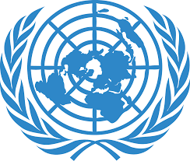 United Nations

**Human Rights Council**

**Office of the High Commissioner for Human Rights**

**The rights of people with disabilities when wars or big problems happen in a country**



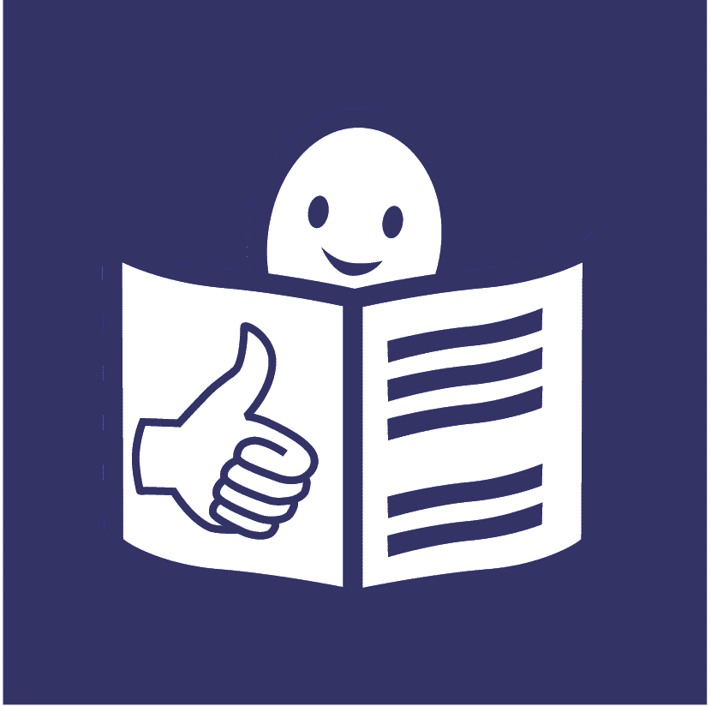

**Who are we?**

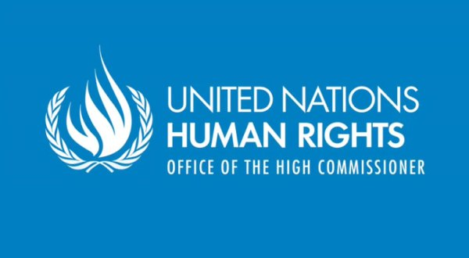

We are called the **Office of the High Commissioner for Human Rights**.



We are part of the United Nations (UN).

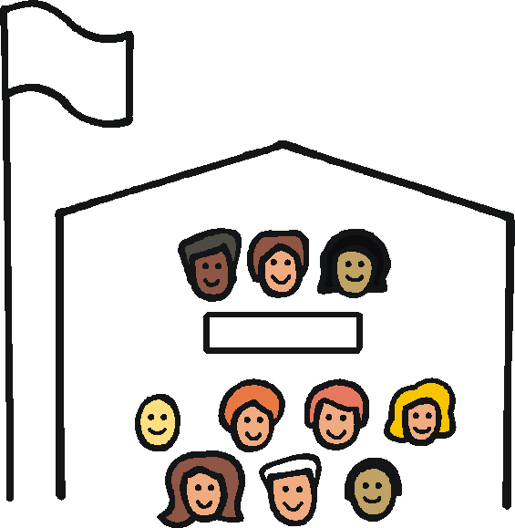

The United Nations is a group of countries that work together to make the world a better and safer place.

**What is this report about?**

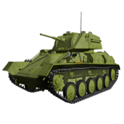

This report is about the rights of all people with disabilities when big problems happen in a country like:

* 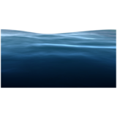war
* earthquakes and floods

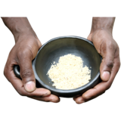

* people not having enough to eat

When things like this happen many people can be in danger.

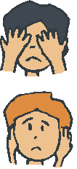

It can be much worse for people with disabilities.



Lots of countries have agreed to make life better for people with disabilities.



They signed a document about this.

It is called the **UN Convention on the Rights of Persons with Disabilities**.

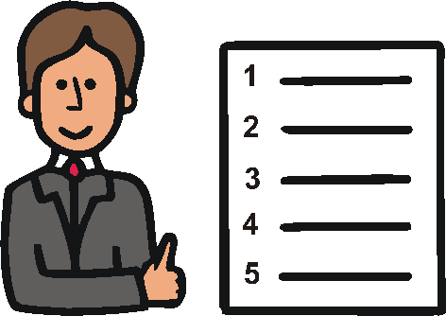

The document says all people with disabilities have rights when problems like this happen in a country.

E:\images\To zip\services.wmf

People with disabilities should be safe and get what they need.

E:\images\To zip\learning disability.wmfWe looked at what is happening with this.



We asked lots of countries what they are doing.



We asked people with disabilities and other groups as well.



This report is about:

* what countries should be doing
* some things that are already happening

**What countries should be doing**

**E:\images\To zip\staff.wmfTreating all people with disabilities fairly**

People with disabilities should be treated fairly and get what they need at all times.



This means women, children and older people too.

It also means people with disabilities who are:

* from other countries
* 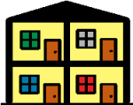staying in places like mental health hospitals or prisons



People with disabilities should not be treated badly.

For example, they should not be hurt or forced to do things they do not want to do.

**Making everything easy for people with disabilities**

**E:\images\To zip\staff.wmf**

People with disabilities should get everything they need in an emergency and afterwards.

For example people with disabilities should get:

* easy information about what is happening and how to keep safe



* good medical care and support to get better



* good support to move to other places or keep safe in an emergency



* wheelchairs or other things they may need to help them move around

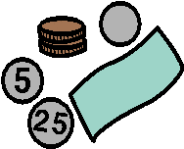People with disabilities should also get:

* good support after an emergency, like support with money, jobs and housing



* support to find family again if they want to



Many people have to live in places like camps while an emergency happens.

These places should be good for people with disabilities to live in.



For example, toilets and food and water places should be easy to get to.

New things may be built after an emergency. Like houses, schools and transport.

All new things should be right for people with disabilities.

E:\images\To zip\access.wmfCountries should help make things right for people with disabilities by:

* changing things where possible to make them easier to use

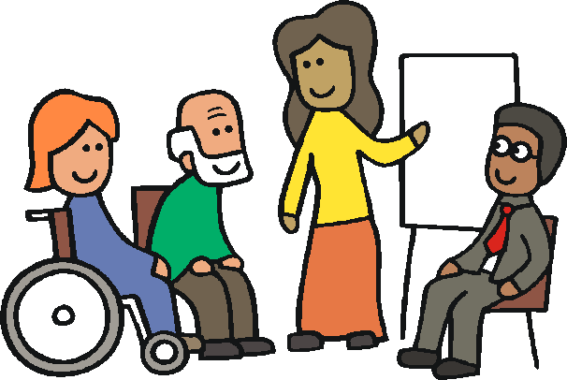

* giving staff training about what people with disabilities need

**Making good plans**

Countries should make good plans to:

* help them get ready for big problems in the country
* stop big problems happening

E:\images\To zip\staff.wmf

The plans should talk about what people with disabilities need.



There should be enough money to make the plans happen.

**Making sure people with disabilities are part of everything**

E:\images\To zip\staff.wmf

People with disabilities should not be left out.

They should be part of everything that happens.

For example, they should help:

E:\images\To zip\meeting room.wmf

* make plans and laws about big problems that may happen in the country
* check how these plans and laws are working



Countries should work with people with disabilities on this.

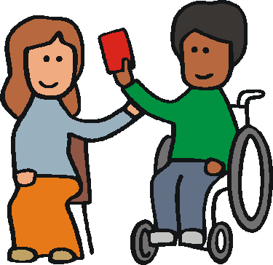

People with disabilities should get support to make their own decisions in an emergency and afterwards.

****This could be decisions about things like:

* money



* saying yes or no to healthcare



* where to go if they have to leave home



Other people should not make decisions for them.

**Children with disabilities**

Children with disabilities should always be safe.

They should get everything they need when something bad happens.

This could be:

* healthcare



* support to get better



* good education in the same schools as children without disabilities

**Better information about people with disabilities**

Countries need better information about people with disabilities and what they need.

This will help countries:

* make good plans about how to support everyone in an emergency
* give people with disabilities the support they need

**Making everyday life better for people with disabilities**

**E:\images\To zip\staff.wmf**

Countries should work to make life better for people with disabilities before war or big problems happen.



For example, people with disabilities should get a good education and support to get a job.



This can stop people being poor.

It can help them cope better

in an emergency.

**Some things that are already happening**



Countries are making more plans that talk about:

* E:\images\To zip\meeting room.wmfwhat people with disabilities need when big problems happen
* how people with disabilities can have a say in what happens



Countries like Chile, Egypt, Fiji, Indonesia and Lebanon are working to get better information about people with disabilities.



Countries like Spain and Chile are making information about emergencies easier for people with disabilities to understand.



Colombia is helping people with disabilities get better mental health care in an emergency.

Some pictures by Photosymbols. Most pictures by The Picture Communication Symbols ©1981–2013 by DynaVox Mayer-Johnson LLC. All Rights Reserved Worldwide.  Used with permission