Special Rapporteur on Extreme Poverty and Human Rights

Issues of Health among B40 women and children

Sharifa Ezat Wan Puteh (Prof. Dr)
Faculty of Medicine
University Kebangsaan Malaysia (UKM)

Co-authors:
Mohd Rohaizat Hassan (Assoc. Prof. Dr)¹, Izzah Syazwani Ahmad¹, Adliah Mhd Ali (Dr.)²
¹Faculty of Medicine, University Kebangsaan Malaysia (UKM)
²Faculty of Pharmacy, University Kebangsaan Malaysia (UKM)

Household income is defined as total income received by members of households from four types of sources. These include income of paid employment, self-employment, income from property and investment and current transfer received, both in cash or in kinds which occur repeatedly within the reference period of a year, or more frequent. It showed an average monthly gross household income of Ringgit Malaysia (RM) 6,141 in 2014, with an increase of 10.3% growth rate annually from 2007 (RM 3,686) (Economic Planning Unit, EPU, Prime Minister Department of Malaysia).The bottom 40% (B40) income group which account 2.7 million households in Malaysia (EPU, Eleventh Malaysian plan report, 2015) clearly explained by the growth rate in the welfare aggregate of bottom 40% is computed as the annualized average growth rate in per capita real consumption or income of the bottom 40% income distribution in a country from household surveys over a 5-year period. This B40 group is categorized as the lowest household income group or low Socio Economic Status which are measured as households that earn a household income of RM3,855 and below in 2014 (EPU report, 2015). The B40 (below 40th quintile income population) group is considered the group exposed to poverty and hard-core poverty in Malaysia. There is a special registry for them administered by the government, called system E-kasih. Living conditions are mostly low-cost flats provided by the government at a nominal rental rate (around RM 124/month) or purchased (priced at around RM35,000/house) through monthly repayment schemes. These flats are called ‘PPR’ flats and are mostly a new settlement program for unlawful squatters that had illegally built sordid houses before. In a UNICEF report 2018, it was mentioned that malnutrition is a problem among children in PPR flats. We did a cross sectional study in 2019 looking at B40 willing participants among one PPR flat in Selangor. Selangor is one of the 13 states in Malaysia, and considered a wealthy state; it is very near to Kuala Lumpur, the capital of Malaysia.
A total of 250 women (aged 18 and over) and 250 children (aged 7 and under) participated in this study with written consents from individual/guardians. Women in PPR flat having unmet needs in healthcare. They were synonym with health problems such as diabetes (16.4%), high blood pressure (20%) and high cholesterol (8.4%). It is therefore not surprising to see certain women with higher than ideal Body Mass Index (BMI). The findings showed that over 60% of B40 women have higher BMI (Pre-Obese= 32%, Obese= 32.8%). The same situation was seen among children’s, where about 10% fall into Severe Thinness/Thinness category (issues with stunting and wasting) while 20% are under the category of Overweight/Obese.
The women expressed the lack of exercise facilities and unaccepted culture for woman to exercise alone or in general public. Sedentary people burn less energy, are prone to obesity, chronic metabolic disease and cardiovascular problems that raise healthcare in general in Malaysia. Eating habit was strongly influenced by their financial condition. Cost and food availability were the main factors in food selection and preparation as long as they can fill in their empty stomach. Healthy eating such as preparation of food with low sugar, low salt, low cholesterol, high vitamin, high mineral were ignored as it was costly to be served in a large quantities for a family. For example, their lunch plate will be served with rice (carbohydrate), alongside egg-based or as those were the most affordable. A proper meal would only be once or twice per day. Usually, rice will be taken in a big portion, the source of protein were fixed and consumption of vegetables and fruits only occasionally. As a result, their calories intake will be higher than it should, which then leading to the cause of overweight and obesity.
Women should be given a support to manage stress and special education to develop healthy eating habits and lifestyle among their family. Simple training to look at food labels and calories can be a simple skill to be taught. Food aid and coupons would be beneficial, however not sustainable. Entrepreneurship skills should be provided for young/single mothers (5.6% of our respondents are single women). Ministry of women, family and community development (a ministry under Prime Minister’s Office) should be spearheading this more vigorously. Profiling of PPR flats residents (by risk, example women and elderly at higher risks) and training PPR leaders in a consistent manner in screening social deprivation and providing help is outmost importance as they are the nearest to these low cost housing families.
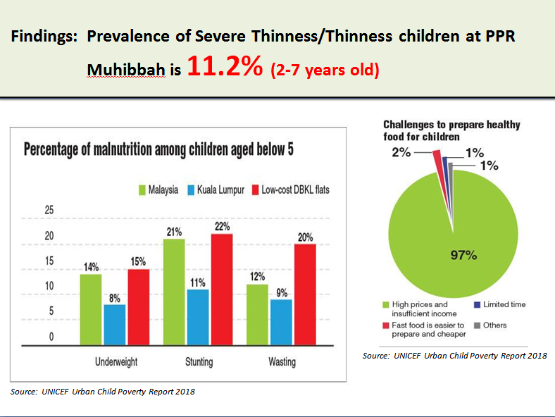

References:
- Food Research & Action Center. 2014. Relationship Between Poverty and Obesity. http://frac.org/initiatives/hunger-and-obesity/are-low-income-people-at-greater-risk-for-overweight-or-obesity/
- Hab Inovasi Sektor Awam MAMPU. 2011. Laporan Inovasi E-Kasih: Kemiskinan Bukan Untuk Diwarisi.http://habinovasi.mampu.gov.my/laporan_inovasi/62-ekasih-sistem-bank-data-kemiskinan-nasional.pdf.
- Jabatan Perangkaan Malaysia. 2017. Laporan Penyiasatan Pendapatan Isi Rumah Dan Kemudahan Asas 2016. https://www.dosm.gov.my/v1/index.php?r=column/ cthemeByCat&cat=397&bul_id=SmtySjF1eX plQTIrVWh3Wkx5N1pyQT09&menu_id=L0pheU43NWJwRWVSZklWdzQ4TlhUUT09.
- Ogden CL, Carroll MD, Fakhouri TH, Hales CM, Fryar CD, Li X, & Freedman DS. 2018. Prevalence of Obesity Among Youths by Household Income and Education Level of Head of Household - United States 2011-2014. Morbidity and mortality weekly report (MMWR). 67(6), 186–189.
- The star. 2019. Letters: Poor Nutrition A Major Issue. https://www.thestar.com.my/opinion/letters/2019/03/28/poor-nutrition-a-major-issue/
- The sun daily. 2016. Elevating B40 households to a middle-class society. https://www.thesundaily.my/archive/2054002-NTARCH407008
- UNICEF. 2018. UNICEF Urban Child Poverty Report 2018. https://www.unicef.org/malaysia/media_urban_child_poverty.html
- Zukiewicz-Sobczak, Wroblewska, Zwoliński J, Chmielewska-Badora J, Adamczuk P, Krasowska E, Zagórski J, Oniszczuk A, Piątek J, Silny W. 2014. Obesity and poverty paradox in developed countries. Ann Agric Environ Med. 21(3):590-4.

