Socioeconomics of the Orang Asli (Indigenous Community) in Malaysia
by
Assoc. Prof. Dr. Doris Padmini A/P S. Selvaratnam
Faculty of Economics and Management
Universiti Kebangsaan Malaysia
Email: pegasus@ukm.edu.my
Mobile: +6019-6682726
Introduction
Orang Asli Census Data 2010: 178,197 Orang Asli (OA) in Peninsular Malaysia. Comprising of three major ethnic groups and various sub-ethnic groups, the majority Senoi are in Perak (50,281) and Pahang (29,439), while the Proto-Malays are found largely in Pahang (37,142) and Johor (13,083). The Negrito are mainly in Perak (2,413) and Pahang (925). They are occupying more than 160 hinterland areas, rural peripheries and urban areas. But sadly, the land title does not belong to the Orang Asli. Once the OA were resettled, today their land if transferred as rubber or oil palm plantations and they live within these plantations. Measures of PLI is not suitable for the OA as they always fall within the hardcore poor bracket. A new measure is needed for the OA if the government is serious to help enhance the livelihood of the less than 200 thousand Orang Asli living in Malaysia today.

Methodology
Research methodology used are Asset Based Community Development Approach Holistic Social Entrepreneurship Model (refer to Appendix) to ensure participation of the Orang Asli community (children, youths, adults, male and female). Instrumental to this is the asset mapping exercise to identify the local strengths and how it may be harnessed to enhance their livelihood. Research members are coming from various faculties to pool in diverse expertise to help the Orang Asli from grassroots.

Kg. Kachau Luar, Semenyih, Selangor, Malaysia
Research Code EP-2015-006, entitled Study on Empowering Orang Asli Community at Kg. Kachau Luar Semenyih, Selangor, Malaysia (30 minutes from Kuala Lumpur city centre) finds the Orang Asli community of Kg. Kachau Luar has 27 households with income below RM650. The unemployment rate is high, whereby the Orang Asli are either unemployed or sustain themselves with temporary odd jobs working in flower nursery, landscaping jobs at the Chinese funeral parlour, construction work or manufacturing line. The dropout rate in education is high and the highest level of education of the head of household (KIR) is at the lower secondary school or PMR. The first married rate is 17 years old. Since 2015, the Faculty of Economics and Management is collaborating with the Faculty of Education to conduct various educational programs, motivations and socioeconomic programs to enhance the identity of the Orang Asli community in Kg. Kachau Luar. Cultural commercialization activities such as jungle trails, herbal trails, hospitals, traditional medicine practices, traditional food and dance practices are targeted as an important intervention program to help improve natural skills and also generate income for these poor and marginalized communities to help generate their income. While aspects of education focus on raising the awareness of the importance of education among OA's children through motivational and learning takes the form of fun and active learning. The activities of enhancing communication skills in Malay and English language for the OA children are also emphasized. In addition, a holistic approach is seen as an important approach to helping the community. This led to the involvement of experts in the Faculty of Engineering and Architecture, the Faculty of Pharmacy, the Faculty of Technology and Information Sciences and focus on the activities to shift to the eco-home village resort's preparation to complement eco-launch. Collaboration with strategic partners such as The Department of Orang Asli Development (Jabatan Kemajuan Orang Asli, JAKOA), Kajang Municipal Council (Majlis Perbanadaran Kajang, MPKj), Parish Integral Human Development Ministry, Holy Family Church Kajang (PIHD HFCK), Bank Rakyat, Virtareal, AJM-Planning and Urban Design Group (APUDG), etc. Seen it as important to carry out various socioeconomic activities besides building eco-homes characterized by traditional Orang Asli findings. This is expected to help maintain the traditional culture of the indigenous community and help them have their livelihoods in line with SDG's goals.

Pos Gob, Gua Musang, Kelantan, Malaysia
Research Code: KRA-2017-029 focuses on Orang Asli communities at Pos Gob, Kelantan. There are ten villages and approximately 400 villagers. The average income is RM250 is this remote village, 16 hours travel off the beaten track from Kuala Lumpur on a good sunny day. Active engagement of researchers and enumerators with entrepreneurs especially women find that they can provide the result of creative accessories of beads, buluh material or pandanous leaves and want to sell them to generate income. The Orang Asli find that the use of colorful beads can result in interesting produce. However, this bead needs to be purchased from Gua Musang or from a mobile retailer who entered the village. On the other hand, natural bead is the bead obtained from their environment, but the amount is uncertain/inconsistent. The price for a product is only an estimate and is likely to depend on the bargaining process. Pos Gob is a settlement in remote areas in the Titiwangsa range in Kelantan. The remote location causes the Orang Asli community to be outdated from the development stream. A remote location challenge coupled with the continuation of unconventional roads to ordinary vehicles causes this community to rarely go out to the nearest town in Kuala Betis. The Orang Asli stated that they did not make bracelets and chains with a desire to sell. It's more about providing accessories for family members. They do not have enough money or transportation facilities to shop in the nearest town to buy modern chains and bracelets or trade what they have. The beads gift from the UKM project has provided the community with the hope of producing a particular decorative produce of beads for sale to visitors who come to Pos Gob. This project has helped to market Orang Asli Temiar products outside of Pos Gob and provide income generation to the Orang Asli communities.

Pos Legap, Sg. Siput, Perak, Malaysia
Pos Legap is located 20 minutes away from Sg. Siput Perak. Although easily assessible by road, the kaleidoscope of the settlement flanked by mountains making is seldom visited by outsiders and the locals only venture out if there are organized programmes or any urgent need for example for medical purpose or to purchase basic food supplies. The programme initiated by UCTC-UKM focus on ICT education for the community but our team specifically focus on socioeconomic development. Courses conducted are towards social entrepreneurship development based on local skills and interests.

Gedung Siam, Gambang, Pahang, Malaysia
In 2018, Cipta Wawasan Maju Engineering Sdn. Bhd. (CWM) contacted the Faculty of Economics and Management (FEP) to extend the help of solar street lights for Kg Orang Asli Kg Gedung Siam, Gambang, Pahang. From 11 to 15 January 2019, Orang Asli at Kg Gedung Siam received 10 solar-paneled street lights. The program is unique as it requires people to install solar panel streetlights. CWM technical staff and solar panel road lighting providers, UKM researchers, and students are ready to help. About 30 Orang Asli youths and adults come in turns taking turns mixing cement holes, learning about solar panels and lifting solar panels to be erected and also attending the workshop to maintain and care for the solar panels.
Average income of the community here is RM750 as they receive payment from the plantation managers. This settlement is an original OA settlement that is now also a rubber and palm oil plantation. The fertility rate is low here probably due to side effects of pesticides useage. This is still understudy by UKM team. The nearest health clinic is about 30 minutes away and only mode of transport is by foot or motorcycles.

References:

Doris Padmini Selvaratnam, Zaini Embong, Hamidah Yamat dan Norlida Hanim. (2018). Faktor Sosiobudaya Kesejahteraan Ekonomi Orang Asli. Pemerkasaan Kesejahteraan Hidup Orang Asli di Malaysia. Penerbit UKM: Bangi. 57-83.

Doris Padmini Selvaratnam, Hamidah Yamat & Rika Fatimah PL (2013). Social Entrepreneurship Model For Economic Transformation In Perak. Research Code: EP2013-007.

Doris Padmini Selvaratnam, Zaini Embong, Norlida Hanim Mohd Salleh, Hamidah Yamat. (2017). Orang Asli Temuan Kg Kachau Luar cultutal commercialisation kit. UKM: Bangi. 1-14

Hamidah Yamat, Siti Halimatun Saadiah Adnan, Doris Padmini Selvaratnam & Norasmah Othman. (2018). Pemerkasaan Pendidikan Anak-Anak Orang Asli. Pemerkasaan Kesejahteraan Hidup Orang Asli di Malaysia. Penerbit UKM: Bangi. 84-103.

NF Mohamed, DP Selvaratnam. (2018). Amalan kesihatan wanita orang Asli Temuan di Kampung Kachau Luar, Semenyih, Selangor (Health practices among female Orang Asli Temuan, Kampung Kachau Luar, Selangor Malaysia)- Geografia-Malaysian Journal of Society and Space.14(4): 89-101

Salleh, N.H.M., Othman, R., Idris, S.H.M., Jaafar, A.H., Selvaratnam, D.P. (2014). The Effects Of Tourism Development Towards Livelihood Sustainability Of The Orang Asli At The Kg.Sg. Ruil, Cameron Highlands. TOURISMOS: An International Multidisciplinary Journal Of Tourism. 8 (2 /Autumn 2013): 301-321. SCOPUS.ERA

https://www.thestar.com.my/metro/metro-news/2019/03/09/funding-of-ecohome-project-gets-off-the-ground/

https://www.youtube.com/watch?v=2HaTU1P7DAU

https://www.youtube.com/watch?v=Yhp8Iq9d1v8

Appendix

Economic
Social
IMPACT???
Researcher/Research Asistant
Mentor PS
Volunteer Coach PS
Skills Training Courses
Children / Grandchildren

direct
Social Entrepreneurship Participants Perniagaan Sosial
indirect
What are the indicators? Get feedback from participants.
What are the changes they want? What are the changes we want?

Politics

Diagram 1 Social Entrepreneurship Model
Source: Doris Padmini Selvaratnam, Hamidah Yamat & Rika Fatimah PL (2013)

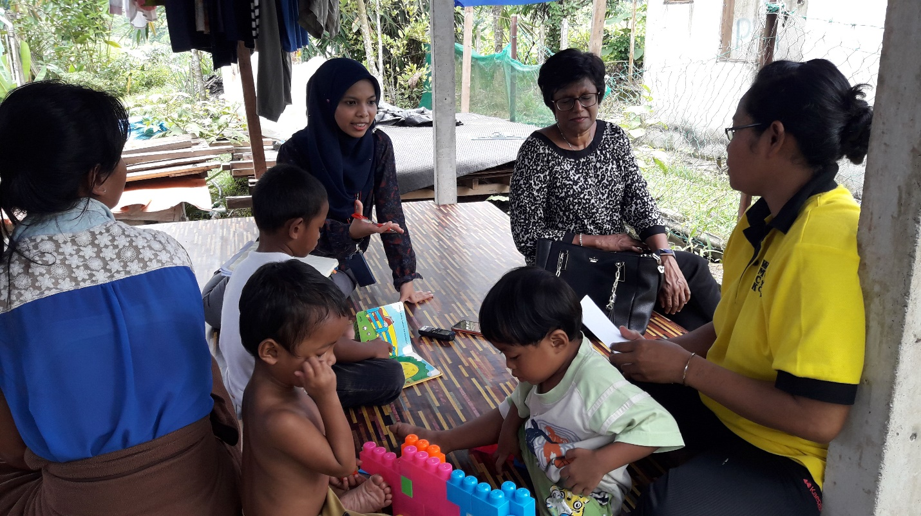
Diagram 2: Mrs. Sarinah teaches the kids based on materials provided by UKM researchers at Kg. Kachau Luar.
Source: University-Community Engagement Observation by Academy of Science Malaysia and Nottingham University staff, 23rd April 2019.

