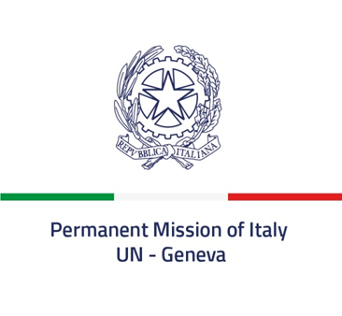
Check against delivery

46th session of the Human Rights Council

Inter-sessional Seminar on Youth and Human Rights

Session 3 | Youth mainstreaming in human rights mechanisms and next steps on youth and human rights at the international level

Statement of Italy
12th April 2021
Thanks Madam Moderator,
Italy aligns itself with the statement delivered by the EU.
Italy considers fundamental that young people are involved and meaningfully consulted in relation to all policies affecting them; hence, as G20 President and partner of the United Kingdom in the COP26 organisation, we set up specific spaces for youth participation. The Y20 Summit, to be held in Milan in July, will allow the youth to entrust G20 Leaders with recommendations on sustainability, climate change, innovation, digitalisation, and inclusion.
In September, the "YOUTH4Climate: Driving Ambition" will be the second major event on youth and climate change gathering 400 young people from the 197 countries that ratified the UN Convention on Climate Change, and will allow to elaborate concrete proposals for the Pre-COP26 and COP26.
Domestically, the Ministry of Ecological Transition has involved young people in the revision process of the National Strategy for Sustainable Development. Accordingly, we are developing an interactive platform called Youth2030. Since the Third National Action Plan on Women, Peace and Security, we have also introduced specific references to UNSCR2250 (2015) and continue to do so with the Fourth Plan. Similarly, the Inter-Ministerial Committee for Human Rights (CIDU), as the National Mechanism for Reporting and Follow up of Italy, has introduced a Human Rights Award and in the judging committee participate two youngsters, appointed as standard-bearers of the Republic, by the Head of State.
Participation is also the main objective of the European Union Youth Strategy, which inspires Italian government’s youth policies. Italian youth organisations are important actors in putting forward proposals for a Recovery and Resilience Plan, to definitively overcome the COVID 19 pandemic, which has dramatically reduced youth access to rights, and increased inequalities. Faced with this “Challenge”, guided by UNSDGs, we will continue to spare no effort to create spaces for youth participation and a dialogue with policy makers in order ensure that youth voices and needs are heard in building a post Covid world.
(321 words) I thank you.

Youth Twenty Summit.

