Contribution to UN High Commissioner report on “ways to bridge the gender digital divide from a human rights perspective”

Cognisant of the gender digital divide and cultural norms discriminating against girls and women, Every1Mobile works to ensure that all our digital content, platforms and strategies are designed with the female as well as the male user in mind. Girls Only spaces are often integrated into our sites, to allow for more candid dialogue in a safe space. We provide anonymity to our users to promote and facilitate the participation of vulnerable groups, including girls and women.

We also understand that it is harder to reach girls and women and from experience understand that a combination of targeted digital promotion, combined with face to face interaction is most effective.

Data is key to understanding users behaviours. We collect gender related data for all users who are able to register on our mobile services. However this registration process needs to be carefully designed so as not to deter engagement and ensure the digital safety of vulnerable women.

We specialise in building online communities and have extensive experience in the area of gender equality. Online communities have the power to facilitate knowledge, attitude and behaviour is more likely to take effect through sustained engagement of audiences. The communities we have built across Africa have succeeded in engaging a disproportionate number of girls and women because they are designed to meet four fundamental needs:
- A hunger to learn and to access clear, accurate and reliable information & education – in a language and tone they can relate to and a female editorial tone and product design.
- A need for a safe platform to share stories and get their opinions and experiences heard, and understand more about the opinions and experiences of others.
- A desire for support and understanding – somewhere they can go to feel listened to, accepted, less isolated, and where they can also support and encourage others anonymously.
- An accessible, low data-consumption and user-friendly online experience on any web-enabled device.

Every1Mobile has developed a unique platform to optimise access to ICTs for low-income and vulnerable populations by addressing barriers to access such as low-end devices, slow download speeds and expensive data.

Every1Mobile is an endorsing organisation for the Principles for Digital Development and have embodied and implemented these values through our work over the last 7 years.

The main factors that keep women offline and challenges for women navigating this space as either experts or users.

The internet was envisaged as a place separate from the divisions and inequalities that rule the ‘real world’. But in fact, gender inequality is just as much at play online. When you think about the roles women and men play in the day to day, it’s easy to see why: for the majority of girls and women, even in more progressive families, they are expected to carry the lion’s share of housework and childcare, as well as bring in additional income for the family. Put simply, from a young age, women often have less leisure time and less privacy in which to play around on the internet or with new technologies, than men do. Add to this factors such as cost, or in more extreme cases, being explicitly banned from using potentially ‘corrupting’ tools like the internet, and you realise that getting women online has to involve tackling gender equality in a more holistic way than just internet usage.

As women who are lucky enough to be comfortable navigating the internet and enjoying all the great things it has to offer, it doesn’t mean the battle has been won. The internet itself can feel like quite a scary place for a woman. Recent research has shown that 76% of women under 30 have experienced abuse online, usually of a sexual nature. To some it might feel like the internet itself is a very ‘male’ place, dictated by the same norms that celebrate characteristics defined as ‘masculine’ - in fact even more so because the levels of aggression that are possible on the internet are even higher for taking place behind an anonymous screen.

Women also struggle to enter careers in technology or online, often sticking to roles we feel are safe, such as writing or marketing. We carry in our heads a legacy of gender socialisation which makes us often less likely to go out of our comfort zones and take risks, we believe that technology is a male industry, and that we’ll struggle to live up to the task. These are factors that contribute to the lack of women in tech and digital.

The strategies used to increase female presence online (including input by speakers on how to increase female participation based on their experiences).

As part of the work we do at Purple, we talk a lot about the importance of creating Safe Spaces, including online. A Safe Space is a space in which person can feel confident that they will not be exposed to discrimination, criticism, harassment, or any other emotional or physical harm. It’s fair to say that the internet can be the furthest thing from a safe space imaginable - just check the levels of casual abuse that get hurled around in Instagram comments and on Twitter.

At Purple, with our online work, we have nonetheless tried to create an environment which is as close to safe space as possible. The Purple website is a community, not just a website. On our Purple social network, we have rules of engagement, which are defined by Purple values of mutual respect, tolerance, and a healthy attitude towards self-reflection. Put simply, you’re encouraged to question your own position, to change your mind, and to admit when you’ve done so. It’s also a place where we are explicit about recognising discrimination towards girls so users know it’s just not acceptable. It’s actually a space in which to practice gender-equitable values rather than just repeat behaviours from the real world.

Through our feedback we can see this tactic has worked - so many girls come to us mindblown they have found a space online where they can feel inspired, confident and supported.

So increasing female presence online has to start with a critical examination of the behaviours we see as normal online, and building content, features and guidelines which support and protect young women.

How can mobile networks and data providers and other telecommunications companies change this trend of underrepresentation of women and girls online?

One phenomenon we have found is that because there are less girls online overall, that means it is more expensive to run campaigns targeting them. It’s not that you can’t create 50/50 demographics on your site, or even higher, but it will cost more and take longer to do so. As an example, putting an advert for Purple up on the Opera Mini web browser is like turning on a tap of user traffic which is representative of normal gender split - your user base becomes heavily skewed in favour of guys. But you also get great headline grabbing numbers. One thing mobile networks could do would be to offer preferential rates to make it commercially viable to promote to female audiences rather than always going for the easy option. If this ‘positive discrimination’ could happen, we might see the internet becoming more balanced overall.

Voices for Change (Purple), Nigeria

E1M is currently working on the Voices for Change gender equality programme in Nigeria funded by DFID and managed by Palladium Group. This five year social norms change programme aims to tackle the complex challenge of changing deep rooted attitudes towards the roles of men and women in society. Targeting 15 million people, V4C aims to change gender norms over a generation of people in Nigeria, and to encourage young Nigerians to ‘speak up’ and ‘speak out’ about the barriers that limit girls and women within their local communities.

The project has required a sophisticated content and social media strategy which needs to appeal both to a wide range of young people and delve into some serious, sometimes controversial issues. We have worked closely with a team of gender experts to design and deliver a content framework and key messaging, underpinned by an evidence-based theory of change.

Look at the key indicators on the performance of Purple’s online offerings so far, what has worked and what has not.

In the past year alone, our distribution of girls on the Purple site has been as low as 28% and as high as 46% as we’ve walked the tightrope of keeping user numbers high whilst also being mindful that we are after all a movement to empower girls and women.

We have found Facebook a great platform to advertise towards girls on because if they are online, they are most likely to be on facebook if nowhere else. It therefore becomes a bit easier to get a female audience, so we have 46% of our facebook audience who is female currently.

One area which made a difference was facebook’s freebasics where we see a clear correlation between 0 data costs and increase in engagement. So girls spend more time on the site and do more, including finishing the Purple Academy, when they access via freebasics.

In our last annual report, we had 60,000 young people enrolled in the Purple Academy online course, of which 24,000 approximately were female, and 36,000 male. This is better than the ‘natural’ web demographics, which we have achieved through active recruitment of girls, but also because the course is probably more appealing to girls. What’s interesting is that girls are more likely to complete the course and learn something than boys are - so our learner numbers are about 50/50. We see similar stats in the numbers of girls taking the Purple pledge - more girls than boys have taken it in the 4 states that we work in, and it’s almost exactly equal across Nigeria.

Stories of how Purple’s digital presence has led to real changes for young people and how this can be amplified with new strategies to welcome women.

We see some amazing evidence of positively affecting girls (and boys!) in the feedback we receive from users, which is overwhelmingly positive. We’ve had over 60,000 feedback submissions and of those who were logged in when they shared feedback, 47% were girls. That might suggest that despite having slightly more boys online, when we do reach the girls, we’re impacting them to such a degree that they are feeding back to us at a much higher rate.

The feedback that we get from girls on the online space shows that by the work we do online, our content, chatrooms, values and of course our online course, is having an impact at the level of knowledge, attitude, and even behaviour. Some recent comments:

While I was taking the course for Purple Academy my boyfriend broke up with me for no reason. [...] It has always been like that: he goes and returns, and because I loved him, I always say yes. He treats me like trash at times, as if I don't know anything.
So after this course, I learned a lot: [...] I've learned to love my self and I've chosen to be the best and not let men look down on me . I told my course mates and friends on whatsapp to join and study the chapters carefully!

Joining purple is the best thing that has ever happen to me, before I joined purple I used to think women as inferior to men, that they don't have anything to contribute. And that women don't have to have equal rights with men. Joining purple has made to see things in a different perspective, and now I am proud of being a woman, it makes me see some potential in me and also how to actualize it.

For a girl of 17 I have always led a success driven life with the goal of being successful LIKE a man but now I know I don't have to allow gender stereotypes to affect or control my drive, now I can proudly be a successful woman without aiming to be like a man because now I know what equal rights and opportunities for both sexes entails.

And because gender equality cannot happen without the active participation of men, it’s also really exciting to see what young men have to say about their time on the site. For them it’s maybe less about self-confidence, than about having a place to learn about the way gender inequality negatively affects men too, having a space to speak up and speak out against injustice that they may have always perceived but never had the courage or knowledge to do anything about:

my advocacy has being improved..the ability to speak up for things that I feel are right ..and also doing things not because the society or people wants me doing them but because I choose to do so..

Its been an awesome experience going through the purple academy, reading posts and exciting stories that are aimed at fighting societal stereotype, getting to understand better the harm caused by gender discrimination. I must confess that i was a fan of "men should do more than women" but purple have really affected that part of me. #ilovepurple

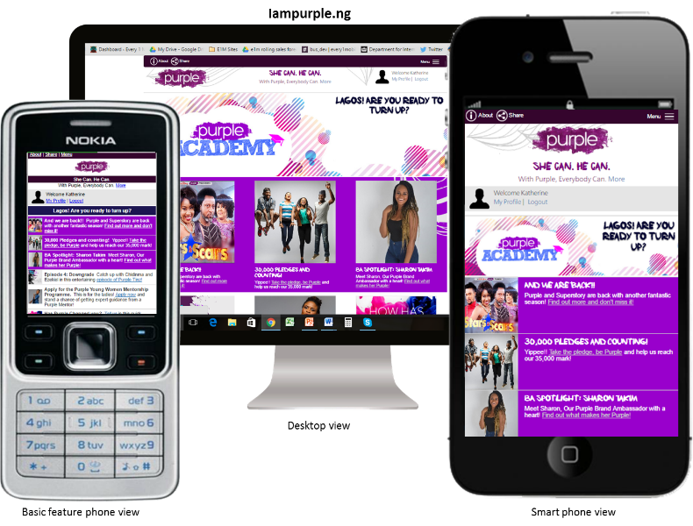
If you too want to bring in strategies to your work that help empower women and men to tackle the gender stereotypes holding them back, it has to shine through in everything you do, even at the level of how you write… The usual “men and women” becomes “women and men” - we put men first even in writing. Be conscious of the way gender socialisation has affected you first, and start raising consciousness around you. Just one piece of knowledge, for example the difference between sex & gender, can be the beginning of a domino effect that can lead you and the people around you to take consciousness of the subtle and not so subtle things that lead to gender discrimination. And don’t ever think that gender equality is just not interesting or sexy enough for your audience - we have hundreds of thousands of young people who feel inspired to be the best version of themselves and support others to do the same, all in the name of 50/50.

