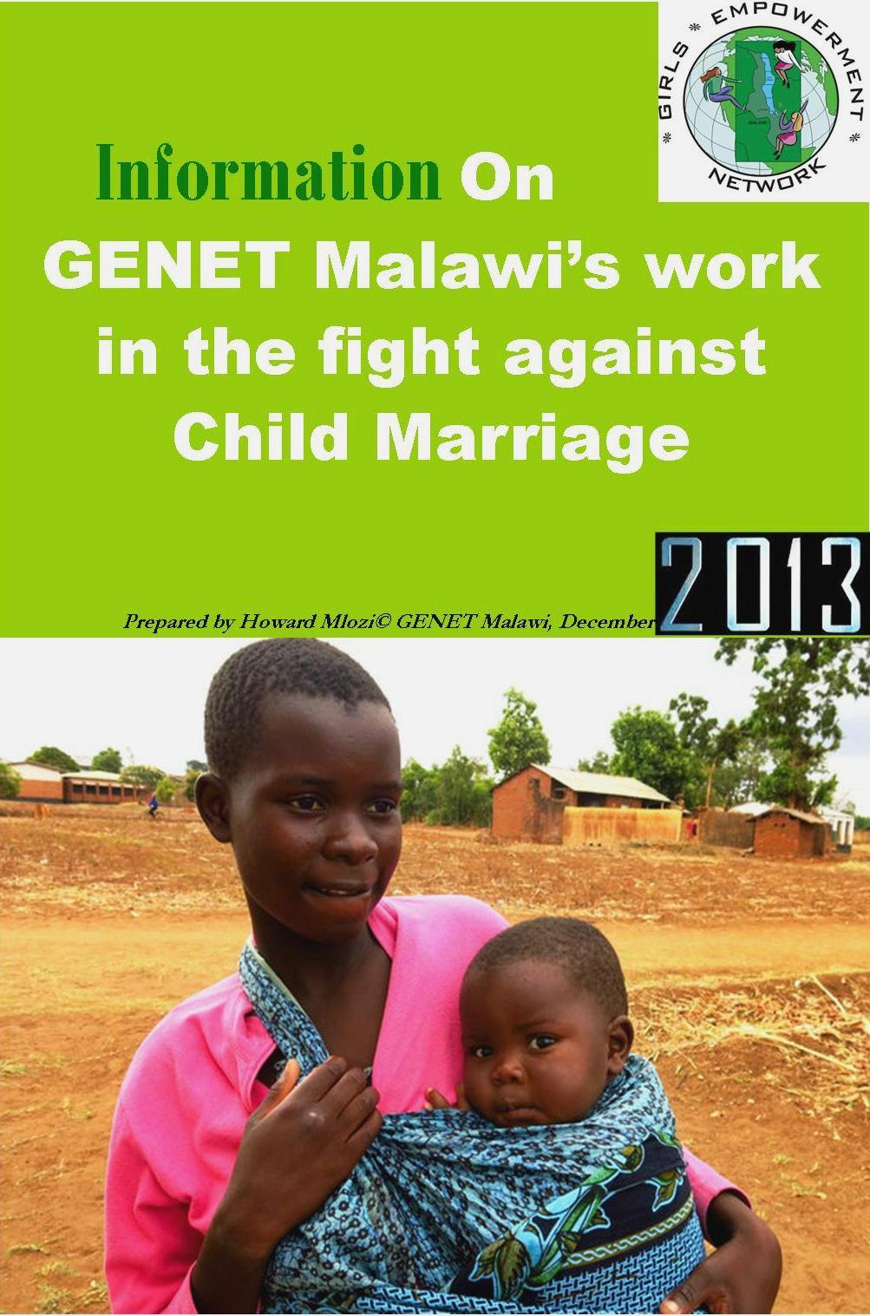

Introduction
Girls Empowerment Network (GENET) Malawi is a local NGO which seeks to advance rights, status and well-being of vulnerable girls and young women in Malawi. GENET empowers girls and young women to advocate for gender equality, justice, and social inclusion. GENET has been in operation since 2008 in Blantyre, Chiradzulu, Mulanje and Mzuzu. The NGO plans to extend to new districts in the coming years.
The NGO believes that through encouraging the leadership of girls, women and their participation in key issues, it uplifts them and benefits the entire community.
GENET Malawi is a member of Girls Not Brides-a global movement which brings together non-governmental organizations from around the world to work towards eliminating child marriage within the period of a generation.
Executive Summery
Child Marriage is a primary violation of girls’ human rights, which is increasingly becoming an alarm for international, national and local communities because it is a barrier to key development outcomes.
Based on the United Nations (UN) Convention on the Rights of the Child, child marriage is marriage under age 18 (UN 2000). Marriage before the age of 18 is a fundamental human rights violation. Child marriage excessively affects young girls, who are much more likely to be married as children than young boys (Mathur et al 2003; UNICEF 2005).
Girls are area of special concern and opportunity since their empowerment is a positive indicator of good things like lower fertility, child mortality and successful micro-enterprise development, which are particularly key to achieving Millennium Development Goals (MDGs), worldwide.
However, child marriage is the most dangerous brute that is devastating lives of many girls in most poor communities of Malawi as they end up in forced and hurried marriages due to deep-rooted cultural beliefs and poverty which lack multi-sectoral and innovative approaches to oust them.
According to 2007 Statistics by The International Centre for Research on Women (ICRW), the figures of child marriage in Malawi stands at 46.9 percent, with the nation ranking number 17 on the list of countries in Africa where Child Marriage is rampant.
Current statistics indicate that Malawi is one of the Southern Africa countries which are grappling with effects of early marriage which include increase in maternal deaths and Sexually Transmitted Infections (STIs). It is estimated that 50% of girls marry before the age of 18; 9% are married by the time they reach the age of 15 years and 20% of girls who are supposed to be in school, are not.
There is a big deal of documentation which shows that early marriage in Malawi condemn innocent girls to lives of extreme poverty, exposure to HIV/AIDS pandemic, ignorance and poor health.
Child brides are often denied the opportunity to have an education that would empower them economically and socially. They lack skills of home management therefore exposed to Gender Based Violence (GBV) which leads to death and trauma. There is also evidence that some end up as prostitutes.
On health alone, first births carry special risks for both adolescent mothers and their children. The primary danger first births carry is prolonged or obstructed labor, which result in deaths or obstetric fistulas. First births also have elevated risks of malaria, and infant mortality.
Teen mothers further risk psychological problems because of immaturity which prevent them from effective handling of their babies’ physiological, emotional, and economic needs. Child brides are five times more likely to die from childbirth complications and 60% of babies born to them are likely to die, too.
Teenage mothers also feel insecure and suicidal due to the social stigma hence majority of them opt for abortion in order to continue connecting with the society. However, they are haunted by social, medical and psychological consequences.
In general, Malawian adolescent mothers are often poorer, less educated, malnourished and prone to greater social problems.
Six of the eight United Nations Millennium Development Goals (MDGs) are directly affected by child marriage in Malawi. And these are: Eradication of Extreme Poverty and Hunger, Achievement of Universal Primary Education, Promotion of Gender Equality and Empowerment of Women, Reduction in Child Mortality, Improvement in Maternal Health, and Combating HIV/AIDS as well as Malaria and other diseases.
Analysis of Malawi laws on Marriage
Marriages in Malawi occur in forms of tradition, legal or religious but tradition unions are not recognized by the state. Often, traditional marriages ignore the law since some of them are arranged or forced ones that involve under aged girls.
Child Marriages and childbearing are deeply embedded in harmful cultural practices. And archaic marriage laws in Malawi also facilitate them with the disregard of young woman’s life and future.
Currently, Section 22 (7) of the Republic of Malawi Constitution says that for people between the age of 15 and 18 years, a marriage shall only be entered into with the consent of their parents or guardians.
As a result, this compels many communities that are misguided by cultural norms to marry off their girls.
However, the crisis of Child Marriage is high in most rural areas of Malawi because they are entered or arranged soon after a girl reaches puberty stage, even before clocking the so-called legal age of 15. To most villagers, a mere kick-off of menstruation period among young girls is a passport to marriage.
In Malawi, girls at the age of 15 are still in lower classes of primary school or drop out due to repetition and souring poverty levels. That is to say, even though they are forced into marriages (which are often with older people), they have nothing to guarantee them of their social and economic independence.
It is estimated that about 50% of Child brides between 14 and 20 years of age marry, divorce or widowed and catch the deadly HIV/Aids in Malawi due to harmful traditional practices and porous laws.
Interventions by Girls Empowerment Network (GENET) Malawi
Problem Statement
Marriage in Malawi for girls may mean “anything from being sent away by your parents to the household of the man you have been given or sold to, to a big feast with church, reception, dinner and honeymoon involved. It can also mean being sent away to take care of yourself with the man who made you pregnant, or moving in with your boyfriend.” By this definition, nine percent of girls are married by age 15, and almost 50 percent of girls are married by age 18, according to UNICEF.
Senior Chief Chitera signing community bylaws (right) as GENET's Communications Advisor Joyce Mkandawire witnesses.
Intervention 1-enactment of Community bylaws
Because of above problem, around 2011 GENET Malawi started a programme called Stop Child Marriage in Chiradzulu district whose dedicated efforts have contributed significantly to the drafting and enactment of community by-laws which are aimed at curbing Child Marriage and perceptions in the area of Traditional Authority Chitera.
Chiradzulu is one of 31 administrative districts in Malawi and one of 13 districts in the Southern Region with high prevalence rate of Child Marriage.
The district lies just about 30km to the northeast of Blantyre and borders with Zomba to the north and Phalombe to the east. According to the 2008 population census, it has an estimated population of 326,000 people. The predominant ethnic group is Yao, but due to proximity with Phalombe, there is a significant population of Lhomwes. The district has six traditional authorities who exercise customary jurisdiction over the people. The community 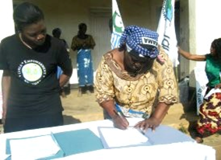of Chitera, where GENET launched its community level advocacy, is predominantly Yao and has an approximate population of 22,000.
District authorities assigned GENET Malawi to start work in Chitera because issues of child marriage were rampant there.
The NGO targeted traditional leaders at three levels – village heads, group village heads and the traditional authority, together with parents in the community to come up with viable strategies to fighting the crisis of Child Marriage. All agreed to mobilize themselves and establish local laws that would stop Child Marriages by imposing penalties such as chickens and goats to offenders.
With facilitation of GENET, the community members drafted the laws which were read to a larger community through marches, walks and awareness campaigns. To cup it all, Senior Chief Chitera singed the community bylaws in agreement at a colorful ceremony marking its official enactment. The District Commissioner of Chiradzulu was also invited to administer the signing of the act into bylaws.
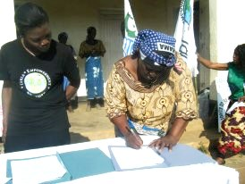
In an effort to increase community awareness of the bylaws, GENET facilitated another walk around the community with girls carrying placards with messages extracted from the bylaws.
Impact: Since the enactment of the bylaws in the area of Chitera, there has been a decrease in child marriage and an increased enrollment of girls in school. A total six girls were rescued from early marriage and expressed interest to work with GENET as ambassadors against Child Marriage. GENET took advantage of this to turn survivors of the Child Marriage into models and tools that help to fight the crisis of Child Marriage.
A renowned village headman in the area of Chitere was also dethroned for impregnating a teenager girl. Parents who insist to marry off their girls are reportedly sending them away from Chitera in fear of facing the consequences. This is apart from a number of girls who spoke highly of changes they have experienced as a result of GENET’s advocacy efforts, such as increased knowledge on the right to education.
Intervention 2-Social and Economic empowerment of young women
Senior Chief Chitera joined by other community members in celebrating the impact of the VSLA scheme during one of the review meetings.
Rural women are the most poorest and marginalized
group of people in Malawi. They are often discriminated against and
secluded from various social and economic activities.
Baseline Survey conducted by GENET Malawi in 2010 in the area of Chitera indicated that poverty was one of the factors that encourage many households to marry off their daughters whom they believe that they create a burden of responsibility for them.
Executive Director of GENET Faith Phiri observed that unless women are empowered both socially and economically, the plague of Child Marriage including other cases of human Rights abuse will continue happening in Chitera. Hence the introduction of a one-year socio-economic empowerment project for
young women, with financial support from African Women’s Development Fund.
The scheme uses the approach of Village
Savings and Loan Associations (VSLAs), which is aimed at improving village women’s socio-economic status by
increasing their participation in economic
activities. It entails distribution of match grants (capital equipments
and materials) to five young women associations, which were trained in vigorous Business Management Training in Micro Entrepreneurship.
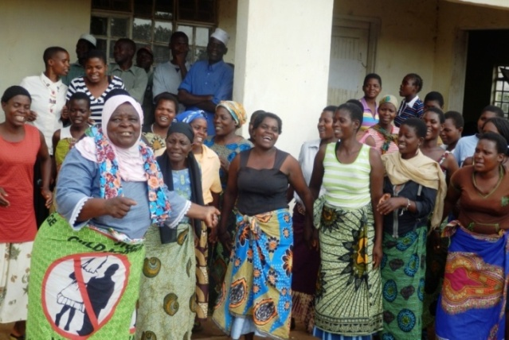
Impact: From the 100 young women,
who are targeted, the initiative has a replicable approach which will
see 5,000 young women benefiting indirectly.
But the first phase of the scheme has seen 40 women from two groups namely; Tikondane and Titukulane VSLAs, receiving a matching grant of K500, 000 (approximately UU$1,222) each group of 20 vulnerable women.
Agnes Filimoni is among 40 young women who have benefited from the VSLA scheme and shares her story:
“Since I embarked on a small-scale business of selling locally made washing baskets my life has changed.
The fact that I am now able to meet some of the needs in the house, my husband, who has another wife, thinks I am becoming rude and don’t want to listen to him. He still wants me to be a kind of a wife whom he was used to see crying each time I want help from him. But I don’t blame him because this is a general problem to do with negative perception which many men have when women in society begin to be transformed,” says Agnes
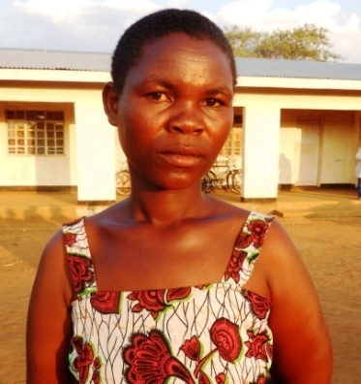
She says poverty, which renders many families hopeless, compels them to push their girls in Early Marriage.
But the economic empowerment project is equipping many women with business skills and knowledge to ensure that their lives are improved and have power to fight Child Marriage and
stand up against all inequalities such as Gender Based Violence.
“This project has empowered me to confront Child Marriage,
which is caused by poverty and poor perception towards a Girl-Child,” says Agnes.
Agnes Filimoni: I am now able to meet some of the needs in my family hence I have no thoughts to marry off girls.
Apart from women, vulnerable girls who serve as heads
of their respective families and have no immediate interest to go back to school also access the grant to ensure they venture into small scale
businesses, too.
“As much as we want teen
mothers and other vulnerable girls, who head their families to go back to school. Some say their
immediate needs are food, shelter and clothes. So, also gave them capital so that they embark on various businesses that could help them generate
income,” says Phiri.
Intervention 3-Promoting girls’ leadership skills
One of the most pressing challenging facing Malawian girls today is lack of knowledge and skills in order to stand up for their rights in society. As a result, it becomes hard for them to gather courage and speak on issues that affect them in their everyday lives. Yet becoming productive and individual contributors who can be effective and proactive in dealing with some of the Human Rights violations abuses is greatest weapon. GENET Malawi introduced leadership programme for girls in order to develop their positive leadership knowledge, attitudes, skills and aspirations.
GENET Malawi believes that with knowledge, girls would be able to make informed decisions about when they want to get married, and also be able to report to relevant authorities if they felt they are subject to unnecessary influence to get married early.
Impact: Vulnerable girls from rural areas of Chiradzulu and Blantyre are now demonstrating improved knowledge and skills on their rights, the art of public speaking, gender and outreach skills. This is appreciated through their active participation in gender and Human Rights issues at both community and national level. About over 500 girls were engaged into a direct training in Sexual Gender Based Violence (SGBV) content, Reproductive Health and Rights, Advocacy and basic leadership skills.
Girls in our catchment areas now have strong self-defense because they realize the negative effects of harmful practices such as Early Marriage, sexual cleansing and many other societal ills.
Intervention 4-fighting for policy change on Marriage bill
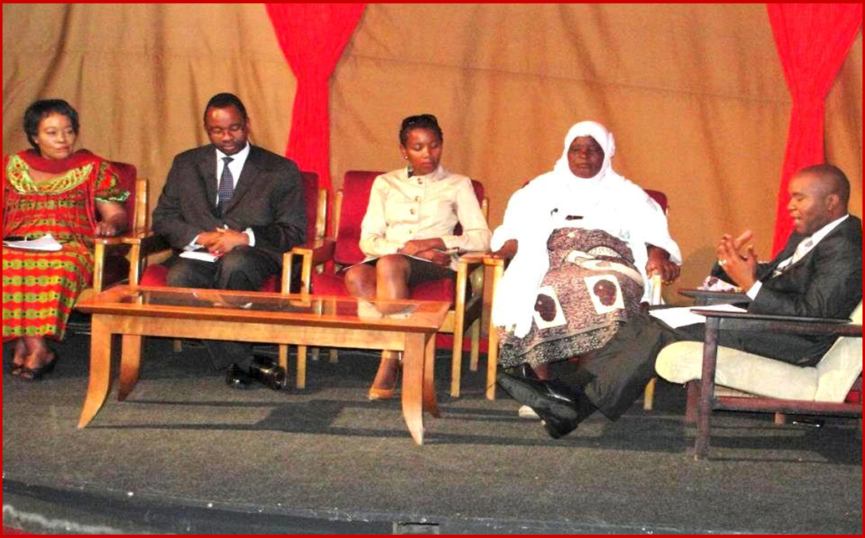
GENET Malawi has also been a very active rights campaigner for the much-needed review of Malawi’s Marriage Bill which is enshrined in the Constitution. The NGO has been working at both national and local levels with various stakeholders in order to influence the government to increase the minimum marriage age from the current 15 to at least 18 years. To this end, GENET Malawi has implemented a number of activities including producing a documentary on the life of a girl married early to raise policy makers’ awareness about absurd proportions of the issues, holding policy dialogue sessions, and participating in a national consultative meeting on the subject.
Panelists which included Lawyer Mandala Mambulasa (left) during a policy dialogue
Impact: A joint campaign called No to 15: Yes to 18 provided a framework within which Centre for Children Affairs (CEAF Malawi) and GENET Malawi undertook a collaborative activity related to the empowerment of girls and women in Malawi.
A girls’ conference was held at Kamuzu Institute for Youth in Lilongwe, the capital city where girls presented a letter to the State President of the Republic of Malawi, asking her government her review the marriage bill from 15 to 18.
The girls’ letter was submitted through Principal Secretary in the Ministry of Gender and Child Development Dr. Mary Shawa.
And through a policy dialogue which was held on September 6, 2012 at Kwacha Conference Centre in Blantyre, systematic suggestions of policies and programs that are aimed at ending the crisis of Child Marriage in Malawi were made. And broader guiding principles for possible solutions were proposed by relevant stakeholders such as young women advocates, lawyers, journalists, girls, chiefs and government officials.
Participants made a resolution that prevention of Child Marriage requires programs that focus on policy change, girls’ empowerment, community mobilization, enhanced schooling, and economic inducements. Among other proposed strategies are:
- Systematic consultations on deciding the legal frameworks that affect girls such as the Marriage Bill for them to contribute.
- Publicity and enforcement of the national law that establishes 18 as legal age of marriage in Malawi. That is to say, only persons between the ages of 18 and 21 should enter in marriage with consent of their parents.
- Communities should be engaged through awareness campaigns or motivation systems to reduce Early Marriages.
- Massive awareness about the implications of teenage marriages should be raised among parents, individual persons, community leaders, and policymakers.
- Development of deliberate policy which will see girls getting married at least after completing their secondary education. There should also be special campaign to bring back teen mothers to school.
- Develop social and economic programs for girls, who drop out of school that includes non formal education programs.
- Empower community leaders and Legalize traditional laws so that those found perpetrating Child Marriages should be brought to the traditional courts and pay fines. The payment of bride price (Malowolo) and the practice of Early Marriages under traditional laws in Malawi is the effect of increased vulnerability of girls. Therefore, these courts will have a direct responsibility to discourage such malpractices that fuel child marriages.

Then a Policy Brief was developed by GENET Malawi and distributed to stakeholders including the government.

Intervention 5-I will marry when I want campaign
Through financial support from Canadian High Commissioner, GENET conducted a story writing training session with a group of adolescent girls from Traditional Authority (TA) Chitera and Blantyre rural. Girls were asked to write their life stories on the subjects: Ambitions, Child Marriage, Education, Cultural practices such as Kusasafumbi. Kusasafumbi is the practice of sexual cleansing performed after a girl has gone through initiation. It usually involves sex with an older man and often leads to the transmission of sexually transmitted infections, such as HIV, or pregnancy.
The participatory review meeting of the girls’ stories revealed that most girls had sex with an older man at the time they came out of an initiation camp hence had a feeling they were ready for marriage and eventually dropped out of school and married. But those who got married experienced the worst kind of abuse at the hands of their older husbands.
Impact: The girls’ appalling stories compelled GENET Malawi to put them together in a publication which, to date, acts as adolescent girls’ tool for advocacy against Child Marriage in Malawi. The publication was launched at a colorful ceremony in Lilongwe and was distributed to policy makers and other stakeholders that were part of the event for their action.
-----------------------------------------------------

GENET Malawi is committed towards elimination of Child Marriage, gender inequalities in Health, Education and Economic opportunities and Gender Based Violence and discrimination against women and girls. And it in its quest to keep the fight against Child Marriage alive, together with other stakeholders, the NGO makes persistent reminders to policy makers about the need to review the Marriage Bill. This is done through organizing girls’ marches, rights campaigns, community mobilization and mutual working relationship with the media, both local and international.
For more information about Girls Empowerment Network (GENET) visit our website: www.genetmalawi.org or follow us on facebook https://www.facebook.com/GENETMalawi or email us info@genetmalawi.org

UNICEF, At a Glance: Malawi, 2010, http://www.unicef.org/infobycountry/malawi_statistics.html#90

