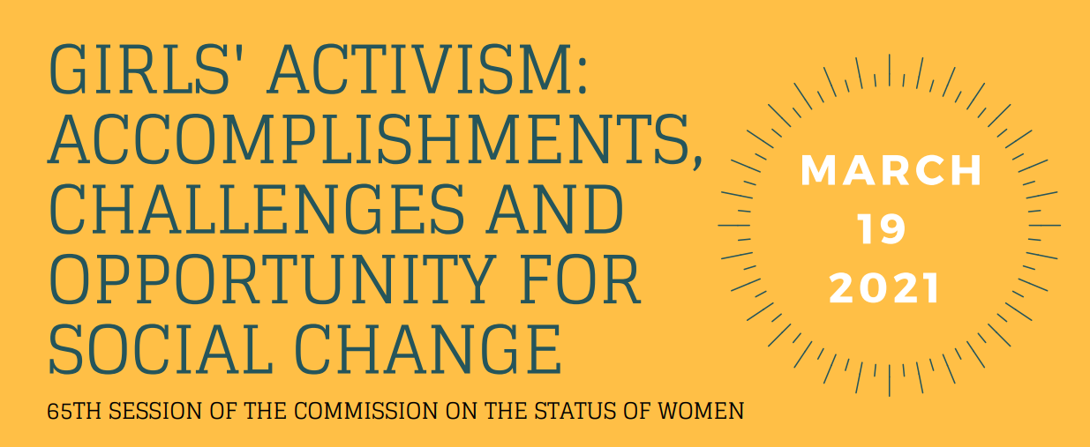

On 19 March 2021, the Working Group on Discrimination against Women and Girls organised a virtual side-event in the framework of the 65th session of the Commission on the Status of Women on “Girls’ activism: accomplishments, challenges and opportunities for social change” to highlight the importance of girls’ and young women’s participation, activism and collective action as an essential precondition for building sustainable, peaceful and just societies. The virtual side-event provided a safe platform for 5 girl activists from across the globe to share their stories and the challenges they have faced in accessing formal and informal decision-making processes.
The girl activists recounted powerful stories on how they started activism, from the corridors of their schools to the streets of their villages, and shared their accomplishments in empowering other young women, bringing education to indigenous children and counselling and supporting young mothers and survivors of child marriage. The girl activists reflected on the challenges they encountered, such as lack of funding and difficulties in obtaining grants, the exclusion of girls from meaningful discussions and the systemic structural barriers to access policy-making fora, as well as threats, harassment and intimidations. The activists further discussed about the importance of support networks and mentorship to prepare young girls to meaningfully contribute to decision-making processes and overcome barriers to their participation, including the inter-generational divide between old and young feminist movements. Finally, it was mentioned how the COVID-19 pandemic has prompted young activists to become more digital, which has led to a stronger inclusion in formal and informal processes led by old feminist movements from which they were previously barred.

Click here to access the full recording of the event

Panellists:
- Ivan Šimonović, Ambassador and Permanent Representative of Croatia to the UN in New York, opening remarks
- Ivana Radačić, member of the Working Group on Discrimination against Women and Girls, moderator
- Mariana Reyes, girl activist from LAC region
- Samantha Chidodo, girl activist from Africa
- Rose Hayahay, young indigenous leader from Asia
- Imogen Senior, girl activist from WEOG region
- Jona Claire Turalde, advisor at FRIDA, the Feminist Fund

