QUESTIONNAIRE FROM THE CHAIRPERSON-RAPPORTEUR OF THE WORKING GROUP ON DISCRIMINATION AGAINST WOMEN IN LAW AND PRACTICE
General
- What status/hierarchy does your Constitution give to international human rights treaties versus domestic law?
Our Constitution does not bind Zimbabwe to concluded international human rights treaties until they have been domesticated. Secondly customary international law may be adopted by Zimbabwe to the extent that it is not inconsistent with the Constitution. Thirdly the judiciary is mandated to keep abreast with international law. Lastly, the Zimbabwe Human Rights Commission may require information from various stakeholders in order to prepare reports required to be submitted to any regional or international body under any human rights convention or treaty.

- Has your State ratified international human rights treaties with reservations to provisions dealing with equality in family life?
No.

- Are the principles of non-discrimination on the basis of sex/gender and equality between men and women established in the Constitution of your State? If yes, please provide references, describe how they are defined (name specific articles) and whether they cover family and cultural life.
Yes. For instance, in the Founding Principles, the Constitution provides for horizontal and vertical application of the Constitution. This is important for women particularly as discrimination does not always happen in the public sphere, but in the private sphere as well. Section 17 of the Constitution provides that the State must take positive measures to rectify gender discrimination and imbalances resulting from past practices and policies.

Section 56 of the Constitution provides the following:

“(1) All persons are equal before the law and have the right to equal protection and benefit of the law.
(2) Women and men have the right to equal treatment, including the right to equal opportunities in political, economic, cultural and social spheres.
(3) Every person has the right not to be treated in an unfairly discriminatory manner on such grounds as their nationality, race, colour, tribe, place of birth, ethnic or social origin, language, class, religious belief, political affiliation, opinion, custom, culture, sex, gender, marital status, age, pregnancy, disability or economic or social status, or whether they were born in or out of wedlock.
(4) A person is treated in a discriminatory manner for the purpose of subsection (3) if—
(a) they are subjected directly or indirectly to a condition, restriction or disability to which other people are not subjected; or
(b) other people are accorded directly or indirectly a privilege or advantage which they are not accorded.
(5) Discrimination on any of the grounds listed in subsection (3) is unfair unless it is established that the discrimination is fair, reasonable and justifiable in a democratic society based on openness, justice, human dignity, equality and freedom.
(6) The State must take reasonable legislative and other measures to promote the achievement of equality and to protect or advance people or classes of people who have been disadvantaged by unfair discrimination, and—
(a) such measures must be taken to redress circumstances of genuine need;
(b) no such measure is to be regarded as unfair for the purposes of subsection (3).”

Section 246 of the Constitution stipulates that part of the mandate of the Zimbabwe Gender Commission is to conduct research into issues relating to gender and social justice, and to recommend changes to laws and practices which lead to discrimination based on gender.

- Are there any specific anti-discrimination or gender equality laws in your State? If yes, please provide references and briefly describe the content of this law(s), in particular whether it covers family and cultural life.
Yes. The fact that there is a provision for the establishment of a Gender Commission, in the Constitution, is also a great milestone for women. Its Bill is currently before Parliament. The following are the functions of the Commission as set out in section 246 of the Constitution:
- to monitor issues concerning gender equality to ensure gender equality as provided in this Constitution;
(b) to investigate possible violations of rights relating to gender;
(c) to receive and consider complaints from the public and to take such action in regard to the complaints as it considers appropriate;
(d) to conduct research into issues relating to gender and social justice, and to recommend changes to laws and practices which lead to discrimination based on gender;
(e) to advise public and private institutions on steps to be taken to ensure gender equality;
(f) to recommend affirmative action programmes to achieve gender equality;
(g) to recommend prosecution for criminal violations of rights relating to gender;
(h) to secure appropriate redress where rights relating to gender have been violated; and
(i) to do everything necessary to promote gender equality.

The Constitution of Zimbabwe fully recognises marriage rights as well as the rights of the parties flowing from the consequences of the marriage. Section 26 of the Constitution provides for marriage based on the free and full consent of the parties. It further recognises equality of the rights and obligations of spouses during marriage and in the event of the dissolution of the marriage. In addition, the Constitution provides for equal rights over custody and guardianship of children, thus eliminating a long standing discriminatory practice whereby the legal starting point was that only men could be legal guardians of children born in wedlock. Further to this, the new Constitution in section 36 (1) (a) confers on both women and men who are citizens of Zimbabwe, the right to pass on citizenship to their children. In addition, citizenship cannot be lost either through marriage or dissolution of marriage an important protection particularly for women.
The Deeds Registry Act [Chapter...] which provides that married women have the right to acquire and register property in their own names, the Marriages Act [Chapter...] provides that marriage in Zimbabwe is out of community of property, meaning that parties can legally own property individually but also can decide to jointly own property which is then dealt with as matrimonial property. The Customary Marriages Act[Chapter..] recognises polygamous marriages while other legislation such as the Administration of Estates Act of 1997 tries to protect surviving spouses in the event of death.
According to the Dongo v Registrar Supreme Court case women are now in a position to apply for their children’s passports without having to ask for the consent of either unwilling or unavailable fathers.
Lastly section 56 (3) stipulates that “Every person has the right not to be treated in an unfairly discriminatory manner on such grounds as their nationality, race, colour, tribe, place of birth, ethnic or social origin, language, class, religious belief, political affiliation, opinion, custom, culture, sex, gender, marital status, age, pregnancy, disability or economic or social status, or whether they were born in or out of wedlock.”

- Have there been any recent legal reforms in your State to guarantee non-discrimination and equality between men and women in family and cultural life? If yes, please explain and provide examples.
Yes, the Constitution (Amendment No. 20). All sections have been referred to in the previous questions.

- Are there any customary, religious law or common law principles/provisions that discriminate against women in family and cultural life? If yes, please explain and provide examples.

The current Constitution came into force in May 2013 and seeks to redress, inter alia, any discriminatory practices or laws against women. Currently Government has undertaken the process of re-aligning all subsidiary laws with the Constitution.

- Are there any good practices that you can share regarding the elimination of sex discrimination in family and cultural life in your State? If yes, please explain and provide examples.
Our Constitution is one good starting point of the way that Zimbabwe has strived to eliminate sex discrimination. Section 56 (3) is one example as previously mentioned.
Zimbabwe has empowered women through its education policies at all levels since Independence, achieving near gender parity in enrolments at primary level and near gender parity at lower secondary (Form 1 to 4). Policies such as the School Re-entry Policy Ministry of Education Circular P35, Ref: G/4/&G/1/3 of 20 April 1999 as amended in 2004 allows girls who become pregnant in school to be re-admitted into the education system so that they can continue with their education. Where the person responsible for the pregnancy is a schoolboy, he too is sent on leave for the same duration. The granting of such leave is accompanied by counselling for the affected school children, as well as their parents, by the school authorities.
One of the most important provisions for women’s political participation in the new Constitution is found in section 124. This provides for 60 vested seats for women in Parliament elected under a party list system of proportional representation. As a result, women now comprise 124 of the 350 MPs in Zimbabwe’s new Parliament, including 86 women in the National Assembly – 60 in the reserved seats and 26 elected directly to the 210 constituency seats. The Constitution in section 120 further makes provision for the election of women to the Senate through a system of proportional representation. The use of the special measure also led to 37 women candidates being elected to the Senate, and one woman was selected to one of the two Senate seats allocated for people living with disabilities, bringing the total number of women to 38 – an unprecedented 47.5 per cent of the 80 Senators provided for under the Constitution.
There have been improvements in women’s participation and representation in community politics and decision-making structures. Women now feature as chiefs and village heads, among others.

- What actions have been taken by your State to eradicate negative gender stereotyopes, including in the media? Please provide examples.
The new Constitution is a progressive document that strives to eradicate negative gender stereotypes. Furthermore editors in media houses are pro-gender and reserve the right no to air advertisements that reflect negative gender stereotyping. The Zimbabwe Media Commission also has the right to promote and enforce good practices and ethics in the media.

- Are tribunals upholding the principles of equality and non-discrimination in matters relating to family and cultural life? If yes, please provide examples.

Government working with Civil Society Organisations and the Judicial Services Commission established the Family Law Court System at High Court level which is aimed at ensuring that cases arising from matrimonial disputes are dealt with in this specialised court rather than the ordinary court system. This has been aimed at ensuring that some of the effects of the adversarial system are mitigated as well as ensuring the expeditious and sensitive disposal of cases.

- Are there any mechanisms to monitor draft legislation, specific provisions in draft legislation or reverse decisions discriminating against women in family of cultural life? If yes, please provide any relevant examples.

Yes. Each Ministry has a Gender focal person. There are also continuous trainings for gender focal persons, led by the Ministry of Women, Affairs, Gender and Community Development.

Family life- Equality within marriage

- Is there a legal designation of head of household? If yes, is the head of household the male member of the family? What rights or obligations are attributed to the head of household?
No.

- Do women have the same rights as men in your State in relation to:’

- The minimum age for marriage? Yes it is 18 years according to section 78 of the Constitution.
- The right to enter into marriage? Yes. According to section 78 no one maybe compelled to enter into a marriage against their will.
- The freedom to choose a spouse and express consent? Yes. According to section 26 of the Constitution no one may enter into a marriage without his or her free and full consent.

- With permission or authorization from parents/guardians/courts, at what minimum age can men and women marry in your State? What enforcement measures are provided by law in this regard?
Section 78 of the Constitution stipulates that the minimum age for marriage is 18. Furthermore the Domestic Violence Act [Chapter 5:16] states that child marriage is a discriminatory customary practice that leads to domestic violence.

- Is there reference to dowry in the legislation of your State, for example, in marriage contracts or in traditional practice? If yes, please explain.
No.

- Are forced marriages or arranged marriages practised in your State?
According to the Constitution and the Domestic Violence Act, forced or arranged marriages are prohibited. However these types of marriages are still practised, which is, interalia, poverty related.
- Is polygamy illegal in your State? If no, is it legal for both men and women?
Polygamy is legal according to the Customary Marriages Act [Chapter 5:07] and the Unregistered Customary Unions in our State and the law applies to men only.
- Is the registration of marriage compulsory in the following cases?
- Civil marriage? Yes
- Religious marriage? Yes

- Are same sex marriages allowed in your State?
According to section 78 (3) of the Constitution, persons of the same sex are prohibited from marrying each other.

- Are same-sex relations criminalized in your State? If yes, please provide references.
No.

- Is equality guaranteed between husband and wife in law and practice with respect to:
- The right to choose a family name
Under civil marriages and registered customary marriages the wife assumes the husbands surname and under unregistered customary marriages the wife may retain her maiden name.
- The right to choose a profession and occupation
Yes. Section 14 provides that “The State and all institutions and agencies of government at every level must endeavour to facilitate and take measures to empower, through appropriate, transparent, fair and just affirmative action, all marginalised persons, groups and communities in Zimbabwe. At all times the State and all institutions and agencies of government at every level must ensure that appropriate and adequate measures are undertaken to create employment for all Zimbabweans, especially women and youths.”
Section 17 (1) (a) stipulates that “The State must promote full gender balance in Zimbabwean society, and in particular the State must promote the full participation of women in all spheres of Zimbabwean society on the basis of equality with men.”
Section 24 (2) (d) states that “the State and all institutions and agencies of government at every level must endeavour to secure the implementation of measures such as family care that enable women to enjoy a real opportunity to work.”

Section 56 (2) provides that women and men have the right to equal treatment, including the right to equal opportunities in political, economic, cultural and social spheres.
Section 80 (1) stipulates that every woman has full and equal dignity of the person with men and this includes equal opportunities in political, economic and social activities.
To a great extent this has been achieved in practice as well.
- The right to choose the place of residence
Yes. Section 66 (2) (b) states that every Zimbabwean citizen has the right to reside in any part of Zimbabwe.
- The right to have and retain one’s nationality
Yes. Chapter 3 of the Constitution states the right to have a nationality by birth, descent and registration. It further states that Zimbabwean citizenship is not lost through marriage or the dissolution of marriage.
- The freedom of movement (including the right to travel abroad)
Yes. Section 66 of the Constitution provides the following:
“Every Zimbabwean citizen has—
(a) the right to enter Zimbabwe;
(b) immunity from expulsion from Zimbabwe; and
(c) the right to a passport or other travel document.
(2) Every Zimbabwean citizen and everyone else who is legally in Zimbabwe has the right to—
(a) move freely within Zimbabwe;
(b) reside in any part of Zimbabwe; and
(c) leave Zimbabwe.”

- Do both spouses have the same rights in law and practice with respect to:
- Ownership of property and land
Section 26 of the Constitution states that the State must take appropriate measures to ensure that there is equality of rights and obligations of spouses during marriage and at its dissolution.
Section 17 c of the Constitution states that “the State and all institutions and agencies of government at every level must take practical measures to ensure that women have access to resources, including land, on the basis of equality with men.”
The mining industry is still predominantly male however women benefited from the loan fund last year and mining fees have been cut down this year as measures to ensure women are beneficiaries in the mining sector.
Ministry of Agriculture polices that include gender mainstreaming. In practice some Zimbabweans still have a patriarchal mindset thus impose the right to ownership of property over their spouses.
The Ministry for Agriculture, Mechanisation and Irrigation Development has also come up with a gender strategy whose implementation is ongoing.

- Management and administration of property and land
Section 17 (1) of the Constitution states that the State must promote the full participation of women in all spheres of Zimbabwean society on the basis of equality with men; Furthermore the State and all institutions and agencies of government at every level must take practical measures to ensure that women have access to resources, including land, on the basis of equality with men.
- Enjoyment and disposition of property and land
Yes.

- Are women who get married subjected to any form of male guardianship?
No.

- Do parents have same rights and responsibilities regarding to:
- Deciding the number and spacing of children
Yes.
- Guardianship, wardship and trusteeship
Yes. Section 80 (2) of the Constitution states that women have the same rights as men regarding the custody and guardianship of children, but an Act of Parliament may regulate how those rights are to be exercised.
- Adoption of children
Yes.
- Alimony
Yes. Section 7 (1) (b) of the Matrimonial Causes Act [Chapter 5:13] states that in granting a decree of divorce, judicial separation or nullity of marriage, an appropriate court may make an order with regard to the payment of maintenance, whether by way of a lump sum or by way of periodical payments, in favour of one or other of the spouses or of any child of the marriage.

- Are de facto unions recognized in law and in your state?
Yes. Unregistered Customary unions are recognized with regards to custody and inheritance laws.
- Do men and women have the same legal rights with respect to dissolution of marriage?
Yes. Section 26 (c) of the Constitution has stated this provision in the previous questions addressed.

- Do men and women have the same rights in law and practice when a marriage or union ends in terms of :
- Equal share of marital property and land
Yes. Section 26 (c) of the Constitution stipulates that the State must take appropriate measures to ensure that there is equality of rights and obligations of spouses during marriage and at its dissolution.

- Custody of children
Section 80 of the Constitution provides that women have the same rights as men regarding the custody and guardianship of children, but an Act of Parliament may regulate how those rights are to be exercised
- Remarriage
Yes.

- Is it contemplated in the legislation of your State that, in the event of a divorce, women should remain in the family or common household?
No.
- Are legal provisions guaranteeing non-financial contributions, including care of children, the sick and elderly in the family, taken into account in the division of marital property upon divorce?
Yes. According to section 26 (d) of the Constitution the State must take appropriate measures to ensure that in the event of dissolution of a marriage, whether through death or divorce, provision is made for the necessary protection of any children and spouses.

- Are rights of widow(er) s the same for women and men in terms of:
- Custody of children
Yes. Section 80 (2) of the Constitution states that women have the same rights as men regarding the custody and guardianship of children, but an Act of Parliament may regulate how those rights are to be exercised.

- Property and land
Yes. This is provided for in section 17 of the Constitution as previously stated.
- Remarriage
Yes.
- Freedom to choose residence
Yes according to section 66 of the Constitution as stated in previous questions addressed.
- Do women have access to legal aid in relation to family matters?
Yes. The Department of Legal Aid Directorate’s major clients are women with issues regarding maintenance, divorce and domestic violence. Furthermore according to section 31 of the Constitution, the State must take all practical measures, within the limits of the resources available to it, to provide legal representation in civil and criminal cases for people who need it and are unable to afford legal practitioners of their choice.
Government in partnership with development partners is also working on decentralising its offices to other towns.

Equality within the family
- What is the legal definition /concept of “family” in your State?
According to section 25 of the Constitution the concept of family includes mothers, fathers and other family members who have charge of children. According to customary law, family includes the extended family.
- In law (including customary law) are men and women equal in the family in your State?
Yes according to the Constitution all laws, customs, traditions and cultural practices that infringe the rights of women conferred by the Constitution are void to the extent of the infringement. However in practice other parts of the country (e.g. rural areas) still treat men and women differently within the family set up.
- Do men and women have the same social status within the family in your State?
There have been great strides due to the Constitution (Amendment No. 20). However family members in some parts of the nation still rank the social status of men and women differently.
- Does your State have data on the number of hours spent by women and by men on functions in the home or in care of family members, including children and the elderly?
No.
- Do men and women in the family have the same rights, in law and practice, with regards to inheritance (including equal rank in the succession)?
The Constitution provides that all laws, customs, traditions and cultural practices that infringe the rights of women conferred by this Constitution are void to the extent of the infringement. Furthermore the State must take appropriate measures to ensure that there is equality of rights and obligations of spouses during marriage and at its dissolution; and in the event of dissolution of a marriage, whether through death or divorce, provision is made for the necessary protection of any children and spouses.

Children are entitled to adequate protection by the courts, in particular by the High Court as their upper guardian. A child’s best interests are paramount in every matter concerning the child.
However cases still arise of inequality with regards to inheritance in the rural, farming and urban areas.
- Does family education in your State include a proper understanding of maternity as a social function and the recognition of the common responsibility of men and women in the upbringing and development of the children?
The Labour Act recognizes that men may be offered any other leave upon the discretion of the employer. This type of leave includes paternity leave. Furthermore the common responsibility of men and women in the upbringing and development of the children is recognised in Zimbabwe.
- If equality is guaranteed in law and practice, does this apply in all different types of families?
Although it is guaranteed according to the Constitution and family laws, it may not always apply in practice, especially with regards to extended families or polygamous marriages.
Violence within the family and marriage

- Are there any of the following traditional practices in your State?
- Female genital mutilation
No.
- Honour killings
No.
- Son preference
Yes. Girls may be forced to drop out of primary or secondary school in the farming and rural areas. However there is legislation prohibiting this issue.
- Dowry deaths
No.
- Polygamy
Polygamy is practiced according to the Customary Marriages Act and Unregistered Customary unions.
- Prohibition of work or travel without the permission of a guardian
No.
- Other
Certain religious sects practice child marriages although the Domestic Violence Act and the Constitution prohibit this custom.
- Is there any anti-domestic violence legislation/regulations in your State?
Yes we have a Domestic Violence Act and the Constitution that speak against domestic violence.
- Does your State have a legal definition of discrimination which covers gender-based violence or violence against women, which includes domestic violence?
Section 52 of the Constitution stipulates discrimination based on gender.
- Does your State have a national policy to eliminate gender-based violence or violence against women, including domestic violence?
Yes. The Zimbabwe National Gender Based Violence Strategy 2012-2015 seeks to improve the efforts of Government, civil society and donors to prevent and respond to GBV through a multi-sectoral, effective and coordinated response. The National Gender Based Violence Strategy is based on the four pillars of GBV programming namely prevention, service provision, coordination and research and documentation. Zimbabwe has also come up with Standard Operating Procedures for Safe Shelters (2012) protocol relating to the provision of shelters for the survivors of gender based violence and Standard Operating Procedures for counseling. The Ministry will operationalise the Strategy through the 4Ps Campaign on zero tolerance to GBV. The 4Ps focus on Prevention, Protection, Programmes and Participation

- Is marital rape considered a crime in the legislation of your States?
Marital rape is considered a crime according to section 68 of the Criminal Law (Codification and Reform) Act [Chapter 9:23]
- Is adultery considered a crime in the legislation of your State?
If yes, is it equally punished for men and women?
Under Zimbabwean laws, adultery is not a crime and a wronged party can seek recourse in the civil court.
- Are there any public campaigns in your State to raise awareness that violence against women and girls is a human rights violation?
If yes, do they attempt to change the attitudes of men?
Yes. These campaigns, led by the MOWAGCD, have included male involvement from, high schools, Civil Society Organisations, Ministers and His Excellency the President of the Republic of Zimbabwe. This therefore proves that the men’s attitude towards violence against women is slowly changing.
- What measures have been taken in your State to raise awareness among law enforcement officials regarding violence against women and girls, including domestic violence?
There has been ongoing training of Zimbabwe Republic Police (ZRP) officers on GBV.
- Are there special law enforcement units to respond to complaints of violence against women and girls, including domestic violence? If yes, do these include female law enforcement officers?
Yes. Government continues to strengthen the Victim Friendly courts, which aim to protect vulnerable witnesses in sexual abuse cases. Although initially intended for child victims of sexual abuse, this system has now been extended for use even in cases of adult female victims.

Victim friendly units at police stations were also set up to discreetly handle cases of violence against women, child sexual abuse and adult rape among other issues, to ensure that vulnerable witnesses are properly handled in reporting and processing their cases. Nationally there are 419 victim-friendly police stations situated at national, provincial and district levels. These stations include female law enforcement officers.
- Please provide information on the incidents/complaints of domestic violence, sexual assault including rape, and child abuse against women and girls in your State.
According to the statistics from the Zimbabwe Republic Police, rape of juveniles is on the increase, with the 0-6 year age group being the most vulnerable. Attached hereto, as Annexure A, are statistics from 2012-2014
- Are there shelters or safe houses for women and girls who are victims of gender-based violence, including domestic violence in your State?
Yes. Musasa Projects in Harare provides shelter to survivors of domestic violence.
Participation in cultural life
- Are men and women equally entitled in law and practice to interpret cultural traditions, values and practices in your State?
Yes. This is shown by the traditional female heads that have been appointed into leadership.
- Are there restrictive dress codes for women which do not apply to men?
No. However certain religious sects have their own doctrines that may impose restrictive dress codes on women.
- Are women in the country allowed to be a member and fully participate in cultural and scientific institutions in your State?
Yes. The Constitution provides for gender balance and equality.
- Are women entitled in law and practice, independently of their marital status, to decide freely whether or not to participate in certain cultural events, traditions and practices in your State?
Yes according to the Constitution. However this is not always the case in practice.

Annexure A
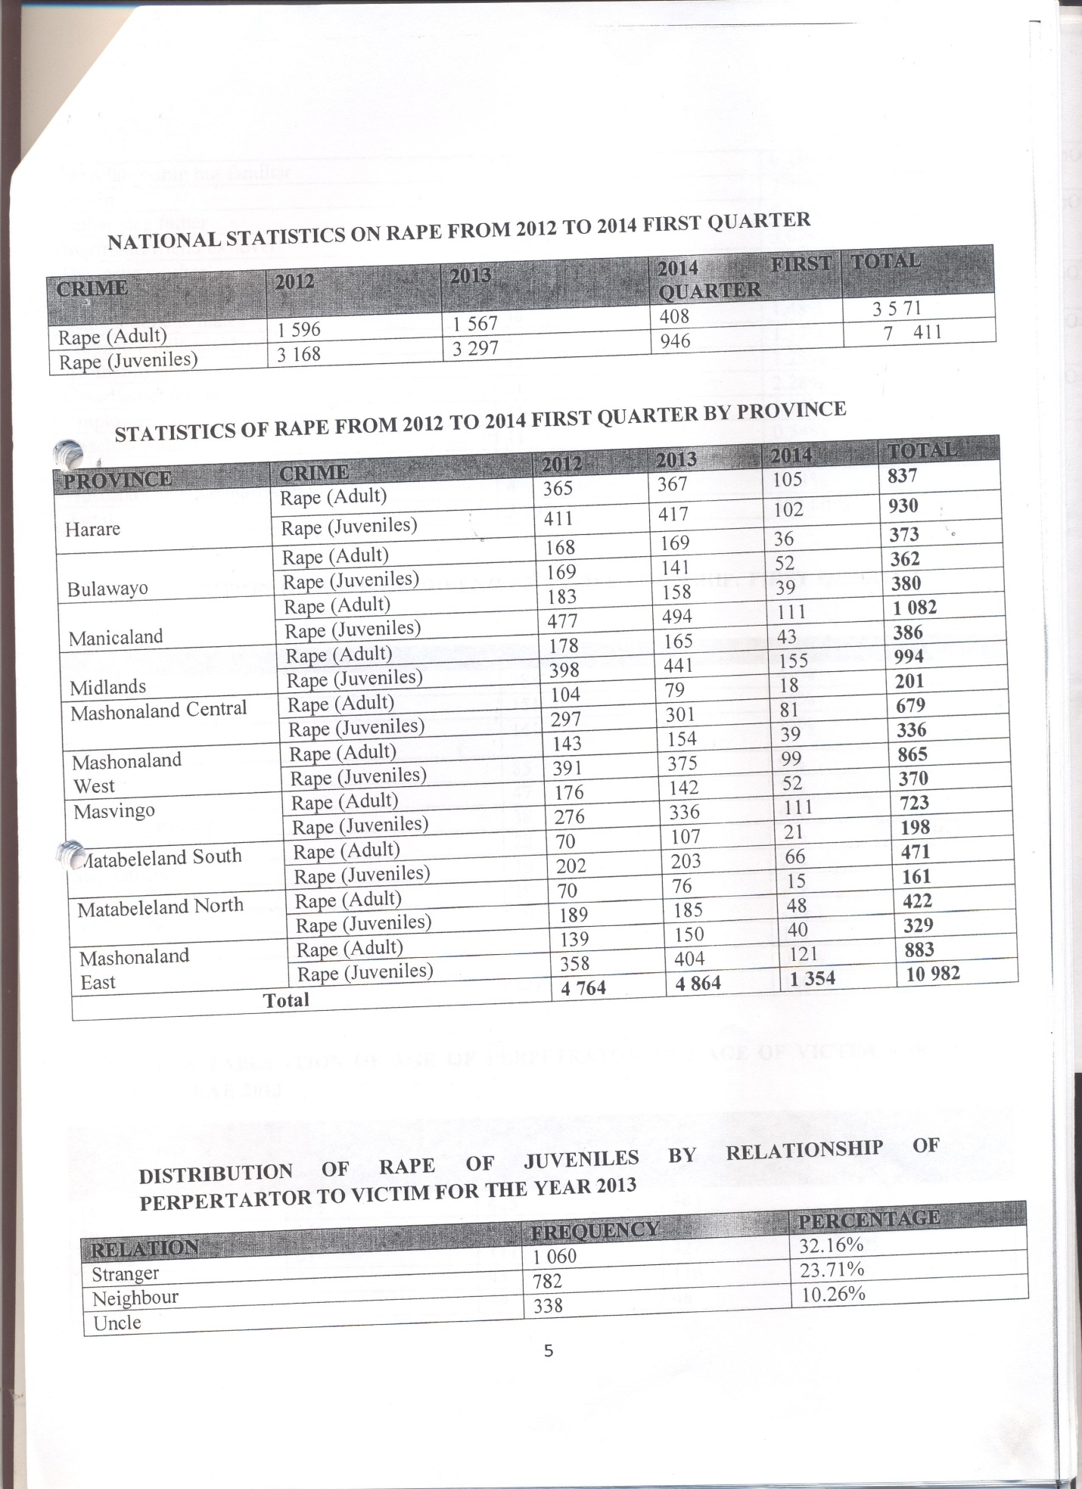
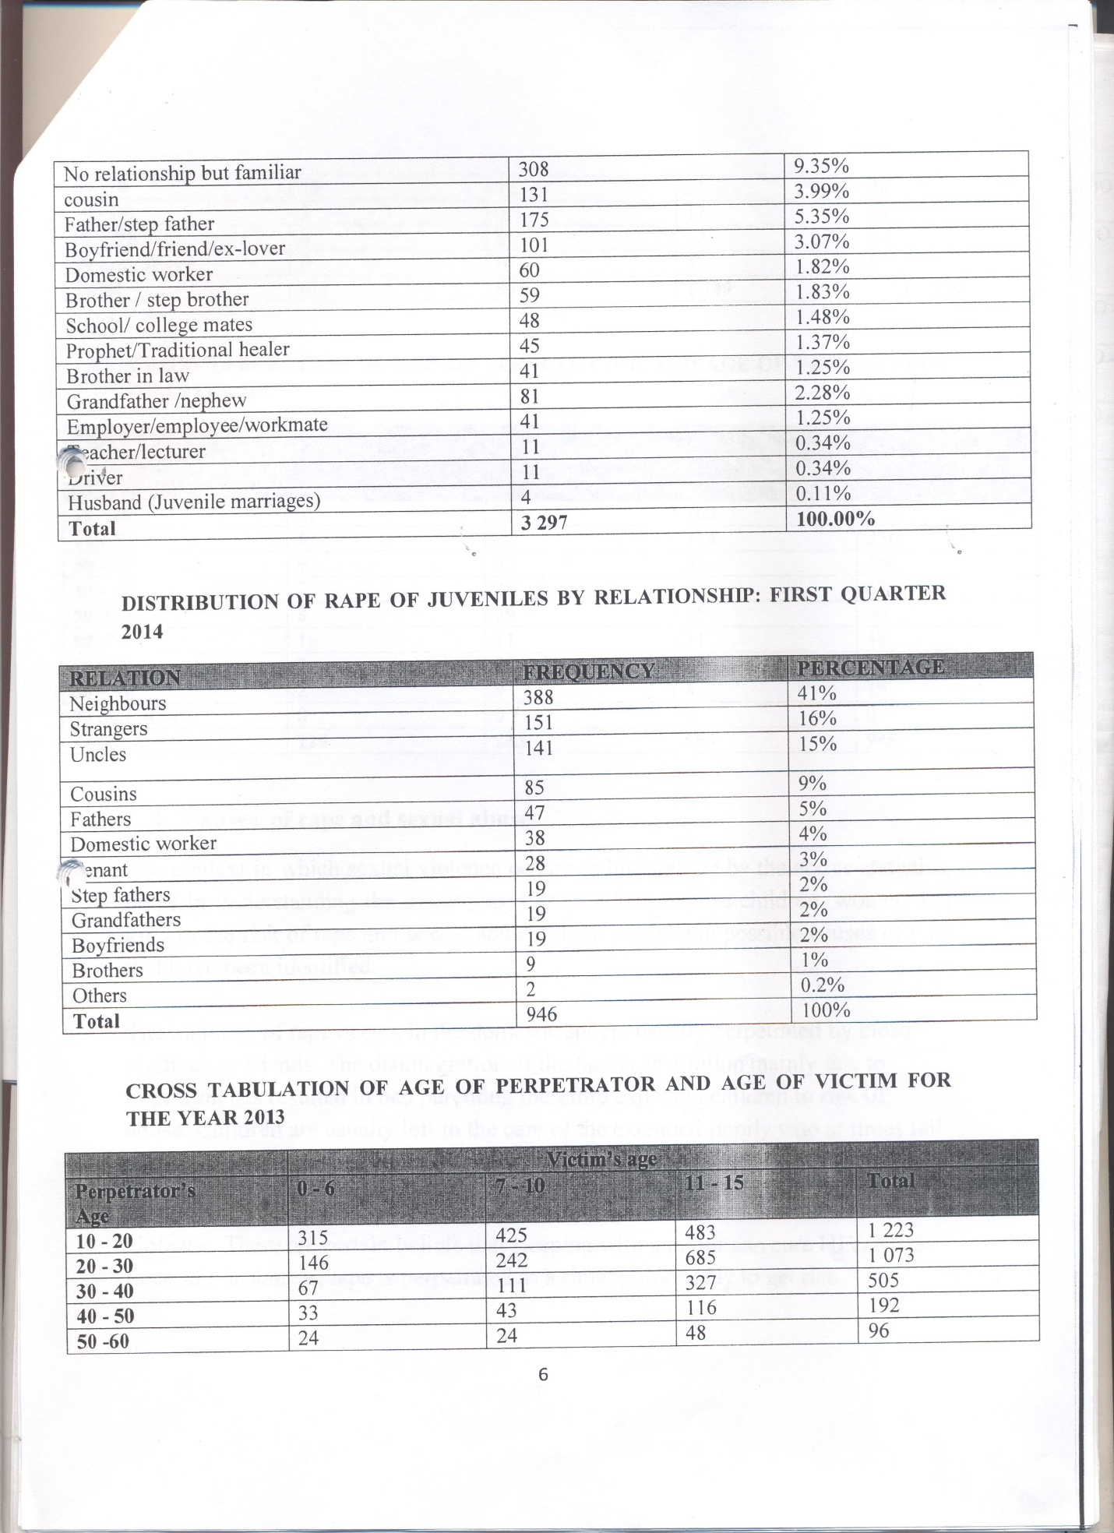
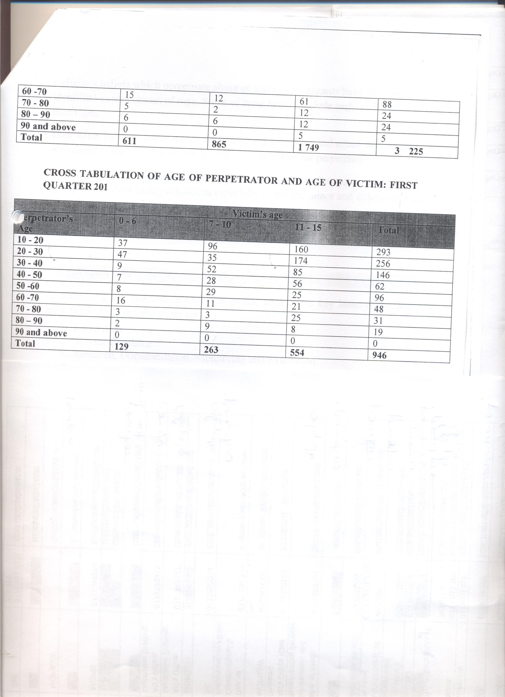

Section 327 (2) states that “An international treaty which has been concluded or executed by the President or under the President’s authority— (a) does not bind Zimbabwe until it has been approved by Parliament; and (b) does not form part of the law of Zimbabwe unless it has been incorporated into the law through an Act of Parliament.”
Section 326 of the Constitution stipulates that “Customary international law is part of the law of Zimbabwe, unless it is inconsistent with this Constitution or an Act of Parliament. When interpreting legislation, every court and tribunal must adopt any reasonable interpretation of the legislation that is consistent with customary international law applicable in Zimbabwe, in preference to an alternative interpretation inconsistent with that law.”
Section 165 (7) of the Constitution provides that “Members of the judiciary must take reasonable steps to maintain and enhance their professional knowledge, skills and personal qualities, and in particular must keep themselves abreast of developments in domestic and international law.”
Section 244 (1) (b) of the Constitution states that “The Zimbabwe Human Rights Commission may require any person, institution or agency, whether belonging to or employed by the State or otherwise to provide the Commission with information it needs to prepare any report required to be submitted to any regional or international body under any human rights convention, treaty or agreement to which Zimbabwe is a party.”
Section 81 (1) (f) of the Constitution states that every child, that is to say every boy and girl under the age of eighteen years, has the right to education

