1 Oct 2018

The Secretariat of the Working Group on discrimination against women
Special Procedures Branch
Office of the High Commissioner for Human Rights
Palais Wilson, Geneva
E-mail: wgdiscriminationwomen@ohchr.org
Web: www.ohchr.org

RE: Communication to the Working Group regarding women deprived of liberty
(in response to the Call for submissions: Women deprived of liberty)

Dear Members of the Working Group on discrimination against women:

Please receive, via this letter and its appendices, my communication regarding the violation of the human rights of women, the arbitrary deprivation of women’s liberty, and the subjection of women to discriminatory punishments deriving from culturally inherited attitudes regarding women in the United Kingdom. (Note that I am not a citizen of the United Kingdom but of the United States; I worked in the UK legally from 2011-2014 with a highly skilled worker visa, and the events I describe here occurred in 2014.) I write in response to the call for communications published at https://www.ohchr.org/EN/Issues/Women/WGWomen/Pages/WomenDeprivedLiberty.aspx with a submission deadline of 1 October 2018. Here I give as much information as I am able: the nature of such violations leaves them often with minimal textual evidence or with textual evidence plagued by inaccessibility, indecipherability, or a priori factual reconfiguration by the hand of the violator. Nonetheless, the body of textual and graphic evidence that I have been able to obtain is substantial (totaling thousands of pages), and I will share all of it upon request. I have compiled from this body of evidence a thematically arranged series of appendices; as it too large to email, I have made it accessible for download via Google Drive here: https://drive.google.com/open?id=1oywKVckF5bZYSd3H-dJVsuVoIn1RPnKR. More substantial still is the evidence that the violences delivered to me during my incarceration have left upon my body– what anthropologist Didier Fassin (2011) refers to as the “trace” of torture – and even more impactfully on my person. I will describe and document here as much as I am able to summarize with readable brevity and as much coherency as I am able to lend into the incomprehensible actions administered to me. I welcome your contact if you require further information or documentation: after a herculean bureaucratic effort (this, one of the many obstacles confronting violence women in their efforts to seek justice), I have been able to obtain the retained files from each of the two institutions where I was abused, and I will share them in full upon request. More importantly, however, I urge your direct investigation of these violations in the sites of their ongoing performance: the same practices that deprive women of liberty and of their civil and human rights (generally) and subject them to torture (in some cases) that I describe here are likely being delivered to women in those institutions in the instant that you read this.

Among the general categories of violation that pertain in the scope of this communication are:
- The arbitrary and discriminatory detention of women
- The torture of women in custody
- Discriminatory application of punishments in law based on sex, including corporal punishment
- Impunity for violations of the human rights of women
- Stereotypical attitudes towards the role and responsibilities of women and the direct translation of these stereotypes into modes of corporal violation
- Lack of due diligence by States to adequately investigate, prosecute and punish perpetrators of violence against women

This communication refers to the juridically authorized and procedurally normalized identification of women with skinny bodies (that is, nonconforming to the United Kingdom’s established socio-scientific norm) as mentally ill; their consequent subjection to detention, violence, and torture; and their more general violation of procedural, civil, and human rights.

In summary, these are the violations I truthfully allege:
- The United Kingdom arbitrarily detains skinny women. In this case, arbitrary should not be understand in relation to the law but of the law itself. That is, skinny women are legally detained in the UK. That law is itself arbitrary, arising in the wake of a centuries-long evolution in social, scientific, and legal norms that take seed in an understanding of the woman (generally) as inherently wicked, deceitful, untrustworthy, and – crucially in the context of this punitive model – irrational and emotionally unstable.
- The United Kingdom’s law allowing such (arbitrary) detentions of skinny women derives specifically from stereotypical attitudes towards the roles and identities of women that, in law, are transformed into legally validated and procedurally authorized (and validating and authorizing) mechanisms of women’s violation.
- Skinny women detained in the United Kingdom because they are skinny women are subjected to punishments, including corporal punishment, to which men are not likewise subjected. (This is primarily because skinny men, free of the a priori suspicions, stereotypes, and allegations to which skinny women are automatically subjected, are not in the first place arbitrarily detained as per Violation 1.) These punishments include – beyond the significant punishments of loss of liberty and legally valid status themselves – enforced corporal immobilization (which can lead, over long periods of time, to permanent and irremediable physical disability) and the negation of access to the outdoors and to fresh air. These punishments are in addition, of course, to the prior punishments inherent in detention itself, which are not insignificant: loss of liberty; loss of legal status; loss of economic and financial means; loss of career trajectory; and loss of reputation and reputability.
- Most seriously, arbitrarily detained skinny women in the United Kingdom are subjected to forced-feeding, a practice understood as torture by numerous international conventions.
- Arbitrarily detained skinny women in the United Kingdom are further violated by institutionalized procedural mechanisms and legal biases that strip women of their epistemic or testimonial privilege (Fricker, 1999, 2007) and exonerate and grant to their violators not merely epistemic or testimonial priority but also full impunity for their violations.
- The United Kingdom maintains oversight mechanisms that, governed and overseen themselves by administrators of the same legal, bureaucratic, and sociocultural structures and norms, guarantee that “no one will see” – or, in any case, that no one will recognize as violational – the violational practices that are already normalized in that operative structure. That is, the United Kingdom practices procedural diligence (in a formal sense), but it surely does not practice due diligence (in a real or truthful sense) to prosecute and punish the perpetrators of the violence I describe here.

My case:

I am a skinny woman, and I was disabled, detained, punished, and tortured over a period of 10 months in the United Kingdom in 2014. I entered an ordinary hospital (Whipps Cross University Hospital in London), at the advice of the doctor, to access the first available colonoscopy opening. I had been suffering from daily diarrhea for nine months; the first available colonoscopy appointment was six months into the future, and the doctor recommended that I instead wait in the hospital for the first unscheduled opening to arise. I entered the hospital in good general health besides my gastrointestinal problems: indeed, I had hiked up a mountain several days earlier. But I soon caught a serious infection and became bedbound, drifting in and out of consciousness; factors provoking my decline included the extremely unsanitary conditions of the hospital (e.g., there was no soap in the soap dispensers; nurses did not wash their hands when they moved from one sick patient to the next, etc.); the unusually bad coordination and communication among different departments and personnel (e.g., doctors rotated on and off cases and no one knew any background information more than they found scribbled – or not – in the sanctified chart; one department might forget about a test scheduled for a patient resting in another; etc.); and an ill-advised fast, obligated by the ordering doctor in preparation for a never-to-occur colonoscopy, that extended to nearly 72 hours. That is to say: I declined from hospital negligence, not from anything that I had done during or prior to my hospital arrival. To this point, I have said nothing about the violation of the skinny woman, but this background information is necessary to understand the discriminatory, violative character of what ensued.

Once in the throes of that infection, I suffered a cardiac arrest, which the hospital staff failed to recognize because they had turned off the monitoring device. I regained a heartbeat only after 20 minutes of death and entered a long coma (lasting somewhere between one and two months). When I awoke, I discovered that I had been diagnosed – while comatose and by a psychiatrist whom I had never encountered in consciousness – as suffering from a mental illness, an eating disorder. He made the diagnosis based only on my extremely low body weight: I did not during my hospital stay nor any time previous to it or following it perform any of the behaviors associated with an eating disorder (such as, e.g., not-eating or vomiting) or engage in any of the thoughts associated with an eating disorder (such as, e.g., believing myself to be “fat”). Indeed, prior to my infection, cardiac arrest, and coma, one doctor had ordered a psychiatric consult – obviously because I, as a skinny, young, athletic woman, ticked enough stereotypically assigned boxes to become an immediate anorexic suspect – and the consulting psychiatrist reported that “the mental state examination was not suggestive of anorexia.” (See Appendix A2.)

Nonetheless, the operative diagnostic norm – the Diagnostic and Statistical Manual of Mental Disorders – allows an authorized diagnoser to ascribe a person with an eating disorder diagnosis – that is, with a mental illness diagnosis – on the sole basis of her weight and whatever imaginative ideas that weight might provoke in the mind of the diagnoser:

Unspecified Feeding or Eating Disorders: 307.50 (F50.9)
This category applies to presentation in which symptoms characteristic of a feeding and eating disorder that cause clinically significant distress or impairment in social, occupational, or other important areas of functioning predominate but do not meet the full criteria for any of the disorders in the feeding and eating disorders diagnostic class. The unspecified feeding and eating disorder category is used in situations in which the clinician chooses not to specify the reason that the criteria are not met for a specific feeding and eating disorder, and includes presentations in which there are insufficient information to make a more specific diagnosis (e.g., in emergency room settings) (American Psychiatric Association, 2013).

The existence of the “unspecified feeding or eating disorder” category allows for mental illness to be ascribed when the clinician “chooses not to specify the reason” and “includes presentations in which there are insufficient information”; in this case, the “insufficient information” that was available was exclusively my low weight. That is, an authorized clinician – in my case, a clinician who had never even met me in consciousness – has the scientific and legal authority to issue a diagnosis based on what psychologists and philosophers have come to refer to as “truthiness: the attachment to one’s opinions because they “feel right,”” (and which, it is not insignificant to articulate, often convoke “harmful action or inaction”) (Narvaez, 2010, 163). The social authorization for the clinician to transform what “feels right” to him into scientific fact and juridically enforceable enunciation relies on his particular position with a particular socio-legal and cultural paradigm.

It also him makes him cognitively, aesthetically, and hermeneutically dependent on the inherited sociocultural norms that he has acquired in his moral formation, social maturation, and professional training within that particular culture. In this case, the United Kingdom in 2014, the relevantly influential culture is composed of aspects (1) British; (2) medical; and (3) psychiatric. Note importantly that this last culture is no minor one: it commends to the psychiatrist axioms about women with nonconforming bodies and identities that grow from the seeds of a psychiatry that emerged in early modernity and that has carried with it to the present day the patriarchal axiomatic truths about women from that era (see, e.g., Barker & Stevenson, 2000; Bhui & Bhugra, 2003; Chunn & Menzies, 1990; Hepworth, 1999; Scull, 1981). The convergence of these three cultures in the person of the psychiatrist disposes him to ascribe physically nonconforming women with the psychiatric diagnosis of an eating disorder, independent of the particular facts pertaining to the particular woman.

I was later able to deduce that this is what had happened in my case: to repeat, I had never not-eaten; I had never vomited; I had never done or believed any of the things associated with an eating disorder. But, because I had a very low body weight, it was possible, within the permissions of the diagnostic manual and the socio-legal order that grants it primacy, to diagnosis me as mentally ill. And, because I not only have a low weight but I am also a woman, I was. Had I been a man with such a low body weight – and one with nine continuous months of daily diarrhea – it would have been conceivable to the doctor’s mind that something could have been physically wrong with me. But I am not a man, and so I “became,” in a momentous diagnostic instant, anorexic. That is, stereotypical attitudes about women – as untrustworthy madwomen subject to eating disorders specifically and to deviance, psychiatric and otherwise, more generally – got (and regularly get) converted into factually unsubstantiated but consequent-bearing diagnosis.

Once the psychiatrist had diagnosed me with a mental disorder – and it is worth repeating that he had (1) the power to do this having never met me and (2) the cognitive inheritances of a patriarchally constituted psychiatric science – he had the legal authority to “section” me: that is, to forcibly and enforcbily detain me and to subject me to bodily punishment under the United Kingdom’s Mental Health Act of 1983. What’s more – and this point is not incidental to the present communication – he could do so with a guarantee of impunity, with no fear of personal consequence, and with the support of the entire body of juridical and institutional mechanisms and structures of the state’s power to enforce his command.

He did section me. When I continued to deny that I had not done the deviant things that the doctors accused me of – that is, of not-eating and vomiting, primarily – because I had not done them, the psychiatrist could and did escalate the severity of his diagnosis with the allegation that I “had no insight” into “my illness.” It is worth repeating the point: I did not admit to doing what I had not done, and this, in the eyes of the regnant socio-legal norm, made me doubly culpable and doubly punishable. The intersection of inherited suspicions regarding women – about women’s skinny bodies, women’s inherent depravity, and the generally untrustworthy character of women – lies at the heart of these diagnostic possibilities. What’s more, these diagnoses carry dire consequences for the so convicted woman.

In my case, it meant that they refused to let me eat (upon awaking from the coma) so that they could instead force feed me (for nearly five months). The technique is considered torture when applied to prisoners, and its character does not change when performed in the hospitals and detention centers I refer to. It is torture. For all my subsequent effort, I have not been able to understand the ethical-moral processes by which it is possible to construe force feeding even possibly as either physically curative or psychiatrically therapeutic. Its physical assault is indescribable; in Ashe 2017a and 2017b, I make feeble attempts to describe it, and in Ashe 2018, I offer the testimonies of others who have been subjected to it. It is so violent that, in my case, it threw me in a constantly body-wrenching and barely conscious state of total exhaustion. Its eruptions in my intestines provoked such explosions of diarrhea that, over the nearly five-month period to which I was subjected to it in the hospital, I lost 20 pounds – all while tethered to a bed, unable to move, and “nourished,” as they tried to frame things, by the 2500 liquid calories they shot unequivocally down my nose each day.

They also denied me all physical therapy – recall that I had been in a several-month coma – and indeed refused to let me move at all: “that might burn calories.” My legs (and body more generally) suffered what now appears to be permanent muscular fibrosis from the lack of movement; and the lack of movement combined with the lack of basic sanitary attention and unhygienic conditions in the hospital led to a case of sepsis that removed of my entire left calf its skin. I have been able to nurse it to superficial healing – only following my escape, when I became free to care for it – but I still have no feeling; and, despite great effort, I have not been able to regain muscular strength. This is especially (and negatively) impactive for me since I have been a competitive athlete for my entire life – even for several years at the national level (in my home country, the USA, and in Italy, where I won the amateur national championship in 2009) – and used to enjoy running and “playing” and hiking in the mountains more than anything else. It is hard for me to sit upright now for any length of time – because my damaged legs swell instantly, and because, having not been allowed even to sit up for nearly six months, my back muscles were damaged – and this makes it very difficult (or in any case painful) to work a regular job. (And this, in turn, makes it very difficult for me to make enough money to survive in the world as it is organized at present).

The hospital psychiatrist sentenced me to a detention center for people diagnosed with eating disorders (which its administrators referred to as a “hospital”: The Priory Hospital in Hayes Grove/Bromley). At this detention center, I was locked by no fewer than five consecutive doors that prevented me from reaching the exterior grounds, and three locked doors that barred my entry into the nearest space of fresh air. Windows opened no more than one inch. (This is to prevent people from suiciding, it seems, though I charge that the existential violation to which one is subjected in such conditions of detention would seem to make suicide the most virtuous of all possibilities available to the detained subject; it is no surprise to me that many so detained people, like many Holocaust survivors, go on to kill themselves following their release or escape.) Access to minutes in the fresh air was a privilege that could be granted or withheld, with or without reason, and the commanding psychiatrist used this prerogative of permission as a tactic, too, to discipline, threaten, and punish.

In the detention center, things got worse for me: the commanding psychiatrist (Dr. Sara McCluskey) could issue the command to torture inmates by force-feeding at will. She did. It soon became clear that she ordered force-feeding in two functional modes: (1) as punishment for an inmate’s imputed offense to her command; and (2) as a deterrent to dissuade conforming inmates against the possibility of future nonconformance or noncompliance. Both are especially notable since offense, nonconformance, and noncompliance included circumstances well outside one’s control: the most common trigger for such a sentence was a drop in one’s weight, sometimes as little as 0.2 kg (the smallest increment measurable on the center’s weighing scale), and sometimes as measured over a period of only 24 hours. Thus in my case, in which (1) diarrhea occurred up to fifteen times per day (yes, I came to count) and (2) whatever mysteries of the non-standardizable human body make human bodies non-standard meant that it was not any actuation of not-eating or vomiting to provoke weight loss (but rather, e.g., the particular volume of diarrhea in one 24-hour period as compared to the previous one), I was under constant threat of punishment by force-feeding for the entirety of my incarceration. I insist that force-feeding is never justified; and I insist that it is especially brutal – that, is more brutal than it ordinarily is – when used, as in my case, not to deliver “nourishment” to someone who refuses to eat but rather to communicate power and to punish the non-conforming body’s “illicit appearance” (Gordon, 2015, 114; Fanon, 2004).

The commanding psychiatrist in the detention center used her power to great effect: in my case, she ordered the executors to force-feed me, applying a delivery speed twice that that even the hospital torturers had applied and a volume far in excess of what (I later learned) is considered normal (that is, considered normal in the ordinary performance of the torture normalized within the UK’s regnant human rights-derogating socio-legal paradigm). I felt the force of the doctor’s word delivered directly to my body: she commanded, the executors executed, and I pained. I was force-fed daily – and every second of it was torture – but there was one day worse than all the others. The eruptions were so convulsive that, on that day, my body heaved up and down in the bed in what must have been foot-high convulsions. I vomited up the feeding tube so grossly that it emerged simultaneously from my nose and from my mouth, showboating on its superfice black-bloody slime from whichever organ it had earlier pierced. The doctor forced another tube down my nose and esophagus and recommenced his performance; my body heaved in response again, and again I violently vomited up the tube. The doctor forced another tube down and began again; and I uncontrollably vomited again. He taunted me all the while. After five repetitions of this sequence, I was nearly unconscious and could not speak. The only thing I could do was lie there in exhaustion and nothingness. They delivered my body to the nearest (real) hospital to be sure that I would not die (so that they could continue to torture me the following day), and the temporary cessation of the torture was enough to bring me back at least to the realm of speakability. The next day they began again. In my case, force-feeding was especially brutal because it was not even construable as “necessary” or even “prudent.” Force-feeding is inexcusable also in cases where a person truly does not-eat or refuses to eat; but it is nothing less than savage when used expressly to communicate the ward director’s brutality – with total impunity – and to communicate it by way of the body. This is a poor description. I cannot describe it, I do not have the narrative ability, and I do not think that anyone does; the political prisoners and suffragettes I quote in Ashe 2018 do a better job, and I encourage you to read them.

I make this communication knowing that you cannot act in any way that will have a consequence for me. But – this is the point – what happened to me is wholly ordinary. Women in the United Kingdom whose bodies fail to conform to the culturally regnant norm are legally and regularly treated similarly. They are diagnosed with eating disorders, whether or not they act or think in ways consistent with the diagnostic criteria; they are forcibly interned in centers of punishment (which the violators skillfully dissimulate as centers of “care” and “treatment”); they are bodily violated using methods immediately comparable to rape (again, see Ashe 2018b and its collection of testimonial sources) and denounced in international human rights doctrine in the context of prisoners as torture; and they have little recourse to legal relief either immediately or over longer periods. (I was not released. I escaped, fled the country, and spend two years on the run. I later discovered that the doctors changed my status to “released” – long after the fact – likely in an effort to avoid the embarrassment of having suffered an escape.)

One woman detained in the facility where I was detained had been detained for – rumor had it – 12 years. Another, incarcerated for two years at the time of my own incarceration, was kept in the ward’s centermost room: as far as I could tell, this was so that her cries and example could serve as a constant, scathing warning to other inmates about what might happen to them if they dared to resist their own violation. This woman pierced the ward with her screams each time the guards (“carers”) entered – six or eight at a time – to subject her forcibly and to force-feed her. She was occasionally permitted out of her bed and emerged for several minutes into the hallway (usually en route to the real hospital following her most recent battery); each time I saw her, she carried a new crutch or bandage or sling, the accessories she had acquired after her last subjugation and violation by those so intent to force-feed her.

Note well, too, that my communication here denounces not only cases of “misdiagnosed” eating disorders but to the cases of all women, diagnosed “correctly” or “incorrectly” of eating practices denounced by the socio-medical norm as disordered. I did not not-eat and I did not vomit (etc.) and yet, because of an operative socio-legal paradigm so imbued and saturated with patriarchal presumption, reality could be replaced by the imaginations and cogitations of a psychiatrist ruminating on the body of a skinny woman, and I could be subjected to the body-maiming, person-annihilating acts to which I was subjected. This is very bad, and I denounce it. But it is only the first aspect of my denunciation. Even when an accused woman “is” anorexic – and I charge that the validity of a label so inculpating the woman-with-nonconforming-body is itself at least suspect – the consequences of her conviction are savage and inhumane. No woman should be detained indefinitely; forcibly fed in the most brutal, punitive, and painful of operations; nor subjected to the sorts of physical disabling acts, as I was, that leave her unable to live well after her release or escape from her captors.

The consequences to me have been not life-changing but life-ending: in addition to all the physical sequelae that you can begin to imagine, I trudge through my painful, difficult existence with a veneer that lacquers the everyday with flashes and memories of the guards (“carers”) coming to get me, of the doctor sneering at me, over me, as he prepared to invade my body with his meter-long appendage. I sleep on a mat, urine-stained with so many nights’ terrorized relivings. It destroyed me financially and professionally, too: I used to aspire to a real academic career, but it turns out that one cannot disappear for a year from the academe and then gracefully and simply reenter. Now I do anything that I can to make enough money to pay the bills. It is hard for me to sit in a chair all day, in any case, so working in an office or a library – as a researcher often does – seems an unlikely or at least very painful future. Now I work from home, where I can sit with my legs up, slouched upon my bed with my computer in my lap: my back, too, is damaged. I “physical therapized” myself, and to relatively good effect: I learned to walk and to climb stairs again, and recently I have learned to “run,” though on my feelingless leg and with fibrosed muscles, this is really only a mind-commanded motion that makes me hop forward from one leg to the other; it is nothing like the soul-freeing, world-communing, graceful bliss that I used to love.

This is a weak communication of the reality, and I am sorry that I cannot write more cogently about this. It is difficult – impossible – to capture ten months (or, as I experienced it, twenty-six million pain-filled, terror-pierced seconds) of pain, terror, and political/legal unpersonhood into a few pages of text. I attach here a collection of documents that speak directly to the experience (to some extent) and try to capture some of its phenomena analytically (to a greater one).

The files here will give some “evidence” of what happened to me. But the most important traces are not writable or photographable but rather inside me. I sleep on a bed mat each night to capture the urine that flows freely in the nightly terrors: every night I relive again and again the “carers” coming to get me, marching me down the hall to force the violating tube up my nose and down my esophagus, making me writhe in pain in those ever-recurring worst moments of assault.

Institution and Individual Violator Details

There were very many individual people who had a hand in disabling and torturing me at both the hospital and the detention center: it is a systemized, normalized practice enculturated in the British medical system, and all of the workers (doctors, nurses, “carers” – I cannot help but enclose that word in quotation marks each time I write it – social workers, everyone) complied with it either in theoretical-ethical agreement or in an impotence bred by fear for job security (as seemed the case, for example, with the many immigrant workers whose legal residence in Britain relied upon their gainful employment). The first matter – the ethical agreement of the workers engaged in acts of violation – is not as implausible as it seems, indeed recalling the bureaucracies of torture that Arendt (1994) wrote of as the banality of evil. I note even that the commanding psychiatrist is a member of the “Law and Ethics of Anorexia Nervosa – Values in Practice Network.” Placing this person and “ethics” in mutual company seems at face value wholly implausible; but, recalling that ethics derives from ethos – custom, our custom – it makes perfect sense that the constructors and managers of the regnant socio-medical corporal norm believe their own position to be good and just.

Two “commanding” doctors, those whose orders directed and outweighed all others, were the lead psychiatrists (who, again, had almost no contact with me but issued the commanding orders to violate and disable me):
- At Whipps Cross University Hospital: Dr. Justin Basquille
- At The Priory Hospital, Dr. Sara McCluskey.
I do not know the names of everyone else. The executor of the torture on the worst day of torture in The Priory (when I nearly died) was a man named Silas, a medical doctor who faithfully (and with taunts) executed the orders of McCluskey.

Note that nearly all of the published information on The Priory is positive. I can see how this happens: the directors take overseers on carefully orchestrated tours to “make them see” certain things and not others. The workers echo the violators’ own stories about they are “helping” their inmates, how the inmates “need” to be treated in such manners, and about how all inmates are culpably anorexic (rather than skinny for reasons caused by something other than their own will or action). I mention this because a superficial inspection that takes things at face value will find little; if you really investigate, however, you will find that what I report here is accurate and truthful. Following immediately in this document are a short list of sources cited in this communication and several photographs that might help to locate something of “the trace” of the violence performed upon me. The full body of appendices is too large to email; I have instead made it accessible via Google Drive here: https://drive.google.com/open?id=1oywKVckF5bZYSd3H-dJVsuVoIn1RPnKR.

Sincerely,
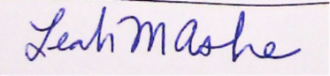

Leah M. Ashe

List of Appendices

Please find the zipped file of all appendices (whose contents I describe here) at this Google Drive Link: https://drive.google.com/open?id=1oywKVckF5bZYSd3H-dJVsuVoIn1RPnKR. The appendices included are:

Appendix A: Documents relating to Whipps Cross Hospital, where I was accidentally killed, then declared anorexic, and then subdued, disabled, and tortured by force-feeding before being sentenced to the anorexic detention center.
- A1: Quality Report for Whipps Cross University Hospital, substantiating my allegations of the generally and globally inadequate conditions (which might help to substantiate my truthful report here, despite what hospital records will say).
- A2: Report (dated 12 February 2014) from the Whipps Cross Hospital psychiatrist (Dr. Odusola) assigned to evaluate me before I lost consciousness. Note its key conclusion: that his “findings were not suggestive of anorexia nervosa.”
- A3: This is report of Dr. Wood, the gastroenterologist (in my home country, the USA) who diagnosed me with Crohn’s disease in 2005. Though my case of Crohn’s is not too bad, I do go through periods – such as the nine-month period of daily diarrhea preceding my visit to Whipps Cross Hospital in January 2014 – when it escalates to awful proportions of daily, explosive diarrhea and excruciating pain. (Or, in any case, it is pain I had thought to be excruciating before I came to be tortured in 2014; now I think of it as comparable to a stubbed toe).

Appendix B: Documents relating to the Priory Hospital, the anorexic detention center where I was viciously force-fed and more generally subjected to arbitrary detention and abuse at the command of the head psychiatrist.
- B1: My first request for an appeal hearing (tribunal) was granted 77 days after my arrival at The Priory, 26 August 2014. These are the questions I wrote and sent to the lawyer assigned to represent me at the tribunal. I suggested that she ask me these questions (“as a lawyer might”) so that I could answer with the truthful answers that ought to have exonerated me. She never reviewed the questions, never asked them at the trial, and, in any case, the judges allowed me to speak only very minimally. The lawyer later told me that she had prepared for the tribunal “in the car on the way over” (which I don’t imagine would have left her sufficient time or attention to even have read the questions, or much else about me).
- B2: The report that Dr. McCluskey delivered to the Tribunal #1, commented by me in preparation for the trial to show all of the false statements she was able to deliver – based on her position of authority and the epistemic or testimonial privilege that it granted her – to the tribunal. I was not permitted to deliver my commented version or my comments to the judges.
- B3: The decision from the first tribunal (dated 26 August). This document shows “how it – the granting of authorization and indemnity for abuse and torture – happens.” The psychiatrist’s word, even if it is a wholesale fabrication, is taken as truth; and my truthful word, despite its truth, is understood as the dissimulation of a madwoman. This is epistemic privilege – and punishment – at work.
- C1: My second request for appeal was granted (via a different appeal channel) on 19 September 2014. This is the text (that I delivered in writing to the judges of the second tribunal; they refused to let me speak it. Since the lawyer of the first hearing had proven so unprepared and unfamiliar with either me or my case, I chose to represent myself at this second hearing. I answered each of the psychiatrist’s accusations truthfully, which should have exonerated me, but – again it was epistemic privilege and power at play – my truth was taken as lie and the psychiatrist’s lie was taken as truth. I lost again.
- C2: This is the presentation that I had prepared for Tribunal #2; they refused to let me present it or deliver it otherwise. It shows pictures of me prior to my period of captivity engaged in my ordinary relationship with food (all the while continuing to have a skinny body that, as it turned out, was punishable under UK law). It also shows pictures of my extraordinary diarrhea, which escalated during the time of my incarceration (due, I imagine, to the abuse to which my insides were subjected there). I began to count the number of times I expelled diarrhea each day, and the number ranged from 10 to 15.
- C3: The tribunal decision from hearing #2. This decision, like the first decision, shows the epistemic privilege enjoyed and the reconfiguration of fact performed by the psychiatrist to continue detaining me. It also demonstrates the disesteeming discourse and a priori testimonial and personal demotion of the alleged anorexic subject.

D Documents produced by me to “try to explain how this could and can happen”:
- D1 (Ashe 2017a), D2 (Ashe 2017b), D3 (Ashe 2018a): These are my papers in the Knowing Violence series, my postdoctoral project over the past year. In it, I treat the absurd reality of what happened to me, and particularly its double knowing/violence relation: on one hand, the victim of torture comes to know violence, and this is not the same sort of knowledge as knowing math or knowing that that is an oak tree but something much, much profounder; and, on the other hand, there is a sort of violence that emanates from the presumptive act of knowing – the knowing-violence – and this is the seed violence from which psychiatrically authorized and socio-legally validated sequelae violences can ensue. I also treat the grotesque violence of force-feeding; see especially Ashe 2018 for a close examination of force-feeding’s brutality and history and a collection of statements from its historical victims.
- D4: A collection of photos showing several effects of my detention, disabling, and torture including:
  - My deformed nose (from the brutal and continuous force feedings);
  - The mat I sleep on each night, stained with the paralyzed urinations of so many nights’ terrors;
  - My damaged leg in different stages of healing. (I still cannot feel it, and sometimes it swells and explodes with puss, as in the photo dated August 15th.)

References Cited

AMA (American Medical Association). 2013. Statement on Force Feeding. Letter from AMA to Secretary of State Chuck Hagel. 25 April 2013. Available at https://www.jhsph.edu/research/centers-and-institutes/center-for-public-health-and-human-rights/_pdf/AMA%20Hunger%20Strikes%20Letter.pdf.

American Psychiatric Association: Diagnostic and Statistical Manual of Mental Disorders, 5th Ed. Arlington, VA, American Psychiatric Association, 2013.

Arendt, Hannah. 1994. Eichmann in Jerusalem: a report on the banality of evil. New York: Penguin Books.

Ashe, Leah M. (2018). “He, she, we, they, and it: The subjects of food and torture.” Presentation at International Conference on Food History and Cultures, Institut Européen D'Histoire et des Cultures de L'Alimentation (IEHCA), Tours, France, 7-8 June 2018. Available online in text (https://nd.academia.edu/LeahAshe) and video (https://www.youtube.com/user/lashend/) versions.

Ashe, Leah M. (2017b). “Knowing food, knowing men: Reflections on food, knowledge, and violence.” Presentation at L'Institut Européen D'Histoire et des Cultures de L'Alimentation (IEHCA) Université d'Été, Tours, France, 28 August – 2 September 2017. Video at https://youtu.be/jGTja5P0XFQ.

Ashe, Leah M. (2017a). “Knowing violence: Psychiatric hegemony and the corruption of care.” Presentation at the European Association of Social Anthropology - Medical Anthropology Network Conference, Lisbon, Portugal, 5-7 July 2017. Video at https://youtu.be/K32VKm2MgTM.

Chunn, D. & Menzies, R. 1990. Gender, madness and crime: the reproduction of patriarchal and class relations in a psychiatric court clinic. In Critical Criminology, 1:2, p.33.

Bhui, K., and Bhugra, D. 2003. Explanatory models in psychiatry. In British Journal of Psychiatry, 183, 170-175.

Barker, P and Stevenson, C. 2000. The Construction of Power and Authority in Psychiatry Oxford: Butterworth Heinemann

Fanon, F. 2004. The wretched of the earth. Trans. R. Philcox. New York: Grove Press.

Fassin, Didier. 2011. The trace: Violence, truth, and the politics of the body. Social Research. 78 (2): 281.

Fricker, Miranda. 1999. Epistemic oppression and epistemic privilege. Canadian Journal of Philosophy. 29 (sup1): 191-210.

Fricker, Miranda. 2007. Epistemic Injustice: Power and the Ethics of Knowing. Oxford: Oxford University Press.
Gordon, L. 2015. What Fanon Said. A philosophical introduction to his life and thought. New York: Fordham University Press.

Hepworth, J. 1999. The social construction of anorexia nervosa. London: Sage.

Jacobs, P. (2012). Force-feeding of prisoners and detainees on hunger strike: Right to self-determination versus right to intervention. Antwerpen: Intersentia. Ph.D. dissertation. Available at https://pure.uvt.nl/ws/files/3976329/Jacobs_Force_feeding_07_09_2012_emb_tot_07_09_2014.pdf.

Narvaez, D. (2010). Moral Complexity: The Fatal Attraction of Truthiness and the Importance of Mature Moral Functioning. Perspectives on Psychological Science, 5(2), 163-181.

Reyes, Hernán. 1998. Medical and Ethical Aspects of Hunger Strikes in Custody and the Issue of Torture. Extract from M. Oehmichen, ed., Maltreatment and Torture. Verlag Schmidt-Römhild, Lübeck, 1998. Available at https://www.icrc.org/eng/resources/documents/article/other/health-article-010198.htm.

Scott, R., & Bowling, T. 2015. Enteral tube feeding in adults. J R Coll Physicians Edinb 2015:45, pp. 49–54.

Scull, A. 1981. Madhouses, mad-doctors, and madmen: The social history of psychiatry in the Victorian era. Philadelphia: University of Pennsylvania Press.

WMA (World Medical Association). 2016. WMA Declaration of Tokyo - Guidelines for Physicians Concerning Torture and other Cruel, Inhuman or Degrading Treatment or Punishment in Relation to Detention and Imprisonment. Adopted 1975, Revised 2016. Available at https://www.wma.net/policies-post/wma-declaration-of-tokyo-guidelines-for-physicians-concerning-torture-and-other-cruel-inhuman-or-degrading-treatment-or-punishment-in-relation-to-detention-and-imprisonment/.

WMA (World Medical Association). 2017. WMA Declaration of Malta on Hunger Strikers. Available at https://www.wma.net/policies-post/wma-declaration-of-malta-on-hunger-strikers/. Adopted 1991, Revised 2017.

Evidence Photos

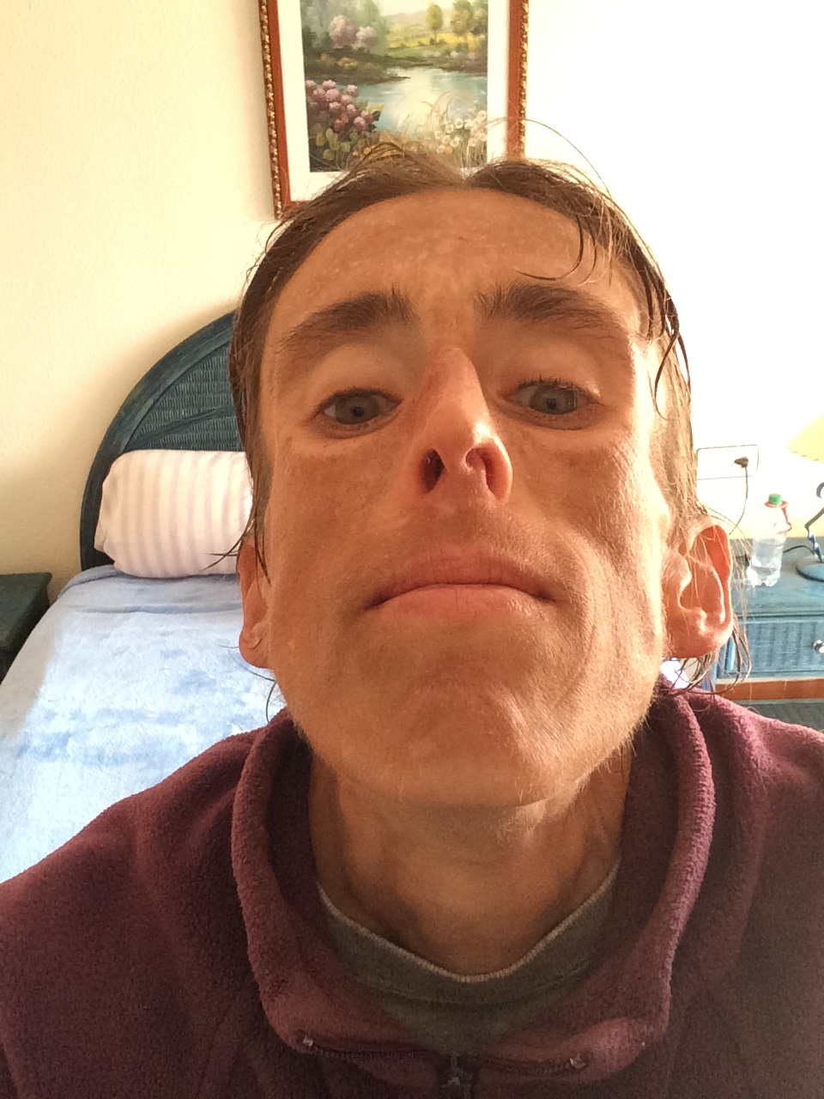  Five months of force-feeding left my nose like this. | 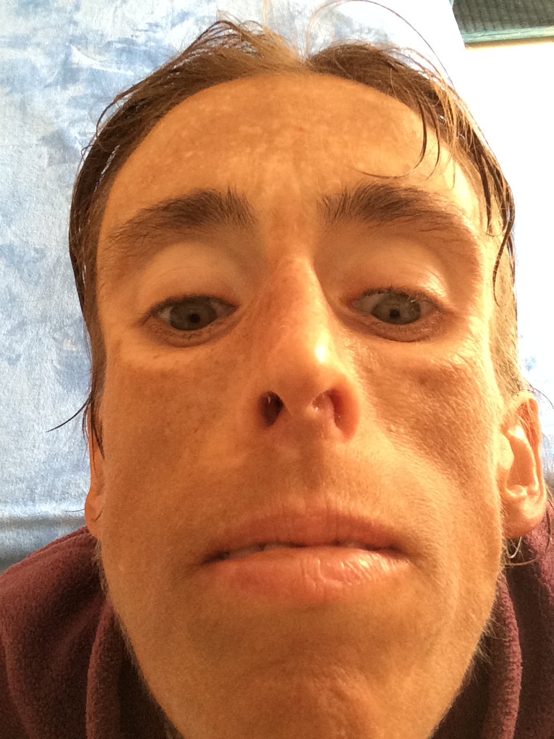
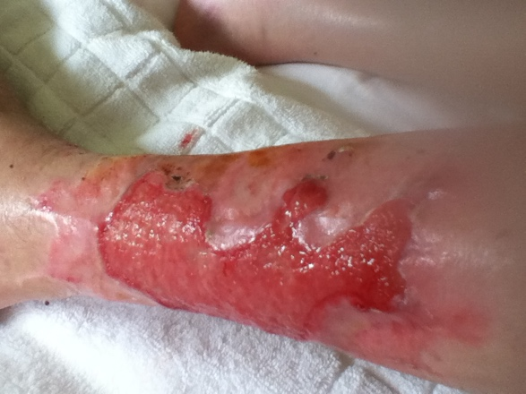  An enforced total immobility, the denial of all physical therapy, and that lack of basic sanitary care in the hospital transformed my formerly athletic left leg into a mostly feelingless, unresponsive appendage. The entire surface area from the ankle to the knee became an open wound that pulsed blood. This photograph is taken towards the end of my internment in the detention center. | 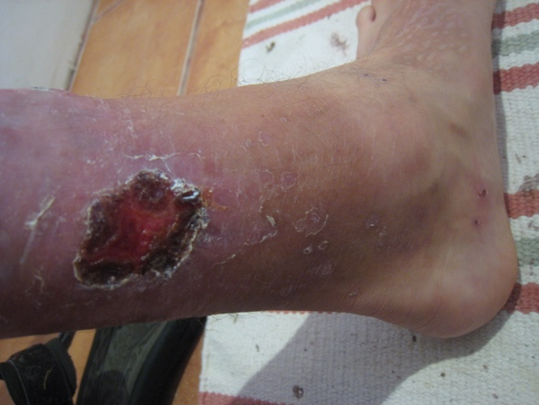  After escaping from the detention center, I was free to care for my leg wound in such a way that it covered entirely with new (if weak) skin, and I was free to “physical therapize myself” (which I did), recovering the ability to walk normally, climb stairs, and do something that approximates a running motion. (I used to love running and playing.) But I can’t feel my left leg between the ankle and the knee, and I have what I euphemistically call a “falling problem.” I can move it by “commanding” my muscles into motion (rather than “responding” or “intuiting” as a way of movement). And my leg sometimes swells and explodes, as in this photo.
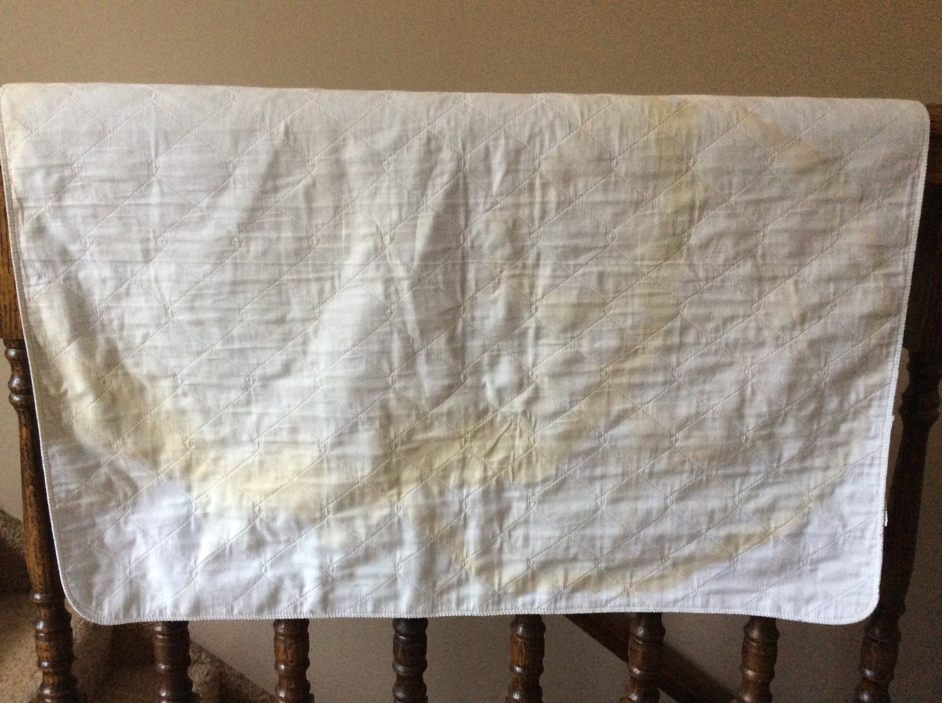 | I sleep on this mat every night, and now it is stained with urine from very many nights’ terrorized relivings in nightmare form of the experience I really lived in 2014.
Since they didn’t move me at all (when I was comatose) nor let me move (afterwards) for approximately four months in the hospital, I had bad bed sores all over. This is the “healed” bedsore on my back. When it was at its worst, it exposed the bone. I can sit and stand now with no problem, but I have difficulty sitting or standing for long periods of time. Instead I work slouched on a bed or couch with my computer on my lab and my legs up. | 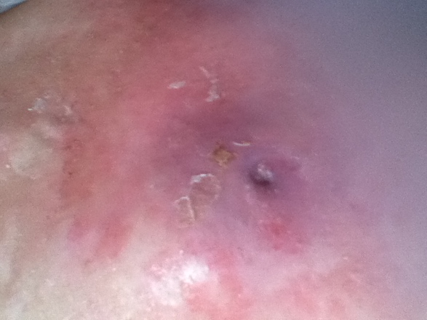
In the following boxes, I paste several pictures that might help you to believe my claim that I am not anorexic and that there really is “something else” that explains my skinny body – something inconceivable to the mind of a psychiatrist in the United Kingdom (or, indeed, in many other Western countries), formed cognitively and epistemically on the presupposition of the figure of the deceitful, wicked woman and operating with a current-day stereotype of the skinny woman as anorexic and mad. I don’t know what the “something else” is that causes my skinniness, and neither, evidently, do doctors; but not-knowing ought not justify the discriminatory, disabling, and torturous actions they delivered to and performed on me and that they likewise deliver to and perform on, in all ordinariness, other skinny women.
 | I have a lot of diarrhea. When I was being abused in the detention center, I began to count; the range was ten to fifteen episodes per day.
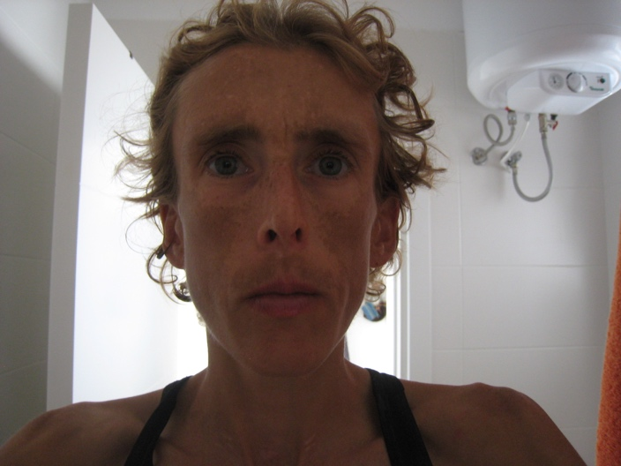 | 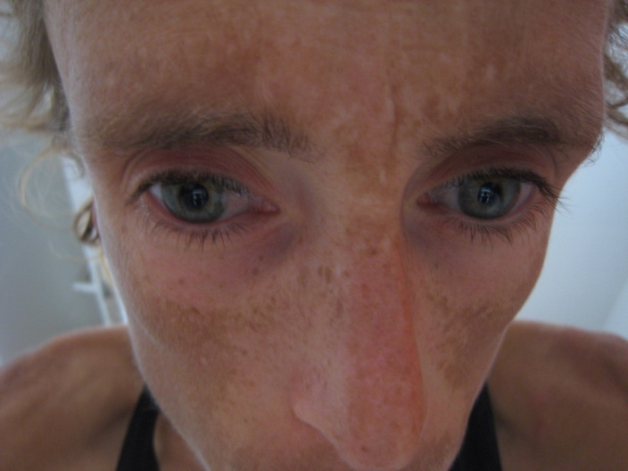  I have a strange facial discoloration. This is more or less apparent depending on the day. It is a pronounced line that makes it look as though I fell asleep while sunbathing and wearing a Venetian mask. (I neither sunbathe nor wear masks; nor do I wear sunglasses.) I suspect that this corresponds to some real biophysical phenomenon (perhaps the same one that accounts for my diarrhea, stomach pain, and skinniness).
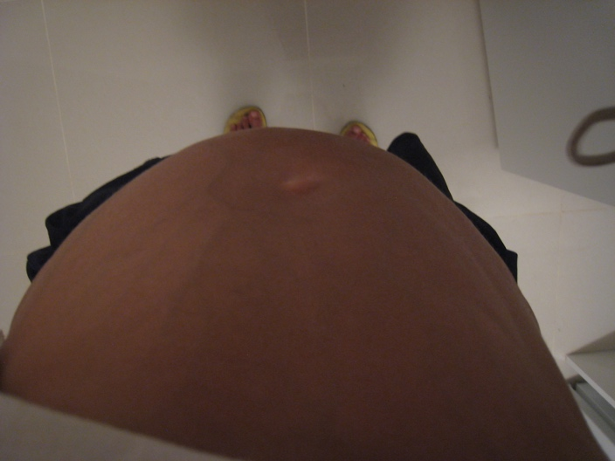  When I have an “attack” (of gastrointestinal pain and diarrhea), the pain is so intense that it makes my head spin, and, if I am in a situation that allows it, the only thing I can do is lie down and hope that it subsides. My stomach expands to several times its normal size, as in this photo. Interestingly, this often occurs after a very large diarrhea (rather than before it, as I would suspect). | 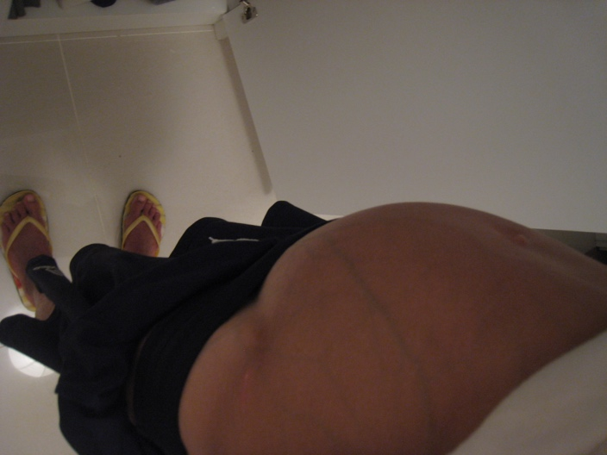

On the woman-specific character of eating disorder diagnosis, see especially Hepworth’s (1999) dated but good elaboration of the historical invention of anorexia as a phenomenon that derives directly from early modern truths about the inherent depravity of women; their translation into “hysteria”; and hysteria’s transformation in “anorexia.”
Note also that leaving nasogastric tubes installed for longer than four to six weeks is, in any case, against medical industry recommendation (Scott, 2015).
The World Medical Association (WMA, 2016, 2017), the International Committee of the Red Cross (Reyes, 1998), Physicians for Human Rights (PHR, 2013), and the American Medical Association (AMA, 2013) all issue declarations forbidding doctors to participate in the force feeding of prisoners without their consent.. The Declaration of Tokyo (WMA, 2016) holds that “where a prisoner refuses nourishment… he or she shall not be fed artificially,” and the Declaration of Malta (WMA, 2017), that: Forced feeding is never ethically acceptable. Even if intended to benefit, feeding accompanied by threats, coercion, force or use of physical restraints is a form of inhuman and degrading treatment. Equally unacceptable is the forced feeding of some detainees in order to intimidate or coerce other hunger strikers to stop fasting. The AMA (2013) adds that “every competent patient has the right to refuse medical intervention, including life-sustaining interventions” (AMA 2013). And the ICRC (Reyes, 1998) says: Doctors should never be party to actual coercive feeding, with prisoners being tied down and intravenous drips or esophageal tubes being forced into them. Such actions can be considered a form of torture, and under no circumstances should doctors participate in them, on the pretext of “saving the hunger striker’s life”. See Jacobs (2012) for a review of relevant international policies, conventions, and agreements and the scopes and limitations of each.

