

**Prison Reform Trust submission to the United Nation call for submissions: Women deprived of liberty**

**About the Prison Reform Trust**

The Prison Reform Trust (PRT) is an independent UK charity working to create a just, humane and effective prison system. We do this by inquiring into the workings of the system; informing prisoners, staff and the wider public; and by influencing Parliament, government and officials towards reform. PRT provides the secretariat to the All Party Parliamentary Penal Affairs Group and has an advice and information service for people in prison.

PRT has a longstanding interest in improving criminal justice outcomes for women and we are currently pursuing a strategy through our Transforming Lives programme, supported by the Big Lottery Fund, to reduce the unnecessary imprisonment of women in the UK.

We welcome the chance to respond to this call for evidence. We have not organised our submission according to the individual questions, but instead provide an overview response within our areas of knowledge and expertise which covers much of the ground. Please note that the figures presented in this response relate to England and Wales and not Scotland and Northern Ireland. Where relevant we refer to our publications, copies of which can be found on our website: [www.prisonreformtrust.org.uk/women](http://www.prisonreformtrust.org.uk/women)

**Women in prison in England and Wales**

The women’s prison population in England and Wales more than doubled between 1995 and 2010 - from under 2,000 women to over 4,000. The numbers have since declined significantly, from 4,144 women in September 2012 to 3,832 in September 2018.[1] These are snapshot figures, and the number of women received into prison for the first time each year either on remand or under sentence is much higher - around 9,000 women a year at the moment. The UK still has one of the highest rates of women’s imprisonment in western Europe.

Women are a small minority of those in the criminal justice system. They represent less than 5% of the prison population, and are easily overlooked in policy, planning, and services - they have been described as 'correctional afterthoughts'. More than 11 years have passed since the Corston Report on Women with Particular Vulnerabilities in the Criminal Justice System. This and many other inquiries and reports have all concluded that prison is rarely a necessary, appropriate or proportionate response to women who get caught up in the criminal justice system.

As can be seen from the graph below, a high proportion of women receiving an immediate custodial sentence in 2017 had been convicted of a non-violent offence, with 42% of women sentenced to prison for theft offences.

**Women who received an immediate custodial sentence by offence group, 2017**

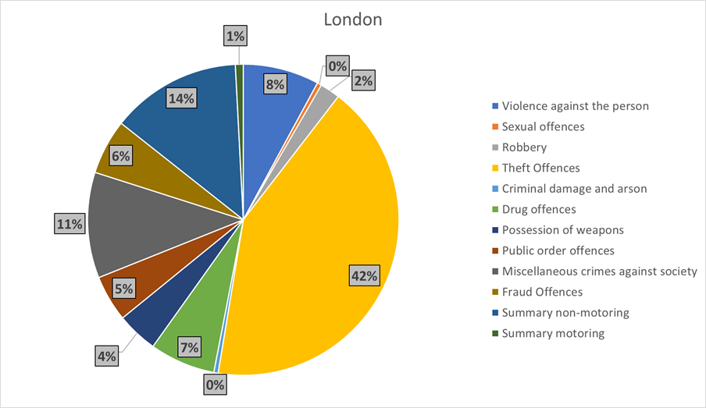

Source: Ministry of Justice statistics

In 2015 TV licence evasion accounted for 36% of all prosecutions for women, but only 6% for men. 70% of the 189,349 defendants prosecuted for TV license evasion in that year were women.[2]

One significant driver of women’s imprisonment is recall to prison. This has risen exponentially since the introduction of compulsory twelve-month supervision for all those released from prison following a short prison sentence, as part of the UK government’s Transforming Rehabilitation reforms to probation services which are now subject to a government consultation.[3] In the period from January to March 2018, 440 adult women were recalled back to prison, a 15% increase on the same period for the previous year.[4]

**Legal framework for a gendered approach**

Treating women and men equally does not mean that everyone should be treated the same. Where the circumstances and needs of women and men are different, distinct approaches may be required to achieve equitable outcomes and the Equality Act 2010 allows women only or women-specific services. The public sector equality duty requires public services, including those delivered by the private and voluntary sector, to assess and meet the different needs of women and men. However, the House of Commons Justice Select Committee concluded in 2013 that “the duty does not appear to have had the desired impact on the provision of gender specific services, or on broader policy initiatives.”

Section 10 of the Offender Rehabilitation Act 2014 amended the Offender Management Act 2007 to give women’s services a statutory foothold, placing a duty on the Secretary of State for Justice to ensure that arrangements for supervision or rehabilitation identify specific need and so make appropriate provision for women.

The UK is a signatory to the United Nations Rules for the Treatment of Women Prisoners and Non-Custodial Measures for Women Offenders (the Bangkok Rules) which require that the distinctive needs of women be recognised. The rules stress the importance of providing physical and psychological safety for women, and mandate the provision of diversionary measures and sentencing alternatives, “taking account of the history of victimisation of many women offenders and their caretaking responsibilities.”

The United Nations Committee for the Elimination of Discrimination Against Women has raised concerns about the levels of incarceration of women in the UK for minor offences and recommended the adoption of ‘alternative…custodial strategies, including community interventions and services’ for women accused of minor offences.[5]

The UN Special Rapporteur on Violence Against Women visited the UK in 2014 and raised concerns over the disproportionate number of black and minority ethnic women in prison, the number of women who have been subjected to violence prior to their imprisonment, and the number of young women who are incarcerated. She called for the development of “gender-specific sentencing alternatives” and recognition of “women’s histories of victimisation when making decisions about incarceration.”

**Female offender strategy and guidance**

The UK government’s female offender strategy, published in June 2018 after a two-year delay, lays out the case for taking a gender specific approach to women who offend or are at risk of offending and for using community solutions to tackle minor offending by women and has been widely welcomed.[6] The strategy makes detailed commitments to improve the treatment of women in contact with the criminal justice system. It was published alongside new police guidance on working with vulnerable women[7] and is set in the context of the government’s commitment to developing an evidence-based whole system approach for women offenders on which guidance is also provided.[8] The common underlying causes of offending for women, including domestic abuse, poverty, homelessness, mental health needs and problematic substance use, are acknowledged and proposals set out for improving the criminal justice response to these challenges.

**Lack of resources**

These documents mark a serious attempt by the UK government to take proper account of the vulnerability of many women offenders and how this contributes to their offending and, crucially, to promote the use of community solutions rather than custody wherever possible. Realising these aims could transform the lives of many women and their children. However the limited resources allocated to support women’s community services, and the lack of a timetable to drive progress, remain of concern. Without sufficient resources, the government’s ambitions cannot be realised.

**Specific needs and characteristics of women in contact with the criminal justice system**

Women in prison in the UK have often been victims of much more serious offences than the ones they are accused of committing. More than half (53%) report having experienced emotional, physical or sexual abuse as a child compared to 27% of men.[9] 57% of women report having been victims of domestic violence.[10] Because many women fear disclosing abuse, both figures are likely to be an underestimate.[11] Women can become trapped in a vicious cycle of victimisation and criminal activity. Their situation is often worsened by poverty, substance dependency or poor mental health.[12]

Women are more likely to be sent to prison for a first-time offence, 22% of women have no previous convictions compared to 12% of men.[13] Women’s offences are more likely than men’s to be prompted by their relationships. With 48% of women, compared to only 22% of men, saying that they had committed offences to support someone else’s drug use.[14]

The specific needs of women in contact with the criminal justice system in the UK, detailed in the Corston report and studies both before and since and now acknowledged by the UK government, are briefly summarised below and are considered in detail in a number of recent PRT publications (see web link above):

* The best interests of children continue to be overlooked in criminal justice decisions concerning the diversion and sentencing of mothers in contact with the criminal justice system, with devastating consequences.[15] Positive developments include the dissemination of training for judges, magistrates and probation workers using resources developed to raise awareness of the impact of maternal imprisonment.[16]
* David Lammy MP’s review of racial bias in the criminal justice system highlighted disparities in police treatment of women and girls from ethnic minorities.[17] Recent reports by the Prison Reform Trust, Agenda and Women in Prison encourage a focus on the intersectional discrimination experienced by Black, Asian and minority ethnic women and girls in the criminal justice system.[18]
* Trauma-informed approaches are needed throughout the criminal justice process given the high levels of experience of abuse amongst women in contact with the criminal justice system.[19] Greater attention is also required to ensure the links between abuse and coercion and women’s offending are fully taken into account in proceedings.
* As highlighted in recent research by the Prison Reform Trust and Hibiscus Initiatives[20], foreign national women and trafficked women have distinct needs that require a particular approach, not least improvements in the provision of foreign language information and female interpreters. There is a continuing failure to identify victims of trafficking and ensure they are not prosecuted for offences which they were compelled to commit.

**Prison Reform Trust**

**October 2018**

**For further information please contact Katy Swaine Williams, Senior programme manager:** [katy.swainewilliams@prisonreformtrust.org.uk](mailto:katy.swainewilliams@prisonreformtrust.org.uk) / 020 7251 5070

1. Ministry of Justice Population Bulletins: www.gov.uk/govermment/statistics/
2. Ministry of Justice (November 2016), Women in the Criminal Justice System 2015
3. <https://www.gov.uk/government/publications/2010-to-2015-government-policy-reoffending-and-rehabilitation/2010-to-2015-government-policy-reoffending-and-rehabilitation> See also: https://www.parliament.uk/business/committees/committees-a-z/commons-select/justice-committee/news-parliament-2017/transforming-rehabilitation-report-published-17-19/
4. NOMS Prison Receptions January-March 2018. https://www.gov.uk/government/statistics/offender-management-statistics-quarterly-january-to-march-2018
5. CEDAW C/GBR/CO/7: Committee on the Elimination of Discrimination Against Women - Concluding observation on the seventh periodic report of the United Kingdom of Great Britain and Northern Ireland, 30 July 2013
6. Ministry of Justice (2018) Female Offender Strategy, London: MoJ
7. Ministry of Justice (2018) Managing Vulnerability: Women – Fact pack, London: MoJ
8. Ministry of Justice (2018) A Whole System Approach for Female Offenders – Emerging evidence, London: MoJ
9. Ministry of Justice (2012) Prisoners’ childhood and family backgrounds, London: MoJ
10. Data Extracted from OASYS, In Thinking differently about female offenders. Transforming rehabilitation, Guidance Document. MOJ/NOMS 2014
11. Gelsthorpe, L., Sharpe, G., and Roberts, J. (2007) Provision for Women offenders in the community London: Fawcett Society
12. Janet Loveless (2010) Domestic Violence, Coercion and Duress, Criminal Law Review, pp. 1-3
13. Light, M., Grant, E. and Hopkins, K. (2013) Gender differences in substance misuse and mental health amongst prisoners, London: MOJ
14. Ibid
15. Prison Reform Trust (2018) What About Me? The impact on children where mothers are involved in the criminal justice system, London: PRT
16. PRT (2018) New resources launched to highlight impact of maternal imprisonment on 17,000 children a year, London: PRT
17. Lammy, D. (2017) The Lammy Review: An independent review into the treatment of, and outcomes for, Black, Asian and Minority Ethnic individuals in the criminal justice system, London: MoJ
18. Prison Reform Trust (2018) Counted Out: Black, Asian and Minority Ethnic Women in the Criminal Justice System, London: PRT; Agenda and Women in Prison (2016) Double Disadvantage: The experiences of Black, Asian and Minority Ethnic Women in the Criminal Justice System, London: Agenda and Women in Prison
19. Prison Reform Trust (2018) There’s a reason we’re in trouble – Domestic abuse as a driver to women’s offending, London: PRT
20. Prison Reform Trust (2018) Still No Way Out: Foreign national women and trafficked women in the criminal justice system, London: PRT