Questionnaire on “Women’s Human Rights in the Changing World of Work”

Core questions - What are the main trends influencing women’s human rights in the world of work in your national context and their impact?

On the types of and quantity work available to women, and the quality and conditions of work, including access to social protection and equal pay

* The employment rate among women in Sweden is high. In fact, Sweden has the next highest employment rate among women of all OECD countries. See table 1.
* Women’s employment rate is lower than men’s employment rate. This can mainly be explained by a low employment rate among foreign-born women, particularly women born outside of Europe. In 2018, 26 percent of all women (aged 20-64) born outside of Europe did not participate in the labour market, compared to 14 percent among men born outside of Europe.
* About one forth (27%) of all employed women in Sweden work part time. The proportion of part-time female workers in Sweden is lower than the OECD average.
* In 2018, women’s pay was 89,3 percent of men’s pay (10,7 % gender pay gap). Since 2007, the gender pay gap has decreased from 16,7 to 10,7. The main explanation to the pay gap is that women and men to a great extent work in different sectors and professions.

1. Employment rate, women and men (15-64 years)



1. Part-time work (women and men)

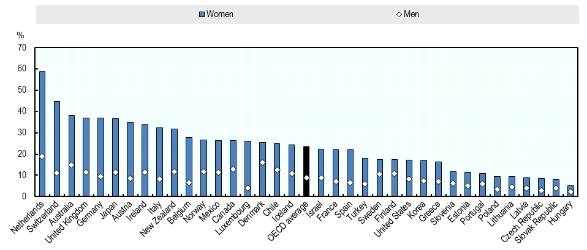

For women’s safety (including violence and sexual harassment) at work?

* The ground-breaking Metoo-movement has also showed that discrimination against women and girls continues. Sweden as well as all other countries, need to demand zero tolerance, and work hard to ensure that sexual harassment and abuse will not happen.
* In order to achieve gender equality, we need the commitment of all men. Men need to be engaged, show solidarity and participate in the struggle and process of change. Gender power relations and traditional gender stereotypes hinder the empowerment of women and girls. In addition, inhibitive stereotypes on men and masculinity are key obstacles for men.
* Men’s violence against women is one of the ultimate expressions of inequality between women and men. This violence must stop. Preventing and combating violence and other abuse against women and girls is a top priority for Sweden.

On women’s rights to (organize and) claim rights?

According to the Swedish Discrimination Act an employer, who becomes aware that an employee considers that he/she has been subjected to harassment or sexual harassment, is obliged to investigate the circumstances surrounding the harassment and where appropriate take the measures that can reasonably be demanded to prevent harassment in the future.

What are the promising practices emerging from your country to ensure the realization of women´s rights to work and women’s rights at work, in the context of technological and demographic change, as well as continuing globalization and the shift towards sustainability? (laws, economic, labour market and social policies; programs).

In order to achieve gender equal power and influence, the government actively promotes gender balance in public decision-making (boards of central public administration, appointment of director generals, ambassadors, etc.).

For instance, the Swedish Discrimination Act has been revised in order for employers to promote an even distribution of women and men in different types of work, in different categories of employees and in leading positions, through education, through other skills development and through other appropriate measures (entered into force in 2016).

Specific questions /Technology

How is technological change impacting on women’s experiences of work in your national context?

*General*

The ongoing digital transformation may strengthen the position of women in the labour market. More flexible ways of working can contribute to making it easier to combine paid work with care responsibilities, but it can also contribute to cementing the division of labour between women and men as pertains to the care of children and the unpaid work at home. Automation will affect to a greater extent less qualified jobs, which gives women an advantage due to their higher participation rate in educational activities, compared to men.

According to the OECD, however, women and men have just as much to gain and lose on the new digital technology. Women can benefit from increased flexibility in the work, but the use of new non-traditional work arrangements can also reduce the quality of work. Automation has so far been most common in sectors such as agriculture and manufacturing, where many men work. In the future, automation will most likely spread to all sectors and most professions, including those traditionally dominated by women.

The number of jobs is likely to increase in business, health, education and social services, i.e. several sectors that have traditionally been dominated by women. At the same time, remaining gender differences in the choice of educational programs may imply that women will be able to benefit less from new jobs that will arise in STEM-related professions (short for *Science, Technology, Engineering, Mathematics*).

*Launch of a Nordic project: why do so few girls want to become engineers?*

Many future jobs will be centred around digitalisation, the development of artificial intelligence and robots, and biotechnology. But far too few girls chose to study the subjects that are relevant to these areas. The Nordic labour ministers want to know why.

The Nordic Council of Ministers for Labour meeting in Reykjavik on 3rd April decided to grant money to a project which will study the education institutions and the labour market.

The research project will focus on how the labour market promotes sustainability and gender equality within STEM jobs (short for Science, Technology, Engineering and Mathematics). Do the social partners promote inclusive working environments? What are the career paths? And can you combine the occupations with family life?

The project will be run by the Nordic Council of Ministers’ co-operative body NIKK (Nordic information for knowledge about gender). It is expected to be finished by the end of 2020. The project also includes a comparative study within the Nordic region and beyond – how do countries outside of the Nordic region approach the recruitment bias within the STEM area?

What are some of the good practices for supporting women to benefit equally from technological advances? (laws, economic and social policies, institutional measures, regulation, actions by employers)

(Stärkt digital kompetens i läroplaner och kursplaner)

Digital competence and digital confidence are both keys to achieving an equal and active citizenship. Hence, it is a key action to create digital competence as well as digital confidence from an early age to ensure that girls and boys, young women and men have equal opportunities in an increasingly digital society.

In March last year, the Swedish Government decided on a package of measures regarding primary school and secondary school. The aim is to strengthen the digital competence in the curricula of primary and secondary school as well as in upper secondary school. In that way we will:

* strengthen the conditions for a national unity regarding education,
* improve the quality of education,
* support girls’ and boys’, young women’s and men’s active participation in an increasingly digitalised working life and society.

The changes mainly concern the tasks and responsibilities of headmasters and teachers, the role of school libraries as well as the teaching of school subjects. Among the improvements:

* Programming is introduced in several subjects, primarily in the subjects of mathematics and technology.
* Pupils will be better equipped to be critical of sources.
* Pupils will work with digital texts, media and tools.

In August 2018, the Swedish Government decided on amendments also to the curriculum for preschools. With a focus on developing better understanding for the digitalisation in girls’ and boys’ everyday life and with a special focus on developing a critical and responsible outlook on digital technology.

These measures are all together important actions to build equal preconditions for the future for boys and girls, young women and men, enabling them to participate in and contribute to society and to ensure that they enjoy the same opportunities, rights and obligations in all areas of life.