CHECK AGAINST DELIVERY

STATEMENT

UNITED NATIONS SPECIAL RAPPORTEUR ON VIOLENCE
AGAINST WOMEN, ITS CAUSES AND CONSEQUENCES

DUBRAVKA SIMONOVIC

30th session of the Commission on Crime Prevention and Criminal Justice

17-21 May 2021

Vienna, Austria

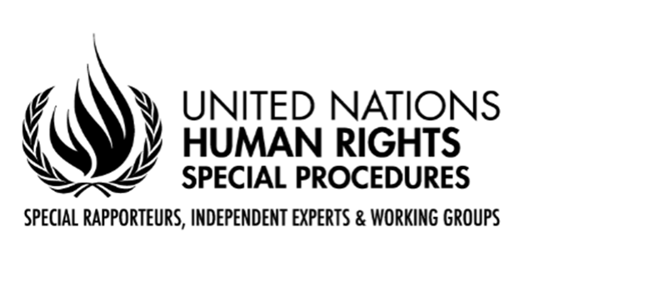

Excellences,
Distinguished delegates,
Chairperson,

It is an honour for me to address you as UN Special Rapporteur on violence against women, and to present my work on two issues of particular relevance to this Commission: femicide and rape.

Distinguished delegates,
The issue of femicide, or gender-related killings of women, has been a thematic priority throughout my tenure.
In 2015, I issued a call to States to establish a “femicide watch”. In 2016, I elaborated a report to the General Assembly on the modalities for establishing such preventive mechanisms and their mandates to conduct analyses of femicide cases from a human rights perspective in order to identify gaps at the national level and to recommend measures for the prevention of femicide.
Since then, I have made yearly calls for information on femicide watches, which are tools for the implementation of the General Assembly resolutions on gender-related killings of women, elaborated by this Commission in 2013 and 2015.
The UNODC Report of 2019 and data collected by my mandate reveal that the vast majority of victims killed by an intimate partner are women, at 82 percent.
I welcome the initiative by UNODC and UN Women to develop a Common Statistical Framework on Gender-Related Killings of Women and Girls, now under consultations, and have provided my inputs to it. It is important to connect this with my Femicide watch initiative.
I take this opportunity to call on all States that have not yet created their femicide watches to do so.
National Institutes of Criminology that follow the work of this Commission can also play an important role in establishing and strengthening such observatories.
I intend to present a follow up femicide watch report to the 76th session of the UN General Assembly.

Ladies and gentlemen,
Let me now briefly refer to my upcoming report on rape as a human rights violation, a crime and a manifestation of gender-based violence against women and girls, both in peacetime and during conflict, with a focus on States’ responsibility to prevent it, to change the prevalent rape culture, culture of impunity for perpetrators and stigmatization of victims.
I call on States to harmonize provisions on the criminalization and prosecution of rape with international human rights and criminal law standards, and to explicitly include lack of consent in their definitions of rape. I also call on States to abolish statutes of limitation for the prosecution of rape in peace and in conflict. As a harmonization tool, I am preparing the Framework for Model Legislation on Rape, which will be annexed to my report to the Human Rights Council.

Distinguished delegates,
In conclusion, I call on this Commission to include violence against women as a permanent and specific agenda item, which should be addressed yearly by its Members.

Thank you

