Questionnaire on criminalization and prosecution of rape
Definition and scope of criminal law provisions

- Please provide information on criminal law provision/s on rape (or analogous forms of serious sexual violence for those jurisdictions that do not have a rape classification) by providing full translated transcripts of the relevant articles of the Criminal code and the Criminal procedure code.
Article 153. of the Criminal Code of Croatia
RAPE
- Whoever, without consent, commits sexual intercourse or an equivalent sexual act with another person or induces another person to perform sexual intercourse or an equivalent sexual act with a third person without his consent, or to perform sexual intercourse with himself without his consent or an equal sexual act, shall be punished by imprisonment for a term between one and five years.
- Whoever commits the act referred to in paragraph 1 of this Article by using force or threatening to directly attack the life or body of a raped or other person, shall be punished by imprisonment for a term between three and ten years.
- The perpetrator who was in a remediable misconception regarding the existence of the consent referred to in paragraph 1 of this Article shall be punished by imprisonment for a term not exceeding three years.
- The perpetrator who was in a remediable misconception regarding the existence of the consent referred to in paragraph 2 of this Article shall be punished by imprisonment for a term between one and five years.
- The consent referred to in paragraph 1 of this Article exists if the person voluntarily decided to have sexual intercourse or a sexual act equated with it and was able to make and express such a decision. Such consent shall be deemed not to exist, in particular if sexual intercourse or a sexual act equated with it was committed with the use of threats, fraud, abuse of position towards a person who is dependent on the perpetrator, exploitation of the person's condition for which he/she was unable to express his/her refusal or over a person who has been unlawfully deprived of his liberty
SERIOUS CRIMES AGAINST SEXUAL FREEDOM
Article 154
(1) Whoever commits the offense referred to in Article 153, paragraph 1 of this Act shall be punished by imprisonment for a term between three and ten years:
1. towards a close person, (Article 87 defines a close person as: “(8) Family members are a spouse or common-law partner, life partner or informal life partner, their joint children and the children of each of them, blood relative in the direct lineage, relative in the collateral line up to the third degree, in-law relatives up to the second degree , adopter and adoptee.) (9) Close persons are family members, former spouse or common-law partner, former life partner or informal life partner, persons who have a joint child and persons living in a joint household.”
2. to a victim who is particularly vulnerable due to his or her age, illness, addiction, pregnancy, disability, severe physical or mental impairment,
3. in a particularly cruel or particularly degrading manner,
4. out of hatred,
5. together with one or more perpetrators, whereby several sexual intercourses or equivalent sexual acts have been committed against the same person,
6. with the use of weapons or dangerous tools,
7. in such a way that the raped person is seriously injured or has become pregnant.
(2) Whoever commits the act referred to in Article 153, paragraph 2 of this Act under the circumstances referred to in paragraph 1 of this Article, shall be punished by imprisonment for a term of five to fifteen years.
(3) If the criminal offense referred to in Article 153, paragraphs 1 and 2 of this Act has caused the death of a raped person, the perpetrator shall be punished by imprisonment for a term not less than five years.
SEXUAL FORNICATION (or LEWD ACT)
Article 155
(1) Who under the conditions referred to in Article 153, paragraphs 1, 3 and 5 of this Act, when no attempted criminal offense has been committed, commits a sexual fornication, shall be punished by imprisonment for a term not exceeding two years.
(2) Who under the conditions referred to in Article 153, paragraphs 2 and 4 of this Act, when no attempted criminal offense has been committed, commits a sexual fornication, shall be punished by imprisonment for a term not exceeding three years.
(3) Whoever, under the conditions referred to in Article 154 of this Act, when no attempted criminal offense has been committed, commits a sexual fornication, shall be punished by imprisonment for a term between six months and five years.
- Based on the wording of those provisions, is the provided definition of rape:
  - Gender specific, covering women only YES/NO - NO
  - Gender neutral, covering all persons YES/NO – YES
  - Based on the lack of consent of victim YES/ NO – YES
  - Based on the use of force or threat YES/ NO – NO
  - Some combination of the above. YES / NO – YES
  - Does it cover only vaginal rape? YES /NO – NO
  - Does it cover all forms of penetration? YES/NO. If yes, please specify. – YES. The provision say: “sexual intercourse or an equivalent sexual act”
  - Is marital rape in this provision explicitly included? YES / NO - YES
  - Is the law silent on marital rape? YES/NO - NO
  - Is marital rape covered in the general provisions or by legal precedent even if it is not explicitly included? YES/NO – NO
  - Is marital rape excluded in the provisions, or is marital rape not considered as a crime? YES /NO –NO
- Are there any provisions excluding criminalization of the perpetrator if the victim and alleged perpetrator live together in a sexual relationship/have a sexual relationship/had a sexual relationship? If so, please submit it.
NO
- What is the legal age for sexual consent?
15 years
- Are there provisions that differentiate for sexual activity between peers? If so, please provide them.
NO
- Provide information on criminal sanctions prescribed and length/duration of such criminal sanctions for criminalized forms of rape.
SANCTIONS AND THEIR LENGTH ARE CONTAINED ABOVE IN THE ARTICLES OF THE CRIMINAL CODE
- What does the legislation in your country provide in terms of reparation to the victim of rape and/or sexual violence after conviction of the perpetrator?
THERE IS CRIME VICTIMS COMPENSATION ACT (BROCHURE ON CRIME VICTIMS COMPENSATION ATTACHED). THERE IS ALSO SPECIAL ACT ON DAMAGE COMPENSATION TO THE VICTIMS OF SEXSUAL VIOLENCE COMMITTED DURING HOMELAND WAR.
Aggravating and mitigating circumstances
- Does the law foresee aggravating circumstances when sentencing rape cases? If so, what are they?
  - Is rape by more than one perpetrator an aggravating circumstance? YES/NO - YES
  - Is rape of a particularly vulnerable individual an aggravating circumstance, or the imbalance of power between alleged perpetrator and victims? (for example, doctor/patient; teacher/student; age difference) YES/NO - YES
  - Is rape by spouse or intimate partner an aggravating circumstance? – YES

- Does the law foresee mitigating circumstances for the purposes of punishment? YES/NO If yes, please specify. – YES
Sentencing
Article 47
(1) When choosing the type and measure of punishment, the court shall, starting from the degree of guilt and purpose of punishment, assess all circumstances that affect the punishment by type and measure to be lighter or heavier (mitigating and aggravating circumstances), and especially the severity of endangering or violating the protected good. , the motives for the crime, the degree of violation of the perpetrator's duties, the manner of commission and the wrong effects of the crime, the perpetrator's previous life, his/her personal and property circumstances and his behavior after the crime, attitude towards the victim and efforts to compensate damage.
(2) The amount of the penalty may not exceed the degree of guilt.
Mitigation of punishment
Article 48
(1) The court may impose a sentence less severe than prescribed for a certain criminal offense when the law explicitly prescribes.
(2) A lesser punishment than prescribed for a certain criminal offense may also be imposed when there are particularly mitigating circumstances, in particular if the perpetrator has reconciled with the victim, if he has fully or largely compensated the damage caused by the criminal offense or seriously tried to compensate, the purpose of punishment can be achieved by such a milder punishment.
(3) A milder punishment than prescribed for a certain criminal offense may also be imposed when the state attorney and the defendant have agreed on it.
Limits of mitigation of punishment
Article 49
(1) The court may commute the sentence in accordance with Article 48, paragraphs 1 and 2 of this Act within the following limits:
1. if the criminal offense is punishable by a minimum term of imprisonment of ten years, the sentence may be reduced to three years,
2. if the criminal offense is punishable by a minimum term of imprisonment of five years, the sentence may be reduced to two years,
3. if the criminal offense is punishable by a minimum term of imprisonment of three years, the sentence may be reduced to one year,
4. if a minimum term of imprisonment of one year is prescribed for a criminal offense, the sentence may be reduced to six months,
5. if the criminal offense is punishable by a minimum term of imprisonment of six months, the sentence may be reduced to three months.
(2) In the case referred to in Article 48, paragraph 3 of this Act, the sentence may be reduced to half of the minimum sentence obtained by mitigation under the provisions of paragraph 1 of this Article, but may not be less than three months imprisonment.
- Is reconciliation between the victim and the perpetrator allowed as part of a legal response? YES/NO If so, at what stage and what are the consequences? - NO
  - Regardless of the law, is reconciliation permitted in practice? YES/NO and what is the practice in this regard?
We have no data or information on the practice in this regard
- Is there any provision in the criminal code that allows for the non-prosecution of perpetrator? YES/NO If yes, please specify. - NO
  - if the perpetrator marries the victim of rape? YES/NO - NO
  - if the perpetrator loses his “socially dangerous” character or reconciles with the victim? YES/NO - NO
Prosecution
- Is rape reported to the police prosecuted ex officio (public prosecution)? YES/NO
YES
- Is rape reported to the police prosecuted ex parte (private prosecution)? YES/NO
NO
- Are plea bargain or “friendly settlement” of a case allowed in cases of rape of women? YES/NO
YES but in the case of criminal offenses against life and body and against sexual freedom for which a prison sentence prescribed is over five years the public prosecutor must obtain the victim's consent for friendly settlement.
- Are plea bargain or “friendly settlement” of a case allowed in cases of rape of children? YES/NO
NO
- Please provide information on the statute of limitations for prosecuting rape.
10 YEARS
- Are there provisions allowing a child who was the victim of rape and to report it after reaching adulthood? YES/NO
YES
- Are there mandatory requirements for proof of rape, such a medical evidence or the need for witnesses? YES/NO If yes, please specify.
NO
- Are there rape shield provisions aimed at preventing judges and defense lawyers from exposing a woman’s sexual history during trial? YES/NO
NO
- Are there procedural criminal law provisions aimed to avoid re-victimizations during the prosecution and court hearings? YES/NO. If yes, please specify.
YES. Public can be excluded from the certain court hearing, testimony can be given through video link.
War and/or conflict
- Is rape criminalized as a war crime or crime against humanity? YES/NO
YES
- Is there a statute of limitations for prosecuting rape in war or in conflict contexts? YES/NO
NO
- Is there explicit provisions excluding statutes of limitation for rape committed during war and armed conflict? YES/NO
YES
- Has the Rome Statute of the International Criminal Court (ICC) been ratified? YES/NO
YES, in april 2001
- Please provide data on the number of cases of rape that were reported, prosecuted and sanctioned, for the past two to five years.
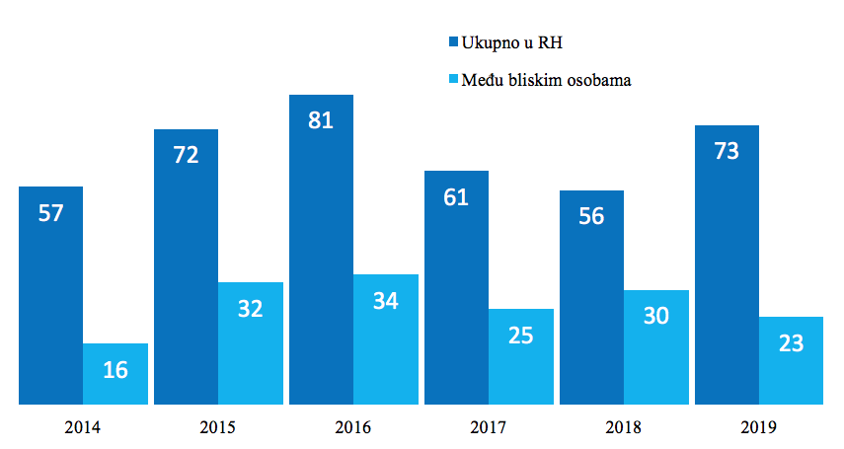
Darker blue – total number of rape cases
Lighter blue – out of total number of rape cases number of rape cases registered between close persons (see definition of a close person above)
Other
- Please explain any particular and additional barriers to the reporting and prosecution of rape and to the accountability of perpetrators in your legal and social context not covered by the above.
Despite the satisfactory legal frame in place, in practice, prosecutions and trials of the rape cases in Croatia are not yet gender sensitive to the extent jurisprudence could be assessed as fully in line with the best international standards. This is mostly due to a significant lack of systematic education of judges and prosecutors on the gender based crimes and sexual crimes against women.

