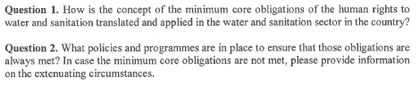
Right to drinking water as a relatively new human right was incorporated in The Constitution of the Republic of Slovenia on November 25, 2016. Before the amendment was adopted, the right to drinking water was treated as a part of the right to healthy living environment. Right to drinking water was already highly protected in national Water act for more than a decade. Water supply is organized on the basis of the mentioned law in public domain with only few exceptions.
First paragraph of the article 70 a of the Constitution determines that everyone has the right to drinking water. It is very simple rule with potential impact on everyone, who is under Slovenian jurisdiction. Second paragraph determines that water resources shall be a public good managed by the state and is connected with third paragraph, which determines that water resources shall be used to supply the population with drinking water as a priority and shall not be a market commodity. Concessions or other exclusive rights granted to any company for water supply are prohibited by the fourth paragraph of the 70 a article of the Constitution of the Republic of Slovenia.
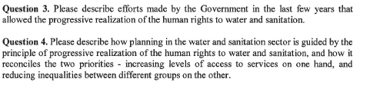
With amendment to the Constitution of the Republic of Slovenia the right to water is ensured on the highest legal level. This act represents important strategic message in the present time when the questions of water resources and water supply become more and more global.

On the basis of Article 70 a of the Constitution of the Republic of Slovenia:
- everyone has the right to drinking water
- water resources are public good within the state management
- water resources are preferentially and sustainably used for the supply of its inhabitants with drinking water and the supply of households and in this section they don't represented a market commodity
- drinking water supply for the population and the water supply for the household is guaranteed by the state through local authorities directly and on non-profit basis.

The state manages the water sources, including the protection of these sources. Water resources are described as actual and potential on the basis of their adequacy for drinking water supply of the population. The state is also in charge for the monitoring of water status, takes care for preventing and diminishing water pollution, encourages sustainable use of water, protects the water environment, promote the situation of natural water sources and secures the necessary preventive measures.

At the moment, the amendment to the Constitution of the Republic of Slovenia is not yet fully implemented, but the main idea is to provide drinking water in all circumstances under the same conditions to everyone.

The present water and environmental legislation already includes institutes related to:
- prioritized use of water for drinking water supply,
- water is natural public good which is not in the ownership of anyone, not even of the state which only manages it
- the proprietor of the water right for public water supply with drinking water can be only local community or the state,
- stipulates the general use of water,
- special use of water is possible exclusively through obtaining the water right,
- possibility of the interference of the water right in case of endangering the drinking water supply (limiting the use or deprivation of the right),
- water rights include time limitations,
The Government also strives to conserve the water resources, including access to drinking water by completing the water supply network and efficiently organizing the waste water treatment as well as by delineating drinking water safeguard zones and defining adequate protection.

In order to adjust the legislation in the domain of water with the Constitution a special Intergovernmental Working Group was established. Among its key tasks were review of the legislation, preparing the list of the necessary changes, directions to the ministries, following the procedure of adopting the changes of the laws and others. The final report of the working group included the overview of the relevant legislation (Water Act, Nature Protection Law, Law on Public Services, Local Self-Government Act, Law on Public Finances, Financing of Municipalities Act).
The Working Group found that the majority of the above mentioned legislation should be amended to different extent but due to change of the Government on March 13, 2020 and present Corona crisis these activities have not been concluded yet.

According to recent analyses, 88.6% of residents in Slovenia are connected to the public water supply system, the rest can provide for their own water supply, which provides the right to water supply for all. Municipalities are responsible for the drinking water supply and also for the construction of necessary infrastructure.

Slovene legislation in relation to water supply does not differentiate population regarding sex, race, skin colour, language, religion, political or other belief, nationality or social category, belonging to national minority, property, birth or any other conditions.

The Government, together with local communities has done a lot for improvement of living conditions of Roma population, which is considered as a vulnerable group, especially regarding their access to drinking water and sanitation. As the final report of the Expert Group for Resolving the Spatial Issues of Roma Settlements shows in 2017 within 83 Roma settlements on the whole Slovene territory lived 6.631 inhabitants and all of them had access to drinking water. More precisely, 5.398 inhabitants (81,4 %) were connected to public water supply system (within the entire Slovene population this percentage is 88,6 %), while 1.201 received water from other sources (their own water supply, containers, water tanks, public taps). 32,2 % of Roma had public sewage system (within the whole Slovenia 62 % of the population is connected to this system).

Due to substantial changes introduced by the new Building Act the legalisation of buildings in Roma settlements is much easier and this ground will facilitate the connection to the public water supply system in Roma settlements.

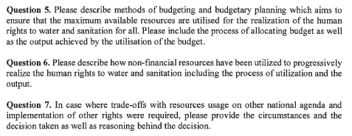
There are some challenges with providing clean drinking water and sanitation in rural areas due to dispersed settlements and consequently higher investments in providing public service of water supply and sanitation. Budgeting methods:
- State budget - Water fund, in line with Water Act
- Municipal budget in line with Financing of Municipalities Act
- EU budget – structural and non-structural funds

