Questionnaire
The Special Rapporteur’s Thematic Report on The Impact of Mega-projects on the Human Rights to Water and Sanitation
Stage | No. | Description
2  Planning & Designing  2 (Cont’d)  Planning & Designing  2 (Cont’d)  Planning & Designing | 6  7  Reply to 6 & 7  Reply to 6 & 7  (Cont’d)  Reply to 6 & 7  (Cont’d)  8 & 9 | What measures have been adopted by your Government to ensure that the framework on the human rights to water and sanitation is implemented in the planning and designing phase, both within and outside of the territory of the State? Please provide information on the challenges or good practices faced during the planning and designing stage to respect, promote and fulfil the human rights to water and sanitation.  What legal and policy framework is in place to clarify the roles and human rights obligation and responsibilities of actors involved in the planning and designing stage? What legal and policy framework is in place to regulate actors – both within and outside of the territory - to perform in accordance with human rights obligations and responsibilities and to conduct human rights assessments of impacts of such projects?  The write-up hereunder answers both Question 6 & 7.  Section 15 (h) of SPAN Act 654 stated that one the function of the commission is to formulate and implement a plan so that all reasonable demands for sewerage services are satisfied and in consultation with the relevant authorities, prepare a sewerage catchment plan formulating the policy and general proposals in respect of the development of any new sewerage system and measures for improvement of any existing system.  With these responsibilities and towards enhance sewerage catchment planning, a thorough study was proposed through the development of the National Sewerage Catchment Plan (NSCP). The NSCP comprises planning policies and strategies to drive the improvement of sewerage services and sewerage infrastructures systems in a systematic, coordinated, staged and cost effective manner which now being finalized by SPAN. The Sewerage Development Plan (SDP) shall be formulated in accordance to the Sewerage Planning Policy and Sewerage Planning Strategy under the NSCP.  Sewerage planning policies shall promote sustainable sewerage and sanitation services that are affordable to both consumers and service providers alike, and which shall support social, economic, cultural and quality-of-life progress of communities without undermining the desired quality and economic productivity of environmental, natural and life support resources. Sewerage planning shall be governed by, and be subjected to National Sewerage Policy Thrusts which will be the sewerage goals as follows:  - Basic human needs  - Sustainable water resources  - Environmental conservation  The enablers in achieving the sewerage goals as mentioned above are:  - Economic and Financial Optimization  - Institutional and Capacity Development  - Technology & Innovation  NSCP comprises seven (7) National Sewerage Planning Policies (NSPP) and nine (9) National Sewerage Planning Strategies (NSPS) as Figure 1 and 2, respectively.  Figure 1: National Sewerage Planning Policies  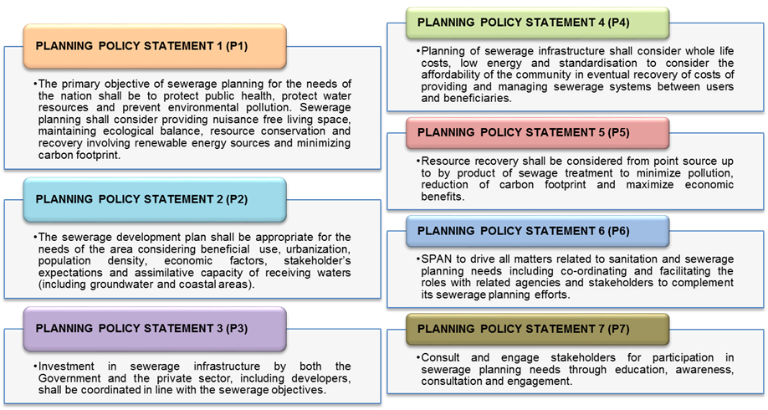  Figure 2: National Sewerage Planning Strategies  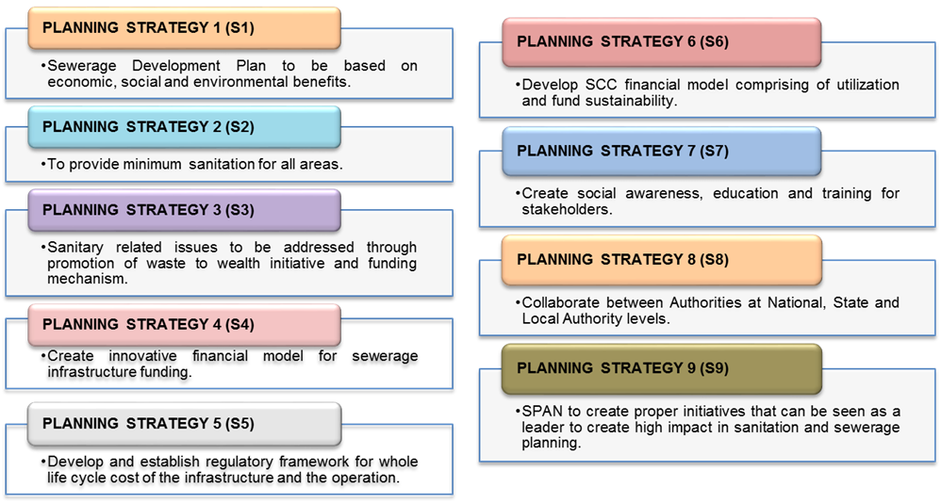  The NSCP should be updated at necessary time frame and shall have an overview of the specific needs and priorities for sewerage improvement and expansion schemes across all demarcated catchment area and will systematically determine priorities for implementation and expansion projects. It will be the basis of the National Sewerage Development Plan (NSDP) which will then guide the sewerage development through Government’s National Physical Development Plans.  The NSCP shall be in line with the policies to achieve the following:  - Suitable land to be identified and set aside  - Primitive systems, other on-site systems and small scale communal systems shall be discouraged and progressively phased out. Ineffective sewage treatment systems such as communal septic tanks, Imhoff tanks shall be discouraged and progressively phased out.  - Sewerage infrastructure to move towards a regionalized system wherever justified based on sewerage policy.  - Government investment in sewerage facilities shall focus on provision of basic sewerage systems for all areas, upgrading of existing systems to ensure performance, expansion of new systems and provision of new sewerage systems to cater for existing issues and growth.  - Funding and institutional support to enable integrated investment by Government and private sectors so that the national needs in terms of sewerage infrastructure is addressed effectively.  - Developments should connect to existing sewerage systems (if necessary upgrading them) rather than construct new systems.  - Where possible, new developments shall provide sewerage infrastructure to not only cater for their development, but also absorb adjacent existing and new developments.  - Principles of standardization, energy conservation, zero waste management concept and waste to resource through, reuse, recycling and resource recovery and sustainability shall also be considered as policy goals.  Not applicable.
4-6  Construction, Short-term Operation & Long-term Operation  4-6  Construction, Short-term Operation & Long-term Operation  (Cont’d) | 12  Reply  13  Reply  14  15  Reply  16 | What are the specific impact of mega-projects on the human rights to water and sanitation when mega-projects are in construction, in short and long-term operation? What measures are in place to prevent, mitigate and monitor those impact?  Operations of existing plants during construction phases do not affect human rights access to sanitation.  The existing system is not completely shut down or access to services terminated. Temporary actions through temporary treatment plants (TTP) are taken to ensure customers do have access to adequate sanitation system connected to the public network. Measures and actions required are built into construction contracts for contractors to ensure services to customers are not affected.  For IST customers, the system is still available until the upgrading of the status to connected system is completed.  As for short-term operations, mechanisms are in place to attend to customer complaints as per our Level of Service (LoS), customer charter, as well as management systems (ISO 9001 requirements).  As for long-term operations, the concern would be more on defective assets due to ageing, wear and tear in which asset risk assessment is undertaken and actions taken accordingly.  Please specify challenges faced or good practices adopted by actors – both within and outside of the territory of a State – involved in mega-projects to ensure the human rights to water and sanitation of affected population in the construction, short and long-term operation phases?  Challenges faced:  - Environment – while in the construction phase, it is vital that performance of temporary treatment plants (TTP) are at par with existing standards. This is especially so in the siting of discharge of effluent from TTP in ways that would not pollute waterways, streams and rivers that might affect the health of residents nearby.  - Public – address spillage/overflows/odour issues that may bring about diseases, ill-health to surrounding communities and impinge upon basic human rights to proper sanitation and clean air.  - Management of construction sites, operation of equipment and machineries, movement of vehicles to ensure adherence to existing regulations to preserve public health and well-being.  Good practices:  - IWK adheres strictly to standards established by National Institute of Occupational Safety and Health (NIOSH).  - Awareness of health and safety in IWK is through ISO 45001:2018 Occupational Health & Safety Management System which manages all health and safety risk, mitigation and opportunity for improvement. In 2018 and 2017, no fatalities were reported in IWK.  Not applicable.  What procedures and aids to access remedy are available when negative impacts of mega-projects amounts to violation or abuse of the human rights to water and sanitation?  Thus far, IWK has not experienced or faced such violation or abuse of human rights. In the normal course of operation, IWK will facilitate JPP/KATS/Ketua Pengarah Tanah & Galian (KPTG) to reserve the land under Section 62 (National Land Code) for sewerage purpose under Federal Land Commission.  Avenues are also available via IWK’s Integrity Unit to hear whistleblowing cases and other cases arising from abuses of such nature, which could tarnish the image of the Company.  Not applicable.
7  Ex-port Assessments  7  Ex-port Assessments (Cont’d) | 17  Reply  18  Reply  19  Reply | How are ex-post impact assessment of mega-projects carried out in practice? Are they required by law or regulations?  IWK routinely conducts inspection and assessment under the defect liability period (DLP) to gauge the condition of the projects. Under standard practice, the DLP for design and build contract and normal contract is 2 and 1 year respectively. Both contracts are subject to condition of contract. For government projects, contracts are oversee by JKR 203 while for private enterprise, they are guided by IEM Condition of Contract/Construction Industry Development Board/Malaysian Institute of Architects (PAM).  What human rights elements have been incorporated in ex-post impact assessment conducted shortly after the construction, at the commencement of operation or during long-term operation? What measures could be adopted to improve the successful integration of human rights approaches in such impact assessments?  After construction, handover and at the commencement of operations, the standard procedure followed by IWK is to gauge the operational performance of the plant through sampling of final effluent (FE). For plants with 5,000 PE and above, sampling of FE is done once a week while for big plants with their own laboratory, sampling of FE is done daily on major parameters. The sampling results are reviewed and analysis of inflow versus outflow is done to ensure optimal operating efficiency of the plant.  The prudent measure and process taken by IWK in ensuring FE meets the Environment Quality (Sewage) Regulations, 2009 (EQSR) means that the Company cares about the environment in making sure harmful pollutants are treated and discharged based on agreed standards and released to the waterways and in doing so honouring human rights to sanitation in not polluting streams and rivers, which are the life-line of any society.  How does the ex-post impact assessment contribute to the learning process and the feedback mechanism to provide guidelines for similar projects?  In the waste to wealth sector of the business, IWK is working towards supporting the Government’s aspiration as expressed in Malaysia’s Green Technology Master Plan to eventually recycle 1/3 of treated effluent and 100% of bio-solids by 2030.  In the desludging business, IWK is providing centralized sludge facilities (CSF) for tankers in select locations to ensure that sewage collected are disposed in a responsible manner and minimize the impact on the environment. IWK is providing the desludging service via its Desludging Business Unit.  IWK is guided by SPAN’s Malaysia Sewerage Industry Guidelines in construction of sewerage plants. All projects are assessed rigorously and for each stage, all requirements must be met including those stipulated by certification agency via Planning, Design and Construction procedures.

- Stage 4 to 6 - Construction, Short term Operation, Long Term Operation : Construction:

Normally will be implemented in few packages.
Common mega projects issues resulting in delay as below:
- Interfacing with other packages and delay in completion of works
- Additional cost such as Care & custody, Loss and expense etc.

Short term Operation:
May not be the most economical option as the initial/investment cost could be high.

Long term Operation:
Better option for Operation but the responsibility on replacement cost must be clearly spelled out in the Agreement. This is important as the replacement cost for major plant can be very high.

- Stage 7 - Ex post Assessment:

Post Assessment is more on ‘lesson learnt’ on the performance of the plant after some period of operation. This will cover scope of plant/equipment used, system design, method of operation, water quality.

