Dear colleagues and friends,

I am happy to share the second newsletter of 2018 and to inform you of my recent and upcoming activities. The main points are summarized as follows:

- Official visit to Mongolia
- Expert consultations on annual reports
- Social media consultation on accountability
- Communications and press releases

* * *

Official visit to Mongolia

I undertook an official visit to Mongolia at the invitation of the Government from 9 to 20 April 2018 to assess the country’s situation regarding the realization of the human rights to safe drinking water and sanitation. During my visit, I visited and interacted with communities in Ulaanbaatar City, Dundgovi aimag and Umnugovi aimag (provinces), examining access to drinking water and sanitation services for Mongolians living in urban and rural areas, including the nomadic population. In particular, I observed various layers of inequalities in access to these services that are a matter of great concern from a human rights perspective.

I am very grateful to all civil society organisations for their support before and during the official visit, the individuals and families who took time out to meet with me and share their experiences, and to the general public who followed my visit.

My full statement on the official visit to Mongolia, including all updates on social media during the visit, can be read in English or in Mongolian and the shorter press release can be read here. I will present my mission report to Mongolia at the 39th session of the Human Rights Council in September 2018.
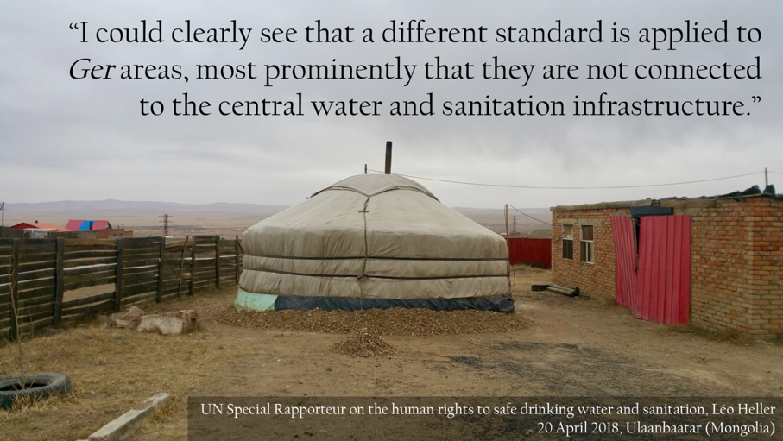
Social media update at the end of the official visit to Mongolia

Expert consultations on annual reports
For this year’s two thematic reports, I am focusing on two themes:

- The principle of accountability in the context of the human rights to water and sanitation for the 73rd session of the United Nations General Assembly in October 2018 (Click here more info); and
- The human rights to water and sanitation of forcibly displaced persons for the 39th session of the Human Rights Council in September 2018 (Click here for more info)

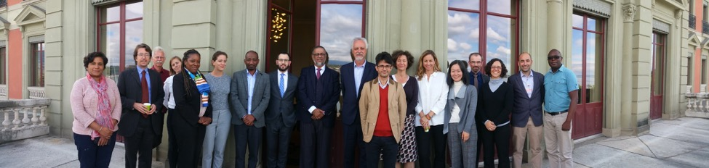
Experts at the consultation on the principle of accountability in the context of the human rights to water and sanitation, 14-15 May 2018.

From 14 to 17 May 2018, I organized two consultations in Geneva for the two thematic reports (see the concept note on accountability and the concept note on forcibly displaced persons) and invited groups of experts to give input on the subjects addressed in the aforementioned reports. The experts – from Africa, Europe, North America, South America and Asia, and with experience in service provision, humanitarian aid and advocacy, international law and human rights – discussed key elements for each of the reports and provided valuable perspectives on the realisation of the human rights to water and sanitation in these contexts. I would like to thank the experts for their time and efforts devoted to these consultations.

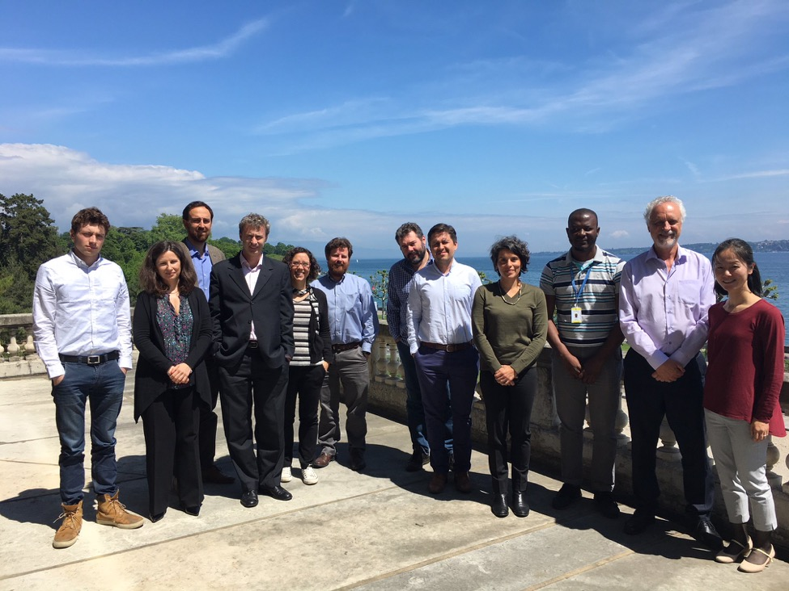
Experts at the consultation on the human rights to water and sanitation of forcibly displaced persons in need of humanitarian assistance, 16-17 May 2018.

Social media consultation on accountability

Throughout the month of June, I am consulting the general public and other stakeholders to share their input on accountability and the human rights to water and sanitation through a consultation hosted on my social media networks. I encourage everyone to submit further input and follow the consultation through the hashtag #WASHaccountability (water, sanitation and hygiene accountability) and contribute on Facebook or Twitter.

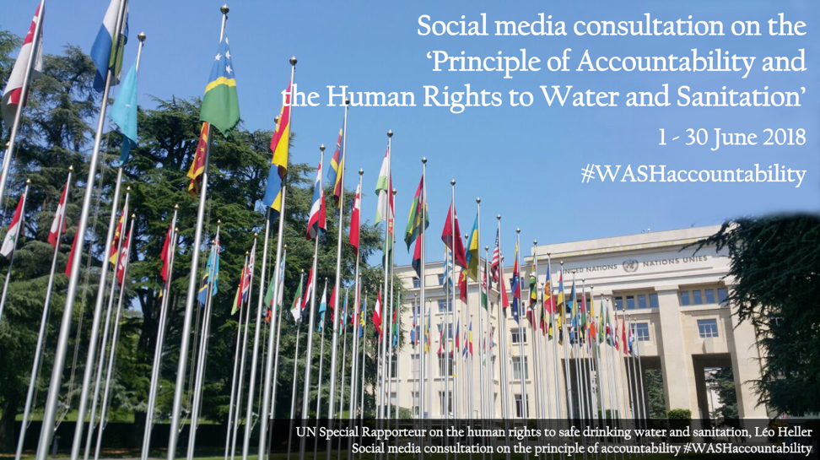
Access the announcement of the social media consultation on Twitter or Facebook
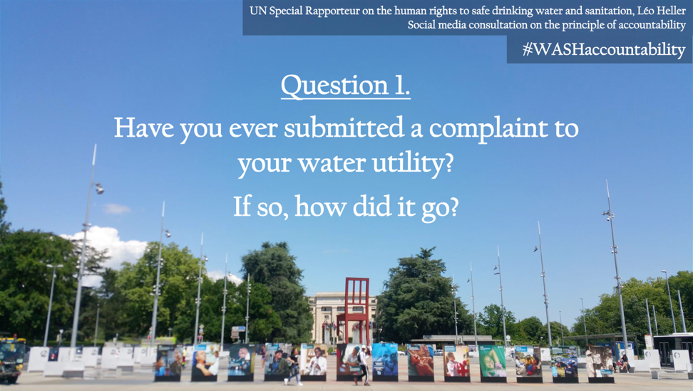
Access question 1 on Twitter or Facebook

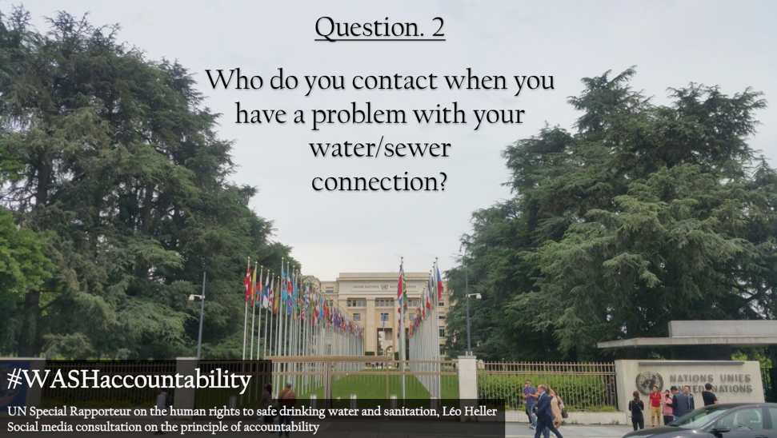
Access question 2 on Twitter or Facebook
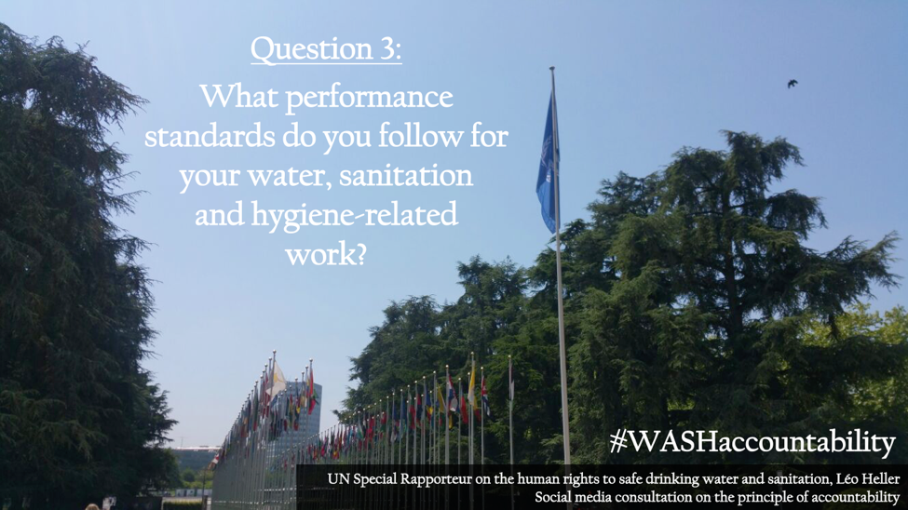
Access question 3 on Twitter or Facebook

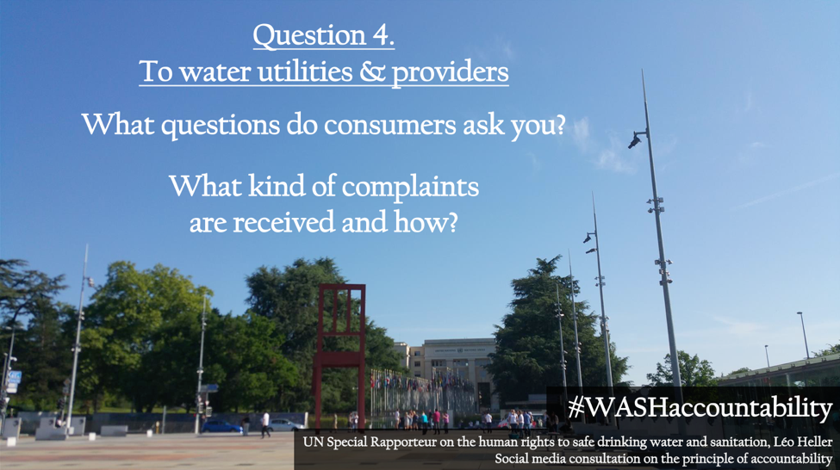
Access question 4 on Twitter or Facebook
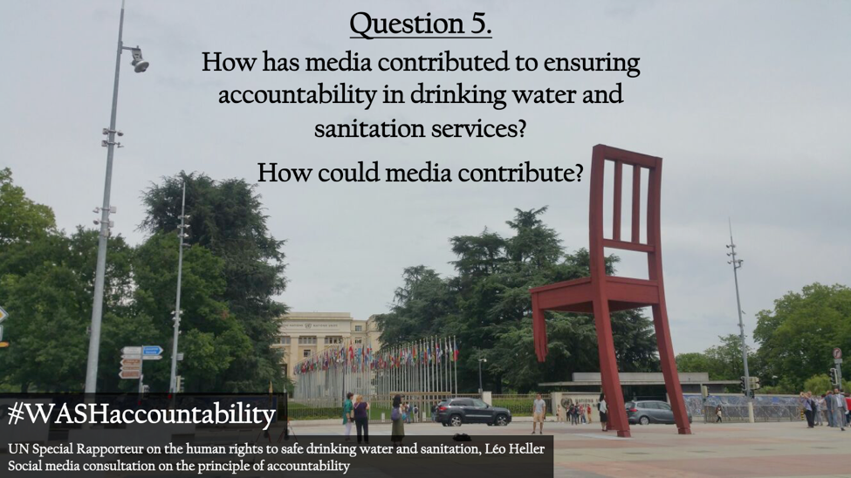
Access question 5 on Twitter or Facebook

Communications and press releases

The following communications were made public following the publication of the Communications report of Special Procedures at the 38th session of the Human Rights Council.

Venezuela (11 Dec 2017) – Regarding the systematic deterioration of living conditions and the increase of poverty and extreme poverty, in particular regarding the human rights to adequate housing, food and health. The Government replied on 11 January 2018.

Haiti (12 Jan 2018) – Regarding the human rights situation and conditions of detention in the civil prison of Port-au-Prince. The Government confirmed reception of this official letter on 31 January 2018.

Libya (23 Jan 2018) – Regarding the negative impact on living conditions of the population in the City of Derna, including their access to safe drinking water, sanitation, food as well as medical services and supplies, following the siege of the city since 2014. No reply was received from the government by 30 April 2018.

France (23 April 2018) – Regarding the fast-track adoption of Bill 714 "for controlled immigration and an effective right of asylum", which was to be examined by the National Assembly as of April 16, 2018. Certain measures included in the draft law would make access to asylum and effective remedy more difficult and contain provisions for suspension or refusal of material conditions of reception, with possible repercussions on the access of migrants to water supply and sanitation services.

Brazil (13 June 2018) – Regarding Project of Law (PL), 6.299/2002 which amends Law No. 7.802 of 11 July 1989, which deals with the research, experimentation, production, packaging and labeling, transportation, storage, commercialization, commercial advertisement, use, import, export, final destination of wastes as well as packaging, registration, classification, control, inspection and inspection of pesticides. The referred amendments would significantly weaken the criteria for approving the experimental and commercial use of pesticides, posing threats to a number of human rights. Concerns exist for the human right to water as the increased use of pesticides can directly affect the safety and quality of water.

* * *

In addition, I led or took part in the following press releases in recent months:

- UN experts condemn deadly police response to protest against copper smelting plant in India, call for probe (31 May 2018)

- France urged by UN experts to take effective measures to bring water and sanitation services to migrants (4 April 2018)

Kindest regards,

Léo Heller
UN Special Rapporteur on the human rights to safe drinking water and sanitation

Follow the mandate!
The website of the Office of the High Commissioner for Human Rights remains the number one place to discover the mandate’s past and upcoming activities.

Medium.com is also being used by the mandate as a mobile-friendly platform to share select media, such as the variety of leaflets created by the mandate. Most of the material placed on Medium is available in English, French and Spanish!

The mandate is also present on major social media platforms Twitter and Facebook (@SRWatSan), where it actively engages with the global community on issues related to the human rights to water and sanitation.

