Check against delivery
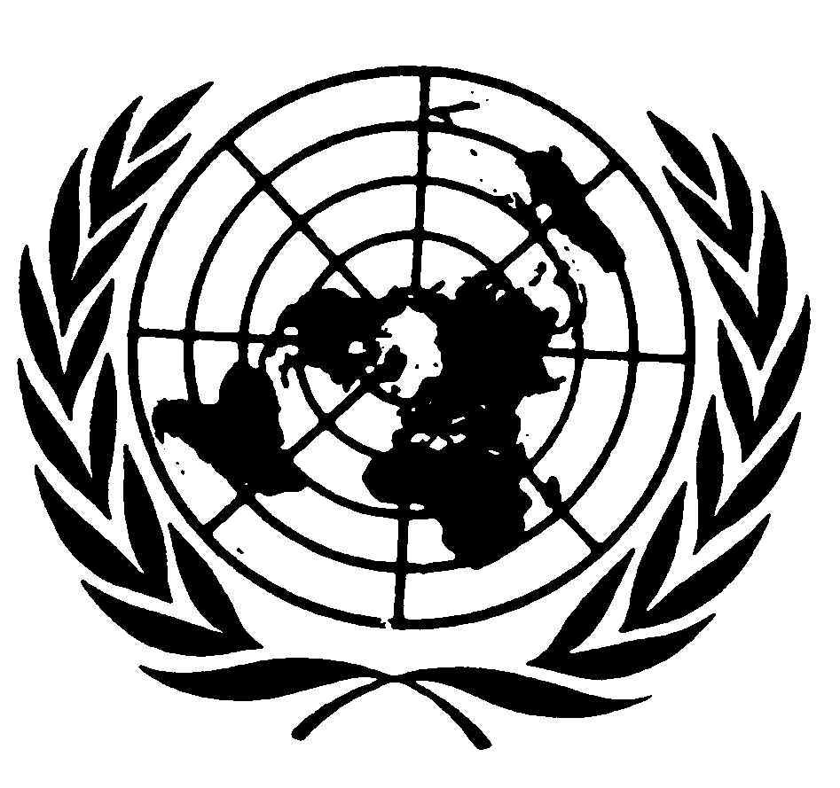

Statement by Ms. Fionnuala Ní Aoláin
SPECIAL RAPPORTEUR ON THE PROMOTION AND PROTECTION OF HUMAN RIGHTS AND FUNDAMENTAL FREEDOMS WHILE COUNTERING TERRORISM

Initiative on Ensuring the Effective Implementation of Countering the Financing of Terrorism Measures while Safeguarding Civic Space

13 October 2020

Excellencies, Ladies and Gentlemen

As Special Rapporteur on the Protection and Promotion of Human Rights and Fundamental Freedoms while Countering Terrorism I am very pleased to join this initiative and reflect on the crucially important intersection between effective countering terrorism financing and safeguarding civic space. There is a consensus that disrupting and preventing terrorist organizations from raising, storage, moving and using funds is essential to counter-terrorism efforts, a motif that has been plain in global counter-terrorism efforts since UNSCR 1373.
It would be fair to say however, that it has taken longer for us to agree that civil society is a vital and essential partner in counter-terrorism but more so, that a healthy, functional and resilient civil society, is less likely to engage in protracted violence and produce the conditions conducive to terrorism than a society than one in which civil society is stifled and marginalized. The value of civil society is well-articulated in human rights discourses including in UN Human Rights Council resolution A/HRC/ 24. The value proposition of civil society’s engagement is captured by the words of the current High-Commissioner for Human Rights Michelle Bachelet when she noted that:
“Civil society participation is the lifeblood of any healthy democracy and society. When civil society channels flow freely, it means vibrant debate, freedom of thought and opinion, and public engagement in policy.”

But civil society is under stress in many parts of the globe. It is estimated that civic space is restricted or impaired in its operations in 111 countries. In 2019, 300 human rights defenders were killed, including a rising number of women human rights defenders who lost their lives. As my 2019 Report to the Human Rights Council meticulously documented, counter-terrorism and securitization plays an outsize role in choking civil society in multiple countries; the extremely wide and opaque definitions of terrorism and extremism in many States function to criminalize that which is protected by international law; and terrorism finance regulation plays a particularly harsh role in limiting the role of civil society in fragile and complex humanitarian crisis and conflict arenas. My most recent report made public this week to the General Assembly (A/75/337), is focused on international humanitarian law and human rights interfaces but pays close attention to the work of humanitarians, essential civil society actors of unique importance in crisis and humanitarian settings. I establish that current matrixes do not permit humanitarian actors to carry out their mandates in a way that complies with international humanitarian law thus compromising the fundamental rights and dignity of highly vulnerable people, and CTF regulation is one of the most significant obstacles encountered by these actors. One concerning aspect emerging from my GA Report was that in the consultation phase for the Report we engaged with multiple (large and small) impartial humanitarian organizations and many attested to the costs in practice that terrorism financing requirements were placing on their capacity to deliver their mandates in some of the most wretched places on earth. Few would place their views ‘on the record’ for the fear of retaliation by States – essentially, they understood that there would be costs for saying out loud what is well understood by all to be the status quo in practice. To state the obvious, when these entities are unable to articulate the concerns and challenges they face in practice, we are facing a profound conundrum to ensure meaningful engagement of civil society, and particularly those on the ground, in countering terrorism financing contexts.

Implementing a ‘risk’ based approach in a human rights compliant manner

The trajectory of entrenching CT financing requirements for States, FATF assessment and ratings and the definition of civil society ‘risk’ are familiar to all in this conversation. The question I turn to ask is if we have moved to a ‘risk-based’ assessment how do we protect human rights in this process and how are the rights and values of civil society advanced and protected in the ‘risk’ universe? In some sense the UN system itself, has provided some overarching answers. UN efforts led by Secretary-General have focused on the 3Ps;
- Promoting civic space: advise on, and proactively advocate for, safe participation of diverse civil society groups in national decision-making processes, including through protests; seize opportunities to expand the space for civil societies and systematically highlight the positive contributions of civil society.
- Ensuring civil society participation: enhance civil society engagement … and strengthen policies and practices on participation of / partnerships with civil society, drawing on examples of good practice from across the UN system.
- Protecting civil society actors: coordinate and strengthen UN responses to protect civil society actors effectively, including from reprisals against those who cooperate with the UN and by identifying and disseminating examples of good practice across the UN system.

If countering terrorism financing is a ‘civil society lite’ space, efforts to change that will require sustained engagement and changes of practice by States, but the push to do that should I think be prompted by self-interest. Namely, recognizing that without positive engagement of civil society it will prove impossible in practice to change the underlying factors that produce and sustain violence on the ground, as evidenced by geographies and sites of conflict and challenge that remain inherently intractable over extended periods.
It may be useful to recall that participation in public affairs is a right protected by international human rights treaties (Article 25, ICCPR), and it is the realization of that right in this context that is at the heart of including civil society. This means in practice creating clear pathways to inclusion for civil society that are accessible, transparent, have ‘feedback’ loops, both at the state and international institutional level, including in those organization that are regulating and overseeing the terrorism financing compliance by States.

Some final Remarks: Who is in the conversation?

One of the lesser understood aspects of the CFT space is the range and diversity of actors in it. From my perspective as SR, when I am in country discussing terrorism financing and human rights obligations I am in conversation with ministries of finance, supervision authorities, sometime private actors (including banks, insurance companies). To state the obvious, these are not sectors well-known for their human rights deep dives, or communities of practice well-versed in human rights obligations, including human rights obligations that can be derived by corporate entities. These entities are often ‘conservative’ in the sense that they view such matters as rights enforcement outside of their sphere of competence or inherently political and not legal obligations in the formal, traditional sense. These constitutes are often risk-averse, meaning what when one speaks of a risk-based approach this can be translated into a ‘take no risk’ (over-inclusive) approach. One clear element then is to educate and address the understanding of these constituencies of the value, norms and need to address civil society impacts, including the specific human rights consequences of over-inclusive risk approaches.

Examples of Good Practice
Given the focus on the challenges we face, I thought it would be helpful to point out areas of good practice where, as Special Rapporteur, I have observed States to be taking positive and well-directed action to include civil society.

Tunisia: State institutions (including the FIU, the General Directorate of Associations and Political Parties at the Presidency of the Government, the Anti-Terrorism Commission) and local NPOs collaborated effectively to update the risk assessment of the sector using a methodology provided by a Global NPO Coalition member. The collaboration, and the work done on implementing Recommendation 8 in a way which protects civil society freedoms, has been much valued all round -- leading to Tunisia being found Compliant with Recommendation 8 in 2019 – one of only six countries globally to be rated so. Just as importantly, there is now I believe a genuine trust and partnership between government and civil society on issues relating to possible TF risks in the NPO sector and measures to be implemented to mitigate these risks. The FATF has also now removed Tunisia from its ‘high-risk and other monitored jurisdictions’ list. The final risk assessment report is expected to be published in October 2020, at the joint (online) event with civil society and the government.
Kosovo: Expert Hub CSO member, along with a group of local CSOs, co-lead and participated in the government ‘s working group on conducting a risk assessment on non-profit sector during 2017/2018. Through coordinated activity, CSOs managed to provide substantive input into a draft risk assessment report and also secured additional time from the government for internal sectoral consultation on the report. As a result, the risk assessment report, which is public, does not include proposals for harmful measures or legislative restrictions specifically targeting CSOs, as it adopted CSO suggestions. In addition, Kosovo CSOs participated in country evaluation meeting with evaluators during 2018. This engagement served as a positive example for Hub members from other countries and is featured in the new FATF Guidance on Risk Assessment, as a good practice.
Nigeria: Nigeria published a National Risk Assessment for Terrorism Financing and ML (completed in 2016), which identified Designated Non-Financial Businesses and Institutions (DNFIs), of which NPOs are a subset, as being amongst those sectors most vulnerable to ML/TF. Spaces for Change, challenged (2019) this assessment of risk for the non-profit sector, disputing the official classification of NPOs as DNFIs and teasing out the nuances between vulnerability and threat, among other issues. The report led to increased and constructive engagement with the FIU (SCUML) and other government and NPO stakeholders, including GIABA, the FATF-Style Regional Body for West Africa.
United Kingdom: The 2017 National Risk Assessment assessed the risk of abuse of nonprofits for terrorism financing as ‘low’. It also flagged the issue and impact of bank derisking on charities. The earlier 2015 National Risk Assessment had assessed NPO risk to terrorism financing as ‘medium’.
Conclusion
Civil society in particular has a crucial role to play as an important vehicle for facilitating public involvement in decision-making processes including on countering terrorism financing. As such, trust-based collaborative partnerships with civil society are well placed to improve policy-making through enhanced identification of the policy needs of different groups and develop relevant solutions. It is imperative that States create a safe and enabling environment in law and in practice that allows civil society, broadly defined, to participate in public affairs at the domestic, but also at regional, and international levels. Regional and international law and policy-making has however frequently been described as suffering from a ‘democratic deficit’, which commonly manifests in ways in which civil society actors are engaged in these spaces.
It is also important that we model participation at the global level. We cannot tell States to include civil society if international organizations and entities (including inter-governmental fora) do not practice what they preach. For the GCTF in order to ‘practice what we preach’ working on issues of CTF this would mean in practice:
• Establishing civil society focal points;
• Developing processes for granting observer, consultative or participatory status to civil society organizations or set up alternative permanent bases for reliable and meaningful cooperation;
• Such status or other forms of cooperation should be based on clear, objective, transparent and non-discriminatory criteria and carried out in an accessible manner. Further, they should not be overly burdensome for civil society organizations who frequently grapple with shortages of monetary, human, and other resources; and
• Undertake regular and transparent public reporting on engagement with civil society actors, and have such engagement be subjected to independent external evaluation.

Thank you for your time. I look forward to taking questions.

See Report issued under the aegis of the Special Rapporteur, “The Impact of ‘Soft’ Law and Informal Standard Setting in the Area of Counter-Terrorism on Civil Society and Civic Space” https://www.law.umn.edu/sites/law.umn.edu/files/hrc-impactofsoftlaw.pdf
A/HRC/24/L.24 https://documents-dds-ny.un.org/doc/UNDOC/LTD/G13/173/19/PDF/G1317319.pdf?OpenElement
United Nations High Commissioner for Human Rights, 2 October 2019, Dublin Platform for Human Rights Defenders, see also See Human Rights Committee, general comment No. 25 (1996) on participation in public affairs and the right to vote, para. 1; UN, Global Counter-Terrorism Strategy, A/RES/60/288, Annex, Pillar I: Addressing the conditions conducive to the threat of terrorism; UN Secretary-General’s Plan of Action to prevent violent extremism, A/70/674.
CIVICUS: The World Alliance for Citizen Participation has identified that civic space is closed, repressed or obstructed in 111 countries across the world, and only 4 per cent of the global population live in areas where civic space is open.
https://www.frontlinedefenders.org/en/violation/killing
A/HRC/40/52
https://undocs.org/A/75/337
Numerous submissions to the mandate sought confidentiality on the basis of fear of retaliation by States against humanitarian organizations working in conflict-affected areas.
UN University, Briefing on UN Sanctions, Nine Points on Designing United Nations Sanctions to Better Protect Humanitarian Activities (2020)
Many jurisdictions decided to regulate the functioning of and impose certain obligations on civil society organizations and the non-profit sector, more generally, as a counter-terrorism measure aiming at preventing or curbing the misuse of non-profit organizations by terrorist groups or individuals, in particular in relation to terrorist financing. The source of such binding domestic regulation, in many States, can be led back to Recommendation 8 of the Financial Action Task Force. Recommendation 8, as initially adopted, asserted that the NPO sector was “particularly vulnerable” to abuse by terrorist actors, despite the lack of evidentiary foundation to back such sweeping assumption.
FATF, International Standards on Combating Money Laundering and the Financing of Terrorism and Proliferation: The FATF Recommendations (Paris, 2019). Noting here the nine FATF-style regional bodies (FSRBs)that have been established and recognized by the FATF Plenary. These bodies include: Asia/Pacific Group on Money Laundering (APG), Caribbean Financial Action Task Force (CFATF), Council of Europe Select Committee of Experts on the Evaluation of Anti-Money Laundering Measures (MONEYVAL), Eastern and Southern Africa Anti-Money Laundering Group (ESAAMLG), Eurasian Group (EAG), Financial Action Task Force of Latin America (GAFILAT), Inter-Governmenal Action Group against Money Laundering in West Africa (GIABA), Middle East and North Africa Financial Action Task Force (MENAFATF), Task Force on Money Laundering in Central Africa (GABAC). These regional bodies, together with the FATF, constitute the Global Network.
"The UN depends on the active engagement of civil society actors. They are critical to achieving the Sustainable Development Goals and addressing climate change. […] Where parts of civil society are considered a threat, we need a principled mindset and to engage constructively.". The Secretary-General of the United Nations 24 February 2020.
Guiding Principles on Business and Human Rights (2011), 3 key principles found in this Principles relevant here include the State duty to protect human rights, the corporate responsibility to respect human rights and the need for greater access to remedy for victims of business-related abuse of human rights.
https://www.nfiu.gov.ng/images/Downloads/downloads/nrareport.pdf
https://spacesforchange.org/unpacking-the-official-construction-of-risks-and-vulnerabilities-for-the-third-sector-in-nigeria/
https://assets.publishing.service.gov.uk/government/uploads/system/uploads/attachment_data/file/655198/National_risk_assessment_of_money_laundering_and_terrorist_financing_2017_pdf_web.pdf#2017
https://assets.publishing.service.gov.uk/government/uploads/system/uploads/attachment_data/file/468210/UK_NRA_October_2015_final_web.pdf

