Australian Government Response to the United Nations Special Rapporteur on contemporary forms of slavery, including its causes and consequences

The nexus between displacement and contemporary forms of slavery

The Australian Government is pleased to contribute to the Special Rapporteur’s report on the nexus between displacement and contemporary forms of slavery.
Please see below information about the nature and extent of contemporary forms of slavery in Australia and about the Australian Government’s response to contemporary forms of slavery. Please note that the Australian Government does not have disaggregate data on the nexus between displacement and contemporary forms of slavery in Australia.
Contemporary forms of slavery in Australia
The Australian Government uses to term modern slavery to refer to serious exploitative practices including trafficking in persons, slavery, servitude, forced labour, debt bondage, deceptive recruiting for labour or services, forced marriage and the worst forms of child labour.
Between 1 July 2019 and 30 June 2020, the Australian Federal Police (the AFP) received 233 modern slavery reports. Forced marriage accounted for 41% of these reports.
Victims of modern slavery identified in Australia are primarily Australian citizens.
Non-Australian victims are primarily from South Asia, the Middle East and more recently, the Pacific region. Further statistics are at Attachment A.
Australia’s Response
National Action Plan to Combat Modern Slavery 2020-25
In 2020, the Australian Government launched the National Action Plan to Combat Modern Slavery 2020-25 (National Action Plan). The National Action Plan provides the whole-of-government strategic framework for Australia’s efforts to combat modern slavery over the next five years.
Implementation of the National Action Plan is supported by the commitment of AUD$10.6 million over five years. This includes AUD$4.4 million in new grant funding for civil society, industry and academia to combat modern slavery in Australia and support research for evidence-based policy.
Under the National Action Plan, the Government has committed to five National Strategic Priorities:
(1) Prevent;
(2) Disrupt, Investigate and Prosecute;
(3) Support and Protect;
(4) Partner; and
(5) Research.
Under these priorities, the Australian Government will implement a range of initiatives that promote a holistic response to the full cycle of this crime.
A copy of the National Action Plan can be found online at < https://www.homeaffairs.gov.au/criminal-justice/files/nap-combat-modern-slavery-2020-25.pdf >
Legislative Framework
Modern slavery criminal offences
Australia has robust criminal offences for modern slavery with penalties of up to 25 years’ imprisonment.
Divisions 270 and 271 of the Criminal Code contain the offences relating to trafficking in persons, slavery and slavery-like practices.
Slavery-like practices include servitude, forced labour, and deceptive recruiting. These offences can apply to the exploitation of a person’s labour or services in any industry, or to exploitation within intimate relationships.
Australia’s slavery offences have universal jurisdiction, meaning they apply whether or not the conduct occurred in Australia, and whether or not the victim or the offender are Australian citizens or residents. The trafficking in persons and slavery-like practices offences have extended geographic jurisdiction, and can therefore apply where the conduct occurred in Australia, or where the conduct occurred outside Australia but the offender was an Australian corporation, citizen or permanent resident.
The Modern Slavery Act 2018
The Modern Slavery Act establishes a practical risk-based framework to directly target modern slavery practices in global supply chains, and support the Australian business community to identify and address their modern slavery risks.
The Modern Slavery Act requires over 3,000 business and other entities to prepare annual modern slavery statements on their actions to address modern slavery risks in their global operations and supply chains. It applies to businesses and other entities in the Australian market with $100 million or more of annual consolidated revenue.
The Government is publishing statements on an online register to ensure they are easily accessible by the Australian community. The Government will also publish annual statements on modern slavery risks in government procurement and investments.
Vulnerable witness protections
The Crimes Act 1914 provides protections for victims and survivors of modern slavery when giving evidence in court. Under Part 1AD of the Crimes Act and Division 279 of the Criminal Code, victims and survivors can:
- give evidence via closed-circuit television, video-link or video recording
- have their contact with the defendant or members of the public limited, and
- have a support person with them while they give evidence.

Part 1AB also makes it an offence to publish material identifying a victim or survivor of modern slavery, and allows victims or survivors of modern slavery to make victim impact statements to the court outlining the harm they have experienced.
The Migration Act 1958 offences
The Migration Act 1958 (Migration Act) creates offences of allowing a person to work, or referring a person for work, if the person is an unlawful non-citizen or a lawful non-citizen working in breach of a visa condition. The offences are escalated to aggravated offences if the worker is being exploited and the person knows of, or is reckless to, that circumstance. The Migration Act also provides for civil employer sanctions in the form of infringement notices and non-fault civil penalties, supplementing Australia’s criminal offences.
Visa framework
Under the Migration Regulations 1994, Australia’s Human Trafficking Visa Framework enables foreign nationals, who do not already hold a valid visa and are suspected victims of modern slavery, to remain lawfully in Australia. Like Australian citizens and other valid visa holders who are suspected victims of modern slavery, they are then able to access support through the Government’s Support for Trafficked People Program. All holders of valid visas receive the same support as clients who are Australian citizens, however their eligibility for some services, or ability to seek employment may be limited by visa conditions. Where a suspected victim has made a contribution to a modern slavery investigation or prosecution of an alleged offender and would be in danger if they returned home to their home country, they may be eligible for a permanent visa to remain in Australia.
Workplace laws
The Fair Work Act 2009 (Fair Work Act) empowers the FWO to enforce compliance with the Fair Work Act, and associated industrial instruments including awards and registered agreements. The minimum entitlements, conditions and protections provided under the Fair Work Act, and associated instruments, apply to all employees in the national workplace system, including migrant workers and international students.
The Proceeds of Crime Act 2002
The Proceeds of Crime Act 2002 provides a scheme for tracing, restraining and confiscating the proceeds of crimes against Australian law, including for modern slavery offences. These proceeds can then be returned to the Australian community to fund anti-crime initiatives.
Support for Trafficked People Program
Australia provides a comprehensive range of dedicated support services for trafficked people through the Australian Government’s Support or Trafficked People Program (Support Program).
Eligibility for the Support Program is determined by the AFP and is based on whether a person is, or may have been, the victim of a human trafficking or slavery-related offence.
The Support Program assists clients, including those who are displaced peoples, in meeting their safety, security, health and well-being needs, seeking criminal justice, and developing options for life after they leave the program.

Attachment A – Statistics
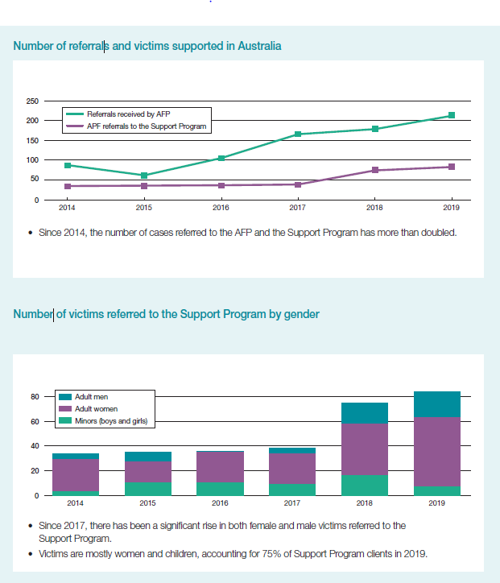
Statistics from the Support for Trafficked People Program
