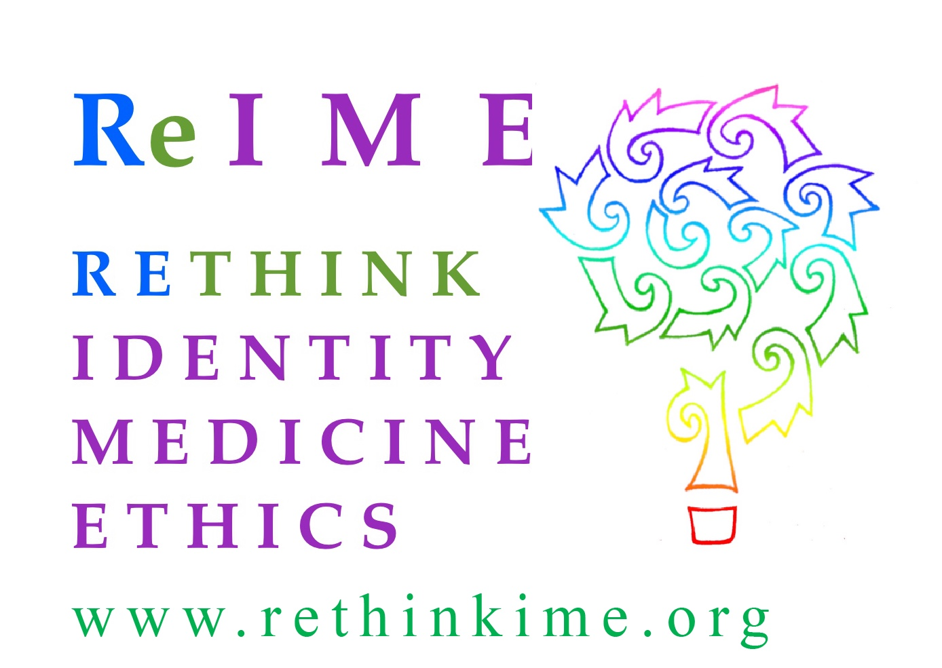

December 18, 2019

Victor Madrigal- Borloz
Independent Expert
Office of the UN High Commissioner for Humans Rights

Re: Call For Input - “Conversion Therapy”
Dear Mr. Madrigal- Borloz,
I am writing in response to your call for input on so called “conversion therapy” related to same-sex sexual attraction and gender identity. Rethink Identity Medicine Ethics, Inc. was established to promote optimal ethical care and treatment for gender variant children and youth. We support the right of young people to explore identities, including sexualities and gender. However, we believe that therapies that address same-sex sexual attraction and those intended to explore gender identities are distinct, with distinctly different evidentiary histories, concerns and outcomes. Specifically, we strongly believe that exploration of gender identities should not be stymied or prematurely foreclosed, especially when such foreclosure may lead to permanent, invasive unnecessary medical procedures and harm.
For this reason, we have provided testimony in opposition to State legislation banning so called “conversion therapy” because they do not clearly define what practices are and are not covered under the ban, and do not adequately address the long term well being and distinct medical concerns for treating minors with gender dysphoria. State bans generally use language that merely prohibits treatments “intended to change” the individual’s gender identity - they are vague, overly broad and create a chilling effect on a array of therapies available to minors dealing with other forms of dysphoria. And therapies that do not outright affirm and confirm the minor’s gender identity can be construed as impermissible efforts to deter, discourage and change the identity. As such, broad “conversion bans” applied to gender identity reify substandard care by preventing this vulnerable population from having ready access to all available treatment options to help lessen or resolve their dysphoria.
As indicated above, the issues around the treatment of “gender identity” and the treatment of same-sex romantic or sexual attraction are distinct - requiring “different models of understanding” and should not be conflated. (Bewley 2019.) While homosexuality was removed from the DSM as a mental health disorder in 1973, “gender dysphoria” is a delineated mental disorder in the current DSM-V with different attributes assigned to children and adolescents which are generally characterized by distress or problems functioning associated with the individual’s preferences related to the opposite gender or their experienced/expressed gender and their assigned gender. (APA 2013.) The cause(s) for gender dysphoria are unknown and is viewed as the result of complex psycho/social and neuro dynamics that can be fluid and changing. (Drescher et al 2014.) Consequently, offering services to eliminate or lessen gender dysphoria - a recognized disorder - is not the same as offering services to eliminate or “change” same-sex sexual attraction. And should not be treated as the same or subject to the same prohibitions.

In addition, the prohibition of offering services with respect to same-sex sexual attraction is based on numerous unequivocal studies that have shown such services that proffer to “change an individual’s sexuality” are misleading and fraudulent as they are ineffectual and create psychological trauma. (Drescher et al 2016.) By contrast, all studies ever conducted on minors, including the most recent studies demonstrate that a significant majority (61-88%) will resolve their dysphoria if they are not socially transitioned (i.e., provided confirming psycho/social treatment). (Waillen et al 2008; Drummond et al 2008; Steensma et al 2013; Cantor 2019.) There are no biomarkers or other observable factors that indicate who will and who will not desist - most of those do desist go on to life healthy gay and lesbian lives. (Cantor 2019.) Also, there are no studies to show that the long term well being of minors is harmed by exploratory therapies such as “watchful waiting” (the prevailing standard of care in the United Kingdom and Australia) for prepubescent children that encourage them to explore and remain curious about their gender identity, and affirm them in this exploration without being confirmed through social transition. Further, if a gender identity is confirmed prematurely, it will make it difficult and distressing for the child/youth to subsequently revert or change to their original or a different gender identity or expression, and may also result in long term physical consequences - consequences not attendant to confirmation of a youth’s sexuality. Therefore, unlike same-sex sexual attraction, an evidentiary basis for the prohibition of offering services to children and adolescents related to gender identity and expression - does not exist. And doing so may be harmful to their long term well being.

Finally, minors are now presenting to gender clinics with gender dysphoria symptoms in unprecedented numbers and with complex case histories. They present at different times (prepubescent and adolescent), with differing amounts of gender dysphoria (moderate and acute), with differing neurodiverse profiles (Strang et al 2014), and co-morbid conditions (depression, anxiety, and personality disorders - Kaltiala-Heino et al 2015). Restricting the types of services that may be provided, including but not limited to extended assessment services because they do not affirm an individual’s gender identity - but rather seek to explore it - is limiting therapists ability to treat the whole person including co-morbid conditions that may be the cause of the dysphoria.

In the last five years, gender clinics have documented a 1000% increase in youth, ages 12 -17 with no prior symptoms of gender variance. Nearly three-quarters of this population are girls - a complete inversion of previous statistics wherein boys had outnumbered girls in similar proportions. (Zucker 2019.) The reasons behind this unprecedented increase in adolescent cases of gender dysphoria is unknown and is currently being studied. It is also not known whether and to what extent the gender expression of this newly presenting population is stable in comparison to those of children who present earlier and persist into adolescence.

There is widespread concern that the vastly disproportionate increase in adolescent girls presenting may reflect concomitant increases in social and sexual anxiety, depression, self- harm, eating disorders, homophobia and body rejection known to affect them at the onset of somatic and psycho/social changes during puberty. Adolescent-onset gender dysphoria - - particularly in natal females - - may in the long term be subject to higher rates of fluidity. (There are now numerous online networks of detransitioners who transitioned in adolescence who are now detransitioning in their 20s.) For this reason, many gender clinics have adopted an “extended assessment” protocol to best treat adolescents. (Churcher Clarke 2019.) In this context, mental health professionals should be able to fully explore all issues affecting an adolescent as well as provide information regarding the possible long term risks of irreversible medical interventions without concern that offering appropriate exploration and information could be construed as an impermissible “effort to change” the individual’s gender identity.

In conclusion, mental health professionals should have the clear latitude to offer appropriate therapies such as “watchful waiting” or “extended assessments” to an individual without concern for disciplinary action. Vague blanket bans prohibiting the offering of services designed to help a minor resolve their dysphoria and desist is tantamount to withholding from them the care necessary to best safeguard their long term well-being and avoid unnecessary medical interventions. On this basis, we oppose so called “conversion bans” that apply to gender identity.

Sincerely,

Jane Wheeler, J.D.
President, Rethink Identity Medicine Ethics, Inc.

CITATIONS

American Psychiatric Association (2013). Diagnostic and Statistical Manual of Mental Disorders, 5th edn, American Psychiatric Association, Arlington.

Bewley, S. (2019). Response to Safeguarding LGBT+ adolescents: Safeguarding adolescents from premature permanent medicalization. BMJ; 364:1245.

Cantor, J. (2019). Transgender and Gender Diverse Children and Adolescents: Fact-checking of AAP Policy. Journal of Sex and Martial Therapy. Published Online December 14th.

Churcher Clarke, A., & Spoliadis, A. (2019). ‘Taking the lid off the box:’ The value of extended clinical assessment for adolescents presenting with gender identity difficulties. Clinical Child Psychology and Psychiatry, Spec. Ed., 1-15.

Drescher, J., Schwartz, A, Casoy, F. (2016). The Growing Regulation of Conversion Therapy. J Med Regular; 102(2): 7-12.

Drescher, J., & Pula, J. (2014). “Ethical Issues Raised by the Treatment of Gender-Variant Prepubescent Children.” LGBT Bioethics: Visibility Disparities and Dialogue. Hastings Center Report 44, No.5 S17-S22.

Drummond, K.D., Bradley, S.J., Badali-Peterson, M., & Zucker, K.J. (2008). A follow-up study of girls with gender identity disorder. Developmental Psychology, 44, 34-45.

Kaltiala - Heino, R. Summary, M., Tyolajarvi, M. & Lindbergh, N. (2015). 2 years of GI service for minors:overrepresentation of natal girls with servers problems in adolescent development. Child and Adolescent Psychiatry and Mental Health 9:9.

Steensma, T. D., McGuire, J.K, Kreukels, B.P.C., Beckmann, A.J., & Cohen-Kettenis, P. T. (2013). Factors associated with desistance and persistence of childhood gender dysphoria: A quantitative follow-up study. Journal of American Academy of Child and Adolescent Psychiatry, 52, 582-590.

Strang, J.F. Et al. (2014). Increased gender variance in autism spectrum disorder and attention-deficit hyperactivity disorder. Archives of Sexual Behavior, 43(8), 1525-33.

Wallien, M.S.C., & Cohen-Kettenis, P.T. (2008). Psychosexual outcome of gender-dysphoric children. Journal of American Academy of Child and Adolescent Psychiatry, 47, 1413-1423.
Zucker, Kenneth J. (2019). Adolescents With Gender Dysphoria: Reflections on Some Contemporary Clinical and Research Issues. Archives of Sexual Behavior, 48(7), 1983-1992.

