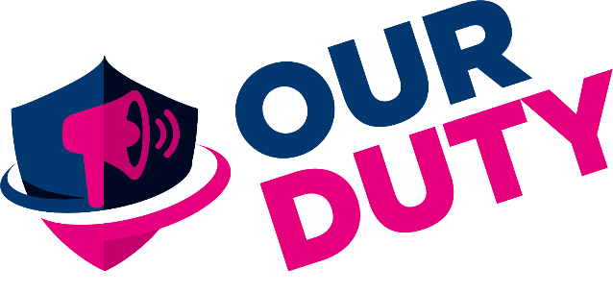

18th December 2019
Dear Mr Madrigal-Borloz
We are writing in response to your call for input on your ‘Report for so-called conversion therapy’.
We are a parent support and child protection group called ‘Our Duty’. We are a group of parents and other concerned parties that believe society is exposing children to a large mass scale unregulated and uncontrolled medical experiment. We formed in order to better support parents who question the affirmation-only model, to challenge current methods and to champion evidence-based science.
We believe that current gender identity assessments and the affirmative model of care for children and young people is harmful. They are not thorough enough nor based on sufficiently robust evidence. These medical interventions that children and young people are seeking can result in compromised fertility and loss of sexual function. We do not believe that vulnerable adolescents have the maturity, competence, or information to making such life-limiting decisions.
The growing number of detransitioners shows that we should be concerned about those who have not had enough time, nor received sufficient support, to accept their sexual orientation or gender confusion; both of which can a natural part of maturation. Many have had experiences of homophobic bullying and/or have parents with homophobic beliefs.
Many underlying factors are contributing to the rapid increase in the number of young people with these identities: mental health issues, autism, ADHD, trauma, and sexual confusion, as well as peer and media influences,

Science suggests that the prefrontal cortex part of the brain (where logic and decision making is based), is not fully mature until around the age of 25.
We are gravely alarmed by gender ‘specialists’, clinicians and activists such as Mermaids and Stonewall et al who are seeking to restrict gender identity assessments even further. They label such necessary exploration ‘conversion therapy’ and even claim that psychological assessment prior to the medical pathway is somehow ‘dehumanising’. Accepting this narrative would see vital gatekeeping and safeguarding removed.
We have experienced first-hand the barrage of abuse that people receive if they dare to question the affirmative model of ‘care’ for gender confused people. Further restrictions will only serve to make clinicians and professionals more fearful of being cautious and that will lead to more harm.
“Conversion therapy” originally referred to the abusive methods once used to try to change a person’s sexual orientation, such as the administration of electric shocks, lobotomies, castration, and the surgical implantation of “heterosexual” testicles without the patient's consent.

These unethical and harmful practices were egregious and rightfully banned.

We believe that medicalising young people with cross-sex hormones and surgeries on secondary sex characteristics is another form of “conversion therapy”.

These practices are just as egregious and unethical as those in the past.

When left alone, many would likely grow up to be healthy gay, lesbian, or bisexual adults.

At our Duty, we call for a Real Conversion Therapy Ban to end this identity-based medical experiment. Drastic and irreversible medical interventions that harm children must be outlawed.

Yours Sincerely,
Our Duty
community@ourduty.group
@ourdutygrp
https://ourduty.group

