Victor Madrigal-Borloz
Independent Expert at the Office of the UN High Commissioner for Human Rights
Palais Des Nations
1211 Geneva 10, Switzerland

December 20, 2019

Dear Sir,

It is with sober concern that we ask that you carefully and compassionately address the needs of individuals who seek the right to shape and control their own sexuality apart from state-led control. CHANGED Movement is a network of men and women with unwanted same sex attraction and gender dysphoria. With deep dismay we are watching bias and bigotry slander thousands of individuals who simply desire to follow their convictions with integrity. As with LGBT rights, all of us who no longer identify as LGBT also deserve freedom from discrimination. Bans on counseling choice or religious principles cause harm.

So-called “Conversion Therapy” is poorly understood and subjectively defined. In many cases, legislation against “conversion therapy” blocks the very means we found to be effective in attaining personal well-being—through counseling, prayer and spiritual disciplines. There are thousands of individuals who are seeking help to live according to personal conscience whose well-being will be threatened by condemnation of these practices. Those of us at CHANGED have chosen NOT to identify as LGBT, many of us have also experienced dramatic change in our sexual orientation (sexual fluidity) or gender. Several of us have detransitioned, having had surgeries or hormone therapies only to later regret having done so. We look to the Human Rights Council to protect our rights to leave the LGBT subculture and live quiet lives according to our convictions. States are closing doors for well-being to people like us who are seeking and experiencing change.

Article 18 of the Universal Declaration of Human Rights reads:
Everyone has the right to freedom of thought, conscience and religion; this right includes freedom to change his religion or belief, and freedom, either alone or in community with others and in public or private, to manifest his religion or belief in teaching, practice, worship and observance.

In accordance with The Declaration of Human Rights, we ask that you protect the freedom to choose how one expresses their sexuality as well as the freedom to pursue change in one’s orientation, which is in alignment with the evidence of modern science. People who have sought and successfully gained change in their sexuality have always existed, yet there has never been such extreme intolerance against us.

Ken Williams, co-founder of CHANGED:
"I was plagued with suicidal tendencies because I didn’t want to live the life that my same-sex attraction was leading me toward. The talk therapy I received from a professional counselor saved my life. My sexual desires have changed, I have now been married to my wife for 13 years. We have four children together. I am connected to thousands who have left LGBT behind. Many of us were suicidal, having experienced broken relationships, abandonment issues, and sometimes physical or sexual abuse. Laws that ban counseling choice promote only one ideology…and force only one lifestyle as a way forward. But, many of us, oncegay, didn’t find fulfillment in our homosexual relationships! Laws like these threaten our safety, autonomy, and pursuit of happiness. We do exist! Many people choose, for one reason or another, to leave an LGBT life behind. It is scary to imagine a world where government ideology controls a person’s options…what therapy they can or cannot receive, what sexual identity they must pursue, or what religious beliefs they are allowed to follow.”

We beseech you, in your pursuit to protect the lives of thousands who identify as LGBT, please also consider those of us who deserve equal protection and the choice to live out our sexuality according to our personal convictions.

Thank you for your consideration,

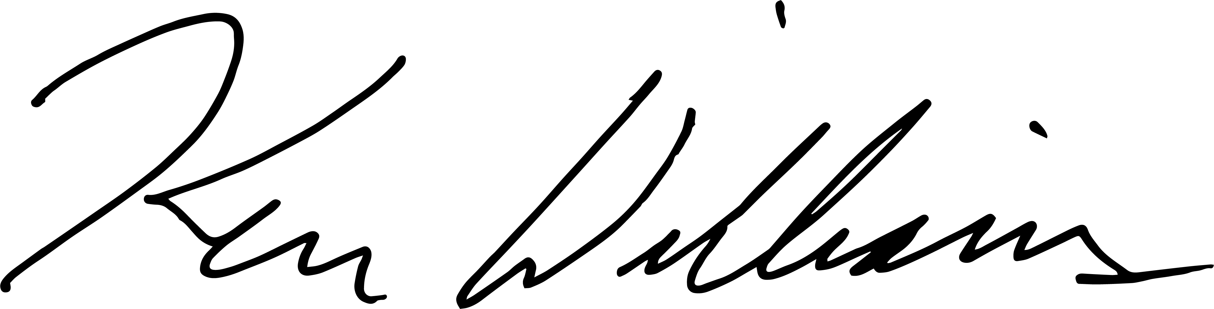

Ken Williams
Co-founder, CHANGED Movement

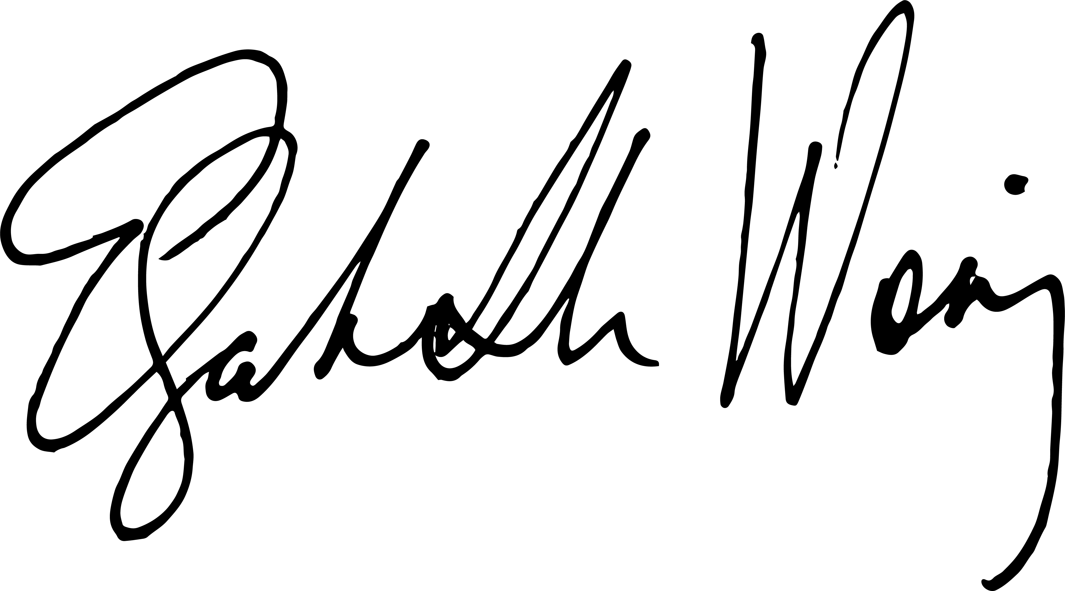
Elizabeth Woning
Co-founder, CHANGED Movement

