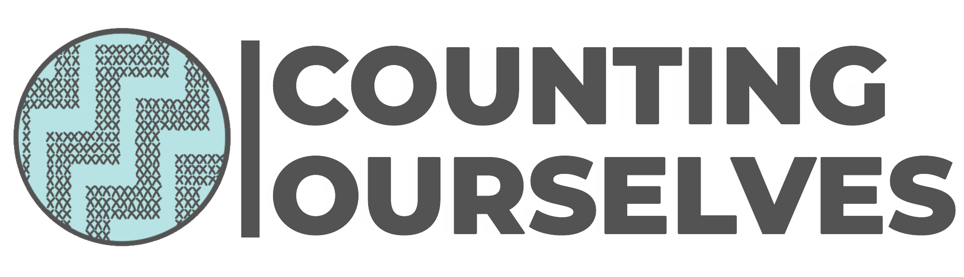
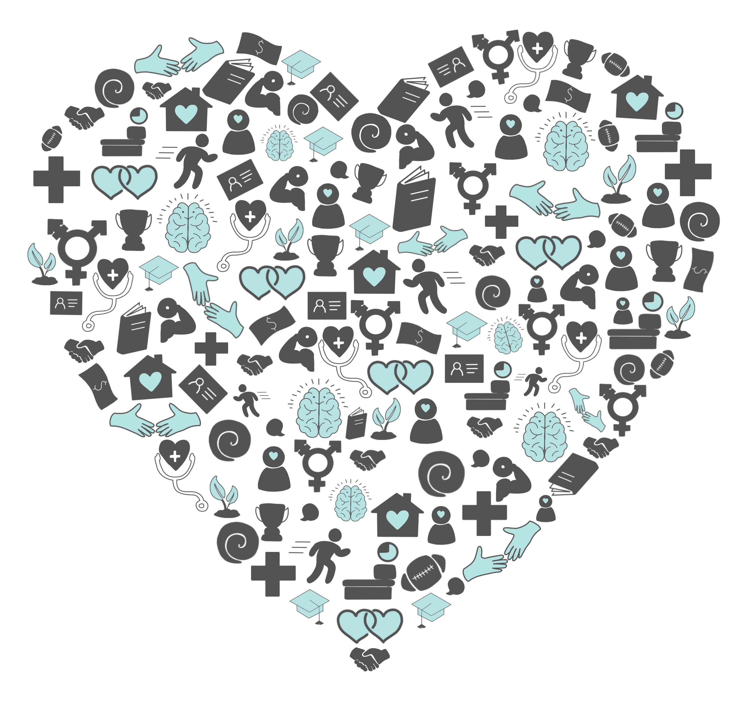

The health and wellbeing of trans and non-binary people in Aotearoa New Zealand

Ehara taku toa i te takitahi, he toa takitini kē
My strength is not in being alone, rather it is as many

Counting Ourselves
http://countingourselves.nz

Illustrator: Huriana Kopeke-Te Aho
Designer: Zakk D’Larté
ISBN 978-0-473-49184-0
Suggested citation: Veale J, Byrne J, Tan K, Guy S, Yee A, Nopera T & Bentham R (2019) Counting Ourselves: The health and wellbeing of trans and non-binary people in Aotearoa New Zealand. Transgender Health Research Lab, University of Waikato: Hamilton NZ.
Version: 23 September 2019

The Counting Ourselves survey and report would not have been possible without funding from the Health Research Council, Rule Foundation and the University of Waikato.

Acknowledgements
The project team members and authors of the report are Dr Jaimie Veale, Jack Byrne, Kyle Tan, Sam Guy, Ashe Yee, Dr Tāwhanga Nopera and Ryan Bentham.
The Counting Ourselves report is a collective endeavour, and there are many people and organisations we wish to thank. We particularly thank the trans and non-binary community members involved in this survey, including:
- the community advisory group members who guided the development of the survey questions and report, and promoted the survey: Bea Alcorn, Nathan Bramwell, Phylesha Brown-Acton, Tai Hartley-Parsons, Roxanne Peoples-Henare, Laurel McLachlan, Soul Mehlhopt, Scout Barbour-Evans, Ahi Wi-Hongi and Jevon Wright
- everyone who generously contributed their time and effort to complete the survey
- artist Huriana Kopeke-Te Aho, who created all the images used on our website, for our social media campaign and in the report
- Allyson, Aram, Claudia, Eliana, Emmy, Georgina, Gio, Isaac, Jacquie, Joey, Karen and Peri, Kī, Te Maungarongo, Tommy, Queen Olivia and the community advisory group members who shared their images and words with us to promote the survey
- Sam Orchard and Stace Robertson, who devised our social media campaign, and Izzy van der Ploeg, who created our website
- Tom Hamilton, who advised us on safety measures to ensure survey participants knew who to contact if they needed support around issues that came up for them as they completed the survey
- other community members who were peer reviewers of the report and brought considerable expertise to that work.
Our study has benefited from the many academics, health professionals, community organisations and officials from government agencies that gave us constructive feedback on our survey questions and draft report, including:
- Individuals: Dr Polly Atatoa-Carr, Tabby Besley, Moira Clunie, A/Prof Simon Denny, Caitlyn Drinkwater, A/Prof Sonja Ellis, Gloria Fraser, Dr John Fenaughty, Mo Harte, Prof Mark Henrickson, Dr Rachel Johnson, Prof Lynda Johnston, Dr Elizabeth Kerekere, Dr Zoe Kristensen, Dr Keri Lawson-Te Aho, A/Prof William Levack, Angelo Libeau, Dr Mathijs Lucassen, Dr Jeannie Oliphant, George Parker, Stace Robertson, Jono Selu, Dr Johanna Schmidt, A/Prof Gareth Treharne and Tycho Vandenburg
- Organisations: the Health Promotion Agency, the Human Rights Commission, InsideOUT, the Mental Health Foundation, the Ministry of Health, the New Zealand AIDS Foundation, New Zealand Parents of Transgender and Gender Diverse Children, Pegasus Health, re.frame, Statistics New Zealand, Te Ngākau Kahukura and the University of Waikato.
Executive summary
Counting Ourselves was a comprehensive national survey of the health, and factors related to health, of trans and non-binary people aged 14 and older living in Aotearoa New Zealand. We worked with a diverse community advisory group to design the questions. Our team is based at the University of Waikato and we also collaborated with other academics, health professionals, community organisations and policymakers with an interest in the wellbeing of trans and non-binary people. We had 1,178 survey participants, with 99% of them completing the survey online.
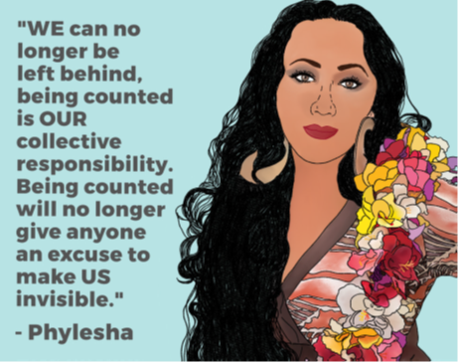
The survey had participants from all regions in the country, who ranged in age from 14 to 83. Most were either youth aged 14–24 (46%) or adults aged 25–54 (47%). Almost half (45%) of participants were non-binary, and we had slightly more trans men (29%) than trans women (26%). The survey had a higher proportion of European participants and a lower proportion of Asian participants than the general population. A quarter of participants had a disability.

Key findings

Gender-affirming care
We found high levels of participants wanting but not being able to access gender-affirming healthcare. This unmet need ranged from 19% for hormone treatment through to 67% of trans men wanting chest reconstruction surgery. Around half of trans women had an unmet need for voice therapy (50%) and feminising genital surgery (49%).
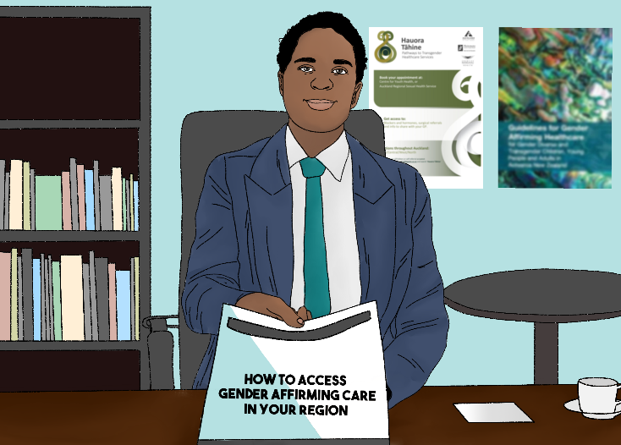
Cost was the most commonly reported barrier for all surgeries, and few participants had been able to access these through the public health system. A third or more of participants had received hormone treatment (48%), counselling support (38%) and mental health assessments (35%) through the public health system, but half of those who wanted counselling or a mental health assessment did not know where to go for these services.

Provider knowledge and competency
- More than half (58%) of participants reported that their main healthcare provider knew most things or almost everything about healthcare for trans and non-binary people.
- In the last 12 months, 13% of participants were asked unnecessary or invasive questions about being trans or non-binary, that were unrelated to their health visit, when they were trying to access healthcare.
- More than one in six of all participants (17%) reported they had experienced reparative therapy: that is, a professional had tried to stop them from being trans or non-binary.
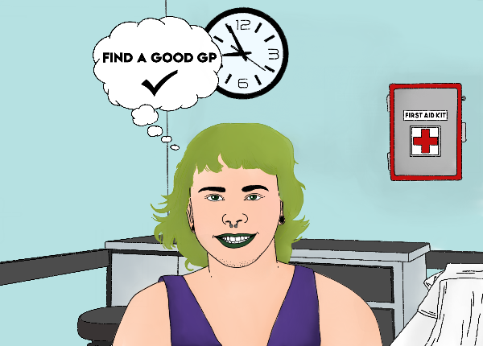

Healthcare access barriers
- Over a third (36%) of participants had avoided seeing a doctor because they were worried about being disrespected or mistreated as a trans or non-binary person, including 20% reporting this in the last 12 months.

Mental health and wellbeing
- Five out of every seven participants aged 15 and older (71%) reported high or very high psychological distress, compared with only 8% of the general population in Aotearoa New Zealand.
- More than half of the participants (56%) had seriously thought about attempting suicide in the last 12 months. Almost two in five participants (37%) had attempted suicide at some point and 12% had made an attempt in the last 12 months.

Substance use
- Participants’ rate of cannabis use in the last year (38%) was more than three times higher than the general population (12%).

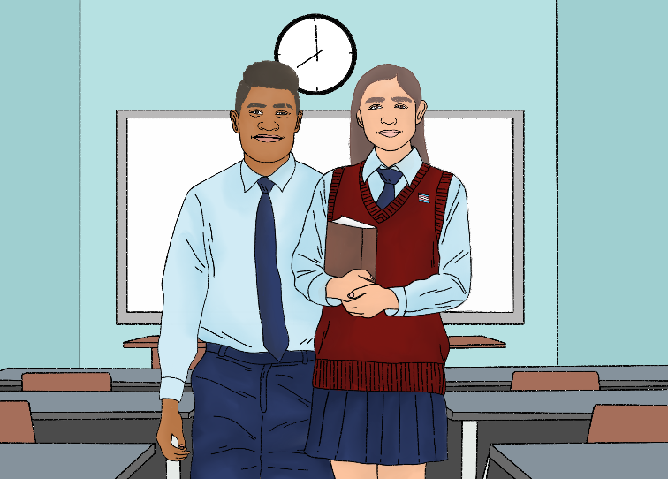
School
- More than one in five (21%) school student participants were bullied at school at least once a week, much higher than the general population (5%).

Sport
- Only 14% of participants were involved in any sporting events, competitions or organised activities in the last four weeks, just over half the rate of the general population (26%).

Discrimination
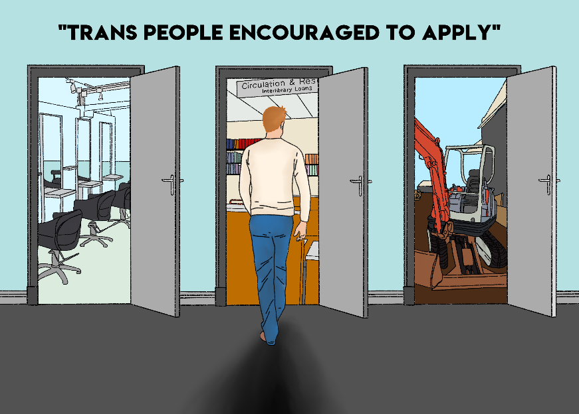
- Two-thirds of participants (67%) had experienced discrimination at some point. For close to a half of participants (44%) this had happened in the last 12 months – this was more than double the rate for the general population (17%).
- In the last 12 months, 57% of participants did not disclose at work that they are trans or non-binary because they feared discrimination.
- Participants who had experienced discrimination for being trans or non-binary were twice as likely to have attempted suicide in the past year (16%) than participants who did not report this discrimination (8%).

Safety and violence
- Almost a third of participants (32%) reported someone had had sex with them against their will since they were 13. This is a much higher rate of sexual violence than for the general population. Participants who reported this were twice as likely to have attempted suicide in the past year (18%) than participants who did not report this (9%).
- Almost half of participants (47%) reported someone had attempted to have sex with them against their will since they were 13.

Material hardship
- Compared to the general population, participants were almost three times more likely to have put up with feeling cold (64%) and gone without fresh fruit or vegetables (51%) in order to reduce costs.

Identity documents
- Five out of six participants (83%) did not have the correct gender marker on their New Zealand birth certificate.

Family/whānau
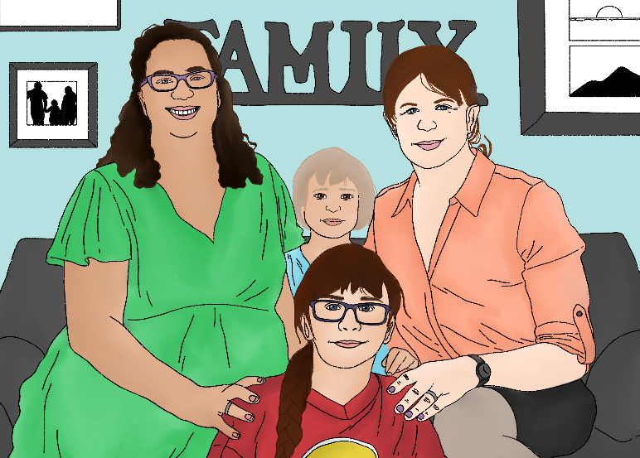
- Many trans and non-binary people have a lot of support within their family/whānau. Among participants whose family/whānau knew they were trans or non-binary, more than half (57%) reported that most or all their family supported them.
- Participants who were supported by at least half of their family/whānau were almost half as likely (9% vs 17%) to have attempted suicide in the last 12 months.

Community connectedness
- Most participants (62%) felt proud to be trans or non-binary, 58% provided a lot of support for other trans or non-binary people and 56% felt connected to other trans or non-binary people.
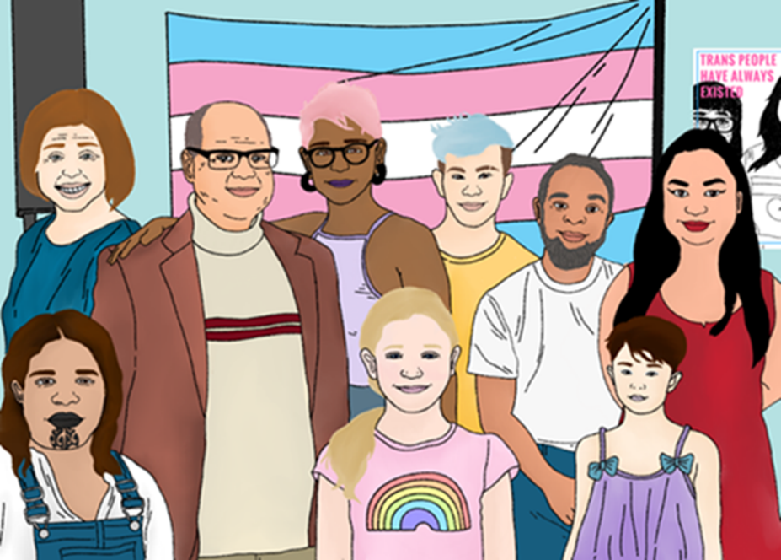
Demographic group differences
- We found higher rates of mental health problems among youth and disabled participants, and our school-age participants experienced high levels of bullying and low levels of support from and connection with their school. Disabled participants faced higher levels of discrimination, violence and hardship, and were more likely to say they could not afford to see a GP or access some forms of gender-affirming care.
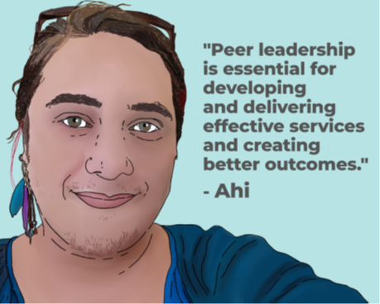
Non-binary participants were less likely to report positive experiences accessing general or gender-affirming healthcare. Both trans women and trans men were more likely to report that their quality of life had improved since identifying as trans. We also found differences between participants’ experiences trying to access gender-affirming healthcare in different parts of the country.
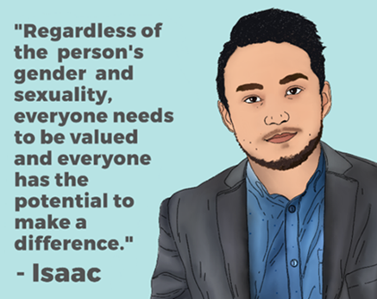
Asian and Pasifika participants were more likely to have experienced not only discrimination or unfair treatment in public places, but also mistreatment or rejection by their family. This is concerning, since our findings suggest that a strong sense of cultural connection is linked to better mental health outcomes. Non-Europeans participants (Māori, Pasifika, Asian and Other ethnicities grouped together) who had a strong sense of belonging to their ethnic group/s were less likely to have seriously considered suicide in the last 12 months.

Recommendations
In order to improve the health and wellbeing of trans and non-binary people in Aotearoa New Zealand, action is needed in all areas covered by this report. Our evidence supports the following eight recommendations. More details are in the conclusion and recommendations section of the report.
- Create clear pathways for gender-affirming healthcare, including training, resources and culturally appropriate services
- Ensure health services respect gender diversity
- Improve trans and non-binary people’s mental health and wellbeing, as a named priority in mental health and addiction policies
- Support schools to be safe and inclusive for trans and non-binary students
- Better protect trans and non-binary people from discrimination
- Protect trans and non-binary people from violence, as a priority in anti-violence work
- Simplify processes for trans and non-binary people to have accurate health records and identification documents
- Support health and wellbeing initiatives led by trans and non-binary communities.

