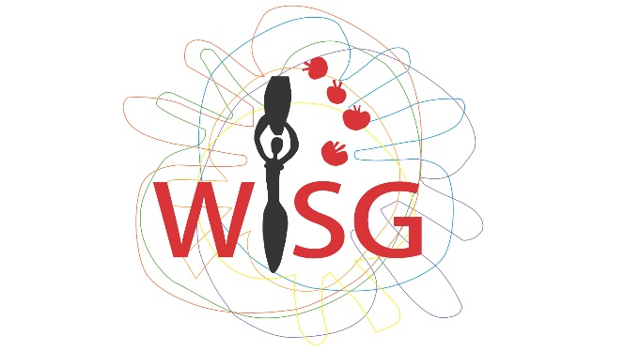

The report is submitted by Women’s Initiatives Supporting Group (WISG) a non-governmental, non- profit-making organization working on LBT women’s rights in Georgia.

This report for the Independent Expert will focus on the impact of the COVID-19 pandemic on the human rights of LGBTQI persons living in Georgia, hence will provide information in light with the proposed questionnaire by OHCHR.

The overall situation in Georgia in regards to LGBTQI persons’ rights, as evaluated by the independent expert in his country report, is discriminatory. This discrimination and stigma that LGBTQI people face in accessing any social service is even more fatal in a pandemic.
For addressing Covid-19, Georgian government had proposed the state of emergency from March 21 to (extended to) May 21. Respectively, lockdown measures increased the risk of domestic violence against LGBTQI persons, as well as the economic crisis has left many who work in the informal or service sector facing debilitating losses in income without any social safety net. During the period of April-May the request for the services provided by WISG has been increased approx. 1.5 times. As long as the majority of our beneficiaries were employed in the service sector and during crisis they lost their jobs, hence their income and additional benefits linked to that employment, the most common requests were related to economic issues. Request on psychological services has been also increased.
Corresponding anti-crisis plan released by the Georgian authorities on April 24, 2020 has left numerous groups beyond the scope of state support, inter alia, the needs and priorities of LGBTQI people has been also omitted. In particular, queer people left without income and employment, as well as without the support of family members or community solidarity, find themselves at serious risk of homelessness. Their urgent needs, including rental subsidies and alternative housing or shelters have been overlooked by the state anti-crisis support programme.
Since the very first days of the lockdown in Georgia, our organization started online and phone interviews with beneficiaries primarily to assess the needs and monitor emerging challenges during the pandemic. We collected information about up to 300 LBT persons in total, out of which 1/3 had different basic needs in terms of losing jobs due to the lockdown, being left without income in rented apartments, having to stay at home with violent/unfriendly family members etc. Despite the availability of the (social and legal) services within our organization, there are challenges and needs in the community that are beyond our current resources to settle.
So that, we have created coordination group with other community and service provider organizations to consolidate our efforts to address the needs of community members in the most critical conditions. After public advocacy for the community needs, the humanitarian aid (emergency kits of food and personal hygiene kits) was provided by the Georgian Government's Inter-Agency Coordination Council for the community based organizations to be distributed among the community members in need.This, however, was an act of fragmented humanitarian assistance and cannot be perceived as an adequate response to either the general or the current critical needs of the LGBTQI community.
Because the need of addressing systematic challenge, on May 1st the platform of Coalition for Equality, had published a statement based on the analysis of the Government’s anti-crisis plan. On the same day the incident took place in front of the Tbilisi City Hall where one of the trans-woman in desperation set herself in fire to protest state ignorance toward problems faced by Trans community during the pandemic.
Later in May, by the effort of UNDP the working group was formed in order to consult the Administration of the Georgian Government to elaborate rapid response mechanism on LGBTQI needs, to alleviate the socio-economic consequences of the community members in time of pandemic. The working group includes domestic NGOs, community based organizations and community members in particular. The latter, participation of the community members per se, thanks to UNDP was the first attempt of such involvement, that has to be welcomed. It has to be noted that UNDP has remained actively involved in the whole process that inter alia gave a hand to our recommendation to fulfill in regards to elaboration so called emergency plan.
For the sustainability and continuality of the plan the criteria and indicators has been determined and suggested to the working group for their opinion. In this regard, two fundamental issues had been risen by WISG: together with the victims of domestic violence, victims of hate (homo and transphobic) crimes shall be determined as the criteria; and as long as the proposed version neglected trans specific healthcare needs of the community members who are in need of continual medical oversight (hormonal treatment for instance), corresponding criteria has been suggested.
As the good practice let us highlight civil initiative taken place. In order to help persons with various social needs, activists and civil groups had created solidarity groups to help those who were most damaged by the mandatory measures in fighting the pandemic. Their mobilisation served as a critical and positive example of civil support. For instance, WISG has promoted and assisted Facebook group of Trans-supporters “Transgender Solidarity Group,” which primarily aimed to raise funds for trans sex-workers to cover rent and provide them with basic products. However, as noted the effect of this single individual/organizational/state donations is very limited and short-term. That is why the advocacy of intersectional approach against the systematic vulnerability is crucial.
As of the long term effect of Covid-19 on LGBTQI persons in Georgia, online needs assessment had taken by WISG on April 16th reveling that the negative long term effect caused by pandemic, is mostly linked to intersectionality, - social and economic factors in particular. We hope that it has shown the government as well as the whole society that ending economic poverty of vulnerable groups is not possible merely by a single individual/organizational/state donation and that economic and employment policy, that gives birth to systemic inequality and vulnerability, has to be changed. The social policy of the Georgian state still fails to acknowledge homophobia, transphobia, and gender inequality as systemic and structural challenges that on the other hand, reproduces homo/transphobic attitudes on a societal level. Hence, homophobia is still regarded solely as an individual issue, and consequently, selective punitive measures for individual homophobic manifestations prevail as the principal state strategy to combat homophobia in general. We have seen that such approach had an aggravating affect in time of crisis.

The support from the state was on food and humanitarian goods, that was distributed under assessing needs by WISG for 43 LB and 45 trans persons.
This act of desperation was broadcasted by several media in complete violation of the ethics and standards of journalism.

