- The Commission on Human Rights of the Philippines (herewith the Commission) hereby submits to the Independent Expert on the protection against violence and discrimination based on sexual orientation and gender identity, its inputs relative to the latter’s thematic report at the 41st session of the Human Rights Council, which will focus on data as a means to create heightened awareness about violence and discrimination based on sexual orientation and gender identity.

- This submission took into consideration local and international reports from government, civil society, the media, and international non-government organizations. This submission also utilized the Commission’s own documentation of independent monitoring activities and statements on the rights of persons with diverse sexual orientation and gender identity, primarily the inputs from the Commission’s Gender Equality and Women’s Human Rights Center (GEWHRC), which has undergone internal deliberations of the Commission En Banc.

Current Situation in the Philippines: LGBT-specific data collection and documentation

- Generally, the government currently has no existing mechanism for documenting or collecting data relative to the lesbian, gay, bisexual, and transgender (LGBTI) population and to date, there are no concerted and visible initiatives to establish such mechanism.

- In terms of identification in legal documents, unlike in other progressive jurisdictions where citizens are able to change entries in legal documents aside from clerical errors, such does not apply in Philippine setting. There are no options for transgender people to change their first names or their gender markers on official documents, as there is no legal gender recognition law, policy, or regulation enabling this to happen.

Data collection relative to violence and discrimination based on sexual orientation and gender identity

- Violations against the rights of LGBT persons is prevalent in the country although rarely (or not properly) documented. While the Philippines inches towards acknowledging different forms of violence based on sexual orientation gender identity and expression (SOGIE), there remains a dearth of data and monitoring from the government.

- In the absence of a national anti-discrimination law or any government mechanism or intervention directed to monitor, let alone address incidents of discrimination, prejudice and violence against the LGBT community in the Philippines, many LGBT victims refrain from reporting untoward incidents for fear of further harassment, prejudicial treatment or violent reprisal. Resultantly, LGBT people are left without protection as access to justice and to remedies remain elusive. Furthermore, the absence of government generated data on LGBT people has rendered the community invisible to policy makers and many government duty bearers.

- The Congress, recognizing the fact that there is an absence of government mechanisms to monitor incidence of violence against members of the LGBT community, is working towards the passage of an act establishing a LGBT protection desks in all Philippine National Police (PNP) nationwide. The objective of the proposed law is to encourage members of the LGBT community to report the incidents of crime committed against them and to discourage further harassment and prejudicial treatment. The bill also seeks to create a police organization that is able and eager to respond to any criminal or emergency incident, regardless of the SOGIE of the people involved.

The Role of the Commission on Human Rights of the Philippines as Gender Ombud

- The Commission on Human Rights, as Gender Ombud, under the Magna Carta of Women (RA 9710) and as a National Human Rights Institution (NHRI) is committed to the protection and promotion of the rights of persons with diverse SOGIE. The Commission recognizes the various forms of discrimination and violence that persons face on grounds of sexual orientation and gender identity and how these are linked with other forms of discrimination. The Commission works with LGBT rights organizations and communities in mainstreaming gender and in the protection and promotion of the human rights of LGBT persons. It has been consistent in advocating for the rights of persons with diverse SOGIE particularly in pushing for the passage of an Anti-Discrimination Law.

- The Commission endeavors to give particular attention to the rights of LGBTI persons along with its mandate to protect and promote their rights, and issuance of policy advisories to concerned government agencies. This has been concretized through the adoption of Gender Ombud Guidelines in 2015. The Guidelines underscores that any form of abuse, exploitation and discrimination against members of the LGBTI community are human rights violations. These are among the cases the Commission investigates and renders legal assistance to. The Guidelines also outlines protocols on handling and investigating said cases.

- In terms of legislative advocacy and the role of issuing policy advisory to the government, the Commission has convened the Stop the Discrimination Coalition aimed at pushing for the passage of the Comprehensive Anti-Discrimination Law.

- In 2010, the Commission signed memoranda of understanding (MoU) with partner civil society organizations (CSOs). Through the MoU, the Commission commits to undertake projects that will strengthen protection programs for human rights based on sexual orientation and gender identity. As of now, the collection of data for SOGIE is purely based on investigation and Legal Aid.

- In 2015 and 2016, two (2) trainings were conducted on the Gender Ombud Guidelines. The three-day training consisted of an introduction to the role of the Commission as Gender Ombud, the Gender Ombud Guidelines including the investigation protocols and the monitoring of Regional Women’s and LGBTI Human Rights profile, SOGIE, Convention on the Elimination of All Forms of Discrimination Against Women (CEDAW) and the resolutions of the CEDAW Committee, and Gender Planning and Budgeting. While recently (2018), the Commission commissioned a gender audit team to gauge the compliance of the Commission in mainstreaming gender in its structures, mechanisms (i.e., policies, programs and services), processes and personnel. The gender audit has surfaced significant recommendations on how the Commission could further strengthen its capacity as Gender Ombud and mainstream gender. The initial steps done include capacity building activities in Commission’s central office and four pilot regional offices. The capacity building with the remaining regional offices will proceed this 2019.

Monitoring and Reporting

- Pursuant to its mandate as Gender Ombud, the Commission has adopted its own set of protocols in handling and investigating cases of persons with diverse SOGIE and encourages other frontline government agencies to replicate such practice.

- The Commission, together with its Regional Offices monitor the implementation and investigate violations of the provisions of the Magna Carta of Women, the most comprehensive domestic legislation on the human rights of women in the country. The data and information gathered from the monitoring forms part of the Regional Women’s Human Rights Profile in their respective regions.

- The Women’s and LGBTI Human Rights Profile Monitoring Tool consists of (a) monitoring results of indicators of the Philippine Commission on Women; (b) Gender Ombud cases handled by the Regional Office; (c) women’s human rights advisories issued; (d) analysis of issues and challenges on the fulfilment of women’s human rights in the region; and (d) recommendations and call for compliance with CEDAW and MCW. The Regional Women’s Human Rights Profile, the outcome document of the monitoring activity forms comprise the comprehensive report called Gender Ombud Report. This report provides a birds-eye-view of the implementation of the MCW which include the accomplishments and good practices, gaps and challenges, and recommendations specific to branches of the government and their instrumentalities.

- In coordination the Regional Offices of the DILG, the relevant offices of the Philippine National Police, the Department of Social Work and Development (DSWD), Municipal Social Work and Development Officers (MSWDO) and making use of inter-agency committees/mechanisms in their respective regional areas of responsibilities (AoRs), the Regional Offices monitor the following:

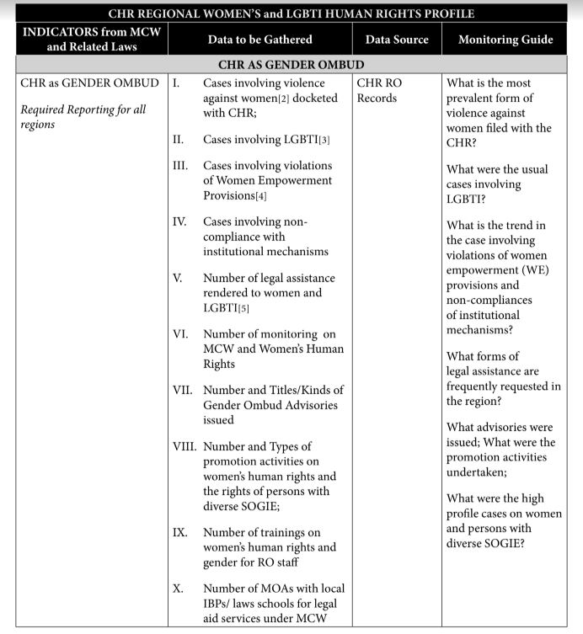

Involvement and participation of civil society in data gathering programs/activities

- Civil society organizations (CSOs) act independently from the government in terms of data gathering activities. Most, if not all CSO-initiated activities focus more on monitoring of protection of rights rather than population census.

Recommendations for data collection:

To improve the government’s collection of data regarding the LGBT population and cases of violence and discrimination against the community, the Commission recommends the following:

- For the government to work towards legal gender recognition and consider the same in the implementation of the national ID system by reflecting SOGIE in the national IDs issued;
- For the government to work towards the amendment of laws that deny legal gender recognition;
- For the government to systematize and institutionalize collection of data concerning LGBTI persons, particularly on the different forms of violence and discrimination directed against LGBTI persons on the basis of their SOGIESC;
- That efforts to gather data on LGBTI communities should ensure protection of privacy and should be accompanied by continuing mainstreaming of human rights in relation to SOGIESC, gender sensitivity, and clear protocols in handling cases of LGBTI persons anchored on dignity and full respect for human rights; and
- For the Philippine government to strengthen partnership with civil society organizations and the Commission in terms of data collection and analysis.

As the National Human Rights Institution (NHRI) of the Philippines, the Commission on Human Rights of has the mandate vested by the 1987 Philippine Constitution and the Paris Principles to promote and protect the full range of human rights including civil and political rights, and economic, social and cultural rights. It has the responsibility to regularly report and monitor human rights situations and violations, and recommend steps in advancing the realization of human rights and dignity of all. The Commission has “A”-status accreditation from the Sub-Committee for Accreditation, and it is a full member of the Global Alliance of National Human Rights Institutions (GANHRI) and the Asia-Pacific Forum of National Human Rights Institutions.
Commission on Human Rights of the Philippines, Inputs on Protection Against Violence and Discrimination Based on Sexual Orientation and Gender Identity, June 9, 2017.
An Act Prohibiting Discrimination on the Basis of Sexual Orientation and Gender Identity or Expression (SOGIE) and Providing Penalties Therefore [Anti-Discrimination Act], Senate Bill No. 1271, available at https://www.senate.gov.ph/lisdata/2517921693!.pdf, (last accessed March 15, 2019).
Commission on Human Rights, Inputs on the Protection Against Violence and Discrimination Based on Sexual Orientation and Gender Identity, June 9, 2017.
An Act Establishing Women's and Lesbian, Gay, Bisexual and Transgender (LGBT) Protection Desks in all Philippine National Police Stations Nationwide, Amending for the Purpose Title VII of the Republic Act Number 8551, as Amended Otherwise Known as the ‘Philippine National Police Reform and Reorganization Act of 1998, House Bill No. 5082 (2016) and Senate Bill No. 926 (2016), available at http://www.congress.gov.ph/legisdocs/first_17/CR00123.pdf (last accessed 20 February 2019)
Id.
Commission on Human Rights, CHR Gender Ombud Guidelines, 2016, available at http://chr.gov.ph/wp-content/uploads/2018/09/CHR-Gender-Ombud-Guidelines.pdf (last accessed 15 March 2019).
Commission on Human Rights, Position Paper on the Pending Bills on Anti-Discrimination on the Basis of Sexual Orientation and Gender Identity, 8 October 2018, available at http://chr.gov.ph/position-paper-on-the-anti-discrimination-on-the-basis-of-sexual-orientation-and-gender-identity-or-expression-bill/ (last accessed 15 March 2019). See also the Commission’s submissions to OHCHR about discrimination of minorities: https://bit.ly/2FDV4vK

