Input for the report of the Independent Expert on protection against violence and discrimination based on sexual orientation and gender identity

The Bisexual Report (UK 2012) has much to say about the effects of biphobia at all levels. It includes references to data on issues like the way that bisexual people have the worst mental health problems, including high rates of depression, anxiety, self harm and suicidality.

http://oro.open.ac.uk/52881/

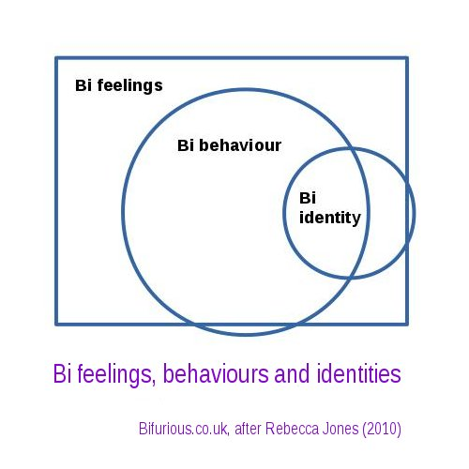

When it comes to data throughout your report, we suggest that you note the following:

It is widely acknowledged that sexual orientation is made up of a number of things, including sexual ATTRACTION, sexual BEHAVIOUR and sexual IDENTITY.

It is absolutely critical that anyone producing data about sexual orientation acknowledge which of those they are talking about and the effects of that decision..

.. but far too few do.

Outside the field of sexual health, the aspect most typically used alone to measure 'sexual orientation' is IDENTITY.

This seriously understates the number of people with bisexual ATTRACTION and bisexual BEHAVIOUR.

http://bifurious.co.uk/wp-content/uploads/bisexual-feelings-behaviours-and-identities.jpg

One factor may well be that activists care a lot about sexual identity. For most, having an LGBT identity will have been a big reason why they do LGBT activism. It can also suit the agenda of homo- and biphobes to talk about identity: self-identification is clearly a matter of choice rather than being innate and the numbers are lower!

The definitions issue is linked to the way that an awful lot of people with lesbian / gay / straight identities have attractions (and sometimes behaviour) that could best be described as bisexual, because they are not all to one gender.

The bi community has always been happy with people who say they're, say, a 'lesbian-identified bisexual' (as well as people who don't have any bi in their identity) but there are far too many lesbian / gay / straight spaces where talking about bisexual attractions is taboo.

There shouldn't be a conflict between saying someone's identity is A and their attraction is B – or even that their behaviour is A or B or C – but it's one of the things that many monosexual spaces decide that they do not want to even address.

The most commonly used definition of bisexuality currently used within the bi community is 'an ATTRACTION to more than one gender'.

We recognise that not every bisexual person is SEXUAL with more than one gender and that not every bisexual IDENTIFIES as 'bisexual'. As well as identities like 'pansexual' or 'queer', many people with bisexual ATTRACTION and/or BEHAVIOUR identify as straight or lesbian / gay or have no sexual IDENTITY in terms usually used at all.

For an example of the latter, see 'Behaviourally Bisexual Men: Identifying needs for HIV prevention' finally published by the UK government's Health Education Authority in 1996.

Commissioned to show that there were very few men with bisexual BEHAVIOUR, the researchers used ads in newspaper personal ad columns and were completely swamped by the response.

Despite the way that the men who responded were actively sexual with men and women - an average of three of each per year, identical in total to the researchers' surveys of gay men which averaged six male partners per year - when asked, 'How do you think of yourself, in terms of your sexuality?' at the end of the interview, over half could not answer.

They were prompted with a second question: 'What term would you use to describe yourself, sexually?' Even then, less than half of the total sample had a bisexual (or similar) IDENTITY. More than one in eight identified as straight, despite having just talked about their bisexual behaviour. Fewer than 1% had a gay identity, one reason why materials explicitly aimed at gay men will simply not be seen as relevant by this population.

The report is long out of print, but is available, with comments from someone in the bi community at https://chaps.org.uk/behaviourally-bisexual-men/

Looking at the first two requests for information about data, we have it for the United Kingdom and New Zealand.

1. After much debate, the UK is in the process of looking at sexual IDENTITY for its next census, due in 2021.

A series of tests by the Office for National Statistics (ONS) have asked about sexual orientation in the Annual Population Survey, via asking about sexual IDENTITY.

The ONS acknowledge that IDENTITY is not the same as BEHAVIOUR or ATTRACTION, and "an individual could respond differently" if asked about those, but there is no acknowledgement that, for the reasons above, this seriously understates size of the bisexual population.

The ONS says "The measurement of sexual identity has been identified as the component of sexual orientation most closely related to experiences of disadvantage and discrimination", but it is the bisexual BEHAVIOUR that is the cause of much discrimination and ATTRACTION that is the cause of much biphobia.

https://www.ons.gov.uk/peoplepopulationandcommunity/culturalidentity/sexuality

https://www.ons.gov.uk/peoplepopulationandcommunity/culturalidentity/sexuality/methodologies/sexualidentityukqmi

The current New Zealand Minister of Statistics has committed to the next Census of New Zealanders in 2023 including questions on gender identity and sexual orientation. As yet the form of the questions is unknown but standards and information are available on the Statistics website.

https://www.stats.govt.nz/reports/sex-gender-and-sexual-orientation

Interestingly, the Statistical Standards document that forms the basis of their work on sexual orientation explicitly acknowledges that "Sexual identity can be fluid, changing over time or across social contexts". Doing this is surprisingly rare, although the idea that sexual orientation often does change over time was in the Klein Sexual Orientation Grid back in 1978.

It also realises that "it is preferable for a person to be able to write in their sexual identity, to fully describe their sexual identity. Choosing from a pre-determined list may prevent people from fully expressing their sexual identity."

Given these, it is surprising that the list of synonyms people may give includes amongst others 'pansexual', 'polysexual', and 'bicurious' as being "sexual identity not elsewhere classified" rather than "bisexual".

If you're categorising people with, for example, a pansexual or bicurious IDENTITY as 'other' rather than 'bisexual', you are going to seriously understate the number of people with a Bi+ IDENTITY.

http://aria.stats.govt.nz/aria/#StandardView:uri=http://stats.govt.nz/cms/StatisticalStandard/PketqbcOW7aEzSjT

2. One common consequence of violence can be contact with medical services, which should also be monitoring health disparities due to sexual orientation.

In 2017, the UK's National Health Service (NHS) released a new sexual orientation monitoring Information Standard. This means that there is now "a consistent mechanism for recording the sexual orientation of all patients/service users aged 16 years across all health services in England".

Again, it asks about sexual IDENTITY and, again, will seriously under-estimate the bisexual population and the issues it faces.

The leading organisation that pressured the NHS to do this was the LGBT Foundation, an LGBT organisation nominally inclusive of all the letters in the acronym it uses.

To go with the NHS's standard the LGBT Foundation published a "best practice" guide which a) didn't mention the issue of under-estimation and b) managed to say, via the definitions it did use, that every bisexual person was also straight?!?

https://bifurious.co.uk/better-than-nothing/

