Report to the United Nations General Assembly on Eliminating Intolerance and Discrimination Based on Religion or Belief and the Achievement of Sustainable Development Goal 16 (SDG 16): NGO Submission on Revocation of Chinese Children’s Right to Freedom of Religion or Belief

- Background
Jubilee Campaign, in special consultative status with ECOSOC, submits this analysis the revocation of children’s right to freedom of religion or belief in China as a response to the request by the Special Rapporteur on Freedom of Religion or Belief for submissions related to Article 2 of the 1981 Declaration on the Declaration on the Elimination of All Forms of Intolerance and of Discrimination Based on Religion or Belief.

- Relevant Legal Framework
Article 14 of the Convention of the Rights of the Child states that “States Parties shall respect the right of the child to freedom of thought, conscience and religion”; moreover, China’s constitution similarly includes a provision protecting freedom of religion for all citizens of China and stating that state entities are prohibited from discriminating based on religion.
Despite such provisions which at the surface appear to protect and even encourage the exercise of the freedom of religion or belief, the Religious Affairs Regulations, formally Decree No. 426 of the State Council Order of the People’s Republic of China on November 30, 2004, outlines a prolonged list of regulations- and superfluous restrictions- related to the practice of religion all religious activities. It is believed that this decree is being used to justify the prohibition of children under the age of18 years from attending church services and other activities with religious purpose. Displayed below are the Articles in the Decree No. 426 that are reported to be applied to the situation in China:
Article 44: It is prohibited to preach missions, hold religious activities, establish religious organizations, or establish venues for religious activities in schools and other educational institutions other than religious institutions.
Article 2: Citizens have freedom of religion or belief. No organization or individual may compel citizens to believe in religion or not to believe in religion, nor may they discriminate against citizens who believe in religion (hereinafter referred to as religious citizens) or citizens who do not believe in religion (hereinafter referred to as non-religious citizens)

- Discrimination in Law and Practice

- Laws and Policies restricting the right to manifest freedom of religion or belief of minority religious communities

Restriction Notices Prohibiting Minors from Attending Church

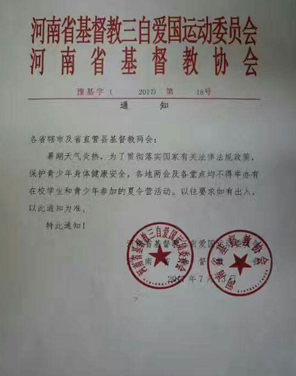
Since 2017, numerous news articles have reported a concerning new trend in which the government prohibits children under the age of 18 years from entering and attending church services and religious events such as Christian summer camps; related incidents have occurred throughout multiple provinces: Henan, Xinjiang, Fujian, Jiangsu, and Zhejiang. It is no coincidence, according to World Watch Monitor, that the provinces in which such restrictions are imposed are known to have relatively high levels of Christians in the population. Individuals have taken photographs of the notices that have been appearing on church doors throughout these provinces:

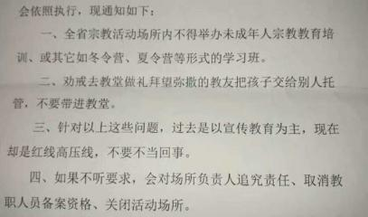

(photo above from AsiaNews.it)

(Photo above from World Watch Monitor)
Both of the above photos are of signs that were placed on church doors in Henan province and provide an example of the rhetoric used to restrict religious activity to minors. The first of which (pictured above left) states that such restrictions are to “protect the health and safety of teenagers during the hot summer holidays” and the second of which “pictured above right) states:
“The two official Church organs in the Henan Province- the Henan Catholic Patriotic Association, and the Henan Commission for Church Affairs- jointly issued a circular on April 8, 2018. This circular, with great severity, requires the affiliates of these two bodies at every level to implement the new regulations on religious activities, adhering to the principle of ‘separating religion from education,’ and in particular prohibits ‘religious associations to organize activities of any form to disseminate religious education for minors.’ Throughout the Province, it is forbidden to organize activities of any form such as school class, summer camp or winter camp, etc. for minors for religious education or formation;”
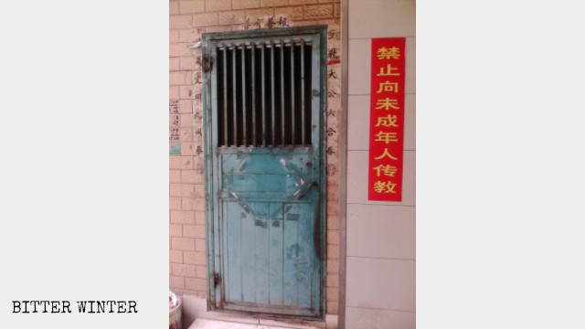
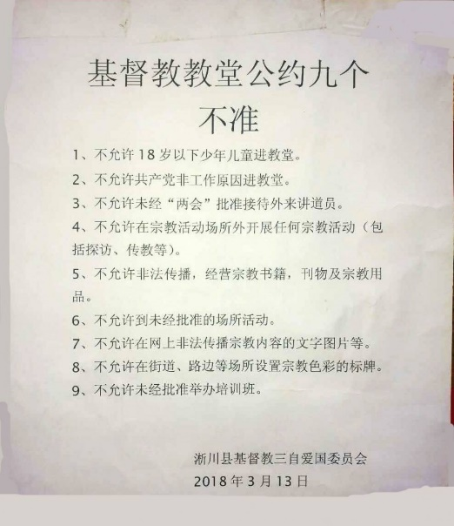
World Watch Monitor reports that similar notices have been found in Fuzhou, Fujian Province, which state “it is forbidden to force or tempt juveniles to believe in any religion and it is also forbidden to conduct religious activities in non-registered religious venues without approval.” Below are a couple more images of notices that make mention of age restrictions for church activity participation:

(Photo by Bitter Winter)

(Photo by Chinese Christian Tribune)
Bitter Winter explains that this new era of restrictions on minors attending religious services and activities was initiated as a direct result of the Regulations on Religious Affairs, which, although being initially signed in late 2017, only came into force by early February 2018; directly after this decree was implemented, local government authorities have embarked on a campaign “from extensive anti-religious propaganda on school campuses to crackdowns on church-organized Sunday schools and summer camps.”

Restriction Notices Appearing in Schools and College Campuses
Similar to the notices appearing on church doors throughout multiple Chinese provinces, multiple media outlets have reported that notices have been erected on schools and campuses that explain that “faith-related activities, information, and symbols” are forbidden. One district in Wenzhou, Zhejiang Province, received a notice from the government stating that “minors receiving religious education and formation too early in churches would seriously affect the normal implementation of the education system,” exhibiting the CCP’s concerns that the growing influence of religion in China could become an increasingly popular narrative combatting the atheist “pro-CCP” and “pro-nationalism” narrative ingrained in Chinese children through traditional education.
According to one school director, “’If too many people turn to religion, then no one will believe in the Communist Party…therefore, dynamic ideological control is crucial for the CCP.’” Another rhetoric that the government uses is that children should not hold religious convictions “’because they are unable to think independently, as they are at a critical stage of development, both physically and mentally, which is crucial for establishing correct outlook on the world, life, and values.’”
Another method to prevent religious rhetoric from ‘infiltrating’ secular schools is by forcing teachers to sign away their freedom to attend religious services; in Zhejiang Province, teachers have reported that the government has been requesting they sign a letter “pledging to hold no religious beliefs” and specifically that they make no efforts to engage in evangelist activity within schools. In Yueqing, a county in Wenzhou, Zhejiang Province, teachers have been ordered to “adhere to the correct political direction, promote atheism, firmly establish a Marxist religious outlook, not believe in any religion, and not teach any religious knowledge to students.”
Parents in Wenzhou have even reported that their family received video messages from their children’s teachers urging the families to not bring their children with them to church, as local education boards have been warned that government investigation teams are likely to conduct inspections to see how many students are attending church with their families. Parents have also received letters from their children’s schools which they must sign to ensure that their children will not be attending “religious venues for scripture study classes or other theological training.”

Promotion of Anti-Religious Rhetoric and Propaganda
In addition to the mass restrictions of minors attending church services and the prohibition of religious instruction in schools, the CCP has intensified efforts to promote the dissemination of anti-religious propaganda in schools and on social media. These propaganda campaigns are used to discredit and disparage religion and discourage children from holding religious beliefs and taking part in religious activity. Below is a notice that was posted on China’s sole social media application, WeChat, which instructs children to “say no!” to religion:
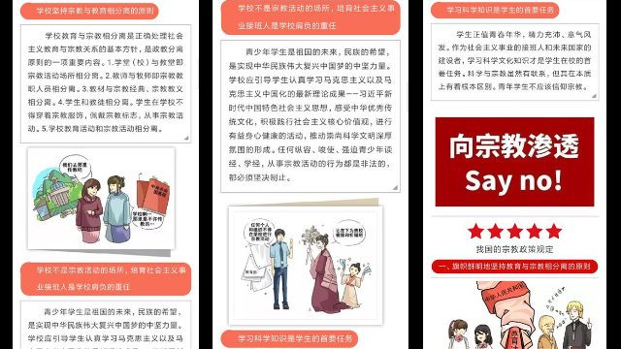
(Photo by Bitter Winter)
According to Bitter Winter, “The authorities are seeking to legalize their actions by painting religions as dangerous, and their suppression as something done for the common good and vital to the society’s well-being. The manipulation of people’s minds is most effective if started from an early age; this is why the Chinese authorities have been increasing their anti-religion efforts on school and university campuses, making it one of their top priorities.”
Another main anti-religious propaganda tactic includes organizing marches and demonstrations criticizing and condemning xie jiao, which literally translates to ‘evil cults,’ but refers to “any independent religious movement either regarded as hostile to the CCP or growing to rapidly for the CCP’s tastes,” both of which criteria applies to the growth of Christianity and other minority religious practice in China. In one xie jiao march, a primary school discredited religion by chanting “Resist Superstition. Believe in Science. Boycott xie jiao.” In fact, photos of such marches and photos of primary school students waiting in line to sign an agreement “not to enter religious venues” display just how young and impressionable these students are; one student explained, “We don’t even know what religion is. The principal just said that we wouldn’t be allowed to leave until we signed our names.”
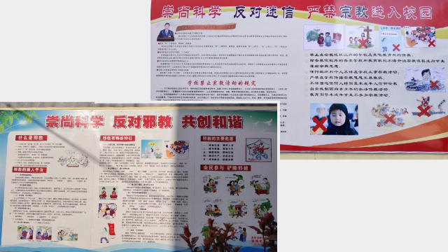
(Photo by Bitter Winter)

- Effects of Discrimination

- Violation of the Convention on the Rights of the Child
In crafting the above policies which restrict the right of Chinese children to access religious activity and instruction in all areas of their life outside of the home, the Chinese government is explicitly violating each section of Article 14 of the Convention on the Rights of the Child:
Article 14
- States Parties shall respect the right of the child to freedom of thought, conscience and religion.

- States Parties shall respect the rights and duties of the parents and, when applicable, legal guardians, to provide direction to the child in the exercise of his or her right in a manner consistent with the evolving capacities of the child.

- Freedom to manifest one’s religion or beliefs may be subject only to such limitations as are prescribed by law and are necessary to protect public safety, order, health or morals, or the fundamental rights and freedoms of others.
Children are not only prohibited from participating in a minority religion of their choice due to the restrictions of their attendance in church, but their parents and guardians are similarly forbidden from raising their children in their family’s religion.
- Parents Discouraged and Restricted from Raising Children in their Faith
In addition to being restricted from attending church and holding religious beliefs/attending religious events in general, children have been encouraged by teachers and local government officials to report their parents if they engage in religious activity or worship. Moreover, the contradiction between receiving anti-religious education and warnings in school and being a child to religious parents “leaves many children confused and sometimes angry with their Christian parents and brings parents in the difficult situation of having to defend themselves almost constantly. For converts, members of their wider family will try to influence the education of their children.”
- Displacement and forced migration of religious or belief communities owing to discrimination, exclusion or land rights violations.
In mid-2019, news reports revealed that Chinese Christians have migrated from their home country to nations that are more accepting of their religious beliefs. Since the mass demolition of churches and state-sponsored persecution of and discrimination against Christians in China, many individuals have escaped with their families and children to nations such as nearby Taiwan or far-away Kenya in order to find communities where they may freely practice their religion.
- Best Practices
Jubilee Campaign urges the Government of China to adopts the following best practices to ensure the enjoyment of freedom of religion or belief for children in China:
Remove age restrictions on church attendance and allow all children and minors to partake in worship and religious activity of their choice.
Allow parents to raise children in their faith.
Cease the country-wide anti-religious propaganda campaigns, which often mischaracterize religion as being dangerous and inciting subversion of the regime.
Stop requiring young impressionable children to sign binding agreements that they will not participate in religious activity within or outside schools.

Religious Affairs Regulations, Decree No. 426 of the State Council Order of the People’s Republic of China on November 30, 2003, Cloth revised and adopted by the 176th executive meeting of the State Council on June 14, 2017, available at: http://www.gov.cn/zhengce/content/2017-09/07/content_5223282.htm?from=timeline
World Watch Monitor, “China bans children- and their teachers- from churches,” 8 September 2017, available at: https://www.worldwatchmonitor.org/2017/09/china-bans-children-and-their-teachers-from-churches/
Wang Zhicheng, “Henan, church banned for children under 18: ‘taking the legs from under the Christian community’s growth among young people’”, AsiaNews.it, 17 April 2018, available at: http://www.asianews.it/news-en/Henan,-church-banned-for-children-under-18:-%E2%80%98taking-the-legs-from-under-the-Christian-community%E2%80%99s-growth-among-young-people'-43646.html
World Watch Monitor, “China bans children- and their teachers- from churches,” supra note 2.
Wang Zhicheng, “Henan, church banned for children under 18: ‘taking the legs from under the Christian community’s growth among young people’”, supra note 3
World Watch Monitor, “China bans children- and their teachers- from churches,” supra note 2.
https://bitterwinter.org/
Cai Mingxian, “Do not enter the church under the age of 18! The key to controlling the development of Chinese churches is still based on external policies,” Chinese Christian Tribune, 12 April 2018, available at: https://www.ct.org.tw/1321727
Zhou Xiaolu, “Bans on Minors’ Religious Activities Enforced Throughout China,” Bitter Winter, 25 October 2019, available at: https://bitterwinter.org/bans-on-minors-religious-activities-enforced/
Tang Wanming, “State Ensures that Children Stay off Religion on Holidays”, Bitter Winter, 25 August 2019, available at: https://bitterwinter.org/state-ensures-that-children-stay-off-religion-on-holidays/
UCAnews, “Chinese authorities ban children going to churches,” available at: https://www.ucanews.com/news/chinese-authorities-ban-children-going-to-churches/80115
Tang Zhe, “China’s Schools Pledge to Do Away with Religion,” Bitter Winter, 4 February 2020, available at: https://bitterwinter.org/chinas-schools-pledge-to-do-away-with-religion/
ibid.
Yang Fan & Qiao Long, “China Makes Teachers, Medical Professionals Pledge Not to Follow Any Religion,” Radio Free Asia, 26 September 2018, available at: https://www.rfa.org/english/news/china/religion-09262018110746.html
ibid.
World Watch Monitor, “China bans children- and their teachers- from churches,” supra note 2.
Tang Wanming, “State Ensures that Children Stay off Religion on Holidays”, supra note 10.
Tang Wanming, “State Ensures that Children Stay off Religion on Holidays”, supra note 10.
Wang Yichi, “Want An Atheist Generation? Start from an Early Age”, Bitter Winter, 29 April 2019, available at: https://bitterwinter.org/want-an-atheist-generation-start-from-an-early-age/
Jiang Tao, “A Secret Document Details the Plan for Persecuting the Movements Listed as Xie Jiao” Bitter Winter, 29 July 2018, available at: https://bitterwinter.org/plan-for-persecuting-xie-jiao/
Wang Yichi, “Want An Atheist Generation? Start from an Early Age”, supra note 19
ibid.
ibid.
UN General Assembly, Convention on the Rights of the Child, 20 November 1989, United Nations, Treaty Series, vol. 1577, p. 3, available at: https://www.refworld.org/docid/3ae6b38f0.html [accessed 28 May 2020]
Open Doors World Watch Research, China: Country Dossier February 2020 update, available at: http://opendoorsanalytical.org/wp-content/uploads/2020/02/China-WWL-2020-Country-Dossier-February-update.pdf [accessed 29 May 2020].
ibid.
Caleb Parke, “Chinese Christians flee China amid crackdown on church: ‘No longer safe for us’”, Fox News, 8 July 2019, available at: https://www.foxnews.com/world/china-christian-church-crackdown-safe
Jenni Marsh, “As churches are demolished at home, Chinese Christians find religious freedom in Kenya”, CNN, 21 May 2019, available at: https://www.cnn.com/2019/04/28/asia/china-christians-africa-kenya-intl/index.html

