**Response prepared by the International Decade for People of African Descent Assembly–Guyana (IDPADA-G) For the United Nations Working Group of Experts on People of African Descent**

1. **THE REQUEST FROM THE UNITED NATIONS WORKING GROUP OF EXPERTS ON PEOPLE OF AFRICAN DESCENT**

**The Working Group would appreciate receiving views from all interested stakeholders on the current human rights situation of people of African descent globally (January-June 2021) as we analyse where we are and the urgent next steps to commemorate the 20th anniversary of the DDPA. The Working Group would also welcome any positive measures that have been undertaken by Member States, national human rights institutions and equality bodies, civil society, and UN agencies, funds and programmes. In addition, the Working Group would welcome any specific recommendations you would like to make to further the protection of human rights of people of African descent in this context.**

1. **EXECUTIVE SUMMARY**

Guyana has had a 400-year history (1621-2021) of anti-African discriminatory and hateful racist public policies by Dutch, British and Guyanese governments. The periods of enslavement (1621-1838), Emancipation (1838). With the passage of the Abolition of Slavery Act, slave owners were generously compensated by the British Parliament for their loss of property and were allowed to continue their unfettered ownership and operation of their plantations. However, the manumitted slaves were released in 1838 without any land or compensation for the free labor they had contributed for over 200 years.

Indentureship (1834-1917) - - In 1838 Guyana had a population of 98,000- but by 1917 over 500 ships docked carrying 238,909 indentured Indian immigrants. Of these only 75,898 returned to India. The vast majority accepted government grants of land and settled in Guyana. Each was given 2 acres, plus an additional 2-acre plot per child over 10 and 1/2 and acre per child under 10, they also received 1/2 acre to build a house. Thus, a family of 6 could have received a grant of 12.5 acres plus pay.

Colonization (1838-1966), Independence (1966-1970), and Republicanism (1970-2021), have all had different challenges for Africans in Guyana but the overarching issue has been an environment that perniciously negates the 30 Principles of the Universal Declaration of Human Rights adopted by United Nations since December 1948. The 30 rights and freedoms set out in the Declaration include economic, social, and cultural rights.

The United Nations is very aware of Guyana’s ethnically polarized society through the reports of:

* Doudou Diène, the Special Rapporteur on Contemporary Forms of Racism, Racial Discrimination, Xenophobia, and Related Intolerance who visited in 2003.
* Gay McDougall, the UN Expert on Minority Issues visited Guyana’s Report in 2009.
* The Working Group for People of African Descent’s Report with 66 recommendations in 2017.

Even former United States President Carter understood the racial environment that existed in Guyana when he brokered a new election in 2001.

Doudou Diène, the Special Rapporteur on Contemporary Forms of Racism, Racial Discrimination, Xenophobia and Related Intolerance observed, *“Every level of Guyanese society is permeated by a profound moral, emotional and political fatigue, arising out of the individual and collective impact of ethnic polarisation.”*

Ms. Gay McDougall, the UN Expert on Minority Issues in her report wrote mirroring Doudou Diene, *“The harsh reality (in Guyana) is one of ethnic polarization among Guyanese of African, Indian and indigenous descent”.* This she indicated is because of “corrosive racial politics*.*

While one hoped that the Durban Conference of 2001 would have been a catalyst for the improvement of Human Rights in Guyana, the situation deteriorated dramatically in 2020 with the US-led interference in Guyana’s election, resulting in the removal from office of a multi-racial coalition under which African Guyanese could see a path to a more equitable and humane society. This new administration led by the predominantly Indian People’s Progressive Party came into office just as Guyana (EXXON) began oil production and has solidified the Indian domination of the public and private sectors (begun in its 23-year rule from 1992 – 2015) to the complete exclusion of African descendants.

United Nation’s rapporteurs and WGEPAD have documented the plight of people of African descent in Guyana. Now, in the midst of Guyana’s fast-growing economy and oil wealth, African Guyanese face utter marginalization in all sectors, mass unemployment through racially biased layoffs and terminations from the public sector, racial bias in hiring in the private sector, racial discrimination in the award of contracts, oil blocks, banking licenses, access to investment capital, access to land for farming and commercial ventures and dramatic reduction or closure of training programmes traditionally utilized by African Guyanese as the path to employment and financial security.

This report highlights the systemic racism, political persecution and economic apartheid now being unleashed against the African Guyanese population. It is our hope that the UN will bring global attention to the dramatic erosion of the human rights of African Guyanese and to the very real threat of the complete marginalization and displacement of our community.

1. **BACKGROUND**

Guyana is a divided society in which Africans are caught in a pernicious “winner-take-all” Westminster electoral system that is driven by racism and racial voting. With much at stake because of Guyana’s new oil and gas sector, the Indian dominated ruling party, the People’s Progressive Party (PPP) is openly and ruthlessly pursuing the Indianization of Guyana, supported by the Modi government of India. The current administration demonstrates cold indifference to the historic contributions of African Guyanese who, as enslaved persons, built Guyana. As reported by the Venn Commission:

[Africans] *“had driven back the sea and had cleared, drained, and reclaimed 15,000 square miles of forest and swamps. This is equivalent to 9,000,000 acres of land. In short, all the fields on which the sugar estates are now based were cleared, drained, and irrigated by African labor forces. All the plantations now turned villages and cities were built by unpaid African labor. In the process of building these plantations, careful research has shown that Africans installed the following (1) 2,580,000 miles of drainage canals, trenches, and inter-bed drains, (2) 3,500 miles of dams, roads, and footpaths, and (3) 2,176 miles of sea and river defense.* The Venn Commission of 1948 also reported that *“to build the coastal plantation alone, a value of 100,000,000 tons of earth had to be moved by the hands of African slaves* [without machinery]*”.*

**Two forces shape race relations in Guyana today and negatively impact the human rights of African Guyanese:**

1. **Hindu Nationalism and its philosophical (caste) underpinnings, and**
2. **The “winner take all” electoral system in Guyana’s racially polarized space**
3. **Hindu Nationalism**

The current government of Guyana has strong ties to the Modi administration of India and governs the country to benefit its supporters, the majority of whom are Indian Guyanese. The PPP relies on their fear and scorn of Africans - - seen as the lowest caste or outcast in the Hindu religion, to maintain political power, driving a racial wedge in the society. The Hindu-grounded sense of hierarchy, along with its prejudice against blackness and an instinctual, negative perception of Africans is a source of anti-African racism in Guyana.

In Race and Stereotypes *Blackman and coolieman”: The roots of prejudice* written by Indian activist Ravi Dev he informs us:

“*The Indians defensively engaged in their own evaluation of the African with whom they were thrown into contact. In addition to British judgment of the ex-slaves as (lazy for refusing slave wages) the Indians utilized their own idiom, myths, and categories to evaluate the African ex-slaves. One consequence of the Aryan conquest of the dark skinned “Dasyus” in early Indian history has been a negative evaluation of the dark skin, which persists to the present even between Indians. When the Indians saw the Africans with their dark skin, kinky hair, large size and other negroid features they labeled them “rakshas” or “lankas” demon followers of the evil king Rawan of the Ramayana. They reasoned that after the burning of the Lanka by Hanuman, the rakshas’ hair was singed and became wooly. The indiscriminate meat-eating habits of the ex-slaves lent credence to the new Indian myth. The Indian category of caste was now extended to include the African who was placed in the position of the outcaste*. Much of this prejudice exists to the present.

The scorn of demonization and relegation did not remain a private affair it was institutionalized. The anti-dark skin prejudices which the Indians had brought with them, and which are rooted in the sanatan dharm, were politicized. The politicization preyed on the Indian insecurity and religious fear of, and dislike for the colour black or dark skin - the Africans, their devil- and proffered reliance for their salvation and protection upon Cheddi Jagan. Africans were portrayed by the P.P.P. as Rakshas people of the evil king Rawan. They were relegated to the level of outcast.

In establishing the presence of caste thinking in Guyana we have quoted the late Guyanese historian, Dale Bisnauth (1936-2013), who observed the Indian attitudes do bear “the malign vestiges of caste thinking.” It was the same Dale Bisnauth as a senior PPP government minister who said that Mashramani the national celebration in honour of the nation’s status as a Republic was Black peoples affair not worthy of government support. Ravi Dev, Dale Bisnauth the late Minister of Education, and other Indian political leaders allude to the existence of Indian caste thinking/consciousness at the elite levels of Indian political society and acknowledge its use to condition Indians’ perceptions of Africans in building the political culture of the Indian community. Its existence in the mindset of the PPP government is not difficult to presume.

The PPP’s 2020 campaign, conducted with the assistance of a Cambridge Analytica-style US firm, Mercury PR, capitalized on the Hindu caste stereotypes of the dark-skinned evil one. These tropes have always been trotted out to win elections, however the PPP and Mercury launched an all-out war on the character and humanity of African Guyanese in their effort to win the 2020 elections and control the nation’s oil wealth. The PPP’s rise to power through a destructive and divisive political campaign, has been followed by a ruthless strategy that seeks to permanently criminalize and destroy African leadership, hauling political figures before the Courts on scurrilous charges, emblazoned across the headlines but whispered when dropped. This on-going attack on the community is also destroying the self-confidence and pride of place in Guyana of all African Guyanese – particularly youth.

1. **The impact of a “winner take all” system in a racially polarized society**

Guyana’s Westminster-style political arrangements facilitate the consolidation of power of one group and has provided the opportunity for the PPP to covertly implement the British (Indian) Colonization Scheme first proposed in 1919. Under this scheme, prominent Indians in Guyana and the British Guiana Government offered India the colony of British Guiana (Guyana) to become a Colony of India.

*We, the Indian representatives of the Imperial Colonization Deputation of British Guiana, now formally state that it is our desire, aim and our object, if possible, to induce more Indians from the Motherland to join our ranks, increase our numbers and so help to make British Guiana and Indian Colony. This is really the Empire’s clarion call to India.*

*As our population is now about 45% Indian (145,000) and our constitution involves equality of all races, we are really offering India a Colony of its own on the Northeastern Coast of South America, with fertile soil and a healthier climate than that of India or of any large tropical Colony.*

*If our Colonization proposition is disinterestedly approached by the Indian labour reformers in India, we have no doubt that they will approve of our Scheme, and that in the very near future the colony will be in a position by the introduction and utilization of Indian agriculturalists and Indian capitalists to place British Guiana in the front ranks of British Colonial possessions. The vast political and national advantage to India of having and Indian Colony on the South American Continent need not be emphasized.*

*We would then have hundreds of prosperous villages and thousands of square miles of flourishing crops springing up from the fertile soil of the Colony, and by the exploitation of the Gold, Diamond, Aluminum, (bauxite ore) and other mineral and forest wealth of British Guiana, the three-century old dream of Sir Walter Raleigh regarding our Magnificent Providence, the fabled land of El Dorado, would be realized.*

The British Guiana Colonisation Scheme initially targeted many areas, namely: (1) 6,300 acres in the Pomeroon behind Hampton Court estate, (2) 8,000 acres on Hog Island on the steamer route to East and West Essequibo. (3) 2,108 acres from Philadelphia to Bonasika Creek adjoining the Boerasiriri Creek and Warimia Conservancy, (4) 7,500 acres on or adjoining the Canals Polder, (5) 32,580 acres on the Mahaica, (6) 14,854 acres on the West Coast and Abary, (7) 7,450 acres on the Corentyne Coast. In addition, there were the lands of the N.W. District which required no empoldering over at least 100,000 acres.[1] Today, all of these areas are occupied mainly by Indo-Guyanese. Many elements of the British Guiana Colonisation Scheme were executed in secrecy.

The arrival of oil has hastened the full implementation and unveiled the successful accomplishment of the Colonization Scheme. While representing 39% of the population, Indians now own and control 85% of Guyana’s economy; Portuguese who number less than 0.26% of the population, own roughly 12% of GDP or more land and assets than 300,000 Africans. Amerindians own 18% of Guyana through the Amerindian Act of 2006. African Guyanese, 29% of the population, own less than 7% of the nation’s wealth.

1. **EROSION OF AFRICAN GUYANESE - HUMAN RIGHTS JANUARY – JUNE 2021**
2. **DISCRIMINATION AND INHUMANE CONDITIONS OF THE CRIMINAL JUSTICE SYSTEM**

The 2017 report of the Working Group of Experts on People of African Descent documents the Human Rights violations against people of African descent with respect to the Criminal Justice system. Those violations still harm our community. In addition, since the 2020 elections,another dimension to the criminal justice system which sees the employ of the state apparatus to pursue political opponents and those who are deemed to be supportive of them. The most recent incursion into this practice is the state’s seemingly relentless pursuits of opposition executive and ordinary members, their supporters and those accused of marring the electoral process - primarily if not exclusively Afro Guyanese. Several of these persons have been taken into custody and detained for the constitutional 72 hours upper limit in circumstances that do not warrant their protracted detention, even if the state is committed to being aggressive in its investigations. Several of these persons have been charged, taken before the court, and placed on exorbitant bail. Some of them have been repeatedly taken before the courts on new charges warranting the lodgment of other heavy sums of bail which are not objectively justifiable when they have been diligently attending court on their other connected charges, given that the core object in the granting of bail is to ensure the attendance of the accused at court. For those persons, there is no objective risk that they may not attend court; and properly, the assortment of other charges should see them released on their own recognisance.

1. **LACK OF ACCESS TO FREEDOM OF EXPRESSION COUPLED WITH THE WEAPONIZATION OF THE MEDIA AGAINST AFRICAN GUYANESE**

Indians in Guyana control 90% of news media (tv stations, cable TV, radio stations and internet companies. An alarming trend has been the noticeably anti-African campaign in the news media now going on for over 250 straight days. Daily, Freddie Kissoon of the Kaieteur News attacks African leaders, African parties, and African organisations. In addition to this daily onslaught, the online Indo Caribbean Diaspora News (ICDN), rewrites history and demeans Africans. These journalists and “historians” are engaged in a total re-writing of history centered on the demonization of Africans.

In 2010, Former President Jagdeo, in his self-appointed role as Minister of Communications, unilaterally issued cable TV licenses to friends and party supporters.

In July 2011, months before his departure as the 2-term President of Guyana and with elections scheduled for November 2011, he issued radio licenses to his ruling Party, the PPP; to his best friends Dr. Bobby Ramroop,; his sister Ruth Baljit ; a Permanent Secretary in the Ministry of Natural Resources Omar Lochan (husband of the sister of Education Minister Priya Manickchand); and to a company whose Director is Kamini Persaud, the wife of then Minister of Natural Resources Robert Persaud (Ruth Baljit’s sister).

Freedom Radio, which operates out of the PPPC’s party headquarters, Freedom House, received five frequencies- 91.1 MHZ; 90.7 MHZ; 90.5 MHZ; 105.9 MHZ and 105.3 MHZ-through New Guyana Company Limited that publishes the Mirror newspaper. Ramroop obtained five frequencies 89.3 MHZ; 89.5 MHZ; 89.7 MHZ; 106.9 MHZ and 107.3 MHZ.

In addition to the lack of access to **Freedom of Expression** by African Guyanese because of the “giving away” of state assets to Indians, there is also a concerted effort to dehumanize Africans and to suffocate “Freedom of Speech and fill the airwaves with views which advocate the superiority of Indians and the Hindu religion.

1. **RIGHT TO WORK – INDISCRIMINATE TERMINATION OF AFRICAN WORKERS AND THE WEAPONIZATION OF JOB CONTRACTS**

With the exception of a few brief periods in our history, since Emancipation and the purchase of abandoned plantations, public policy has sought to displace Africans from their land and to cripple their entrepreneurial efforts. The private sector is dominated by Indo Guyanese who discriminate against African Guyanese in hiring, as a result African Guyanese find themselves disproportionally employed in the Public Sector of Guyana.

The current Indian majority PPP government has taken several bold steps to weaponize their control of the government by firing over 1500 African Guyanese without cause and in pernicious ways and, often employing less qualified Indo-Guyanese. The position of Chief Medical Officer in the Ministry of Health is a very pernicious example.

Dr. Singh was promoted to Chief Medical Officer over Dr. Karen Boyle. Dr Singh’s credentials and experience do not compare with those of Dr Boyle. He graduated from a medical school in Cuba decades ago and has not sought post graduate studies but remained a junior doctor working in Obstetrics and Gynaecology in a government-run hospital in the outskirts of Georgetown for his quite lengthy career.

Dr Boyle on the other hand, won the prestigious Guyana Scholarship and studied medicine in Russia, completed a master’s degree in public health at Columbia University and her PhD in Public Health at the University of the West Indies. Recognising her qualifications, the previous administration appointed Dr Boyle as Deputy Chief Medical Officer in 2016. Dr Boyle is recognised internationally for her academic work where she served in senior technical and management positions on multiple international donors funded projects. She, a public health specialist, was fired, even as Guyana struggles against the COVID19 pandemic and replaced by an obstetrician.

The following is a sampling of the over 1500 African Guyanese unjustly terminated in recent months, during the pandemic, among them are single mothers, cleaners and drivers.

| **Name** | | **Sex** | **Position held** |
| --- | --- | --- | --- |
| **First** | **Last** |
| Troy | Bentick | M | Driver |
| George | Liverpool | M | Driver |
| Royston | Liverpool | M | Driver |
| Nigel | Bentick | M | Driver |
| Michael | Davis | M | Driver |
| Deborah | Mitchell | F | Cleaner |
| Shavone | Brutus | F | Receptionist |
| Tiffany | Cox | F | Exec. Assistant |
| Neibert | Paul | M | Exec. Assistant |
| Shawein | Smith | M | Handyman |
| Elson | Low | M | Policy Analyst |
| Dennis | Pile | M | Policy Analyst |
| Rondell | Need | M | Accountant |
| Loriann | Richmond | F | Budget Officer |
| Susanna | Williams | F | Case Manager |
| Faith | Wintz | F | Case Manager |
| Dawn | Holder-Cush | F | Chief Executive Officer |
| Brenden | Glasford | M | Legal Advisor |

Training programmes that are the entry point to the labor market for African Guyanese have been terminated. For example, the Bertram Collins Public Service Training College which provided a secure track into government service has been abruptly closed. The Nursing School in Linden, with its predominantly African student body, has been closed – even as Guyana struggles to manage the pandemic and in the face of recognition of the need for more health workers.

Forty-three African employees were fired from the State Assets Recovery Agency (SARA) and the agency shuttered after just four years. SARA had identified almost 400 cases of state asset corruption and theft. Most of the cases (90%) were against Indo Guyanese. SARA was created with help from the IDB, the UN and the STAR Initiative (UNIDO and the World Bank). Guyana is a signatory to the United Nations Convention Against Corruption (UNCAC). The United Nations Convention against Corruption is the only legally binding universal anti-corruption instrument. The Convention's far-reaching approach and the mandatory character of many of its provisions make it a unique tool for developing a comprehensive response to a global problem. The Convention covers five main areas: preventive measures, criminalization and law enforcement, international cooperation, asset recovery, and technical assistance and information exchange. The Convention covers many different forms of corruption, such as bribery, trading in influence, abuse of functions, and various acts of corruption in the private sector. A highlight of the Convention is the inclusion of a specific chapter on asset recovery, aimed at returning assets to their rightful owners, including countries from which they had been taken illicitly. Most of the United Nations Member States are parties to the Convention.

In the absence of SARA, the PPP government can return to the practices honed during its 23-year term in office (1992-2015) during which it used its power to allocate state assets and state contracts to its Indian supporters. Indeed, Dr. Clive Thomas, wrote:

“There is the existence of a cabal or coterie of persons comprised mainly, but not exclusively, of selective crime bosses, state officials, security personnel, elements of the criminal justice system and political bosses, advisors and other insiders. The combination is unique and derives from the historical antecedents as well as social, economic, and political circumstances in Guyana. This group as identified wields enormous power as well as commands considerable economic wealth. As the ruling elite this group has placed itself above the reaches of domestic law while at the same time leading the political charge in Guyana for law, order, public safety and human security**”.**

The displacement of African Guyanese from key positions and jobs is related to the establishment of criminal and other networks to help Indians with contracts, concessions, bank loans, jobs etc.

1. **THE DENIAL OF ECONOMIC RIGHTS**

Apart from attacks on the Public Sector which provides most of the earned income for African Guyanese, the Indian-dominated PPP has systematically denied the economic rights of African Guyanese. For example:

* African Guyanese have been excluded from the allocation and sale of oil blocks. Since 2010, when oil blocks were first granted to Guyanese, with or without experience in the industry, the record of the PPP has been the following:

1. Edris Dookie (Indian), CGX, 4 concessions in Pomeroon, Corentyne, Georgetown, Berbice
2. Nabi Oil & Gas (Indian)????
3. Edris Dookie (Indian), Mid Atlantic Oil & Gas, Canje Block
4. Ryan Pereira (Portuguese), (Cataleya Energy), Kaieteur Block

The sole African Guyanese application for an oil block was derailed by bogus, race-baiting articles in the Kaieteur News.

With respect to the distribution of land, nine Amerindian tribes received approximately 19% of Guyana’s lands through the Amerindian Act of 2006. This resulted from a Reparatory Justice Act passed in Parliament. Three of the 9 Amerindian tribes: the Wai Wais, the Macushis and the Wapishanas, came to Guyana 100 to 200 years after Africans were brought to Guyana.

African Guyanese have a legitimate claim to 15,000 square miles or the 18% of Guyana which they reclaimed from the sea or made economically viable as enslaved persons, and in which process over 473,000 lives were lost. Both Indians and Amerindians fight this just claim.

Reparatory justice is also another significant denial of economic rights for African Guyanese.

African Guyanese have also been discriminated against in the distribution of commercial lands While African Guyanese, desperate for adequate housing have been deliberately distracted by the offer of house lots, prominent discussed and advertised in the media, Indo-Guyanese have been quietly granted huge swathes of lands, gold concessions, sand concessions, forestry concessions, bank loans and government contracts.

**COVID19 relief** has also been racially skewed. While the PPP government announced G$25,000 grants for all Guyanese, in fact, homes of PPP supporters were given the grant while most African Guyanese homes were given promissory pink slips that have not as yet been honored.

At the same time, the Guyana Times reported that G$28 billion in COVID-19 relief was given to the Private Sector which is predominantly Indian and Portuguese. As of this writing, it is not possible to confirm that any of the few existing African Guyanese businesses received any assistance.

**Infrastructure** – Guyana has just suffered historic floods in May and June. Government has again discriminated against African Guyanese in the distribution of disaster assistance and in addressing the drainage issues that the flood revealed. In fact, in one instance, the pump from a flooded African Guyanese village was removed to an Indian community, leaving the African families and farmers to fend for themselves.

In addition, roads are being repaired in Indian communities while African communities have not received the same benefits. Decisions on the installation of street lighting, maintenance and other public services are similarly biased.

1. **Racial discrimination against Haitians**

The Indian PPP government of Guyana has now officially banned Haitians without a visa from traveling to Guyana without first obtaining a visa in clear violation of the Guyana constitution and the CARICOM Treaty.

On July 2, 2002, Haiti became a full member of the Caribbean Community and Common Market (CARICOM). As a full member citizen of one state are free to travel to another state without a visa. This visa free travel allows a non-citizen to enter another member state and stay for six months but is not permitted to work. When the original Treaty of Chaguaramas was revised in 2001, it created the Caribbean Single Market and Economy commonly known as CSME.

It is under the CSME provisions that allows for the free movement of people and abolishing a work permit for citizens of one member state to work in another member state. CSME was to enhance regional integration and it is under the CSME that Haiti became a full member state of CARICOM.

So, to read that Haitians will now be required a visa to enter Guyana and that they will be deported post-haste, if they arrive without such a visa, does not speak of integration it speaks of racism and segregation

The government also recently refused 19 Nigerians entry into Guyana and launched a vicious, racist attack on the Prime Minister of Trinidad & Tobago, Dr Keith Rowley.

Meanwhile, Indians from India are readily received in Guyana and have been for decades, many being brought in by Balwant Singh hospitals and Indian commercial interests. Both India and Nigeria are Commonwealth states.

1. **Extra Judicial killings**

Guyana has had a history of ethnic killings going back to the 1960s. The latest versions of this have been the political assassinations of Ronald Wadell and Courtney Crum Ewing. This has gone a step further. The brutal and purposeful murders of the Henry Boys indicate that the lives of African Guyanese are again viewed as “property” or of having no value. These were racial killings as indicated by the X marked on their faces and not their bodies.

This reminds African Guyanese of the Mahaicony murders of the 1960s where, for example, Mr. Wilkinson was chopped to death, his body mutilated, and his penis cut off and placed in his mouth. The official report documents 167 Africans killed by Indo Guyanese in 1964 alone.

The lives of African Guyanese continue to be free game in 2021.

1. **Right to democracy - free and fair elections**

The March 2020 elections were evidence of the critical need to review and amend the laws covering elections, conduct a new voter registration process to ensure a clean list of electors and ensure that all ethnic groups are allowed to fairly participate in Guyana’s democracy. With the Indian-dominated PPP in power, African Guyanese are concerned that the problems revealed in the March 2020 elections, have not been addressed to ensure that the local government elections constitutionally due before the end of 2021 are free and fair.

Local government elections are the constitutional mechanism through which Guyanese are able to elect their leaders at the constituency level. In the 23 years of the PPP/C administration prior to 2015, local government elections were never held. To date, there is no evidence of proper plans being put in place to conduct the 2021 local government elections.

The CARICOM Report on the March 2020 Elections Guyana recommends “as a minimum condition of electoral reform, the team recommends the urgent need for the total re-registration of all voters in Guyana. It is clear that given the state of the voter registration of the country that Guyana was not adequately prepared for the 2020 polls”.

The Organisation of American States in its report of the March 2, 2020, elections said the following, “Comprehensive reform of the voter registration system, along with the necessary legislative authorizations for registration, changes to voter lists and submission of complaints about the exclusion or inclusion of voters.” The OAS said further “Undertaking a House-to-House registration exercise at the earliest opportunity upon completion of the election and periodically thereafter.”

**RECOMMENDATIONS**

**In addition to endorsing the full implementation of the Durban Declaration and Programme of Action, IDPADA-G calls for:**

1. **The urgent convening of an International high-level Enquiry into the situation in Guyana.**
2. **A national census and house to house voter registration supervised by a competent international team**
3. **The immediate re-instatement of all terminated African Guyanese employees.**
4. **Re-opening of the arbitrarily closed training institutions and training programmes**
5. **Ensuring unbiased and fair access to the banking sector**
6. **Fair and unbiased distribution of land and equipment to agricultural cooperatives along with appropriate support for African Guyanese farmers.**
7. **Affirmative action in the award of all contracts.**

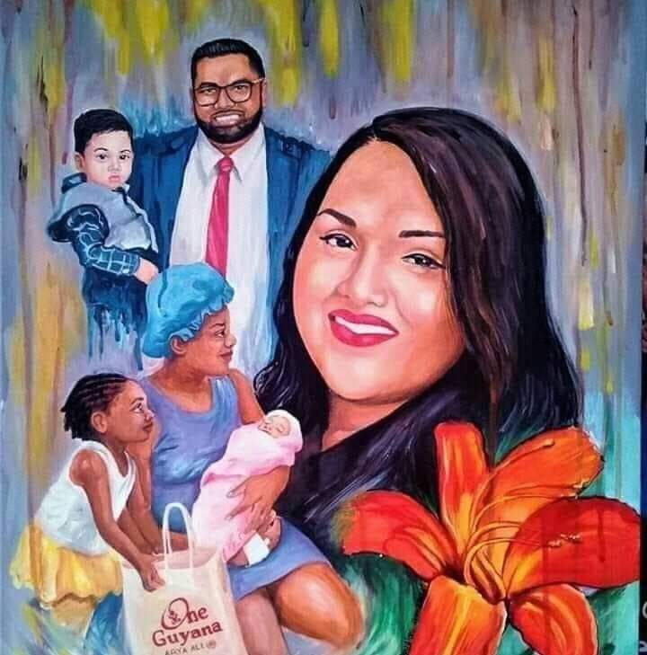All efforts are made through social media, the press, and the public security system to demean, criminalize, and ostracize African Guyanese. This recent painting that appeared on President Irfaan Ali’s page depicts an African mother with her children in a supplicant pose, begging bag in the child’s hand. The single mother, her baby and begging child are juxtaposed below the intact prosperous image of the President’s Indian family. Notice the absence of the black father but the Indian father proudly holding his child.

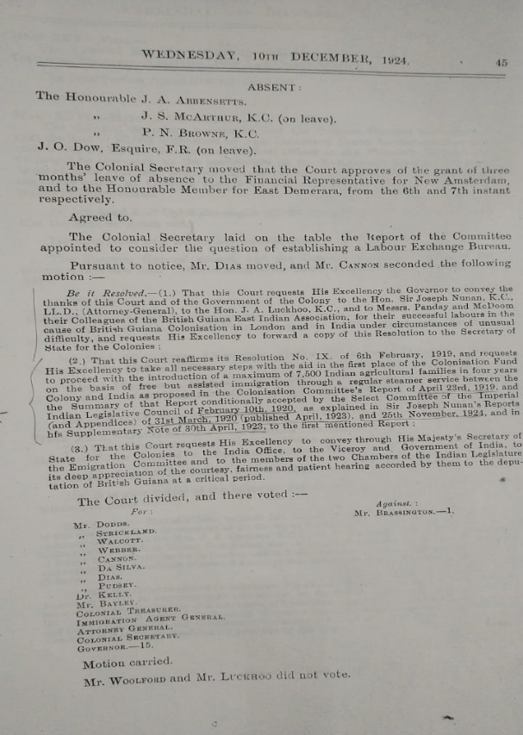The Colonization Scheme has been incrementally and covertly implemented since its crafting. The document below attests to expenditures approved by the Combined Court from a fund established to finance the Colonization Scheme deputation to India and Britain.

1. p.24 Preliminary Report of the Honourable Sir Joseph Nunan, K.C., LL.D., on the Second Deputation to India (1924)