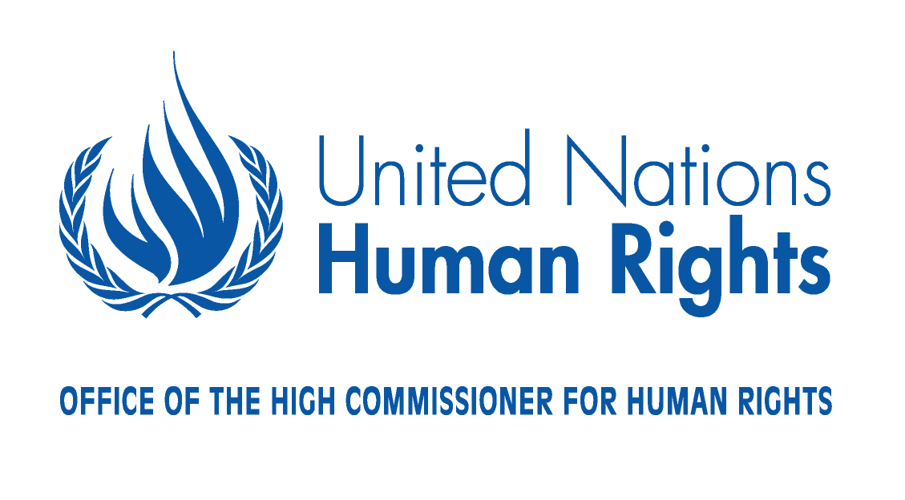
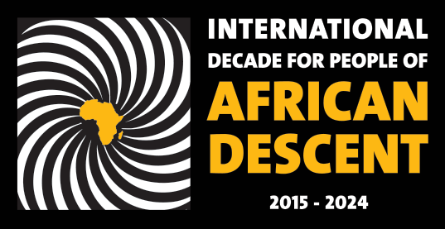

Agenda
REGIONAL MEETING FOR EUROPE, CENTRAL ASIA AND NORTH AMERICA ON THE INTERNATIONAL DECADE FOR PEOPLE OF AFRICAN DESCENT
Organized by the Office of the High Commissioner for Human Rights
23-24 November 2017

Venue: Room XIX Palais des Nations, Geneva, Switzerland

THURSDAY, 23 NOVEMBER

OPENING
10:00 - 11:00 | Poetry Reading  Opening statement by Mr. Zeid Ra’ad Al Hussein, United Nations High Commissioner for Human Rights and Coordinator of the International decade for people of African descent  Appointment of Chairperson and Rapporteur  Chairperson: Ambassador, H.E. Yvette Stevens, Chair of the Intergovernmental Working Group on the Effective Implementation of the Durban Declaration and Programme of Action  Rapporteur: Ms. Gay McDougall, Member of the Committee on the Elimination of Racial Discrimination  Statement by Ms. Opal Tometi, Co-founder of Black Lives Matter and Executive Director of the Black Alliance for Just Immigration  Statement by Mr. Sabelo Gumedze, Chairperson of the Working Group of Experts on People of African Descent  Statement by Ms. Anastasia Crickley, Chairperson of the Committee on the Elimination of Racial Discrimination  Statement by Ms. Rokhaya Diallo, French journalist and activist  General Statements of participating Member States

PANEL DISCUSSION RECOGNITION

Moderator: Ambassador, H.E. Yvette Stevens, Chair of the Intergovernmental Working Group
on the Effective Implementation of the Durban Declaration and Programme of Action

11:00 – 13:00 | Mr. Ahmed Reid, Member of the Working Group of Experts on People of African Descent  Ms. Nelly Schmidt, Presidente du Comité Scientifique International du Projet de L’UNESCO La Route de l’esclavage: résistance, liberté, héritage.  Mr. Pastor Murillo Martinez, Member of the Committee on the Elimination of Racial Discrimination  Ms. Elisabeth Kaneza, President of the Kaneza Foundation for Dialogue and Empowerment  The Honourable Michael Coteau, Minister Responsible for Anti-Racism and Minister of Children and Youth Services, Province of Ontario, Canada (video message)  General debate
13:00 – 13:20  13.25 – 15.00 | Launch of the AfroFoody project, an OHCHR sponsored blog on the heritage and cultural contribution of people of African descent (Room XIX)  Open space discussion: Towards a Draft Declaration on the promotion and full respect of human rights for people of African descent.  Moderators: Members of the Working Group of Experts on People of African Descent, Mr. Ricardo Sunga, Mr. Michael Balcerzak and Ms. Marie-Evelyne Petrus Barry (Room XXVII) (Refreshments and interpretation provided)
PANEL DISCUSSION JUSTICE

Moderator: Mr. Sabelo Gumedze, Chair of the Working Group of Experts on People of African Descent (WGEPAD)

15:00 – 18:00 | Ms. Hanna Suchochka, Independent Eminent Expert on the Implementation of the Durban Declaration and Programme of Action  Mr. Mamodou Jallow, Member of the Swedish Parliament, Founder and chair of the Pan African Movement for Justice in Sweden and the former vice chair of the European Network Against Racism  Ms. Deborah Coles, Director, INQUEST  Mr. Louis-Georges Tin, President, le Conseil Représentatif des Associations Noires de France (CRAN)  Dr. Rebekah Delsol, Programme Manager, Fair and Effective Policing Project, Open Society Justice Initiative

FRIDAY, 24 NOVEMBER 2017
PANEL DISCUSSION RECOGNITION (continued)

10:00 – 11:30 General debate
PANEL DISCUSSION DEVELOPMENT

Moderator: Ambassador, H.E. Taonga Mushayavanhu, Chair, Ad Hoc Committee on the Elaboration of Complementary Standards

11.30-13:00  13:00 – 15:00 | Ms. Verene Shepherd, Member of the Committee on the Elimination of Racial Discrimination  Ms. Tena Šimonović Einwalter, Chairperson, Executive Board of the European Network of Equality Bodies (EQUINET)  Ms. Thenjiwe Tameika McHarris, Co-Founder of Blackbird  Mr. Hilaire Sobers, Human Rights Specialist,  IACHR and representative of the Special Rapporteurship on People of African Descent and Against Racial Discrimination.  Ms. E. Tendayi Achiume, Special Rapporteur on contemporary forms of racism, racial discrimination, xenophobia and related intolerance (video message)  General debate  Open space discussion: Towards provision of effective remedies and reparatory justice. Moderator: Ms. Verene Shepherd, Member of the Committee on the Elimination of Racial Discrimination (Room XXVII) (Interpretation provided)
PANEL DISCUSSION DEVELOPMENT (continued)

Moderator: Ambassador, H.E. Taonga Mushayavanhu, Chair, Ad Hoc Committee on the Elaboration of Complementary Standards

15:00 – 16:30 General Debate
CLOSING

16:30 – 18:00 Summary of key points by Moderators of open space discussions

Summary of general debates by Ms. Gay MacDougall, Rapporteur of the
Regional Meeting

Closing remarks, Chairperson of the Regional Meeting

