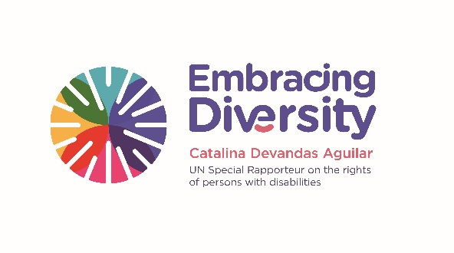english

**Expert Group Meeting**

**Inclusion of the rights of persons with disabilities in the work of the United Nations human rights experts**

**3 and 4 July 2017**

Madrid, Spain

**List of Participants**

UN Human Rights Experts

1. **Mr. José Francisco CALI TZAY**, Committee on the Elimination of Racial Discrimination, (Guatemala)
2. **Mr. Jorge CARDONA LLORENS**, Committee on the Rights of the Child, (Spain)
3. **Ms. Virginia BRAS GOMES**, Committee on Economic, Social and Cultural Rights, (Portugal)
4. **Mr. Pablo CERIANI CERNADAS**, Committee on Migrant Workers, (Argentina)
5. **Ms. Catalina DEVANDAS AGUILAR**, Special Rapporteur on the rights of persons with disabilities, (Costa Rica)
6. **Ms. Alda FACIO**, Working Group on discrimination against women and girls, (Costa Rica)
7. **Ms. Lorena GONZÁLEZ PINTO**, United Nations Subcommittee on Prevention of Torture (SPT), (Guatemala)
8. **Mr. Claude HELLER ROUASSANT**, Committee against Torture, (Mexico)
9. **Mr. Nicolás MARUGÁN**, Committee on the Elimination of Racial Discrimination, (Spain)
10. **Mr. Luis Ernesto PEDERNERA**, Committee on the Rights of the Child, (Uruguay)
11. **Ms. Ana PELAEZ**, Committee on the Rights of Persons with Disabilities (former member), (Spain)
12. **Ms. Silvia QUAN**, Committee on the Rights of Persons with Disabilities (former member) and representative of the International Disability Alliance (Guatemala)

Academia, UN and other representatives

1. **Ms. Pilar ALVAREZ-LASO**, UNESCO, (Costa Rica)
2. **Mr. Francisco Javier ANSUÁTEGUI**, University Carlos III, Madrid (Spain)
3. **Mr. Francisco BARIFFI**, Universidad Nacional de Mar del Plata, (Argentina)
4. **Ms. María del Carmen BARRANCO**, University Carlos III, Madrid (Spain)
5. **Mr. Ignacio CAMPOY**, University Carlos III, Madrid (Spain)
6. **Ms. Lilly CHING**, Inter-American Commission on Human Rights (Spain)
7. **Ms. Patricia CUENCA**, University Carlos III, Madrid (Spain)
8. **Mr. Rafael DE ASIS**, University Carlos III, Madrid (Spain)
9. **Mr. Alberto DURÁN**, Deputy Counsellor General to the President of the Spanish National Organization for the Blind (ONCE), (Spain)
10. **Mr. José María MURIEL**, Ambassador on Special Mission for Human Rights, Democracy and Rule of Law, Government of Spain (Spain)
11. **Mr. Luis Cayo PERES BUENO**, Expert on the Convention on the Rights of Persons with Disabilities (Spain)
12. **Ms. Irene VICENTE**, University Carlos III, Madrid (Spain)