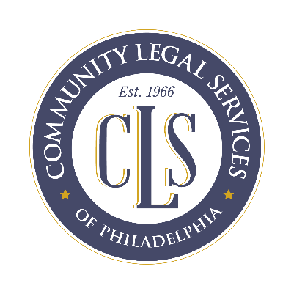
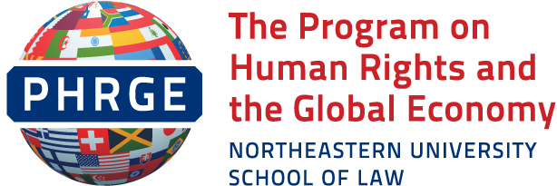

October 3, 2017

Professor Philip Alston – United Nations Special Rapporteur on Extreme Poverty and Human Rights
United Nations
srextremepoverty@ohchr.org

Dear Professor Alston:
Thank you for extending this opportunity to interested parties to provide information on the linkage between poverty and human rights in the United States (U.S.). We hope this writing will assist you in your assessment of human rights and poverty in the U.S.
Community Legal Services (CLS) provides free legal services to low income Philadelphians. CLS’s Energy Unit provides direct representation to low income Philadelphia residents to maintain, restore and afford electric, gas, and water service. The Energy Unit also represents tenant and senior organizations and works with lawmakers and other stakeholders to improve utility affordability policy and promote utility consumer protections. Finally, Energy Unit attorneys represent the interests of residential customers in Philadelphia Water Department rate increase proceedings. The Program on Human Rights and the Global Economy (PHRGE) is the human rights program of Northeastern University School of Law in Boston. PHRGE has particular expertise on the human right to water, and recently drafted a primer on the human right to water in the U.S.
In this submission, we will recognize the challenge of water affordability in the U.S. and the sources of law governing the human right to water. We will profile Philadelphia’s response to the water affordability challenge -- an approach that shows considerable promise in that economically stressed city, and that may be a model for other communities. We will discuss the intersections of race and water affordability and the systemic social and economic impacts of increased water rates. We anticipate that your official visit will offer strong support for positive advocacy for the ongoing water affordability challenges in the U.S. We encourage you to visit Philadelphia as part of your mission.
The International Law Framework

Article 3, of the Universal Declaration of Human Rights (UDHR), establishes a fundamental human right to life, which has been construed to encompass a right to clean and potable water. The UDHR sets out the foundational human rights principles that provide the standards for governing treaties that followed its 1948 inception. One such treaty is the International Covenant on Civil and Political Rights (ICCPR), which also includes a “right to life.” The International Convention on the Elimination of All Forms of Racial Discrimination (CERD), which has also been ratified by the United States, further commits the U.S. to ensure rights to housing and to public health – both intimately connected to water – on a basis of racial equality.

In ratifying CERD, the U.S. noted its understanding that “that [American] states and localities are responsible for implementation in areas traditionally under their jurisdiction, such as criminal justice, education and water access.” A similar understanding was attached to U.S. ratification of the ICCPR. Therefore, local governments share in the U.S. obligation to implement both CERD and the ICCPR.
Growing Water Unaffordability in the US:
Water and sanitation are both basic human needs and fundamental human rights implicit in the “right to life,” but in the U.S. today that lifeline is economically out of reach for some. A recent national study reported the “average monthly American water bill is $120” and this figure is forecasted to grow even higher over the next five years. Although the Environmental Protection Agency suggests the earnings to affordability ratio based on a $120 monthly water bill requires a minimum annual salary of $32,000, in depth studies of self-sufficiency indicate families must have significantly higher earnings to meet their basic needs, with urban areas having the highest percentage of families with insufficient income. These rising costs present affordability challenges for many low income American households, placing them at risk for “water poverty.” Consequently, lower income urban communities have greater exposure to the risk of water poverty. Philadelphia is a case in point: despite overall increases in household income, Philadelphia continues to have “the highest deep poverty rate” among the ten largest cities in the nation.

There is also the relationship between water affordability and race, which has stimulated a racial divide in the U.S. In the United States, “more than one-fourth of black Americans are living in poverty.” African Americans make up almost 50% of the greater Philadelphia region and across “all race/ethnicity groups ages 25 to 64, Non-Hispanic Black or African Americans had the highest unemployment rate at 17.7%.” Unemployed, underemployed or low income African Americans are particularly vulnerable to increased costs for basic needs as well as water utility “predatory debt collection” schemes that target low income individuals and racially profile people of color. People facing such poverty struggle to adhere to standard billing and payment policies for necessary utilities like water and sanitation. In Philadelphia, a recent study reports that “four out of every 10 water department accounts are delinquent,” representing “more than 227,000 customers.”
The Philadelphia Response:
Modest water affordability plans or proposed plans can be found across the nation in cities like Chicago, St. Louis, Baltimore and Detroit, but no other city currently has a plan like Philadelphia’s. Philadelphia’s water affordability approach is unique because it aims to make water affordable for low income households in the long term. Under this program, some households within the affordability program can receive monthly bills as low as $12 per month.

In 2014, in Philadelphia alone, there were a reported $250 million in outstanding water liens, the majority of which are uncollectible debts encumbering residential properties. When the City seeks to increase its water rates, its rate consultants assume that only 2% of any debt more than two years old will be repaid in the current period. As a result, the City adjusts (increases) what it bills to customers in recognition of the fact that some customers are not able to timely pay the cost of the water and wastewater services they received. Although doing so permits the City to continue to deliver water and wastewater service, maintain and operate the water and wastewater treatment and distribution system, and repair and upgrade aging infrastructure, the impacted community of debtors remain subject to potential loss of water service and loss of housing due to unpaid water bills they cannot afford to repay. The City’s water debt creates a situation that can directly and drastically impact the ability of the economically impoverished to continue to access their human rights to water and housing.

Working with CLS, the Philadelphia City Council responded to this situation with positive legislation aimed at assisting as many as 60,000 households in Philadelphia. Their new plan launched in July 2017. However, the journey to the current water affordability program included both setbacks and successes.

In Philadelphia, the City’s charter establishes a single water department that is responsible for delivering and cleansing water. Operationally speaking, there is no indication that the Philadelphia Water Department (PWD) has deviated from its obligation to provide sufficient water, but the Department has not always supplied water, without interruption. Indeed, as many as 36,000 residential customers have service terminated annually. Today, the City estimates as many as 60,000 of PWD’s residential customers may not have sufficient income to afford their water bills. If these households cannot afford their water bills, they risk an interruption in water service, jeopardizing health, safety, custody of minor children, and continued housing.

Within Philadelphia, lower income communities bear a disproportionate amount of the City’s water debt. For example, although the City is divided into 10 districts for City Council representation, the City’s data revealed that one, lower-income district “owed 20 percent of PWD’s debt, despite that [impoverished segment] only representing 10 percent of the [Philadelphia] population.” The City government realized there was a dire need for water affordability measures. The City had previously implemented a program to try to assist low- income customers. That program, the Water Revenue Assistance program (WRAP), provided long-term repayment agreements and a potential discount to level and reduce the water bill based on estimated usage and qualifying income criteria. One problem, which contributed to WRAP’s inability to meet the needs of low income customers, was that a resident’s water bill could still increase while the resident was in program if the actual usage exceeded the program’s estimated usage level. The charges for additional usage were added to the customer’s account at the end of each 12 month cycle of WRAP enrollment.

The inadequacies of programs like WRAP actually undermined the ability of impoverished Philadelphians to maintain their water service. One person who fell victim to this is an unemployed, disabled black male, Mr. B. In the late 1990’s, Mr. B inherited his home from his mother. This gift came with a burden of an inherited water debt. Shortly after taking legal possession of the property, Mr. B was saddled with an unexpected water debt of over $7,000. Mr. B sought help and was qualified for the WRAP program, but his outstanding $7000 balance continued to grow. When Mr. B fell behind in his WRAP payments, he was dropped from the program, received a shut-off notice and his entire accrued debt became subject to collection. Mr. B’s water debt eventually reached over $12,000.
Realizing the failures of the WRAP program, in 2015 CLS worked with Philadelphia City Councilwoman Maria D. Quiñones-Sánchez to draft legislation for a new program to replace WRAP. This program, now known as the Tiered Assistance Program (TAP), is predicated on “income-based payment plans.” Under TAP, the rate payer’s income – and not water usage – determine monthly bill amounts, eliminating the possibility of additional accrual for customers whose water use may be unpredictable. TAP is expected to streamline recertification, so that residents may remain in the program continuously as long as they stay within the program’s income guidelines. Additionally, a resident remains eligible for TAP bills even if they fall behind in payments. TAP is funded through the water rates paid by non-participating customers, residential and non-residential. Mr. B is currently in the TAP program.
Residents like Mr. B, who may experience financial difficulties while they are in the TAP program, will not be dropped from the program. Instead, TAP will work with the resident to get caught up on their current bills if they fall behind and only TAP bills need to be paid to avoid shut-off, not old balances. After two years of continuous payments in the program, penalties on unpaid water bills that accrued prior to TAP participation are forgiven. Under the City’s current regulations, the principal amount of unpaid water bills that accrued prior to TAP participation would be forgiven over a period of 15 years. CLS continues to work toward a shorter, more sensible debt forgiveness timeline that would create a meaningful incentive for timely payment, and provide low income customers with much needed relief from water debt that can jeopardize housing stability.
TAP commenced in July 2017, making Philadelphia “the first city in the country to have openly designed a fiscal policy that observed, if not codified, the human right to water.” Currently, there are over 1,400 residents in the program in less than two months; but the City estimates up to 60,000 families could be eligible. CLS’s Senior Supervising Attorney, Robert Ballenger, believes that it’s premature to confirm the program a success, but he is hopeful and has a realistic and achievable goal of enrolling 30,000 families in the program within one year. Bureaucracy and the lack of implementation systems present barriers, but the more positive the buzz, the greater chance of achieving the program’s enrollment goals. It is a slow process and creating awareness and getting people to register for this program adds to this challenge. The City currently uses direct mail and a local advertising campaign to spread the word. CLS has been monitoring the implementation of the TAP program and advocates with the City to improve outreach and enrollment methods. CLS seeks to inform each of its new clients of the availability of the TAP program, and conducts community education regularly regarding utility assistance programs. CLS plans to conduct further media outreach in the near future to encourage more families to apply for TAP. In addition, CLS provides legal representation to individual TAP applicants who have encountered barriers to enrollment.
The TAP legislation is proof that viable solutions can be developed to make water affordable for urban residents like Mr. B., even in areas of extreme poverty such as Philadelphia. The relationships CLS developed with local government and their clients are stellar examples of a response model other urban areas around this nation might use to address their own water affordability issues, in service to their communities.
Conclusion:
In human life, water is one of the most important human needs. However, the U.S. Constitution does not explicitly address economic, social and cultural rights, such as the right to water. For this reason, your visit to the U.S. is critically important and will draw attention to the ways in which federal and local governments are falling short of meeting critical needs of those in extreme poverty.
However, there are positive models available as well, and we believe that the Philadelphia water plan is one such model. We strongly encourage you to contact CLS and consider visiting Philadelphia to gain a greater first-hand appreciation of the ways in which diverse actors in the city have come together to meet the human rights challenges posed by water unaffordability.
We hope you find this information helpful. We welcome any questions you may have and would be happy to supply any additional information that would be helpful.
Sincerely,
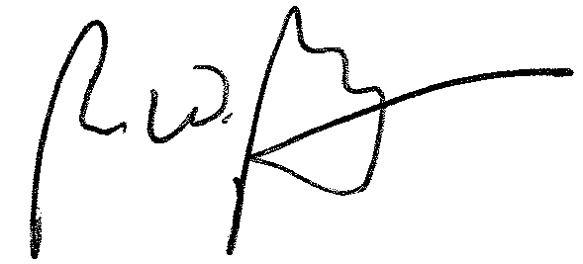

Robert W. Ballenger
Senior Supervising Attorney
Energy Unit Co-Director
Community Legal Services, Inc.
1424 Chestnut Street
Philadelphia, PA 19102
Tel: 215.981.3788
RBallenger@CLSPhila.org

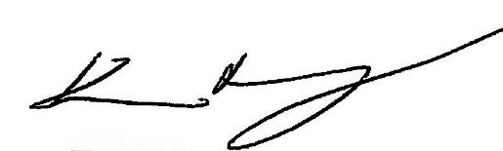
Kevin Murray
Executive Director
Program on Human Rights and the Global Economy (PHRGE)*
Northeastern University
School of Law
(617)373-4972
*We thank Bonnie Smith, J.D., LLM, a student at Northeastern University School of Law, for her work in developing this submission.

International Covenant on Civil and Political Rights, Dec. 16, 1966, United Nations Treaty Series (https://treaties.un.org/doc/publication/unts/volume%20999/volume-999-i-14668-english.pdf).
International Covenant on the Elimination of All Forms of Racial Discrimination, March 7, 1966, 660, U.N.T.S.195 (http://www.ohchr.org/EN/ProfessionalInterest/Pages/CERD.aspx). And U.S. pledge on commitment to advancing human rights and fundamental freedoms in the United States. See Letter from the Permanent Representative of the United States of America to the United Nations addressed to the President of the General Assembly, April 22, 2009, A/63/831 General Assembly, 1, 2 (http://www.un.org/ga/search/view_doc.asp?symbol=A/63/831&Lang=E).
See Human Rights Committee Concluding observations on the fourth periodic report of the United States of America. GE.14-42673 CCPR/C/USA./CO April 23, 2014 at p.2 item 4 (d)
Human Rights Office of High Commission, International Covenant on Civil and Political Rights, Dec. 16, 1966, 2200A, O.H.C.H.R.
Citing EPA Study referencing average monthly water bill and annual income ratio. Nsikan Akpan, Affordable Water May Soon Dry Up, Especially if You Live Here, PBS Newshour (Sept. 25, 2017, 10:35PM), https://www.pbs.org/newshour/amp/updates/affordable-water-may-soon-dry-especially-live
Pathways PA, Overlooked and Undercounted: Impact of the Great Recession as Measured by the Self-Sufficiency Standard for Pennsylvania (Oct. 2012) (a family of one adult, one infant and one preschooler requires an income of $57,746 to be self-sufficient in Philadelphia County, compared to $46,490 in Erie County; Philadelphia has the highest percentage of families living below the self-sufficiency standard in Pennsylvania) http://pathwayspa.org.mytempweb.com/wp-content/uploads/2014/01/Overlooked-and-Undercounted-2012.pdf
Nsikan Akpan, Affordable Water May Soon Dry Up, Especially if You Live Here, PBS Newshour (Sept. 25, 2017, 10:35PM), https://www.pbs.org/newshour/amp/updates/affordable-water-may-soon-dry-especially-live
Morgan Zalot, As Philadelphia's Median Income Increases, Staggering Poverty Rate Barely Budges, NBC Philadelphia (Sept. 26, 2017, 7:58PM) http://www.nbcphiladelphia.com/news/local/Philadelphia-Poverty-Rate-Median-Income-Census-Statistics-394316301.html
Scathing U.N. report: “Structural racism” endures in U.S., and the government has failed to protect African-Americans’ rights, SALON MAG. (Sept. 16, 2017, 11:16AM) http://www.salon.com/2016/10/07/scathing-u-n-report-structural-racism-endures-in-u-s-and-the-government-has-failed-to-protect-african-americans-rights/
Philadelphia Works, A non-profit organization serving employer and job seekers, (Sept. 16, 2017, 12:40PM) http://www.philaworks.org/workforce-information-works/philadelphia-data/philadelphias-labor-force/
Emily Green, U.S. Households Under Pressure from Rising Water Bills, The SOURCE, Oct. 2017, at 52
George Spencer, 7 Years, No Water at Home for Senior, NBC Philadelphia (April 8, 2016) http://www.nbcphiladelphia.com/news/local/7-Years-No-Water-375060031.html
Cassie Owens, Philly City Council Helps With Water Shutoffs and Blight Prevention, NEXT CITY (September 16, 2017, 4:15PM) https://nextcity.org/daily/entry/philadelphia-water-bills-low-income-payment-plans
Telephone Interview with Robert Ballenger, Senior Supervising Attorney, Community Legal Services, Inc., (Sept. 2017).
Testimony: CLS Supports Water Affordability in Philadelphia, Community Legal Services (June 10, 2015) https://clsphila.org/learn-about-issues/testimony-cls-supports-water-affordability-philadelphia
Cassie Owens, Philly City Council Helps With Water Shutoffs and Blight Prevention, NEXT CITY (September 16, 2017, 4:15PM) https://nextcity.org/daily/entry/philadelphia-water-bills-low-income-payment-plans
Emily Green, U.S. Households Under Pressure from Rising Water Bills, The SOURCE, Oct. 2017, at 52

