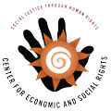
Fiscal Impoverishment in the United States
SUBMISSION
to the UN Special Rapporteur on Poverty and Human Rights
Center for Economic and Social Rights
October, 2017

Fiscal policy—that is, the raising and spending of public resources—is one of the most important structural policies which determines the degree to which a State can ensure human rights for all, without discrimination. Who pays for what public services, and who truly benefits, are fundamental questions at the heart of any efforts to combat poverty, protect democracy, and realize human rights. This submission provides input to the United Nations Special Rapporteur on Extreme Poverty and Human Rights, Professor Philip Alston, in advance of his official visit to the United States from 4 to 15 December 2017. In particular, it provides information relevant to questions (ii), (iv) , (vi) and (ix) of the Special Rapporteur’s call for input.
Poverty amongst plenty: Fiscal impoverishment in the United States
Today, more than 45 million people – almost 1 in 7 – Americans live in poverty. The US is the fourth most economically unequal country in the OECD, with very low inter-generational mobility, and gaping racial disparities in access to quality education, healthcare, housing, fair wages and wealth. A stunning 95 percent of income growth since 2009 has gone to the top 1% of income earners, making the 2009-2012 ‘recovery’ the most lopsided in favor of the ultra-rich in US history. The top 10% now hold 50% of the income in the country, and this trend is only increasing.

Tax and fiscal policy is hardly disrupting these regressive tendencies. In many ways, fiscal decisions are only deepening economic, social and gender inequalities while further impoverished people. While Federal income taxes are mildly progressive, for example, state and local level taxes in every state in the country impose higher effective tax rates on poor families than on the richest taxpayers. Undocumented immigrants – who receive very few public services – contribute $10.6 billion in taxes every year, while those with high levels of wealth and capital are taxed little, if at all. The US loses around $500 billion to tax abuse every year, with a good proportion of that via multinational tax avoidance. Despite the headline 35% rate, US companies – through successful lobbying and using tax loopholes and incentives – pay on average 14 percent in corporate income tax, with around two-thirds of companies, especially the very profitable ones, paying no federal income tax at all. As a result, low-income workers pay proportionally more in tax than corporations that make billions of dollars in profit, while the tax base is depleted. Some call it a “soak the poor” strategy, which pushes low-income families further into poverty and increases the likelihood that they will need to rely on social protection programs – which are themselves chronically under-funded. In fact, the US as a whole brings in much less revenue (25% of GDP) than its comparative countries in the OECD (35% of GDP).

These abstract statistics don’t paint the full picture of millions of individual human stories of economic and social rights abuse in one of the richest countries in history – so many of which come back to failures and impunity in how Federal and state governments raise and spend public resources. Whether it is children exposed to toxic levels of lead poisoning, explosive child and eldercare costs keeping women at home in unpaid domestic care work, disproportionately high infant and maternal mortality rates in communities of color, classrooms plagued by rats, roaches, and mold, staffed by underpaid teachers, with huge education funding gaps based on race and economic status, or the completely unavoidable deaths from failures in natural disaster prevention and relief -- in every case, the connecting fiber between these seemingly isolated incidents of basic human rights infringements in the US have come back to public authorities seeking to evade their human rights duties by claiming that the budget is too weak and the public revenue too shallow to afford a life of dignity for people.
Proposed tax changes threaten to deepen disparity and impoverishment…
In this context, congressional and White House representatives recently released the outlines of their long-awaited tax plan, the “Unified Framework for Fixing Our Broken Tax Code.” Despite overwhelming evidence showing that extreme inequality in the US is damaging lives and the economy, the government’s tax roadmap would give 80 percent of the total tax benefits to the richest one percent, whose income share has already been growing exponentially since the 1980s. The grand majority of taxpayers in the bottom 95% of the income spectrum, meanwhile, would pay slightly more in taxes after ten years.

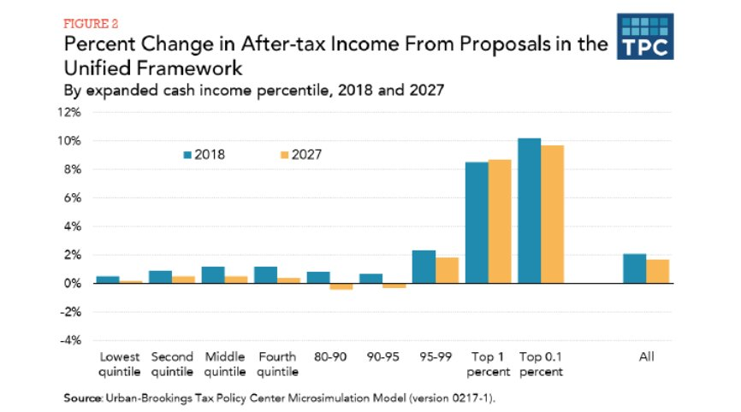
Figure 1: Distributional consequences of current tax proposals (Tax Policy Center, 2017)

The proposed reforms would also radically rewrite how, and how much, corporations are taxed. Far from being over-taxed, US companies at present contribute relatively little compared to other G7 countries in actually financing public services – limiting the overall progressivity of the US tax code. The Unified Framework would cut the corporate income tax rate to 20%, while rewarding US multinationals with a tax holiday for the more than $2.6 trillion they hold overseas. Moving to a fully ‘territorial’ system, the proposals would only tax multinational on their domestic income, completely exempting taxation of profits characterized as foreign. The result would be increased corporate tax avoidance by multinationals, a more complex corporate tax system rigged in favor of multinational companies at the expense of domestic businesses, wages and the public purse.

At a time in which key public services around the US are simultaneously overburdened and severely underfunded, these tax cuts will cost an estimate $2.4 trillion over the first ten years and $3.2 trillion over the subsequent decade in lost Federal income. Combined with the steady undermining of the Internal Revenue Service which further undermines revenue collection, these significant revenue losses will lead to unsustainable fiscal deficits, deep cuts to social services, or both. The most effective programs at alleviating poverty in the US - Social Security, the Earned Income Tax Credit, Medicaid and the Supplemental Nutrition Assistance Program (SNAP) – are also the most at threat. While not tied directly to budget cuts, a $ 2.4 trillion budget hole will need to be made up somewhere, and there are strong indications that this will occur through backdoor cuts to social welfare, with long-lasting impacts on the social and economic rights of already disadvantaged sectors of the population.

Figure 2: Revenues lost in current tax reform proposals (Tax Policy Center, 2017)

The almost-inevitable budget cuts that would come from a $2.4 trillion hole in revenue would be particularly felt by low-income women and women heads of household. It has been well-documented elsewhere how disinvestment in public services increases women’s unequal burden of unpaid care work, restricting their rights to work, education and more. Existing programs in the US which go some way to alleviating or supporting care (e.g. Medicaid, child and elder care, food security and after-school programs) have already been explicitly targeted for cuts. At the same time, key provisions in previous Trump-Ryan tax plans posed deeper wage and tax disparities between men and women. For example, Trump’s original plan would eliminate the head-of-household status, financially punishing single parents – 90 percent of whom are women. Taken together, cutting programs which benefit lower-income people in the United States will have particularly harmful consequences for women and their families.

…while undermining the ability of other governments around the world to progressively invest in human rights.

As the world’s largest economy, few countries’ tax policies and practices have as far-reaching an impact on human rights, poverty alleviation and sustainable development worldwide as those of the US. At present, the US—whether by design or by default—is the world’s third most important financial secrecy jurisdiction. As one of the world’s premiere ‘on-shore’ tax havens protecting anonymous shell corporations, the US now plays a central role in attracting illicit financial flows, enabling tax abuse and allowing economic elites and tax evaders the world-over to shield themselves from paying their tax dues in countries around the region. This systematic permissiveness of tax evasion and avoidance by US authorities not only affects people’s lives in the US. It represents a tremendous material cost on many governments around the world, undercutting their redistributive capacities to reverse growing economic and gender inequalities and undermines their fiscal space to invest in human rights.

The corporate tax reform proposals being considered at present would exacerbate this problem. This is because the move to a ‘territorial’ tax system discussed above - combined with a drop to a 20% corporate rate - would drive deeper tax competition between countries. This is not a bug, but an express intention of the drafters of the tax plan. Other countries, especially low and middle-income economies which rely more heavily on corporate taxes, would likely be prompted reduce their rates even further and increase tax privileges for corporations to compete for investment. To offset the decreased revenue, governments would likely increase regressive consumption taxes while further depleting funds for public services and poverty reduction measures around the world. In this way, the spillover effect of the proposed US corporate tax reforms could very well be borne by the poorest people in the world.

If enacted in such a way, the US would seriously undermine the universal commitments made by the international community to increase revenue mobilization to tackle poverty and inequality through the Sustainable Development Goals adopted in 2015. As recognized this year by the UN Committee on Economic, Social and Cultural Rights, tax competition and corporate tax avoidance is 'inconsistent with human rights.' Current tax proposals would run counter to the international legal obligations of the US to – at the least – not undermine the realization of economic and social rights.

Conclusion

In his official mission to the United States, we would encourage the UN Special Rapporteur to explore the fiscal foundations of human rights in the United States. Tax and fiscal policies have the potential to be vital human rights tools in the United States. By mobilizing sufficient domestic resources to finance growing needs for public services, by redistributing economic gains rigged in favor toward the wealthy, by ensuring a degree of accountability between the State and its people and by correcting market failures which drive violations of rights and protecting common goods, such a healthy environment. Aligning tax and fiscal policy with human rights standards and principles can be a powerful corrective force to foster sufficient, equitable, and accountable public financing—the life blood of democracy. We look forward to contributing to the Special Rapporteur toward this objective.

