**Questionnaire 2: The Human Rights of Older Women**

**The rights of older women in international, regional and national law, policies and programmes**

1. What legal instruments, policies and programmes exist to address the particular challenges faced by older women, and how are they implemented and monitored?

To be old basically means to be in a certain stage of life course. To understand and improve the situation of older women the life course approach is appropriate. The life course approach explains how life is comprised of numerous transition phases requiring decisions to be taken. How a person decides on arriving at such a junction is not only a matter of personal preferences and the availability of resources, but is also contingent on numerous other factors at social, economic, individual and possibly also family levels. Gender equality policy oriented to life course is charged with the organisation of such factors.

The outcome of the social organisation of paid work and (unpaid) care work: personal financial and social situations are heavily contingent on gender. It is not the task of gender equality policy to give guidelines on the way people should life their lives – but it should enable people to choose their way of living and to live their preferences. The German Government believes policymaking should support both women and men in their efforts to integrate paid work and private care work equally with their life course. To implement this means a big leap forward to gender equality for older people.

For further information see:

Sources: <https://www.bmfsfj.de/bmfsfj/meta/en/publications-en/second-gender-equality-report-122440>

<https://www.bmfsfj.de/resource/blob/119794/b69d114cfbe2b6c1d4e510da2d74fd8d/zweiter-gleichstellungsbericht-der-bundesregierung-bt-drucksache-data.pdf> (full version in German)

<https://www.bmfsfj.de/bmfsfj/meta/en/publications-en/who-takes-care-of-children--household-and-the-elderly-/160284>

For the German development cooperation, gender equality is a goal in itself and thus a guiding principle for the BMZ and its implementing agencies. With the Development Policy Action Plan on Gender Equality 2016-2020 (GAP) Germany is making significant contributions to achieving the global objectives and fulfilling its own national commitment. One cross-sectoral activity under the GAP is to tackle multiple discrimination based on religion, ethnicity, skin colour, sexual orientation, disability and **age**. In addition, the rights of older women are an explicit goal in the following sectors: rural development, agriculture and food security; health, including sexual and reproductive health and rights (SRHR); as well as violence against women and girls.

Sources:

[Gender Equality in German Development Policy (bmz.de)](https://www.bmz.de/en/publications/type_of_publication/strategies/Strategiepapier340_02_2014.pdf)

[Development Policy Action Plan on Gender Equality 2016 – 2020 (bmz.de)](https://www.bmz.de/en/publications/type_of_publication/strategies/Strategiepapier363a_03_2016.pdf)

1. **What type of statistical data are collected on older women, if any, and is it disaggregated by age, gender, and other relevant factors? How are older women defined for the purposes of law, policy and data collection?**

For the German Government, data availability, especially the availability of disaggregated data is important. With its GAP, Germany is setting up measures to strengthen the focus on multiple discrimination when collecting disaggregated data for gender analyses and project reports. Whenever possible, they should also record age and disability, indigenous origin as well as other aspects pertinent to discrimination.

1. **Has the COVID-19 pandemic affected older women differently than older men and how?**

Since older women are the majority of persons living in institutions they are affected to a higher extent by the existing contact limitations and curfews.

The intensity of the restrictions of every day live does not differentiate between older men and women. The health risks caused by the contact limitations affect both to the same extent. The German survey on older persons offers insights on the differences in comparison of the years 2017 and 2020. there are differences in the reported income losses during the first wave of the pandemic.



Differences in the feeling of loneliness during the pandemic:



Differences in the feeling of loneliness by caring/non-caring relatives:

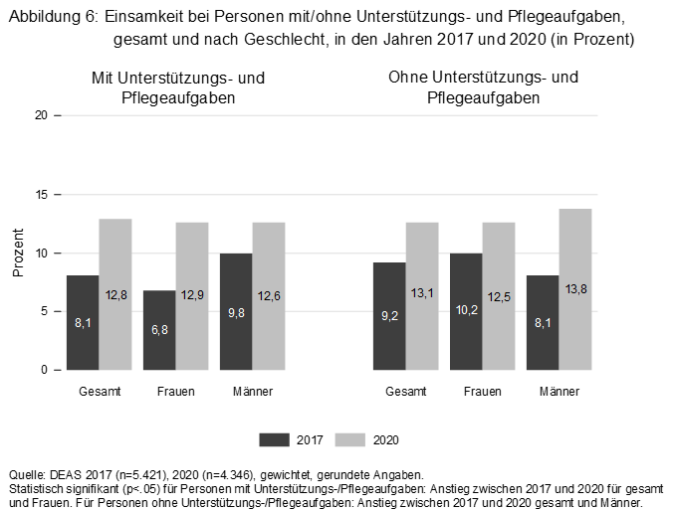

Women and men over 46 years are affected differently by the pandemic in the change to short-time work:

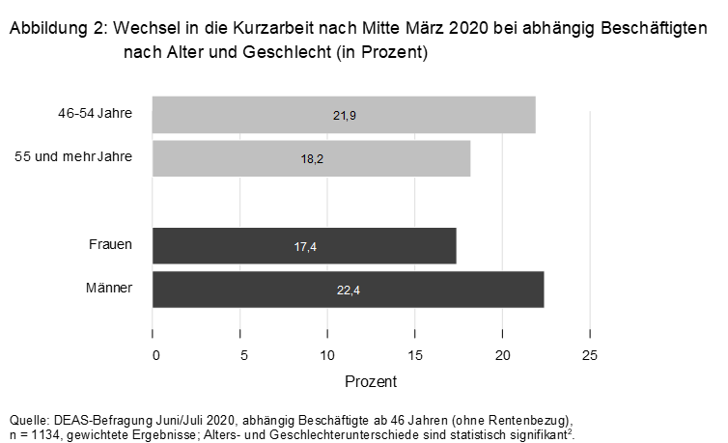+

The same holds true for the average weekly working time at home:

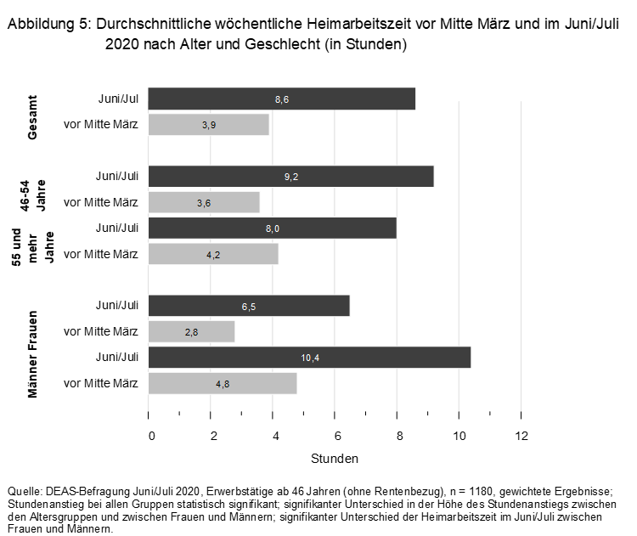

Differences regarding employment while at the same collecting pension:

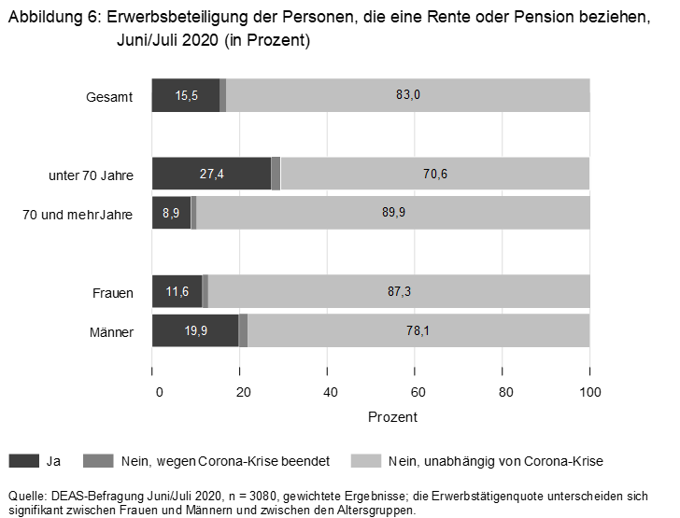

1. **Please share examples of how older women participate in and contribute to economic, social and cultural life, including inter-generational solidarity and support.**

Older men and especially older women contribute to a great extent to social cohesion by various forms of volunteering and engagement, e.g. caring for relatives and grandchildren, visiting services in hospitals, volunteering in school lunches, low threshold teaching of digital skills to other older persons. Eurostat’s publication “Ageing Europe” reports for the entire EU a high degree in volunteering by older persons. It is especially remarkable that older men volunteer in the formal sector while older women take on care work, often in their own family.

1. **What forms of structural and systematic discrimination do older women face (for example through laws, policies, traditional and customary practices, etc.) and what measures have been taken to address them?**

One example is the cultural sector where women in Germany on average earn significantly less than men. This is the finding of the study “"Frauen und Männer im Kulturmarkt – Bericht zur wirtschaftlichen und sozialen Lage" – women and men in the cultural market – report on the economic and social situation” that was published in June 2020 by Deutscher Kulturrat and supported by the Federal Commissioner for Culture and Media. This study is part of the commitment of the Coalition Treaty to issue a report on the social and economic situation in creative professions. The meta study sheds light on the fact that the average income of male members of the Künstersozialkasse in 2019 was 20890 Euro, compared to 16518 Euro for female members. These gender specific income gaps affect the professions of journalism, directors and actors.

The study “Situation of Artists in Berlin – Situation Berliner Künstler*innen” published in 2018 by Institut für Strategieentwicklung (IFSE) shows what this means in old age. Artists, according to the survey, could only expect a pension of 357 Euro. While the study does not differentiate between genders, the same study also states that female artists have 28% less revenue than male, it is clear that female artists will be affected by smaller pensions.

It remains a fact that women in creative professions are often remunerated less than men. This discriminatory practice must be broken. As a first step it is important to conduct regular screenings to shed light on the extent of the smaller financial value given to female artists

1. **How do intersectional factors exacerbate the combined effect of ageism and sexism, including the perspective of older LGBTI women, older women with disabilities, older migrant women, older women belonging to indigenous and minority groups, etc.?**

Elderly lesbians are underrepresented in popular and academic discourse (Traies, 2014). Moreover, there is significant concern in scholarship that health and social care providers currently still fail to meet the needs of elderly lesbians despite the increasing number of LGBTQ persons amongst the elderly population. There is a large disparity between EU Member States as well as between rural and urban regions in the provision of specialist, safe and respectful services for older lesbian women*. Elderly care and health services have a problematic history with marginalised sexual identities (Addis et al., 2009). Many studies indicate a fear amongst elderly lesbians of disclosing their identities to service providers.

The heteronormative structuring of residential facilities has a debilitating effect on the well-being of older lesbians (ibid.). Qualitative data from the UK shows that the loss of independence and the move into a formal care facility is associated with a loss of identity and fear of a hostile environment (Traies, 2014). A study from the US found that older lesbians prefer specific services for lesbians or women* only and that they are aware that most facilities do not respect their sexual identity (Averett, Yoon and Jenkins, 2011). The same study also indicated significant experiences of homophobia in private and public places and also with service providers that appeared to inform older lesbians’ legitimate wish for lesbian-only services (Averett , Yoon and Jenkins, 2013). Research from the UK indicates that older lesbians are invested in strong friendships and informal mutual care networks (Traies, 2015; Traies, 2014). It can thus be concluded that elderly lesbian communities compensate for the lack of specialist care and support through unpaid care work.

Scholars stress that older lesbians are particularly invisible, which can be attributed to ageism and sexism, particularly to the desexualisation of old age and the dominant association of women’s sexuality with procreativity (Averett, Yoon and Jenkins, 2013; Traies, 2014). However, a number of lesbians choose to conceal their sexual orientation amid having lived through repression (Traies, 2014; Rufli, 2015). In research and community debates, the category elderly lesbians tends to be homogenised; furthermore, there is an urgent need to recognise the heterogeneity amongst elderly lesbians and to develop a better understanding of intersectional discrimination (Averett, Yoon and Jenkins, 2011; Traies, 2014). There is a lack of research on elderly lesbians of colour and on older lesbians living in rural areas (Addis et al., 2009).

Source:

<https://static1.squarespace.com/static/5cbc8e61fd67936e5b006c6a/t/5fb40a652b231537f53ebd2b/1605634664036/Boulila+Advancing+Liveable+Lives.pdf>

BMFSFJ, Documentation of the discourse “Counseling and support needs of transsexual persons and their relatives in different life situations”

<https://www.bmfsfj.de/blob/112292/f25b3c1c705fa36bdb5f932debb2b97a/imag-band-4--dokumentation-fachaustausch-data.pdf>

Considering the special life situation of lesbian women in old age the Federal Ministry for Family Affairs, Senior Citizens, Women and Youth within the framework of the program “„Gemeinschaftlich wohnen, selbstbestimmt leben – living together – living self-determined” supports the model project RUT - Gemeinschaftliches Leben und Wohnen von lesbischen und queeren Menschen – living together and housing of lesbian and queer persons”. The project investigates possibilities of participation and community in the neighborhood.

<https://www.serviceportal-zuhause-im-alter.de/programme/modellprogramm-gemeinschaftlich-wohnen-selbstbestimmt-leben.html>

1. **What forms does gender-based violence and abuse against older women take and how is such violence prevalent? Please share available data and statistics, including in relation to femicides.**

Regarding the issue of violence in care settings, the following can be noted: In Germany and the end of 2019 ca. 4.1 million persons in need of care according to SGB XI were living. 80% of the persons in need of care (respectively 3.31 million persons) were card for in their home, amongst them 2.33 million mainly by relatives. 2.5 million of the 4.8 careers at home are active in the labor market. More than 70% of the careers are women. Care work takes time, money and power. The reconciliation of care and work life has become increasingly difficult in times of the COVID-19 pandemic and can be very challenging for careers. Many reports of difficulties of work-life balance and a sinking life quality or a decrease in their health situation. However, already before the Corona pandemic a survey of the Zentrums für Qualität in der Pflege (ZQP) showed that many reported suffering pressure and negative thoughts and feelings towards the persons of the person in need of care. 36% felt downtrodden, 29% are often angry.

([https://www.zqp.de/informelle-pflege gewalt/?utm_source=ZQP+Newsletter&utm_campaign=d2e3aceda9-EMAIL_CAMPAIGN_2020_02_27_08_19&utm_medium=email&utm_term=0_08b9f0520e-d2e3aceda9-142806625](https://www.zqp.de/informelle-pflege%20gewalt/?utm_source=ZQP+Newsletter&utm_campaign=d2e3aceda9-EMAIL_CAMPAIGN_2020_02_27_08_19&utm_medium=email&utm_term=0_08b9f0520e-d2e3aceda9-142806625)).

Against this background the portfolio of the telephone helpline for care run by the Federal Ministry for Family Affairs, Senior Citizens, Women and Youth in 2016 was broadened to counsel in situations of stress. (wege-zur-pflege.de). The number of contacts has increased during the pandemic as well as counselling in crisis. Furthermore, the brochure “Violence and Aggression amongst Inhabitants of Institutions of Care for Older Persons” published in 2020 can be consulted. This publication wraps up the results of a study on violence amongst inhabitants of care institutions and gives advice on dealing with the issue in training and education facilities for care professionals, but also for caring relatives.

(<https://www.bmfsfj.de/bmfsfj/service/publikationen/gewalt-und-aggression-unter-bewohnerinnen-und-bewohnern-von-einrichtungen-der-stationaeren-altenhilfe/163372>

Regarding violence against women in general, please note that academic research suggests the prevalence and frequency of intimate partner violence is reducing significantly with age. However, violence in older age does happen. According to the Istanbul Convention the term domestic violence also includes violence in care facilities and intergenerational violence.

The Police Crime Statistics of Germany (PCS) are one of the most important data sources for the description and analysis of crime. Once a year a Crime Statistics Analysis on intimate partner violence is published, which also provides data disaggregated by gender and age group.

The German government does not have data on whether violence against older women increased during the Covid-19 pandemic.

1. **Please provide examples of how the life cycle perspective is integrated into policies and programmes to prevent and address gender-based violence against women and girls.**

With its Gender Action Plan GAP, Germany is making significant contributions to promote effective efforts to eliminate all forms of VAWG of all ages and in all spheres and stages of life.

1. **Please share information about reporting, accountability, remedy and protective mechanisms available and targeted to older women victims of gender-based violence and discrimination.**

**The questions 8 and 9 are answered together.**

In line with Germany’s federal system, responsibility for implementing the Istanbul Convention also lies to a large extent with the 16 German Federal States (Länder) and more than 11,000 municipalities. This includes in particular the provision, expansion and financing of help and support facilities for women victims of violence. All Länder have taken broad measures to ensure access to services during the Covid-19 pandemic.

Older women have the same options to access the different services for victims of violence as girls and younger women do. The German Federal government implemented several measures to increase resources and support for women’s and civil society organisations and to ensure that women, who experience violence, can rely on a functioning support system during this time of crisis.

The National Helpline “Violence Against Women”, which was implemented in 2013 and is funded by the German Government, is continuing their extremely important service during the coronavirus crisis. It offers around the clock support for women of all ages on 365 days per year and can be reached via phone, chat or email. More than 80 qualified female support workers offer help and guidance to women, who are affected by violence, people from their social circle and professionals working in the sector. The support is free, anonymous, confidential and available in 18 languages. Due to coronavirus-related measures the helpline team is facing additional challenges, but everything is done to ensure continued service.

In order to support the Laender with the provision of support services for women, who experience violence, and their children, the Federal Ministry for Family Affairs, Senior Citizens, Women and Youth started a government funding programme “Together against violence towards women” – with a total budget of around 171 Mio. Euro for the years 2019 to 2024. The aim of the programme is to further progress in the whole support system with investment and non-investment projects to close existing gaps, for example by reaching and supporting target groups, who haven’t sufficiently been able to access services in the past, this includes older women, who experience violence.

For the investment part of the Federal funding programme the expansion, conversion, new construction, refurbishment and acquisition of support facilities as part of innovative projects will be funded with a budget of 30 Mio. Euro per year for the years 2020 until 2024.

These primarily serve to further improve the accessibility and usability of protection and counselling facilities for women affected by violence. The main beneficiaries are intended to be women victims of violence for whom there are not yet sufficient capacities or a sufficient number of specialised support services nationwide, for example for women with disabilities who are reliant on accessible forms of support. This will also improve access to support services for older women.

Supporting women’s shelters and specialist services during the Covid-19 pandemic is the aim of the new project “Help System 2.0 - Sustainable technical empowerment for counselling services and women’s shelters during the COVID-19 pandemic”, which the ministry is funding as part of the federal funding programme “Together against Violence towards Women”. 3 Mio. Euro have been allocated to the support system since the beginning of the project (15 October 2020) - for technical equipment and the digital support of women, who experience violence by providing qualifications for support workers and qualified translations. The project is implemented by the Association of Women’s Shelters (FHK). It contributes both to the upkeeping and improvement of the support sector under increasingly difficult conditions due to the pandemic and offers options to women of all ages to access help and support, when they are affected by violence.

Together with Germany’s biggest grocery retailers the Federal Ministry for Family Affairs, Senior Citizens, Women and Youth started the national initiative “Not Safe at Home?” on 29 April 2020. Thousands of stores followed the initiative and took part in the nationwide action against domestic violence. They put up posters in central places in their stores and places important information in newsletters, on their websites, on receipts and products.

The neighbourhood in the direct environment is especially important in cases of violence in families and intimate partnerships, to show the victims what options they have against violent situations in the domestic sphere and where they can find support offers. This is why the initiative „Stronger than violence“ started the action “Our neighbourhood is #Stronger than violence” in November 2020. In cooperation with supporters from the economy and civil society, the action raises awareness for the initiative “Stronger than violence” and the website, which includes information, tips and support offers. Everyone can take part in the action and actively take a stand against domestic violence.

All interested companies, administrations, clubs or private persons, who want to support the neighbourhood action, can find the download materials on the website of the initiative www.stärker-als-gewalt.de. The initiative “Stronger than violence“ continues in 2021.