Call for input: thematic report on the human rights of older women

Deadline
22 March 2021
Issued by
Independent Expert on the human rights of older persons
Purpose
To inform Independent Expert’s forthcoming report to the 76th session of the General Assembly

Background
The Independent Expert on the enjoyment of all human rights by older persons, Claudia Mahler, is mandated by the United Nations Human Rights Council (HRC/RES/33/5) to report on developments, challenges and protection gaps in the realization of the rights of older persons as well as to assess the implementation of national, regional and international standards and identify best practices relevant to the rights of older persons. Throughout her work, the Independent Expert adopts an intersectional approach so as to address multiple and aggravated forms of discrimination faced by older persons.
Older persons represent a large, and the fastest growing, segment of the global population. Women form the majority of older persons with global demographic data consistently showing that women tend to live longer than men, especially at advanced ages. Older women also make substantial contributions to our societies and economies, including as informal caregivers, volunteers and community leaders. Ageing, however, is not gender-neutral and inequality and discrimination experienced by women during their lifespan is often exacerbated in older age. For example, older women are at a higher risk of living in poverty and of facing barriers in accessing basic rights such as health, adequate housing, and protection from violence, abuse and neglect. Yet, the specific challenges created by the intersection between age and gender often remain invisible and understudied.

Objectives
In this context, the Independent Expert will examine how older women experience ageing differently and what specific human rights concerns and challenges they face. In particular, her report will seek to analyse the causes of the discrimination and inequality affecting older women, identify good practices and formulate concrete recommendations.

Key questions
In order to inform the preparation of her report, the Independent Expert would like to seek contributions from States, national human rights institutions, civil society, academia, international and regional organizations, and all other relevant stakeholders, with a particular emphasis on sharing concrete examples and good practices where available.
While the Independent Expert welcomes any information, reports, legislation or other materials deemed pertinent to the protection and promotion of human rights of older women, she is particularly interested in the areas highlighted in this questionnaire:
Download the questionnaire (PDF): English | Français | Español

How to submit inputs
Please send your submissions in English, French or Spanish in attachment by email to olderpersons@ohchr.org, indicating in the heading “Submission to the call for contributions on older women – 2021”. Please also kindly indicate whether you have any objection for the responses provided to be made available on the OHCHR webpage of the Independent Expert.

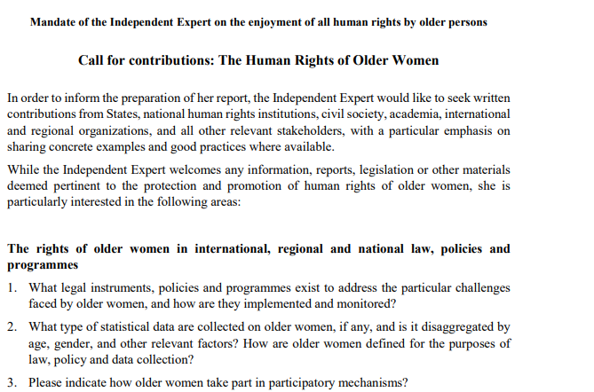1. The National Commission for the Promotion of Equality (NCPE) monitors the implementation of Cap. 456 Equality for Men and Women Act, and works towards ensuring that Maltese society is free from discrimination based on the grounds of sex/gender and family responsibilities, sexual orientation, age, religion or belief, racial or ethnic origin, and gender identity, gender expression or sex characteristics in employment; banks and financial institutions, as well as education. In its work, the NCPE investigates cases of alleged discrimination and sexual harassment, raises awareness on equality issues and through its policy-work provides input from an equality perspective.
- In Malta, the Human Rights and Equality Commission (HREC) Bill and the Equality Bill are currently being discussed at Parliamentary Committee Stage. Once the Bills are enacted, the current National Commission for the Promotion of Equality (NCPE) will be transformed into the HREC that will have a considerably extended remit and powers. This will give the Commission the power to take binding decisions on cases of discrimination and will extend its remit to also cover human rights.
- The National Strategic Policy for Active Ageing: Malta 2014-2020 focused on three main themes: active participation in the labour market; participation in society; and independent living.
- The Malta National Lifelong Learning Strategy 2020 seeks to improve the quality of life of older people through lifelong learning opportunities and facilitates women’s participation in the workplace through lifelong learning.
- With respect to the rights of older women, the European Commission’s ‘A Union of Equality: Gender Equality Strategy 2020-2025’ aims at closing the gender employment gap in order to address the proportion of women living in poverty, particularly in older age.
- The European Commission’s Green Paper on Ageing focuses on long-term care, pensions and active ageing.
2. Statistical data is collected and can be obtained from the National Statistics Office (NSO).
3. In 1993 the University of Malta launched the University of the Third Age Malta (U3A) which offers an extensive range of learning programmes. U3A is a key pillar in Maltese national policies on lifelong learning and active ageing.

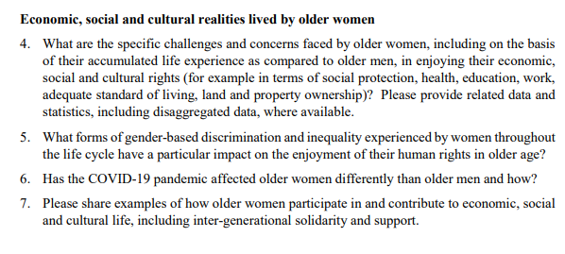

4. According to Eurostat data, women’s healthy life years in 2019 stood at 65.1% in the EU27 and 73.5% in Malta, whereas that of men stood at 64.2% in the EU27 and 72.9% in Malta respectively. Even though the statistics show that women live longer healthier years, women’s self-perceived health in old age is not as good as men’s, and such perceptions of ill health increase with age. Moreover, women aged 65+ are more likely to report unmet medical needs than their male counterparts. In Malta 21.4% of women are at risk of poverty or social exclusion, as opposed to 18.8% of men; women live longer with higher risks of poverty in their ageing years.

5.Women (including older women) are more likely than men to be the informal caregivers of adult dependent family members, as well as the main carers of children and grandchildren. Informal caregiving can entail physical and mental stress that affects the wellbeing of the caregivers and that of the dependant/s, and also affects their participation in other spheres including work.
Statistics show that women in the 55-64 year cohort are less likely to be in employment than their younger counterparts. Career interruptions of women throughout their working life results in disadvantages including lost opportunities for training and promotions, that tend to accumulate with age and are reflected in their income. In fact, the gender pension gap is much wider than the gender pay gap, which in 2019 stood at 29.4% in the EU27 and 39.5% in Malta; and 14.1% in the EU27 and 11.6% in Malta, respectively. Both the gender pay gap and the gender pension gap subsequently increase women’s risk of poverty.
With respect to unpaid care work in Malta, EIGE’s Gender Equality Index 2020 revealed that 85% of women carried out the role of the ‘people caring for and educating their children or grandchildren, elderly or people with disabilities, everyday’, in comparison to 57.7% of men. With respect to ‘people doing cooking and/or housework, everyday’, 96.4% of women accounted for this role, as opposed to a mere 31.4% of men. Malta has the highest percentage in the EU - 30% - of women who are inactive in the labour market due to care responsibilities. Unpaid care work is negatively impacting women’s role and advancement in paid work, which as a result hinders their lifelong economic independence.
The Maltese government is aware of the aforementioned challenges which directly affect women, and as a result has put forward the following initiatives in order to promote and protect a good quality life for elderly women, particularly:
- Along the years, pensions have been adjusted upward annually through the Cost of Living Adjustment (COLA) mechanism.

- Elderly women, who are aged 65 years and over, who have paid some social security contributions, however have spent numerous years out of the labour market due to informal work (unpaid housework and caregiving roles) and are not entitled to a pension, are receiving an increase in their annual bonus.

- Financial support is given to elderly women and men who are 75 years or older for them to continue living in their community.

- The Carer at Home Scheme is a service for senior citizens (60+), with the aim of enabling them to live in the community rather than an institution. The allowance has also been increased in recent years.

- Elderly people who are 70 years of age and over are entitled to free public transport.

6. The COVID-19 pandemic has taken its toll on older women, particularly due to them living longer and are likely to be living alone and in isolation as a precautionary measure, are more likely to experience malnourishment and malnutrition, and at other general risks since they cannot have contact with people outside their household.

7. Elderly women (10.9%) in Malta are more likely to participate in formal or informal voluntary activities or active citizenship, than their male counterparts (9.4%).

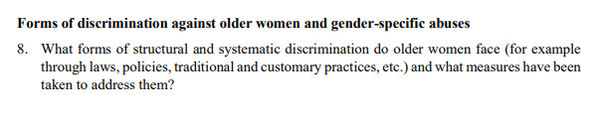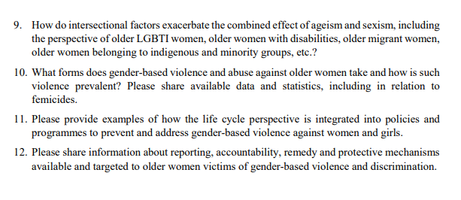
8. Ageism is “the most widespread form of discrimination across the EU” that older women particularly face, due to their longer life expectancy. The COVID-19 pandemic has reiterated the strong impacts of ageism since it affected and threatened the equal enjoyment of human rights by older persons.

9. In order to mitigate discrimination that is led by ageism and sexism, and exacerbated by other intersectional factors such as LGBTIQ older women, in 2018 Malta launched its second LGBTIQ Strategy and Action Plan 2018-2022. The following are measures which are directly aimed at LGBTIQ older women:
- The adoption of the Equality Act and the Human Rights and Equality Commission Act, to tackle discrimination in all spheres of life, and intersectional discrimination.
- The identification and addressing of specific needs of LGBTIQ with respect to older people, including those who are in care settings.
10. In 2015, the National Commission for the Promotion of Equality (NCPE) carried out a Research Study on Violence on Older Women and Men- A qualitative perspective by which 31 face-to-face in-depth interviews were carried out with victims/survivors of elder abuse, 30 of whom were women and 1 was a male participant, respectively. 52% of the respondents were aged between 60-69 years, while the remaining 48% were aged 70+.
The NCPE had put forward a number of recommendations with the aim of addressing elder abuse in Malta. In the past five years, advancements have been made with respect to service provisions, and awareness-raising and empowerment initiatives aimed at the victims and perpetrators.

https://legislation.mt/eli/cap/456/eng/pdf
https://activeageing.gov.mt/en/Pages/NSPAA.aspx
https://medecms.gov.mt/en/Documents/Malta%20National%20Lifelong%20Learning%20Strategy%202020.pdf
https://eur-lex.europa.eu/legal-content/EN/TXT/PDF/?uri=CELEX:52020DC0152&from=EN
https://ec.europa.eu/info/files/green-paper-ageing-fostering-solidarity-and-responsibility-between-generations_en
https://www.um.edu.mt/services/u3a
https://ec.europa.eu/eurostat/databrowser/view/hlth_hlye/default/table?lang=en
European Institute for Gender Equality, 2017. Gender Equality Index 2017 – Measuring Gender Equality in the European Union 2005 – 2015.
Ibid.
https://appsso.eurostat.ec.europa.eu/nui/submitViewTableAction.do
European Union, 2018. Informal care in Europe. Exploring Formalisation, Availability and Quality.
Ibid.
https://ec.europa.eu/eurostat/databrowser/view/ILC_PNP13__custom_470372/bookmark/table?lang=en&bookmarkId=ca6425d8-bd3e-4a09-b6d8-c181ea76bc6a
https://ec.europa.eu/eurostat/databrowser/view/sdg_05_20/default/table?lang=en
https://eige.europa.eu/publications/gender-equality-index-2020-malta
https://www.age-platform.eu/sites/default/files/Human%20rights%20concerns%20on%20implications%20of%20COVID%2019%20to%20older%20persons_Final_18May2020.pdf
https://ec.europa.eu/eurostat/databrowser/view/ILC_SCP19__custom_729611/default/table?lang=en
https://equineteurope.org/2020/covid-compounding-inequalities-against-older-persons/
https://age-platform.eu/special-briefing/discrimination-abuse-older-age-insidious-process-brought-light-covid-19
LGBTIQActionPlan.pdf (gov.mt)
https://ncpe.gov.mt/en/Documents/Projects_and_Specific_Initiatives/Forms%20of%20Violence/Report%20-%20Violence%20Elderly.pdf
The following were the main findings: - 81% of the perpetrators were the husband/ partners; 16% were the victims’ children or partners; and 3% were the wife - A large percentage of respondents stated that the abuse was carried out in the household – behind closed doors and the abuse lasted from 31 to 40 years - The forms of abuse experienced by the victims were mainly psychological/emotional, followed by neglect, physical, financial/material, and sexual - The majority of respondents stated that they have opened up about the abuse they were experiencing with their sister/daughter only, whereas 36% of respondents stated that they only spoke about said abuse only after it stopped (separated/divorced) - The majority of the victims did not seek help from third parties.

