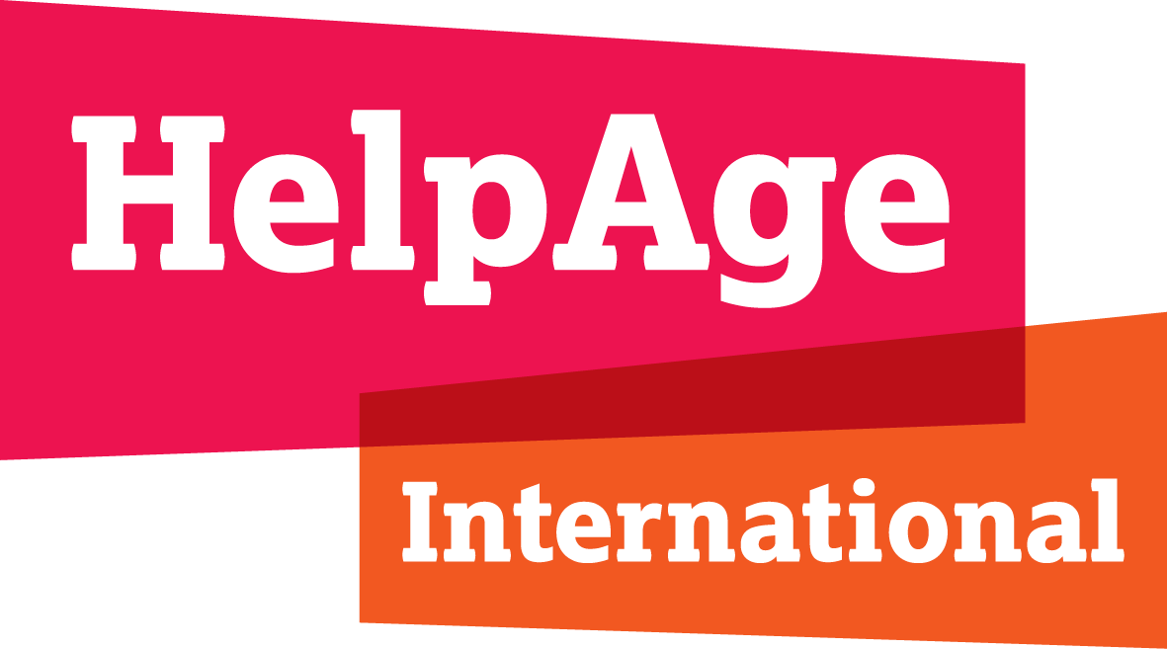

HelpAge International submission for the consultation on the human rights of older women by the Independent Expert on the enjoyment of all human rights by older persons

March 2021

1. Economic, social and cultural realities lived by older women

1.1 Unpaid care
Older women’s rights, and their economic contributions, including their unpaid and underpaid care work, are still absent from discussions about women’s economic empowerment. Globally, older women provide on average 4.3 hours of unpaid care and domestic work per day. This includes essential care for children, those with physical, mental and cognitive health and other support needs, as well as for spouses and other older people with care support needs.

The unpaid care that older women do supports the economic empowerment of other generations of women and girls, but often creates barriers for older women to access their own economic rights. For example, although older women’s work can help them to stay connected to and active in their households and communities, they are often not supported in their roles by informal or formal systems – which creates barriers for them to access economic rights including decent work. Unpaid care often leaves them without rest and leisure time undermining their right to the enjoyment of just and favourable conditions of work.

1.2 Control over resources
Cumulative gender inequalities mean older women are likely to be among the poorest and most marginalized in terms of access to and control over resources. Current statistics on global multidimensional poverty, with asset and housing deprivation as one of the indicators, reveal that 107 million multidimensionally poor people are age 60 or older—a particularly stark figure given that the COVID-19 pandemic is likely to increase poverty amongst this age group. Older women are less able to rely on savings in older age as they have often worked fewer years and earned less in that time. Older women’s lower levels of savings are compounded by a lack of financial planning. In developing economies, only 16% of adults reported to saving for old age while men are six percentage points more likely than women to save at a financial institution. Access to financial services may also be denied older women.
“We are prohibited from getting credit to micro-finance because we are older women. They believe we area too old and might die any time. Are younger people not dying too?”
69-year-old woman, Nigeria

In emerging economies, older people over the age of 65 have the lowest financial literacy rates of any age group. Older women are significantly less financially literate than men. Women in low-income countries may also lack the documented proof of birth, identity or citizenship required to access some productive resources. Older women figure prominently amongst those who lack these forms of documentation having spent their entire lives outside of spheres that encourage or demand documentation, such as the formal work sector.

1.3 The right to work
Older women remain economically active, particularly in low and middle-income countries, and evidence shows they are still doing significant amounts of work – paid and unpaid. The share of older women in the labour force in LMICs has increased since 1990. The ILO estimates that globally 28 per cent of men and 13 per cent of women aged 65 and older participated in the labour force in 2019. In low-income countries, this percentage rises to 33 per cent for women. Older women in poorer contexts are more likely to take on paid work, often to support their households.
While work can be a key part of older women’s identities and connectedness to their households and communities, many older women are facing challenges with multiple responsibilities and poor working conditions that have a negative impact on their mental and physical health.

Women of all ages work mainly in the informal sector. In low-income countries, 92.1 per cent of employed women are in informal employment. Informal employment tends not to be decent or dignified work which respects the rights of workers in terms of providing safety at work, a fair income and equality of opportunity for personal development. Older women in paid work are often in precarious and informal roles and working under unsafe conditions without access to social protection.

Older women’s work is often driven by economic necessity, but also the need to remain active, fulfilled and connected, and to avoid dependency. The type of work is driven partly by age-based and gendered norms and expectations which present barriers to doing the work and the amount of work that they would choose. In addition to experiencing discrimination based on their gender, older women also experience specific discrimination based on their age, being regarded as less capable. It is one of the barriers contributing to shorter working lives. Many older workers face ageism in matters related to employment, including recruitment process, continuance of employment, career advancement, retirement policies, and safe and healthy working conditions, in both the formal and informal sectors.

“Older women are seen as less active hence employers prefer younger women to take up the roles in the workplace.”
51-year-old woman, Zimbabwe

1.4 Right to land, property and inheritance rights
Older women’s access to land ownership and other property through inheritance or other means is insecure and often challenged if it is not realised through their dependence on a husband or a male family member. These inequalities are due both to discriminatory legislation as well as to entrenched socio-cultural norms. Globally, older women are more likely to be widowed and less likely to remarry than older men, affecting their access to economic assets such cultivable land and other property.

“[I was no longer able to make my own decisions] soon after I retried from my teaching job 16 years ago and had to come back to my village. I lost my husband a few years later and my income started declining.”
76-year-old woman, Tanzania

1.5 Right to education and lifelong learning: digital inclusion
The educational and digital divide remains a gendered one with older women invariably being disadvantaged, accentuating their social and economic isolation and ability to access and have control over productive resources.

More than 50% of women aged 65 and older are illiterate compared to about 35% of men in the same age groups often as a result of discriminatory gendered norms across the lifecourse around access to the right to education. The digital divide remains a gendered one with gender differences in internet uptake being more marked for older generations.

As governments migrate public-sector services including stimulus packages to the online domain, the lack of digital literacy skills is likely to exclude older women even more. This may accentuate older women’s social isolation, and may pose challenges to accessing timely information, tele-medicine and e-commerce resulting in less consumer power and fewer economic opportunities. Lack of digital skills to use electronic services will further exclude older women and give rise to age-related inequality.

1.6 The right to social security and social protection
The right to social security includes the right to an adequate pension. This right applies to everyone whether they work in the formal or informal sector or have worked all their lives in unpaid care roles. Women are much less likely than men to receive a pension, and if they do, they tend to have considerably lower benefit levels, partly due to discrimination against women in the labour market, gender-biased pension scheme design and a greater share of family responsibility by women.

In times of crisis, social protection is often framed as unaffordable, leading to cuts in public spending. Austerity measures prescribed by international financial institutions often disproportionately impact women of all ages and the right to social protection for older women is in jeopardy in many countries. To deal with demographic ageing and financial constraints, states have reformed pension systems in different ways, including raising the retirement age, cutting benefit levels, raising workers’ contributions, and strengthening links between contributions and benefits. These policies have had not only negative macroeconomic effects, but also negatively impact on older women’s right to social security and social protection.

Investment decisions in socio-economic infrastructure for the provision of essential services fail to address the specific constraints faced by older women. Older women’s economic disadvantage means they are more reliant on publicly funded social protection initiatives such as pensions. However, they are also less able to access social protection schemes that are often contingent on previous financial contributions through formal employment. Contributory pension schemes can disadvantage low-income earners and those with insufficient contribution histories, which are disproportionately women, including older women. Social pensions are not based on continuous participation in paid formal sector employment and therefore more accurately reflect women’s life-courses. To ensure that social pensions effectively reach all older women, especially the marginalised, social pensions should be provided on a universal basis.

2. Forms of discrimination against older women and gender-specific abuses

In a consultation HelpAge conducted in 2017 with across 19 countries, older women spoke about the discrimination they faced in public life.

“When you start to speak in a meeting and you are an older woman, you are shut down, not listened to.”
Group discussion, Uganda

The participants said that ageism and age discrimination were particularly strong against widowed or single women. Older widows were not allowed to participate in family and social events, some were accused of being witches. Those living with family members were insulted and denied any autonomy within the family in terms of food, participation in decision-making, freedom of movement, the right to work and disposal of their property according to their wishes.

“Single older women who are widowed, not married, or divorces face the most discrimination.’
51-year-old woman, Zimbabwe

Older women with disabilities were considered at particular risk of discrimination, being deprived of their liberty and right to live independently, forced to live in institutions, denied appropriate food and medical support with no access to employment or adequate social security.

“Older women with disabilities regularly face a rude attitude in hospitals, clinics, on transport…Society shows indifference to them. They often become victims of manipulation and discrimination.”
65-year-old woman, Kyrgyzstan

Older women living in rural areas, older women migrants and refugees, older women living with dementia or with HIV and AIDS, without children, with low literacy levels, considered to have a lower social status, without proper documentation or living in poverty were also identified as being subjected to intersectional discrimination.

3. Reports related to the human rights of older women

- HelpAge International (2017), Entitled to the same rights: What older women say about their rights to equality and non-discrimination and to freedom from violence, abuse and neglect, 2017 https://www.helpage.org/newsroom/latest-news/older-women-speak-out-about-their-rights-in-new-helpage-international-report/

- HelpAge International (2017), Violence against older women, 2017 https://blog.ageinternational.org.uk/wp-content/uploads/2017/12/HelpAge-ViolenceAgainstWomen-LowRes2.pdf

For further information, contact Bridget Sleap, Senior rights policy adviser, HelpAge International
bsleap@helpage.org

https://www.ageinternational.org.uk/contentassets/b73c56b5662f44c2988f4018f1acb679/who-cares---age-international---nov18.pdf
UN Women, “Challenges Facing Older Women”, Statement by Phumzile Mlambo-Ngcuka, Under-Secretary General and Executive Director UN Women, February 28, 2017
United Nations Development Programme and Oxford Poverty and Human Development Initiative (2020). Global Multidimensional Poverty Index 2020: Charting pathways out of multidimensional poverty. http://hdr.undp.org/sites/default/files/2020_mpi_report_en.pdf
https://socialprotection.org/sites/default/files/publications_files/AARP%20Journal%202019%20-%20Social%20Protection%20for%20Older%20Women%20-%20Ortiz%20and%20Juergens.pdf
World Bank. 2017. The Global Findex Database 2017. Https://globalfindex.worldbank.org/
HelpAge International (2017), Entitled to the same rights: What older women say about their rights to equality and non-discrimination and to freedom from violence, abuse and neglect, 2017
L. Klapper, A. Lusardi and P. van Oudheusden, Financial Literacy around the World (Insights from the Standard & Poor’s Ratings Service Global Financial Literacy Survey, 2015), http:// gflec.org/wp-content/uploads/2015/11/3313-Finlit_Report_FINAL-5.11.16.pdf?x87657;
A. Hung, J.Yoong and E. Brown, “Empowering Women through Financial Awareness and Education”, OECD Working Papers on Finance, Insurance and Private Pensions, No. 14 (Paris: OECD Publishing, 2012) http://dx.doi.org/10.1787/5k9d5v6kh56g-en
Desai, Deofasi, Lu (2018) The global identification challenge: Who are the 1 billion people without proof of identity? (worldbank.org)
https://www.tandfonline.com/doi/full/10.1080/00220388.2018.1451637
https://www.ageinternational.org.uk/contentassets/b73c56b5662f44c2988f4018f1acb679/who-cares---age-international---nov18.pdf
ILO Labour Force Estimates and Projections Database (2017)
International Labour Office (2018). Women and men in the informal economy: A statistical picture. https://www.ilo.org/wcmsp5/groups/public/---dgreports/---dcomm/documents/publication/wcms_626831.pdf
https://www.ageinternational.org.uk/contentassets/b73c56b5662f44c2988f4018f1acb679/who-cares---age-international---nov18.pdf
Overseas Development Institute – Between work and care: Older women’s economic empowerment https://www.odi.org/sites/odi.org.uk/files/resource-documents/12509.pdf and upcoming research from Age International
https://www.ilo.org/wcmsp5/groups/public/---ed_protect/---protrav/---travail/documents/publication/wcms_711798.pdf
International Labour Office (2018). Women and men in the informal economy: A statistical picture. https://www.ilo.org/wcmsp5/groups/public/---dgreports/---dcomm/documents/publication/wcms_626831.pdf
https://www.ageinternational.org.uk/contentassets/b73c56b5662f44c2988f4018f1acb679/who-cares---age-international---nov18.pdf
https://www.ageinternational.org.uk/contentassets/b73c56b5662f44c2988f4018f1acb679/who-cares---age-international---nov18.pdf
UNECE, Combating ageism in the world of work (2019) https://unece.org/DAM/pau/age/Policy_briefs/ECE-WG1-30.pdf; https://www.helpage.org/silo/files/keeping-our-dignity-english.pdf
HelpAge International (2017), Entitled to the same rights: What older women say about their rights to equality and non-discrimination and to freedom from violence, abuse and neglect, 2017
Women and Girls’ Education - Facts and Figures UNESCO. www.unesco.org/new/en/unesco/events/prizes-and-celebrations/celebrations/interntional-days/international-womens-day/women-ed-facts-and figure/REFERENCE?
“You will get nothing” Violations of Property and Inheritance Rights of Widows in Zimbabwe. Human Rights Watch report 2017. http://www.hrw.org
HelpAge International (2018), Freedom to decide for ourselves: What older people say about their rights to autonomy and independence, long-term care and palliative care, 2018
Women and Girls’ Education - Facts and Figures UNESCO. www.unesco.org/new/en/unesco/events/prizes-and-celebrations/celebrations/interntional-days/international-womens-day/women-ed-facts-and figure/
https://webfoundation.org/2020/03/the-gender-gap-in-internet-access-using-a-women-centred-method/
https://www.oecd.org/social/empowering-women-in-the-digital-age-brochure.pdf
https://socialprotection.org/sites/default/files/publications_files/AARP%20Journal%202019%20-%20Social%20Protection%20for%20Older%20Women%20-%20Ortiz%20and%20Juergens.pdf
https://www.ilo.org/wcmsp5/groups/public/---dgreports/---dcomm/documents/publication/wcms_310211.pdf
International Labour Office (2018). Social protection for older persons: Policy trends and statistics 2017-19. https://www.ilo.org/secsoc/information-resources/publications-and-tools/policy-papers/WCMS_645692/lang--en/index.htm; UN Women (2015). Progress of the world’s women 2015–2016: Transforming economies, realizing rights. https://www.unwomen.org/-/media/headquarters/attachments/sections/library/publications/2015/poww-2015-2016-en.pdf?la=en&vs=0
https://www.ituc-csi.org/Pension-systems-adequacy-sustainability
https://www.ituc-csi.org/Pension-systems-adequacy-sustainability
World Social Protection Report 2017-2019. ILO, 2017
https://www.ituc-csi.org/Pension-systems-adequacy-sustainability; The World Bank’s new White Paper falls short on its objective of ‘protecting all’ - Development Pathways
https://socialprotection.org/sites/default/files/publications_files/AARP%20Journal%202019%20-%20Social%20Protection%20for%20Older%20Women%20-%20Ortiz%20and%20Juergens.pdf
HelpAge International, Entitled to the same rights: What older women say about their rights to non-discrimination and equality, and to freedom from violence, abuse and neglect, 2017

