Check against delivery

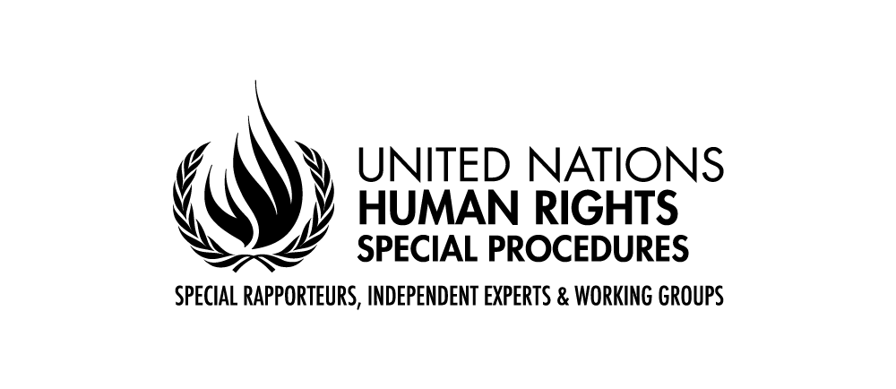

Claudia MAHLER
Independent Expert on the enjoyment of all human rights by older persons

Berlin, 8 October 2020

UNITED NATIONS GENERAL ASSEMBLY

75th session

President,
Excellencies,
Ladies and Gentlemen,

It is an honor for me to address you – remotely from Berlin – in my capacity of Independent Expert on the enjoyment of all human rights by older persons, for the first time since I assumed my mandate in May 2020. I am also very pleased to be able for the very first time to introduce a dedicated thematic report to the General Assembly, in addition to my annual report to the Human Rights Council.
At the outset, allow me to pay tribute to my predecessor, Rosa Kornfeld-Matte. I wish to acknowledge her path-breaking work in advancing the human rights of older persons during her tenure as the very first special rapporteur on the human rights of older persons.
The comprehensive report (A/HRC/33/44) presented to the Council in September 2016 constitutes a global status determination on the human rights of older persons. It provides the analytical framework for advancing the human rights protection for older persons, while it concludes that existing arrangements are inadequate and that dedicated measures to strengthen the international protection regime are required. As part of my mandate, it will be my role to provide further analysis on the existing challenges and protection gaps to contribute to the realization of the rights of older persons.

President,
Ladies and Gentlemen,
In the face of the further spreading of COVID-19, I would like to extend my profound sympathies and condolences to all those who have suffered loss and bereavement.
The pandemic has – until now - had a disproportionate impact on older persons and has magnified existing violations of their rights. In light of this, I have dedicated my report to the General Assembly to the impact of COVID-19 on the enjoyment of all human rights by older persons (A/75/205).

Excellencies,
Ladies and Gentlemen,
The pandemic has very broad effects on older persons: they have been denied health services; they have been physically and socially isolated; and they have been the victims of ageist attitudes. Despite being such a diverse group, older persons in general have been labelled as vulnerable and branded as burdens to societies. The pandemic has made very evident the urgent need to combat stigma and age discrimination.
The pandemic has shed light on the barriers preventing older persons from fully enjoying their human rights. It has also shown that older persons are left behind. It has made visible protection gaps that will need to be addressed beyond the response and recovery stages. It has also highlighted the need not only for urgent action from Governments in response to numerous challenges, but also for preventive measures.
Efforts to protect older persons should not overlook the multiple roles older persons play in society, including as caregivers, volunteers and community leaders. It is essential to be aware of and embrace the full diversity of persons in the older persons’ category. Women, for instance, are overrepresented among both, older persons and the paid and unpaid care workers who look after them. The participation of older persons in the crisis response, including as health workers and caregivers, must be recognized.

Excellencies,
Ladies and Gentlemen,
As you are aware, the UN Secretary-General has issued a Policy Brief on the Impact of COVID-19 on Older Persons in May 2020. As a result, many of you – 146 States - pledged to fully promote and respect the dignity and rights of older persons and to mitigate the negative impacts during and after the COVID-19 pandemic on their health, lives, rights and well-being. I am particularly encouraged by this unprecedented show of political support.
Yet, the lack of a comprehensive and integrated international legal instrument to promote and protect the rights and dignity of older persons continues to have significant practical implications. Current instruments do not specifically address the issues of ageing or make them sufficiently visible. They therefore preclude older persons from the full enjoyment of their human rights. Crucial areas have not been covered extensively. This includes legal capacity, quality of care, long-term care, palliative care, assistance to victims of violence and abuse, available remedies, independence and autonomy, and the right to an adequate standard of living, in particular with regard to housing. Each of those areas raises a set of issues and protection concerns that deserve in-depth analysis, taking into account regional specificities and best practices.

President,
Excellencies,
Ladies and Gentlemen,
Although older persons constitute a focus group in the context of the pandemic, they remain chronically invisible. The pandemic has exposed this flagrant lack of data on older persons and their lived realities. This is the subject of the in-depth analysis of the latest annual report to the Human Rights Council, which I had the honor to present a few weeks ago to the 45th session.
This data gap constitutes, in itself, an alarming sign of exclusion and renders meaningful policymaking and normative action practically impossible.
Making older persons visible and lending them a voice will be my guiding principle in discharging the mandate entrusted to me. I attach particular importance in continuing the constructive dialogue with Member States of all regions and to safeguard a space for meaningful engagement and exchange with a broad array of actors and stakeholders, including older persons themselves.
I thank you for your attention and support.

***

