INTRODUCTION:

Migrants in transit are not a legal condition according our national law, only a description. We don’t distinguished between migrants in transit (because transit is quite relative) and migrants. Both are suffering the same political and legal contradictions and human rights violations.

In this overview we want to reflect our perception and action as Cáritas Spain.

A. Exit restrictions in countries of origin and the externalisation of border controls which could have an impact on the human rights of migrants in transit.

There is no real restriction for desperate people. In Cáritas Spain‘s position it is necessary to push for another approach. The restriction policies are expensive, inefficient and violate human rights.
- The lack of legal pathways.
The lack of legal pathways and the externalization of border controls are responsible of the majority human rights violations.
People must choose the worse way to go out because there is no way if you are not an investigator, a famous writer or a rich man. In Spain we receive a lot of subsaharian people after 3 or 4 years on their back. People who has family in regular situation in other European countries but who are not allowed to ask for family reunification or the EU members have denied.
This is the case of many minors who leave their families for many reasons (fathers died, they belong to new re -estructured families and they are not accepted (seconds marriages, for ex).
Family reunification means to have a legal way to entry and to be integrated but every day we experienced how difficult is to achieve a family reunification procedure, not only in the strict meaning but enlarge too.
The difficult to obtain visa for only 3 months because the conditions in Spain are quite complicated.Iif you want to host someone from a third state ( non EU member) the procedure is quite long: you must ask a police report, a certificate from your neighbours in the building where do you live; to demonstrate what is your relation whit the person who is coming. We have some bad experiences for ex, a mother who couldn’t come to help her daughter with her new baby born; a grandma who wanted to come to visit their little children; even people who are been invited to Cáritas events and are not allowed to entry because the lack or visa in many occasions.
In the other way, statistics show us, the visa is used as a legal way to entry in the EU and people decide afterwards to stay even in irregular situation. That means we are causing people stay in irregular situation, even if they don’t want to stay because they can’t coming back without an entry ban.
Underskilled profiles are more representative as investigators, cientist etc but facts show us it is impossible to acceded in a proper way to Europe if you are not a singer or a football player etc… In contradiction, many statistics shows Europe need workers ( migrants) and not only high skilled.
Humanitarians visa are also a way to exit the country in case of conflict but in fact they don’t provide those visas. The Spanish asylum law was amended two years ago but before this change it was possible to apply for asylum at Spanish embassies.

- Border externalization:

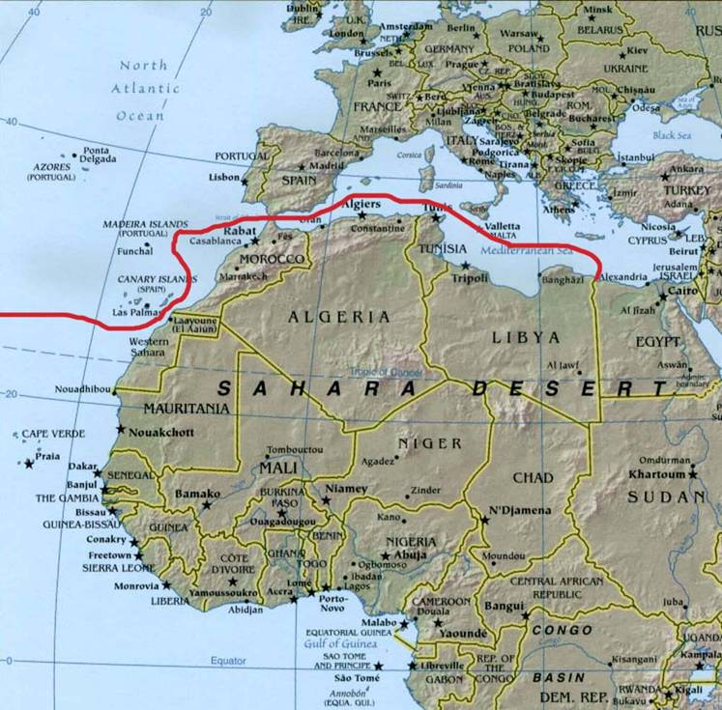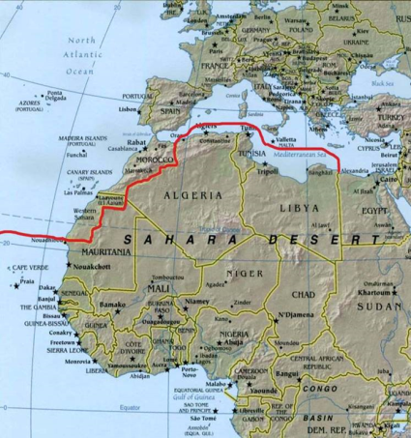
2
1

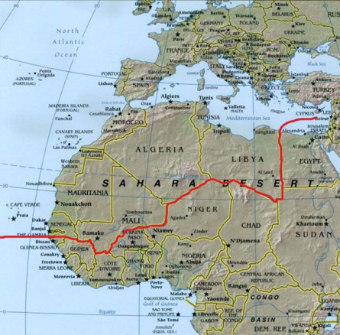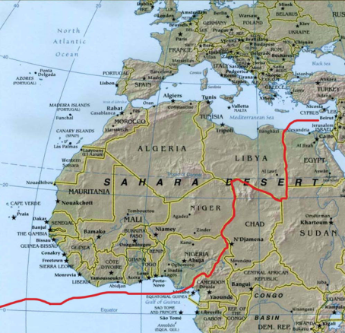
4
3
This different pictures show us how much the Spanish external border whit Africa have changed during the last 10 years because of readmission agreements ( first, second and third generation agreements) but also linking development agreement to fluxes control.
The consequences are people must search worse and dangerous ways to try to arrive to Europe.

B. Particular measures in countries of transit, including:

- Access to essential services in transit, such as health care and services;

On 2012 the Spanish government changed the health care law to exclude migrants in irregular status. Before this change, migrants in irregular situation had a free health care access by being registered in the council register.

Now, irregular migrants are still excluded from general health care, but they have access to emergency services. Minors and pregnant women have all the health rights according to the new law.

Some regions in Spain have approved to extend the health care for Spanish to migrants in irregular status.

Cáritas Spain have denounced in several occasions this human rights violations to the Spanish Ombusman and asked political parties to change the law.

There is a strong social movement working together in that way. It’s called “white tide” and they fight for the right to a public and free ( for those who can’t afford it) health care.

THIS IS A CLEAR EXAMPLE OF INTEGRATION. The Spanish society fight to extend human rights to migrants (even if they are in irregular situation).

- Protection from violence, including sexual and gender-based violence, as well as abuse and exploitation of migrants in transit by State and non-State actors;

Protection from violence, sexual and gender –based violence victims are protected at legal level (whit some contradictions) and women in irregular situation could obtain an exceptional circumstances permit. (article 131 Foreigners Law).Also smugglers and trafficking victims can apply for this specific permit.

For gender-based violence, Spain has a very progressive legislation whit no distinction between migrants (in regular or irregular situation) or Spanish/ Europeans victims. Anyway the difficulties for migrant women are evident ( they have fear to go to the police, some cultural patterns have to take into consideration…)

For smuggling and trafficking victims the main problems are to identify victims to try to protect them. Cáritas Spain work in network with other specialized NGO’s. La red Española contra la trata push for a real victim’s protection.

Cáritas Spain also takes part at European level as COATNET member.

- Specific measures to protect and ensure the best interests of all migrant children in transit, whether they are travelling on their own or with their parents/guardians;

Unaccompanied minors are in theory protected under the Spanish law, considering them first as minors than migrants. But in fact, we have some problems whit teenagers and the procedure to recognize them as minor.

Last year, the Spanish government approved a Protocol to try to coordinate in a proper way the public administration roles and responsabilities, but we still have problem.

Accompanied minors?

There is an increasing number of minors who come to Spain “accompanied” but who are in fact smuggler‘s victims. Last year, the Spanish police start to make DNA analysis to each minor who come to Spain whit an adult. I mean minors who arrived to Spain in an irregular way, in general by “´Cayucos” or Fortune boats.

Some social agents present in the south border places told us, Sexual exploitation mafias use children to guarantee women stay into the criminal organization.

The violence against women migrants in transit is a very hard reality. Sometimes they arrived in Spain after being abused several times, and children are the consequence of those abuses. The link between mother and child are weak.

- Rescue of migrants in distress at land, sea and air borders, provision of immediate assistance and referral to adequate services;

We have no real experience in this area.

- Alternatives to immigration detention and protection against arbitrary detention;

There are alternatives to immigration detention in our national law but the experience we have is they are not chosen by the police who decide about the process : the normal one –without detention- or the summary one.

The consequences are we have people in detention who finally are not deported at all but stay in a close detention center, under bad conditions, sometime for 60 days (the maximum).

Cáritas have proposed to the government several times to close the detention centers and to implement other alternatives to detention.

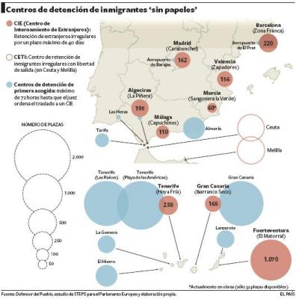

There were 9 detention center in Spain, but last year, Capuchinos, the Malaga Detention Center was close because of structural deficiencies.

In 2014 the Spanish Government approved a new legislation about the internal regime in detention center. Caritas Spain together whit the Migrant’s Jesuit Service in Spain had a very intense previous/ subsequent advocacy work.

The new legislation obliged the Government to publish the detention figures, but we have no news for the moment.

There is a new practice, denounced by many NGO’S called “ Express Expulsion” which violate basic rigths. People is effectively expulsed in less 72 hours.

- Measures to ensure that any returns of migrants in transit are carried out in accordance with international law and standards, including the principle of non-refoulement and the prohibition of collective expulsion.

This year the government approved an amendment to try to legalize what is described in an informal way “hot devolutions” in Ceuta and Melilla and we define as summary expulsions.

The summary expulsions violate not only our constitutional law but also international/european conventions subscribed by Spain.

Several NGO’S have promote and appeal Court’s decision on constitutional ground for this issue. Caritas Spain was involved since the beginning in this procedure.

The High Commissioner of Human Rights for the European Council has also denounced this illegal practice, and our Ombusdman (Defensor del Pueblo ) too.

http://www.coe.int/en/web/commissioner/-/commissioner-muiznieks-intervenes-before-the-european-court-of-human-rights-on-migration-cases-concerning-spain?inheritRedirect=true&redirect=%2Fen%2Fweb%2Fcommissioner%2Fthematic-work%2Fmigration

Summary expulsion continues and violations of human rights too.

Collective expulsion is also in practice by paying air companies for this purpose:

http://www.intermigra.info/archivos/News914/ConcFin.pdf

http://www.elmundo.es/solidaridad/2014/06/12/53983e74ca474189138b457e.html

http://legalteam.es/lt/relacion-de-ultimos-vuelos-de-deportaciones-de-inmigrantes-realizados-desde-espana/#

C. The availability and adequacy of a human rights-based approach to transit migration, including:

- Governance of irregular migration, including avoiding the criminalisation of migrants in an irregular situation;

We believe in human rights approach in Human mobility. We believe migration is an opportunity to all countries development.

BUT we need to build the right to migrate as a real human right with 3 axes:

- The right to stay at home because I live in peace and I have ressources and possibilities to live. The link to development and sustainable goals.
- The right to leave my country in a safe way and the right to enter in another country in a safe way too.
- The right to live in a third country as a human being and to be integrated in the new society or to come back to my country.

We want to push for an extensive recognition of human rights for people in mobility, and pushes States to sign it. We think as Cáritas Spain the International Convention for migrant workers is not enough.

As Cáritas Spain we continue to advocate the Spanish Government to sign this Convention but we also believe we need more.

- Measures to prevent and combat all forms of xenophobia, racism and religious intolerance against migrants;

- Real access to education for migrant children. The real access means not only to be registered in a school but also to have adequate resources to have an intercultural approach.

- In our experience racism and xenophobia can be neutralized by working stereotypes and rumours about migrant whit the society but it needs to be supported by an Integration Policy coordinated by the State. Spain, in 2007 built whit all the agents involved (public administration, enterprises, ngo’s, migrant organizations) and Estrategic Plan for migrants integration and whit 200 millions euros for.
http://extranjeros.empleo.gob.es/es/Programas_Integracion/Plan_estrategico2011/pdf/PECI-2011-2014.pdf

The Spanish crisis and the public cuts have stopped this interesting tool to work together against racism and xenophobia at all level ( education, health services, social protection, mass media, local level, community action, housing policies, employ measure…)

- Some councils and ngo’s are working in a coordinated action called: “Anti rumours Agents” . It is a very interesting exercise because allow to work whit communities, whit schools…
http://www.antirumores.com/

- Cáritas Spain publishes a blog on migration (nobody without future) as a public tool to sensitize, to receive materials, to see other experiences on integration. : www.nadiesinfuturo.org

In October 2015 we have also approved a Church framework on migration and asylum
With the principal Catholic Church organizations to coordinate messages and advocacy in migration issues. The basis is Hospitality + Dignity =Migrants whit rights.

- Public speech is racist and xenophobic but the ethic code for communicators It is not a very useful tool in fact. https://monitorando.files.wordpress.com/2011/04/libro-actas-congreso-etica-comunicacion.pdf

- Human rights-based approaches to border governance, including in the context of counter-smuggling measures;

There is not border for human rights. So, for Cáritas Spain, the first think is to recognize humans rights violations in the border as a failure of migration policies in Spain and in Europe. Control flows as the stronger policy is an old fashion one.

We advocate for policy consistency in Foreign Policies, in Commercial and Economic policies, in
International Development etc…

We are very worried about Walleta Summit results.

Anti smugglers measures are an illusion. Our policies are in the roots of mafia benefits. People can’t leave their countries in a safe way and the mafias know that. When we build a bigger wall, they search another way, more dangerous, more expensive…

Legal pathways are the best antimafia measures.

d. Data collection measures to monitor the situation of migrants in transit, including on the number of migrants killed, injured or victims of crime while attempting to cross international borders.

Cáritas Spain has a data base of all the social intervention IN Spain. But we are convinced we need to share as network more information, to coordinate this info because we accompanied migrant during all the migration transit.

We have some interesting experiences whit other colleagues from the network. As a consequence we could help and accompany them in a better way.

http://www.policia.es/documentacion/no_comunitarios/car_requisitos.html
http://www.caritas.es/qhacemos_campanas_info.aspx?Id=814
http://yosisanidaduniversal.net/portada.php
http://www.accem.es/es/monograficos/trata-de-personas/red-espanola-contra-la-trata-de-personas
http://www.abogacia.es/2015/04/23/pueblos-unidos-denuncia-el-aumento-de-expulsiones-expres-sin-abogado-de-inmigrantes-con-arraigo/

