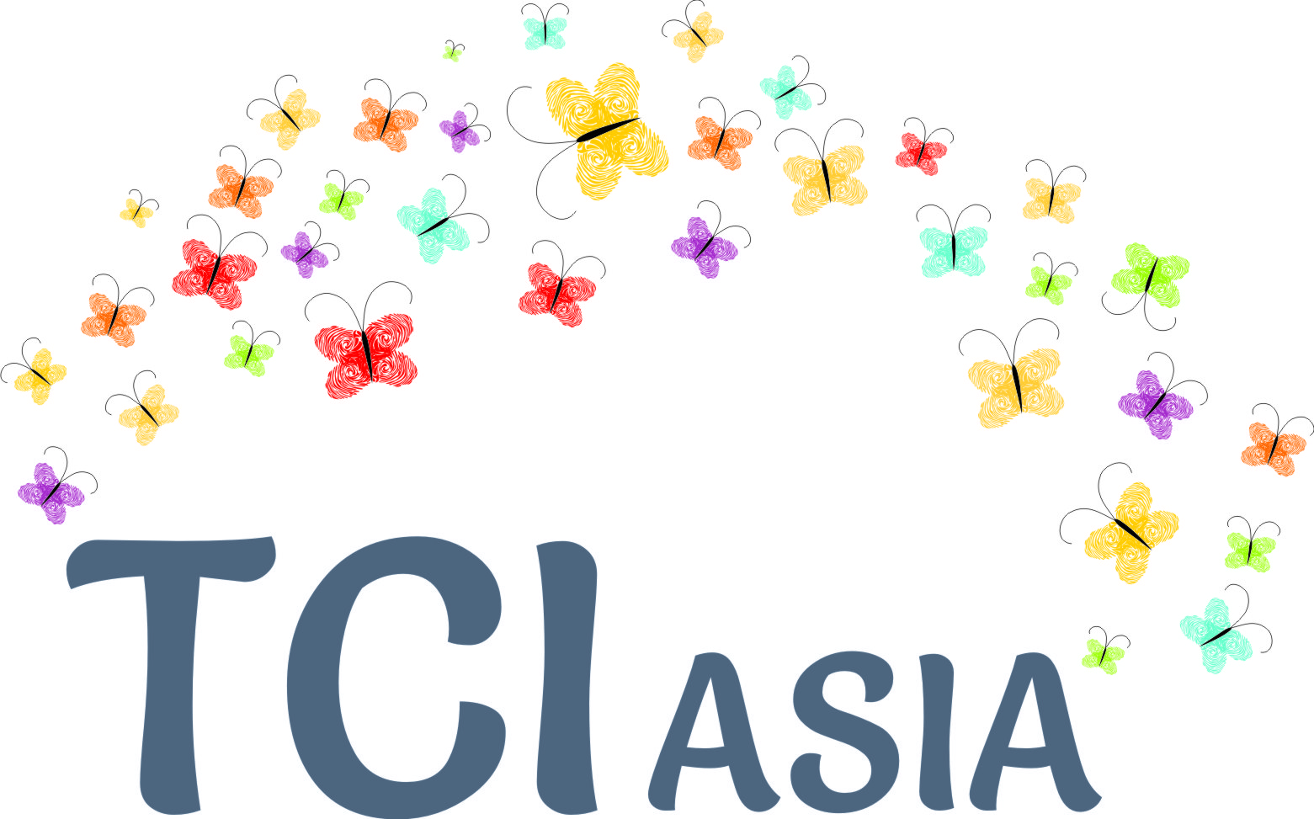
"Mental Health and Human Rights: Identifying strategies to promote human rights in mental health. 14-15 May, Room XVI, Palais des Nations, Geneva
General Statement by Bhargavi V Davar, Convenor, TCI Asia
"Mental health & Human Rights: Setting the Scene"

The Convention on the Rights of persons with Disabilities gives no new rights; Rights recognized as separate in UDHR and various earlier conventions are integrated in a way, to give new meaning to concepts like "legal capacity", "liberty", "equality", "non-discrimination", "progressive realization", and so on. In this way, jurisprudence worldwide has taken a whole new significance with the CRPD.

What has this change meant for people living, working and supporting people with psychosocial disabilities, their families and communities in the global South? What is the status of our human rights? TCI Asia stands for "Transforming communities for Inclusion - Asia". We work across Asia, and Pacific, in 17 countries, exchanging with diverse stakeholders, learning from and capacity building persons with psychosocial disabilities. There are reasons why our focus has been on "Inclusion" and full and effective participation, from the beginning.

Some Asia Pacific countries have old colonial policy framework. But another policy scenario is that, most Asian countries are without mental health laws, or mental health services. Violations of human rights happen more often in families, neighbourhoods and communities. Governments addressing these, for example, the extraordinary violence of women and girls with psychosocial disabilities within old policy framework; or unregulated care institutions where nothing else exists. There are also dozens of old, colonial incapacity laws especially in the Asian commonwealth, including plenary Guardianship, resulting in disempowerment, disqualifications, impoverishment and civil death.

For example, in our experience, where old legal frames of incapacity exist, several cases where family members contest each other's "insanity" are known, especially when substantial property and contractual matters are involved. Our network also offers support to many children who are forcibly institutionalized, drugged with hazardous pills like Ritalin, under the false promise of "cure" for lack of academic proficiency, and interactional family issues, justifying coercive treatment and end up dropping out of the system. There is also a network of women, who face huge discrimination, deletion of all decision making rights, and are often condemned by families and doctors, into institutions of different kinds or otherwise face severe social exclusion, because they dared to be "different".

Asia is emerging economic power, and in direct proportion to that, a lucrative site for pharmacracy. Clarion calls by psychiatrists to "fill the treatment gap" of "mental disorders" is resulting in growth of traditional mental health care of pills and institutions. New MH legislation, where they have been made, just like the old ones, has only led to greater violence and violation, enduring detention, isolation and segregation, possibly for life. This kind of "modernisation", as Mr. Puras has described well, is leading to increase in the "global burden of barriers", newer forms of coercion, modification of old institutions (e.g. jails, "vagrant homes", social care institutions) for involuntarily incarcerating persons with psychosocial disabilities.

Inclusion is not about forced institutionalization or treatment. But additionally, Inclusion is also not about community medicine, increasing the number of beds, psychiatrists or availability of pills. It is not creating 'group homes' with custodial management; and it is not community treatment orders. There is widespread belief today in the global south that a mental health law and pills will bring inclusion and protect the human rights of persons with psychosocial disabilities. Forced treatment in community has however resulted in 'zombism', people severely afflicted by the side effects of hazardous medications and other cruel, inhuman degrading treatments.

For example, a woman who was seen as "schizophrenic" over many years, had an insurmountable struggle, trying to convince her neurophysicians, that her fainting, amnesia, and other such extraordinary brain phenomena were "real". Her psychiatric prescription was increased even more. Eventually after months of struggle, they discovered a brain tumor in advanced stage. Including health care, all services need to be reframed from "incapacity" to "inclusion".

No one here is going against the law! It is the law that is grievously faulty. As Mohammed Yunus has said, "An old road can only lead an old destination. For anything new to happen, we need to make new roads". It is fair to say, pre human rights law are old roads, and Inclusion is the new one.

"Inclusion" as signified by CRPD, Article 19 - Living independently and being included in communities) has given hope, and more important, the faith and the encouragement to build new programs, opening up opportunities and access to all kinds of services in communities. Both generic and specific. My key message is that we have to change traditional legal practice of how to 'fairly' deprive liberty or how to 'fairly' establish that a person is 'incapable'. In its place we need to usher in a whole new set of community practices with the idea of "Inclusion", as required by the new human rights paradigm- all rights for all persons with disabilities without exception, also reiterated in concluding observations and in the General comments wrt CRPD.

Inspired by the idea of inclusion, in Pune city, a community based inclusion program for supporting people with psychosocial disabilities works in people's neighbourhoods, families near and far, and with a number of actors and agents, under the name of "Circle of care". It is primarily designed as a development program, also addressing psychosocial issues and inclusion. Worldwide, there are several such programs as evidence of good practices.

Governments do not need new mental health laws, nor do they need to reform incapacity and insanity laws. Those needs to be repealed where they exist; and a moratorium placed on making new mental health laws. Governments need guidance and pilots on the ground, gathering evidence on carefully planned de-institutionalization, socially innovative care giving solutions in the communities. They need policies on Inclusion, which is intersectional- Inclusion in all development linked services; in all SDG goals and monitoring. Attitudinal change and shifting mentality, in all human services, general and specific, is indeed the first step towards the paradigm shift.

Our constituency is invisible and denied reality, histories, memories, families and our social spaces. We place before you, esteemed ladies and gentlemen, an appeal to revive and resuscitate our personhood!

Thank you!

