**Hit by Multiple Crises**

**The Situation of the Munda Indigenous Community in the Subdistricts Koyra and Shyamnagar**

**(Khulna Division, Bangladesh)**

**during the COVID-19 crisis**

**and in relation to severe impacts of climate change**

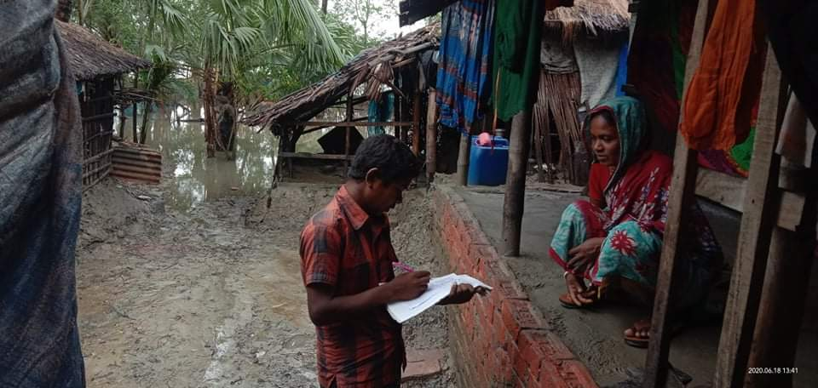

**Input for the Report of the**

**Special Rapporteur on the Rights of Indigenous Peoples**

**to the UN General Assembly on the**

**Impact of COVID-19 on indigenous peoples**

Author: Yi Yi Prue, Advocate, Dhaka Judge Court

With the active support of:

Initiative for Right View (IRV),

Sundarban Adibasi Munda Sangastha (SAMS) and

Coastal Education and Diversity Improvement Organization (CEDIO Shyamnagar)

Dhaka, 19 June 2020

**Input for the Report of the UN Special Rapporteur on the Rights of Indigenous Peoples**

**1. About this report**

The UN Special Rapporteur has called for inputs to his report on the impact of COVID-19 on indigenous peoples (Annex 1) to be presented in the UN General Assembly in October 2020. It is to be noted that the People’s Republic of Bangladesh currently does not recognize the indigenous peoples as indigenous. The 15th Amendment of the Constitution (30 June 2011) calls the people of Bangladesh “Bangalees” as a nation. Since then indigenous peoples by official sources have been grouped – together with other minority communities - as “tribes, minor races, ethnic sects and communities” or as “small ethnic groups”. This is part of the problem as it is an obstacle to designing approaches and policies according to the specific cultural, economic and social needs of the communities, who in the area of coverage of this document mainly belong to Munda community.

In this document the term “indigenous” is used as defined by international law, e.g. in the ILO Convention 169 (1989) or the UN Declaration on the Rights of Indigenous Peoples (2007). In this regard, the Munda community is considered indigenous and their situation qualifies to be analysed under this call for inputs (Annex 2).

This report has been compiled under very difficult circumstances in the aftermath of the super cyclone Amphan and the consequent wave swiping away more than hundred villages which devastated large areas in the coastal zones of Bangladesh with water receding from most of the flooded areas only just before this report had to be completed. This situation features as a specific element of this report, highlighting the impacts of a combination of multiple crises affecting the Munda communities in the two Subdistricts Koyra and Shyamnagar (Annex 3). For these communities earlier economic and social deprivation has been aggravated by climate change effects and this again multiplied by the COVID-19 pandemic.

Community members were contacted only in the week after 14 June 2020 while the pandemic is still evolving in the country. All the field research (Annex 4) has been done by unpaid volunteers – indigenous and non-indigenous - who met the affected people in their current temporary shelters in spite of heavy rain falls. Similarly the interviews with health officials, journalists, staff of NGOs and Munda leadership, the analysis and editing of this report were done on a voluntary basis without any funding.

**2. Responses to selected questions**

Collection and analysis of information by state authorities:

The Union Nirbahi Officers (UNO) on both Subdistrict (Upazila) levels confirm that the health complexes are open for everybody. They ensure that every patient will get equal treatment in their health complex. So far (17 June 2020), no Munda community person has come to the health complexes for treatment during the COVID-19 crisis. There is no specific data disaggregated according to ethnic/ identity group or age, gender, etc. available until today. They do not have the staff at their disposal to survey the health situation in the remote villages inhabited by the Munda community. In the past, when volunteers reported about local health issues, the UNOs confirm that they paid attention to the situation.

Community members in both subdistricts confirm that during the COVID-19 crisis they have not been contacted by health authorities concerning their health situation. This is an issue as the analysis shows that though their villages are remote, the community members are not completely isolated, but on the contrary, through their work as daily laborers and the search for work they are in regular contact with other persons outside their villages and therefore may be infected. Communication to the outside of their community on social and health issues happens mainly with humanitarian NGOs; only very few respondents have been in contact on this subject with the Union Parishad (lowest political/administrative level). No systematic evaluation of their health situation has happened though Munda organizations keep track of the social situation of their community members and were able to produce disaggregated information on the damage done by cyclone Amphan to Munda villages within a few days only. No systematic testing happened in the Munda villages. This is illustrated by a community report in contradiction to the official statement: one young male Munda community member was tested positive when he crossed the border from India. He was treated in hospital, however the authorities are not aware of this.

Munda community members hesitate to contact authorities on own initiative because they know they are considered as impure and uneducated. Trust to be treated with respect and dignity is very low. They remain reserved towards outsiders and avoid mixing with mainstream population. Even the responses during this survey show a significant quality imbalance depending on who asked the questions, an indigenous or a non-indigenous surveyor.

Increased risks for the Munda community

The following factors increase the risks of infection by COVID-19 or of severe developments of the disease in case of infection among Munda community members:

* Family relations across the border to India result in regular exchange and contacts while West Bengal (India) is among the hot spots of the pandemic.
* Various outside village contacts happen for economic reasons: search for work, daily labour. The mobility and working conditions without any security standards increase the possibility of infections.
* Health conditions in the community are poor in general and health care systems are difficult for Munda to access because of their culture of avoiding contacts to outside of their community. This is especially true for senior community members.
* Involving with the health system is considered to be expensive for community members. Only in case of severe suffering they would frequent (preferably private) hospitals, selling their belongings in order to be able to pay the bills.
* The fear of being stigmatised reduces the readiness to be tested on own initiative. The official practice of red-flagging houses of infected persons has been observed by Munda community members. They fear red-flagging as this falls in line with their long experience of being stigmatised and treated in disrespectful ways.
* The low levels of literacy and of formal education, including limited proficiency in Bengali language reduce access to information on protective measures.
* Unhealthy and contaminated drinking water because of increasing salinity of ground water due to climate change influence the well-being of community members.
* Nutritionals issues because of low income, increasingly difficult agriculture/ home gardening due to climate change effects, unemployment, etc., increase the vulnerability to diseases and infections.

Several of these factors are mutually inter-depending and their impacts are increased by the lockdown since 26 March 2020, by the Amphan cyclone and the following flood with all its destructions.

Own initiatives and lessons to be learnt

Munda community organisations do have information available on the social and health situation of community members and they are able to survey the status of the community within very short time. They could be empowered by using this information for designing strategies for health care systems. So far, this does not happen yet.

Since their arrival in the region, Munda people have been surviving under adverse living conditions. Village communities are mutually supportive to their members. This was visible during the aftermath of cyclone Amphan, when persons whose houses were destroyed stayed with other families, when food was shared and when temporary loans were given by friends.

There is a strong belief within the community in their own resilience, their ability to survive as a community and that the traditional practices of sharing and beliefs have contributed to survival in the past. Hope is connected with the protection of the environment as this crisis is often considered as a warning that people should love the natural environment.

There is a traditional practice and knowledge of using natural herbs to alleviate minor diseases. Munda communities have a long standing knowledge of the Sundarban mangrove forests and its potentials for herbal cures and medicines.

Input by indigenous peoples to COVID-19 responses

Nobody from among the local Munda community leadership has been asked for inputs on policy making for COVID-19 responses or relief efforts. The Munda people in both subdistricts even lack access to decision makers on subdistrict level. Their opinion was not sought by the responsible authorities.

Community members communicate with NGOs working in their areas and sometimes with the chairperson of the Union Parishad, however this being a level where no policies are designed. Even the Munda community leaders expressed that they find it unimaginable that they would be listened to and that their opinion could be taken into consideration (response: “not applicable”; another: “it is not possible”). When food aid was distributed after the lockdown was imposed on 26 March 2020, Munda cultural organisations submitted a list of vulnerable households to the local political, administrative and military leadership on subdistrict level which however they experienced was not taken into consideration. The distribution of relief was highly mediated and increased the feeling among the Munda that they are left out.

Dissemination of information

Official information about COVID-19 was only available in Bengali language. A Munda community organisation produced a short video on the pandemic in the local dialect of the community. Official information was disseminated mainly by NGOs through leaflets, media and banners. A state sponsored food aid distribution (four weeks after the lockdown was imposed) included visible examples of social distancing and wearing masks. In some areas information was spread through speakers (hand-microphone sound systems) in the roads.

The understanding of community members about COVID-19 is generally basic but correct. As explanation for COVID-19 the following terms were frequently mentioned: fever, cough, breathing problems, cold, (deadly) virus, mask, people die. Protection measures (wearing masks, social distancing, no meetings, regular hand washing) are considered difficult to implement in daily life in the villages.

The lack of material in Munda language is less a practical communication problem (many speak Bengali), but more a problem of identification with the message and of ownership of its content when the Munda community have experienced discrimination throughout their lives.

There is no Munda person involved in health services, not even as community health worker.

Good practices and targeted measures

In Shyamnagar Subdistrict a coordinating body of civil society organisations (NGO Coordination Parishad) includes Munda cultural organisations and they are able to bring in their concerns on this level. They assume that their perspectives are transported by this way to local administration.

Munda community organisations are in contact with traditional village leaders of the community. They trained them on protection measures like social distancing, hand washing, etc. This was transmitted by village assemblies to the rest of the villagers. This seems to have worked better in Shyamnagar Subdistrict where there is a larger community in more accessible localities. In the Unions in Koyra covered by this survey, the Munda’s understanding about the pandemic and protective measures seems to be less.

Economic, social and cultural impacts

The majority of the Munda community members make their living as daily labourers (construction, brickfields, farms, prawn farms, motor cycle taxi drivers, vegetable sellers), to a smaller extent as farmers or as fisherfolk. Some work in prawn cultivation. The average amount of income that is available to the money earner is little more than 1 ½ USD per day. Often there is only one person earning money in a family with households between 2 and 8 persons, at average a family has about 4 members. If work is available, even children work to contribute to the family income. This has an impact on school attendance.

Although a significant part of the Munda population catches fish in order to enrich their families’ food supply, only few persons mentioned this during the survey. The reason is that in most cases Munda are not recognised as fisherfolk (not entered into the official list) and therefore would not be allowed to sell fish on the market. This also means that they do not profit of government support during breeding times when catching fish is prohibited.

They have no possibility to save money or to stock food for longer periods. The most important impact of the COVID-19 crisis for the community was so far the loss of work and consequently income through the lockdown. This nearly immediately resulted in hunger (“hunger” and “food crisis” being frequent responses by the community members interviewed). Food relief distributed by administration and political actors did not reach the community (with very few minor exceptions). Less than 15% of the community members in Shyamnagar responded that they got temporary support from the Union Parishad. Most got some relief from humanitarian organisations, often too little for too short time. The composition of the relief has not been discussed with them beforehand.

After the cyclone Amphan hit the region on 20 - 21 May 2020, river embankments broke, especially in Shyamnagar Subdistrict. Involvement in the repair of the embankments provided some of the community members with work for a few days. However the disaster hit the Munda community disproportionally because their settlement areas are in the coastal zones of the subdistricts and their villages were among those which were washed away first. Prawn farms and fishing boats were destroyed, cattle was only partly saved. A part of the agricultural land at the time of the interviews was still under water, making cultivation impossible and increasing the salinity of the soil.

Intersecting forms of discrimination

The general discrimination of Munda people in every day’s life is high and touches all community members. They have no access to services, live on very low income, are neglected and considered uneducated, impure and outcaste and do consider themselves not part of local society with the same rights, in spite of their history of having been the first to make that land arable.

COVID-19 served as a magnifying lens on the general deprivation of a community which at the same time increasingly has become victim of climate change effects. The rising sea level increases the salinity of the ground water and reduces the fertility of the soil. For the past two decades the frequency and destructive power of cyclones from the Bay of Bengal has permanently increased. This was highlighted when in the middle of the COVID-19 crisis super cyclone Amphan hit land in West Bengal (India) on 20 May 2020 and moved along the coastal areas to Bangladesh for about 24 hours. The following flood broke embankments so that sea water flooded agricultural lands for many kilometres inland, destroyed more than hundred villages, fruit trees and many prawn and crab farms along the coast.

The cyclone warning systems that were established in the past 12 years worked well so that in Khulna and Barisal Divisions more than two million people and some of the cattle were evacuated one day earlier into cyclone shelters. However many houses were lost (see photo in Annex 5). At the moment of finalising this report, most affected families live in temporary make-shift accommodations (plastic sheets) on high land places or on road sides, stay with family or friends or have even remained in the cyclone shelters; others are living on small fishing boats in absence of their houses.

Social distancing had not been possible in the cyclone shelters as this cyclone and the following flood exceeded the impact of past disasters and more and more people had to be accommodated in the cyclone shelters (usually school buildings). Personal hygiene was a huge problem, which especially was felt by women. Even after leaving the shelter, the absence of toilets has been mentioned as a problem by women interviewed. Munda community members complain that they were accommodated in the older cyclone shelters with less possibility to maintain personal hygiene. They report that they could not sleep in these shelters.

Education materials of children were lost in the disaster. The food crisis beginning with the lockdown due to the pandemic was aggravated by the consequences of the cyclone. Adaptive reactions included reduction of meals to once a day or once in two days, sale of personal belongings (mobile phone) to get money, loans from friends or local shop keepers. This highlights how a (natural?) disaster pushes the Munda as a vulnerable community closer to ruin and into sustained dependency.

**Annex 1**

**Call for inputs**

**Report of the Special Rapporteur on the rights of indigenous peoples to the General Assembly**

**Impact of COVID-19 on indigenous peoples**

**Deadline: 19 June 2020**

Pursuant to resolution 42/20 of the Human Rights Council, the Special Rapporteur on the rights of indigenous peoples will dedicate part of his report to the General Assembly to assess and report on the impacts of the COVID 19 on the rights of indigenous peoples. The report will study existing initiatives undertaken by States, indigenous peoples and others to ensure that the rights and specific needs of indigenous peoples are considered and addressed in the fight against the pandemic. It will also identify protection gaps which require Member States and their partners’ attention.

The Special Rapporteur is calling for inputs from Member States, indigenous peoples representatives bodies and organisations, civil society actors, health workers and agencies, national human rights institutions and other stakeholders, to contribute to the preparation of his report, which will be presented to the General Assembly in October 2020.

 The Special Rapporteur is concerned that COVID-19 is both highlighting and exacerbating current and ongoing human rights situations faced by many indigenous peoples. This report will enable the Special Rapporteur to collect, present and to bring these critical concerns to the attention of the General Assembly and the Human Rights Council for their consideration and action. Indigenous peoples are over-represented among the poor and suffer higher rates of malnutrition, combined with impacts of environmental contamination and in many cases, lack of access to adequate health care services as a consequence, many have reduced immune systems, respiratory conditions and other health conditions, rendering then particularly vulnerable to the spread of disease.

Curfews, lockdowns, quarantine and other imposed isolation measures imposed as a response to the pandemic may cause additional hardships for access to basic economic, cultural and social rights. Increased State security measures imposed during emergency situations as this may also directly impact indigenous communities.

The impact of COVID-19 on indigenous peoples should be researched and documented to guide States’ responses and to ensure these exceptional times do not exacerbate or justify impunity for violations of indigenous peoples’ rights. Bearing in mind the importance of human cultural diversity and innovation in surviving crises such as pandemics, the national and international COVID-19 responses may also find answers in traditional indigenous knowledge and practices.

The Special Rapporteur will seek to present examples of good practices, of indigenous participation and consultation in implementing solutions and responses to the COVID-19 pandemic. This report will assist States better understand the specific impacts of the crisis, and prepare targeted responses with the participation, vision and approaches of indigenous peoples.

The Special Rapporteur will take stock of emerging guidance on the topic, including the Inter-Agency Support Group on Indigenous Peoples’ Guidance Note, the UN Department of Economic and Social Affairs (DESA) Note on considerations to be given with regards to indigenous peoples during the COVID-19 pandemic, the FAO statement on indigenous peoples’ health and the Expert Mechanism on the Rights of Indigenous Peoples statement, and also draw from positions taken at the regional level, such as the press statement by the African Commission’s Working Group on Indigenous and the Inter American Commission’s statement and resolution 1/2020 on Pandemic and Human Rights in the Americas.

**Potential issues to be addressed in the report:**

* Incidence, mortality rates and increased risk of infection in indigenous communities
* Disparities and obstacles to adequate healthcare, water, sanitation and information, and lack of culturally appropriate and accessible services.
* Participation of indigenous peoples in the elaboration of State and provincial response to the pandemic as well as implementation of programs and policies developed by Indigenous programs and institutions
* Impacts of lockdown, quarantines and other responses on access to food, livelihoods, education and justice
* Availability of information in indigenous languages
* Impact of the pandemic and related responses on indigenous women, elders, children and persons with disabilities.
* Discrimination and disproportionate impacts of State restriction, confinement measures and other pandemic-related policies on indigenous peoples
* Impact of national emergency measures on land security, land tenure and increased vulnerability to land grabbing and imposed development impacting indigenous peoples lands and waters during the COVID-19 pandemic
* Indigenous communities living in voluntary isolation
* Role of indigenous peoples’ healing models and traditional knowledge systems in developing effective responses

Please indicate if any other area should be addressed in the report.

**Questionnaire for responses by States, indigenous peoples and other actors:**

* How does the State collect and analyse information on the impact of COVID-19 on indigenous peoples and individuals? Is disaggregated data on indigenous peoples, including health impacts, available?
* Please provide information and specific examples showing the increased risks and/or disproportionate health impact of the pandemic on indigenous peoples. What measures have been taken to provide health care and other forms or urgent assistance for remote communities?
* How are indigenous peoples supported in their own initiatives to fight the pandemic, protect health and provide assistance in their own communities? What lessons can be learnt from indigenous traditional practices and community-based programs in lock down and emergency?
* How are indigenous peoples given the possibility to shape the national COVID-19 response to ensure it does not have discriminatory effect on their communities? Is their input sought and respected in the programs that could affect them?
* How is information about COVID-19 and prevention measures disseminated in indigenous communities? Is such information available in indigenous languages?
* Please provide examples of good practices and targeted measures to redress the disproportionate impacts of the pandemic on indigenous peoples’ health. If these are being carried out by State, provincial and local governments, please explain how these measures were designed in consultation and implementing free prior and informed consent with the indigenous peoples concerned in order to ensure that such measures are adapted to the cultural and other specific needs of these indigenous communities.
* Please provide information on the economic, social and cultural impact of lockdowns, quarantines, travel and other restriction of freedom of movement on indigenous communities. Please provide information on measures taken to ensure indigenous communities do not experience discriminatory impacts on their access to livelihoods, food and education. How are indigenous peoples taken into account in the development of assistance and relief programmes? Where are the gaps if any?
* Please provide information on how indigenous women, older persons, children, persons with disabilities and LGBTI persons are or may be facing additional human rights challenges during the pandemic. Please provide information on targeted measures taken to prevent intersecting forms of discrimination, and ensure indigenous women, children, older persons, persons with disabilities and LGBTI persons’ access, protection and services with due regards to their specific needs within indigenous communities.
* Please provide information on how States of emergency may contribute to threats or aggravate ongoing human rights violations against indigenous peoples, including with regards to the freedom of assembly and the protection of their traditional lands and resources. What measures have been taken to protect the lands, territories and resources of indigenous peoples against invasions and land-grabbing by external actors during the pandemic?

<https://www.ohchr.org/EN/Issues/IPeoples/SRIndigenousPeoples/Pages/Callforinput_COVID19.aspx>

**Annex 2**

**Munda community as indigenous people**

The Munda community in the coastal areas of the Subdistricts Koyra (Khulna District) and Shyamnagar (Satkhira District) of Khulna Division, Bangladesh count as “indigenous people” under international law.

1. The community calls itself “adibasi” and is called by its non-indigenous neighbours “adibasi”. This is the term used in South Asia for indigenous peoples. Their self-organisation uses this term: Sundarban Adibasi Munda Sangastha, meaning Sundarban Indigenous Munda Organisation. In India Munda are registered as “scheduled tribes”. Local Bengali people in the region also call them “Munda” or “bano” (forest dweller).

2. Munda speak their own Mundari language, an Austroasiatic language, distinct from the Indoaryan mainstream Bangali language. They consider this as an identity marker.

3. Munda people during Pakistani rule were protected by the Rashtriya Praja Law (1950), Sect. 97, not permitting to sell community land to individuals outside their own community.

4. Munda people settle in the coastal areas, mainly in the two subdistricts Koyra and Shyamnagar in small villages of the southernmost Unions, close to and inside the Sundarban mangrove forests. They trace their history back to Ranchi (Jharkhand, India) from where they were brought during British rule as labourers to help landowners to clear the jungle to make it cultivable. They believe that they are the first settlers in this area who cleaned the forest and made it cultivable. They relate this history to their physical ability and diverse experience to make forest areas cultivable.

**Annex 3**

**Description of the Coverage Area**

The Subdistricts Koyra (Khulna District) and Shyamnagar (Satkhira District) of Khulna Division, are the most south western regions of Bangladesh close to the border with India. They reach far into the Sundarban mangrove forests covering the coastal areas.

Koyra Subdistrict:

|  |  |
| --- | --- |
| Total population | 193931 (2011) |
| Total indigenous population (including other small communities) | 2250 |
| Total households | 45750 |
| Total Munda population | 1644 |
| Total Munda households | 396 |
| Unions total | 7 |
| Unions covered | Koyra Sadar, Uttar Bedkashi, Dokhin Bedkashi (238 Munda households) |

Map :



(Source: Syed Hafizur Rahman (2017). Assessing the Gaps in Policies and Practices to Protecting Climate Vulnerable at Three Districts in Bangladesh. Download: <https://www.researchgate.net/publication/323867897_Assessing_the_Gaps_in_Policies_and_Practices_for_Protecting_Climate_Vulnerable_at_Three_Districts_in_Bangladesh>)

Shyamnagar Subdistrict:

|  |  |
| --- | --- |
| Total population | 318254 (2011) |
| Total households | 72065 |
| Total Munda population | 1776 |
| Total Munda households | 438 |
| Unions total | 11 plus 1 municipality |
| Unions covered | Shyamnagar Sadar, Iswaripur, Munshigonj, Burigoaliny, Ramjannagar, Gabura (total 368 Munda households, 1486 individuals) |

Map:

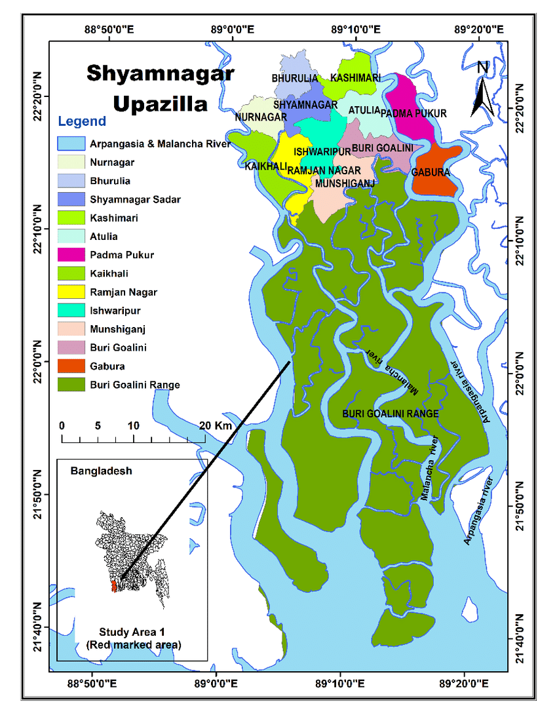

(Source: Syed Hafizur Rahman (2017). Assessing the Gaps in Policies and Practices to Protecting Climate Vulnerable at Three Districts in Bangladesh. Download: <https://www.researchgate.net/publication/323867897_Assessing_the_Gaps_in_Policies_and_Practices_for_Protecting_Climate_Vulnerable_at_Three_Districts_in_Bangladesh>)

**Annex 4**

**Methodology of field study**

a) The field study was conducted with the help of the following organisations:

* Initiative for Right View (IRV),
* Sundarban Adibasi Munda Sangastha (SAMS),
* Coastal Education and Diversity Improvement Organization (CEDIO) Youth Team Shyamnagar

Special thanks to Kazi Zaved Khalid Pasha, coordinator of IRV.

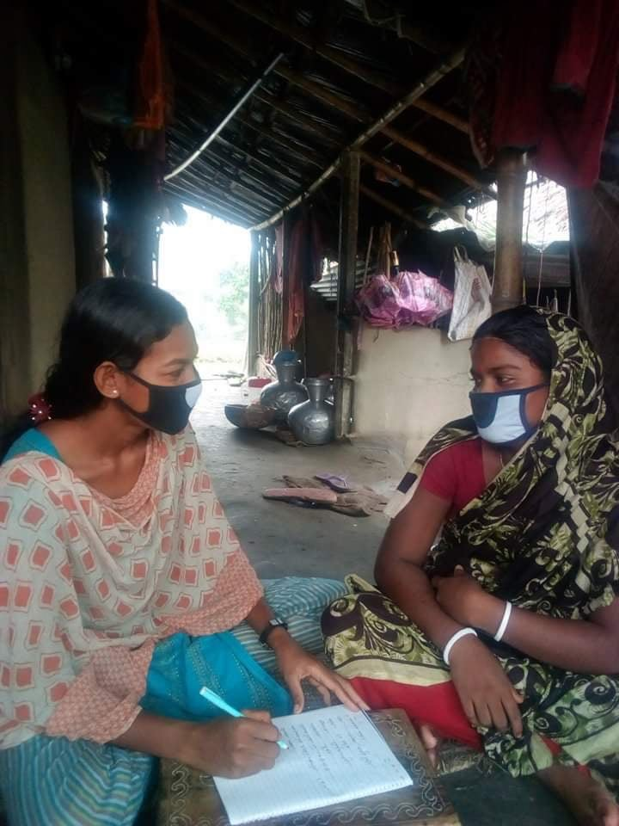

b) The following volunteers were involved in the survey of community members’ experiences:

* 15 persons.

c) Questionnaire for Community members

Personal information:

* Name, Age, Residence, Community, Contact info
* Number of family members?
* What is your work?
* What is your means of income?

Specific questions:

1. What do you understand about the COVID-19?

2. Did you get any health support during the COVID-19 crisis and what?

3. From whom did you get support?

4. What changed after Amphan?

5. What did you do to fight COVID-19 and protect your own health?

6. How did you support other members of your community who are vulnerable?

7. Did you in the COVID-19 crisis ever feel discriminated against? How/ give an example please.

8. How are you affected by the COVID-19 measures?

9. During the pandemic and during the lockdown situation and Amphan cyclone what happened to you and where did you stay?

10. When you were outing to find work, did you take permission from administration?

11. What did you do to protect yourself from infection by COVID-19?

13. What support did you get from others (administration, NGOs)?

d) Description of the sample:

Community members interviewed based on questionnaire:

* in Koyra Subdistrict: total 31 persons, including 5 women
* in Shyamnagar Subdistrict: total 77 persons, including 11 women

Other respondents in long open semi-structured interviews: 8 persons, subdistrict health officials, community leaders, NGO activists, journalists.

Survey of newspaper and internet (social media) coverage.

e) Contact: Yi Yi Prue, Advocate Dhaka Judge Court, [prueyiyi102@gmail.com](mailto:prueyiyi102@gmail.com)

**Annex 5**

**Multiple crises**

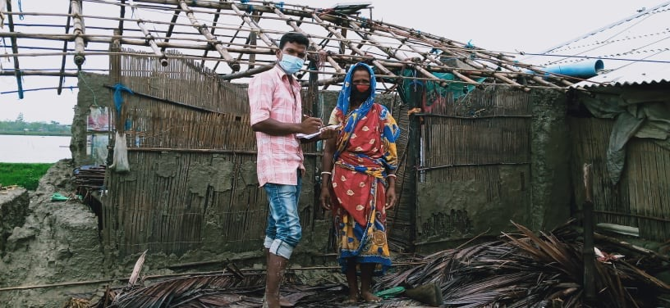

Volunteer interviewing cyclone victim