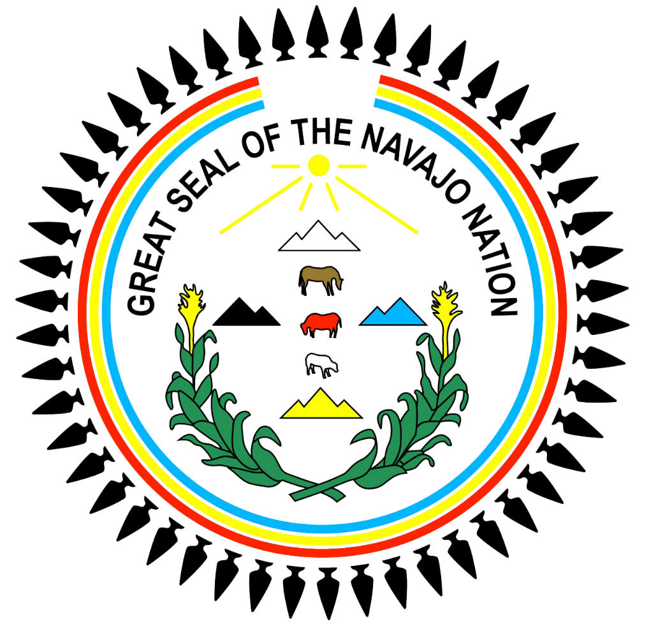

The Navajo Nation Report on the Impact of COVID-19 on Indigenous Peoples
to
the United Nations Special Rapporteur on the Rights of Indigenous Peoples

Transmitted by: Doreen N. McPaul
Navajo Nation Attorney General
June 19, 2020
Introduction
The Navajo Nation (“Nation”) is the largest land-based Native American Tribe in the United States (“U.S.”), with a Reservation encompassing over 27,000 square miles across the states of Arizona, New Mexico, and Utah. The Nation has over 309,000 members, with over 154,000 people residing in multi-generational households on the Reservation.
Traditionally, Navajos believe the Diné Bahane, the Navajo Creation Story in which Changing Woman created the original clans of the Navajo and bore the Monster Slayer Twins who saved the Navajo from destruction by the Naayéé, or monsters. Currently, the Nation is facing a Naayéé in SARS-CoV-2, and the COVID-19 disease it causes, likened to a monster that harms and kills. The Hatałii (Chanters/Healers) advise that this Naayéé will invade the Nation and stay, building its strength so it can kill many. The Nation has named the disease Dikos Nitsaaígíí Náhást’éíts’áadah, translating to “Big Cough 19.”
As of mid-May 2020, the Nation had the highest per capita COVID-19 infection rate in the U.S., directly attributable to a breach of the U.S. federal government’s trust responsibility to the Nation, a legally recognized obligation of the U.S. to protect tribal treaty rights, lands, assets, and resources, including guarantees for healthcare and infrastructure development. While the Navajo government has taken steps to combat this Naayéé, systemic relief can only be achieved through full collaboration with the U.S., including the opportunity for free, prior and informed consent related to all relief matters affecting the Nation. In light of the United Nations Declaration on the Rights of Indigenous Peoples’ minimum standards for the survival, dignity, and well-being of indigenous peoples, the Nation offers the following report shedding light on how the rights of Navajo people are affected by Dikos Nitsaaígíí Náhást’éíts’áadah and what measures are needed to protect Navajo citizens and to preserve the Navajo way of life.

I. The United States Federal Government Response - the U.S. must consult the Nation on matters affecting Navajo people
The U.S. responded to COVID-19 by enacting the CARES Act, which included an eight-billion-dollar allocation for Native American Tribes to use for emergency expenditures associated with fighting COVID-19. The U.S. took more than one month following enactment to disburse sixty percent (60%) of the tribally allocated funding, and still has not released all of the remaining funding to date. Further, the CARES Act requires Tribes to expend all allocated money by December 30, 2020, a timeframe that creates unrealistic deadlines given existing infrastructural barriers such as the lack of running water and paved roads across the Reservation. The federal government’s truncated window to expend these funds does not allow the Nation to comprehensively address the deep-seated issues exacerbating Dikos Nitsaaígíí Náhást’éíts’áadah, and instead encourages a stopgap response; the U.S. designed and enacted the CARES Act without the free, prior, and informed consent of Tribes, and the corresponding regulations and deadlines ignore the systemic barriers Tribes face, hindering a comprehensive response. These federal actions create an unequal response, with states swiftly receiving funding, while Tribes struggle to protect indigenous citizens as they wait for full distribution of their share of assistance aid. The Nation emphasizes that the U.S. must, at a minimum, waive the spending deadline and other federal regulations to allow Tribes a fair opportunity to fight Dikos Nitsaaígíí Náhást’éíts’áadah, which includes tackling the infrastructural obstacles heightening the Navajo community’s root vulnerabilities.

II. Health and Healthcare - the U.S. must provide Navajo people the highest attainable health services and support traditional healthcare practices
Dikos Nitsaaígíí Náhást’éíts’áadah directly affects Navajo peoples’ rights to health, evidenced by: (1) the Nation’s reduced ability to support its community health workers and community-based programs; (2) the predicted disproportionate health impact on Navajo people with respect to chronic illnesses; and (3) the lack of disaggregated data, and emerging data gaps.
First, many Navajo people receive healthcare information through radio and local community campaigns, and even more learn important information through large annual gatherings. With the current stay-at-home orders in effect, the dissemination of healthcare information, including via community-based programs, is currently limited to radio communication and modes requiring an internet connection or regular cellular service, the latter of which are limited across the Nation. An essential part of effective healthcare delivery on the Nation, community health workers historically work with limited staffing to engage and educate communities. With Dikos Nitsaaígíí Náhást’éíts’áadah, community health workers must now divert their attention to the current health emergency, interfering with their regular duties and leaving a gap in health education for many Navajo people. The U.S. should actively direct more healthcare workers to the Nation in order to meet the rising demand for care, as well as acknowledge and fund the Nation’s existing traditional health systems.
Next, Dikos Nitsaaígíí Náhást’éíts’áadah is predicted to have a disproportionate impact on Navajo people with chronic illnesses. There are fewer than twenty (20) medical clinics and facilities on the Nation, often with limited hours, and while some providers are transitioning to telehealth appointments, limited internet and cellular service across the Reservation render this option difficult, if not impossible, for many Navajo people. Screenings and other forms of early diagnoses for unrelated health concerns are disrupted given the already limited number of medical service providers now focused on Dikos Nitsaaígíí Náhást’éíts’áadah. The interruption of early detection programs and the resulting predicted health impact on Navajo people, a population at risk of chronic illnesses, significantly challenges Navajo people’s right to enjoy the highest attainable standard of health. The U.S. should allocate more funding to Tribes to increase their ability to provide needed healthcare services to their communities.
Finally, the various healthcare systems Navajos navigate – tribal, state, federal, and private – across three states and eleven counties within those states – presents a data challenge for the Nation. Early on, the Nation reported cases by county, consistent with the states, due to the relatively low numbers, however, the data was not meaningful to Navajo people until it was reported by agency. Determining whether to report Navajo data by residence (on or off reservation) presents another challenge, as the same people may be reported twice for the same county. Finally, the federal government includes border town data and other Tribes’ data, while the Nation’s data does not, and health corporations authorized by the Nation also report data in their own unique way. The U.S. and states must acknowledge the unique experience of individual Tribes and work to provide data that represents them.

III. Water - the U.S. must support the Nation gaining control over its water resources
Water is a fundamental resource, and lack of access to and control over water has long been a barrier to development across the Nation, a problem that has become even more evident in the time of Dikos Nitsaaígíí Náhást’éíts’áadah. Many Navajos are particularly vulnerable in this regard, as approximately thirty percent (30%) of households on the Reservation do not have running water and must haul water to meet their needs. According to the Nation’s Department of Water Resources, there has been a consistent lack of funding from the U.S. to address drinking water access for homes across the Reservation, and the lack of adequate domestic and municipal water is the greatest water resource problem faced by the Nation. Access to water is integral to ensuring the Nation’s ability to meet the health needs of its citizens, including at a minimum, the ability to support the necessary preventative hygiene measures such as handwashing that combat the spread of Dikos Nitsaaígíí Náhást’éíts’áadah.
Beyond daily needs on the Nation, water also facilitates jobs and economic security. Without water infrastructure and access, economic development remains stymied, contributing to unemployment and stagnating community growth. Looking ahead to economic recovery following Dikos Nitsaaígíí Náhást’éíts’áadah, the availability of water will greatly impact the Nation’s ability to develop its tourism industry, a mainstay of the Nation’s economy. Comprehensively addressing these problems must begin with adjudication of the Nation’s water rights, the subject of long-running settlement negotiations with states. The U.S. and states must commit to the settlement of these negotiations, and then collaborate with the Nation in designing and implementing infrastructure projects that will provide homes across the Reservation with clean running water.

IV. Broadband Internet - the U.S. must support the Nation’s sovereign right to maintain and strengthen its institutions
The remote and vast expanse of the Navajo Reservation, scarce financial resources, and limited infrastructure create poor access to broadband internet. The resulting digital divide deepens institutional inequities in many areas across the Nation by: (1) putting disadvantaged children further behind in their education; (2) hindering an efficient and decisive government; (3) preventing the provision of critical public health announcements; and (4) limiting the Nation’s emergency health care, law enforcement, and emergency command operation responses. Indeed, Dikos Nitsaaígíí Náhást’éíts’áadah highlights the importance of access to high-speed fiber-based telecommunications services for every resident on the Nation. According to the Navajo Tribal Utility Authority, sixty percent (60%) of the Nation’s residents lack fixed internet access, and what broadband access exists is consequent to a patchwork of service providers, resulting in sporadic to non-existent connectivity. For the first time, the U.S. is offering Tribes the opportunity to acquire spectrum ownership over unassigned spectrum over their Tribal lands, though regulatory barriers remain that will complicate the Nation’s ability to complete broadband infrastructure projects that take advantage of this opportunity. The Nation has a right to exercise sovereignty over its territory and people by acquiring and utilizing this spectrum ownership, and the U.S. must work with Tribes to remedy the existing barriers in order to uphold its international and domestic legal commitments.

V. Education - the U.S. must support the Nation’s right to control its educational systems
The Nation identifies the following primary needs for schools serving Navajo children as a result of Dikos Nitsaaígíí Náhást’éíts’áadah, each addressed in turn: (1) respect for tribal sovereignty over schools within the Reservation; (2) increasing access to broadband internet; and (3) investing in the development of cultural resources for continuous learning beyond the classroom.
With the widespread outbreak of Dikos Nitsaaígíí Náhást’éíts’áadah across the Reservation, the Navajo Nation Board of Education (“BOE”) mandated the closure of all school campuses on the Reservation, including public schools operated by the states of Arizona, Utah, and New Mexico. The BOE exercised this authority in accordance with the Tribe’s sovereign right to control its educational systems and institutions, as well as its right to self-determination, autonomy, and self-government over matters relating to the education of Navajo people. However, the three states overlapping the Reservation passed their own regulations governing school responses to the pandemic, and schools are resisting the Nation’s directives, stating they will operate according to the directives of their respective state governors, not the Nation. This disharmony and lack of concerted action to protect Navajo students disrupts the Nation’s ability to self-govern and to protect its residents within its own borders. The federal government and all states should defer to the sovereignty of Tribes to regulate health emergencies within tribal borders.
As discussed above, many Navajo households have poor or no access to broadband internet, affecting a large percentage of Navajo students. With the closure of schools, there is an increased need for internet access so students may continue their studies through distance learning methods. However, lack of internet access makes it difficult for schools on the Reservation to deliver academic programs outside the classroom, seriously jeopardizing Navajo students’ ability to continue their studies. Technological infrastructure is essential to ensure Navajo students are able to exercise their right to all forms and levels of education, and the U.S. must, in conjunction with the Navajo government, take effective measures to ensure that students on the Reservation have remote access to education.
Finally, the move to distance learning illuminates the need for the Nation to continue providing education in the Navajo language in keeping with Navajo cultural methods of teaching and learning. Investing in culturally appropriate distance learning resources is essential for the continued cultural education of Navajo youth. National funding should support and strengthen schools’ ability to nurture language and cultural development for students through remote instruction. There is a great need to invest in the development of Navajo cultural resources for the continuous learning of Navajo students in order to ensure that the Nation can control the provision of education in a culturally appropriate and responsive way.

VI. Vulnerable Populations - the U.S. must work to combat all forms of violence and protect vulnerable protections
While Dikos Nitsaaígíí Náhást’éíts’áadah has had a disproportionate health impact across the Reservation, the responsive curfews, shelter-in-place orders, and lockdowns, combined with related financial strains, may inadvertently place vulnerable populations on the Reservation at heightened risk of intimate partner and family-based violence by increasing daily exposure to abusers and decreasing the ability to escape abusive situations. Global research indicates that added stresses such as economic insecurity and poverty-related stresses, coupled with the increased ability to isolate and control vulnerable populations, can further escalate the rate of violence during times of public health emergencies.
Since the outbreak of Dikos Nitsaaígíí Náhást’éíts’áadah on the Nation, there has been a decrease in criminal charges filed for domestic violence related crimes, and a reduction in reporting of abuse and neglect of children, elders, and incapacitated adults. While the precise reasons for these decreases are unknown, it is concerning given previous research on the correlation between public health emergencies and increases in violence against vulnerable populations. This area presents a current gap in data on the Nation.
While the Nation has a comprehensive framework to address and mitigate abuse and neglect of vulnerable populations, increased funding and assistance from the U.S. may be necessary to deal with this inadvertent effect of Dikos Nitsaaígíí Náhást’éíts’áadah. The U.S. must increase collaboration with the Nation to help address the heightened needs of vulnerable populations, especially if future data shows that an increased number of intimate partner and domestic violence incidents occurred during Dikos Nitsaaígíí Náhást’éíts’áadah.

VII. Voting Challenges - the U.S. must facilitate the Nation’s right to full political participation
In response to COVID-19, many states are attempting to move away from in-person voting to voting by mail. For Navajo voters, the rural and vast nature of the Reservation creates unique challenges for voting by mail-in state and federal elections. A lack of home mail delivery service and transportation challenges reaching post office locations means voting by mail will deter many Navajo voters. Even for Navajo voters who do manage to register, then travel to and subsequently mail their ballots at distant post offices, there is still a high likelihood that ballots will not be mailed by the set deadlines and therefore not be counted. The lack of in-person voting imposes a discriminatory burden on Navajo voters, especially as a protected class under the Voting Rights Act. The Nation is concerned that changes to the voting process will result in Navajos having less opportunity to participate in the political process by exercising their voting franchise as compared to other state citizens.
Navajo citizens’ ability to effectively participate in the political process is also hindered by the effects of discrimination on the basis of race and tribal status in education, housing, employment, and health services, which have resulted in a lower socioeconomic status. For example, housing presents a logistical challenge to registering and obtaining a ballot when a non-traditional address or lack of a permanent residential address makes it difficult for eligible citizens to register to vote even if they consistently reside in one precinct. Language barriers also hamper voting efforts, and while the Nation has advocated for and worked to provide language translation services at in-person polling stations, these services are not available when voting by mail. Without translation services, the ability of Navajo language speakers to participate effectively in the political process is reduced. States must work with the Nation to ensure that state responses to COVID-19 and the historic effects of discrimination on the basis of race and tribal status, do not result in continued disenfranchisement of Navajo voters.
VIII. Census activities - the U.S. must ensure the Nation’s right to full political representation
In accordance with the U.S. trust responsibility and the Nation’s treaty rights, the U.S. is responsible for healthcare and infrastructure development on the Nation. Funding allocation decisions to meet these needs depend on information collected from the decennial Census. Census results are also used to inform other funding allocation decisions; for example, the initial CARES Act funding to tribes was distributed based on population data derived from U.S. Census figures, underscoring the importance of an accurate and fully representative census count.
Historically, Navajos have been undercounted in the Census, even without the barriers currently posed by the public health emergency. Dikos Nitsaaígíí Náhást’éíts’áadah’s spread has gravely impacted 2020 Census activities on the Nation, which could result in an incomplete count of Navajo citizens. Traditionally, the Census count happens by mail, phone, or online access, with in-person follow up as necessary. However, Census questionnaires cannot be mailed to post office boxes, which is how a majority of Navajos on the Reservation receive mail. Thus, a significant portion of Census taking on the Reservation must involve in-person interviews, given the previously discussed limited access to internet. For approximately three (3) months, in-person interviews were not conducted on the Reservation, bringing the Census count of Navajos to a halt. Though the U.S. has made adjustments to census activities overall, including extending reporting deadlines, the adjustments do not effectively account for the particular difficulties presented by Dikos Nitsaaígíí Náhást’éíts’áadah. The U.S. must further extend its Census deadlines, as well as collaborate with the Nation to develop and execute a specific strategy, to ensure that the Nation receives its fair share of funding, based upon complete Census counts.

Conclusion

Dikos Nitsaaígíí Náhást’éíts’áadah exposes the roots of inequality and threats to the Nation’s social, political, and economic self-determination. The threat to Navajo people’s rights to health, self-determination, economic security, education, and free prior and informed consent, among others, provide only a few examples of the true state of inequality faced by Native communities in the U.S. The Nation hopes that current circumstances raise national and international awareness of the many violations of indigenous peoples’ rights and drive systemic change. It is our prayer that the Naayéé, Dikos Nitsaaígíí Náhást’éíts’áadah, helps Navajos remember traditional teachings regarding prayer and hygiene, and encourages the U.S. to address past and ongoing injustices against indigenous peoples.

See Annex 1 for further information on the Navajo population.
COVID-19 and Dikos Nitsaaígíí Náhást’éíts’áadah will be used interchangeably throughout this Report.
Hollie Silverman, Konstantin Toropin, Sara Snider, Leslie Perrot, Navajo Nation surpasses New York state for the highest Covid-19 infection rate in the US, CNN (May 18, 2020), https://www.cnn.com/2020/05/18/us/navajo-nation-infection-rate-trnd/index.html.
Navajo Nation Treaty, 1868, Annex 2.
These include a Declaration of Emergency, issued March 11, 2020 by the Navajo Nation Commission on Emergency Management with concurrence by Navajo Nation President Jonathan Nez; five (5) Executive Orders issued by President Nez, closing the government and schools, and putting most government employees on paid administrative leave (March 13, 2020; March 31, 2020, April 21, 2020, May 12, 2020, and June 3, 2020); and the fifteen (15) Public Health Emergency Orders issued by the Navajo Nation’s Health Command Center, directing citizens to shelter in place, between March 18 and June 16, 2020. See Annex 3 for these documents.
See Annex 4 for a comprehensive list of the Nation’s requests to the U.S. Department of Interior regarding COVID-19 relief.
UNDRIP, Articles 18 and 19: The Nation has a right to participate in decision-making in matters affecting their rights; and States must consult and cooperate in good faith with the Nation in order to obtain their free, prior and informed consent before adopting and implementing legislative or administrative measures that may affect them. In this instance, the U.S. has an obligation to consult with the Nation when implementing legislation designed to address COVID-19 relief efforts on the Nation.
Coronavirus, Aid, Relief, and Economic Security Act (“CARES Act”), Pub. L. No. 116-136, Title V, §5001, 134 Stat. 281 (2020).
U.S. Department of Treasury, The CARES Act Provides Assistance for State, Local, and Tribal Governments, https://home.treasury.gov/policy-issues/cares/state-and-local-governments.
CARES Act, Title VI, §601(d)(3).
Study of the Expert Mechanism on the Rights of Indigenous Peoples, “Free, prior and informed consent: a human rights-based approach,” A/HRC/39/62, August, 10, 2018.
UNDRIP, Article 24: The Nation has a right to their traditional medicines and to maintain health practices, as well as the right to access all social and health services without discrimination. The Nation further has the right to enjoy the highest attainable standard of physical and mental health. The U.S., in its response to COVID-19, must ensure that the Nation has the opportunity to maintain its traditional health practices and must further ensure that Navajo citizens enjoy highly responsive, effective, and accessible health care.
UNDRIP, Article 32: The Nation has the right to determine and develop priorities and strategies for the development or use of their lands, territories, and resources, including water. The U.S. must support the Nation in its efforts to gain control over its water resources.
As pointed out by the Working Group on Indigenous Populations/Communities in Africa, the precarious conditions in which indigenous populations live, including lack of clean drinking water, as well as lack of decent housing and toilets, constitute a risk for the spread of COVID-19. Honourable Commissioner Soyata Maiga, Press Release on the Impact of COVID-19 Virus on Indigenous Populations/Communities in Africa; https://www.achpr.org/pressrelease/detail?id=493.
According to the Nation’s Department of Water Resources, access to the Colorado River system is critical to many areas of the Nation, but requires obtaining state water rights or working with states to quantify the Nation’s water rights.
UNDRIP, Articles 2 and 5: The Nation has the right to be free from any kind of discrimination in the exercise of its rights, as well as the right to maintain and strengthen its distinct political, legal, economic, social, and cultural institutions, while retaining its right to fully participate in the life of the State. Without internet, the Nation’s ability to maintain its own institutions, and to participate in the institutions of the State, are severely limited, and the U.S. is obligated to remedy this limitation.
Federal Communications Commission, 2.5 GHz Rural Tribal Window, (updated March 13, 2020), https://www.fcc.gov/25-ghz-rural-tribal-window.
UNDRIP, Article13: The Nation has the right to control its educational systems, as well as the right to all levels and forms of education of the State without discrimination. The U.S. must take effective measures to ensure Navajo citizens have access to education.
Navajo Nation Board of Education Resolution, NNBEMA-611-2020, March 31, 2020. See Annex 5.
UNDRIP, Articles 21 and 22: The Nation has the right to ensure that effective measures are in place to protect vulnerable tribal members, including elders, women, youth, and persons with disabilities. The U.S. is obligated to take measures to ensure that Navajo vulnerable populations enjoy full protection against all forms of violence and discrimination.
For purposes of this report, “vulnerable populations” refers to those children, adults, and elders exposed to, and those who have experienced violence in the home, abuse, and/or neglect.
See Generally, Ashley Abramson, How COVID-19 may increase domestic violence and child abuse, American Psychological Association, (April 8, 2020), https://www.apa.org/topics/covid-19/domestic-violence-child-abuse; Amber Peterman, Alina Potts, Megan O’Donnell, Kelly Thompson, Niyati Shah, Sabine Oertelt-Prigione, Nicole van Gelder, Pandemics and Violence Against Women and Children, Working Paper 528 at Section 2.2, (April 2020), https://www.cgdev.org/sites/default/files/pandemics-and-vawg-april2.pdf.
Id. at Section 2.1.
Based on data provided by the Navajo Nation Acting Chief Prosecutor, on June 5, 2020.
Personal interview with the Executive Director of Navajo Nation Division of Social Services, on June 2, 2020.
See Generally, Amber Peterman, Alina Potts, Megan O’Donnell, Kelly Thompson, Niyati Shah, Sabine Oertelt-Prigione, Nicole van Gelder, Pandemics and Violence Against Women and Children, Working Paper 528 at Section 2.2, (April 2020), https://www.cgdev.org/sites/default/files/pandemics-and-vawg-april2.pdf.
UNDRIP, Articles 5 and 13: The Nation has the right to participate fully in the political life of the State, as well as the right to understand and be understood in political proceedings. The U.S. is obligated to ensure that Navajo voters have the ability to fully participate in State elections.
Voting Rights Act of 1965, Pub. L. No. 89-110, 79 Stat. 437 (1965) (as amended, the Voting Rights Act protects American Indians from voting practices that have a disparate impact on their right to vote).
2019 was the International Year of Indigenous Languages; UNDRIP Articles 5 and 13 are implicated by the diminished opportunity for Navajo people to vote due to language barriers.
UNDRIP, Article 5: The Nation has the right to participate fully in the political life of the State, and the U.S. is obligated to ensure that Navajo members are fully represented in the 2020 Census.
Navajo Nation Treaty, 1868, Annex 2.
U.S. Census Bureau, What is the 2020 Census, https://2020census.gov/en/what-is-2020-census.html.
Secretary Steven T. Mnuchin and Secretary David L. Bernhardt, Press Release, Joint Statement by Treasury Secretary Steven T. Mnuchin and Secretary of the Interior David L. Bernhardt on Distribution of Coronavirus Relief Fund Dollars to Native American Tribes, (May 5, 2020), https://home.treasury.gov/news/press-releases/sm998.
U.S. Census Bureau, Conducting the Count, https://2020census.gov/en/conducting-the-count.html.
U.S. Census Bureau, What to Look For in the Mail, Frequently Asked Questions – Does the Census Bureau send mail to PO Boxes?, https://2020census.gov/en/mailings.html#:~:text=No%2C%20the%20Census%20Bureau%20cannot,the%20place%20where%20you%20live.
Per the imposed stay-at-home orders and curfews, the Navajo Census Office did not conduct in-person interviews beginning March 16, 2020. The Navajo Nation Attorney General recently deemed Census taking an essential government function however, allowing the Navajo Census Office to resume in-person interviews on June 11, 2020.
U.S. Census Bureau, 2020 Census Operational Adjustments Due to COVID-19, https://2020census.gov/en/news-events/operational-adjustments-covid-19.html.

