Report of the Special Rapporteur on the rights of indigenous peoples to the General Assembly
Impact of COVID-19 on indigenous peoples

Written evidence concerning the impact of COVID-19 on Indigenous Peoples in the plain lands of Bangladesh

Submitted by Indigenous Peoples Development Services (IPDS)
June 2020

Introductory Note: The term “Plainlands Indigenous People” in Bangladesh refers to all Indigenous communities in the country outside of the Chittagong Hill Tracts (CHT). This catchall term encompasses a heterogenous array of different peoples who identify as Indigenous or adivasi on the basis that they a) consider themselves to be the first settlers of specific areas and b) have cultures and societies that are distinct from the majority population. The total number of Indigenous People in Bangladesh, including the CHT, is estimated to be 3 – 4 million. According to the Government of Bangladesh, as of 2011 1.6 million lived in the plains. Throughout the submission the terms adivasi, Plainlands / Plains Indigenous Peoples / IPs are used interchangeably.

Executive Summary

This submission is based on a rapid study conducted between 3rd and 17th June, comprising 1205 Household Surveys, 20 Key Information Interviews (KIIs) and six micronarratives, as well as primary and secondary sources. The submission is divided into two sections.

Section One, “Quantitative Evidence” is based on the Household Survey and responds specifically to the request for information concerning:

- The “economic, social and cultural impact of lockdowns, quarantines, travel and other restriction of freedom of movement on indigenous communities.”

Section Two, “Qualitative Evidence” is based on the 20 Key Informant Interviews and six micronarratives, as well as primary and secondary sources. This section responds specifically to requests for information concerning:

- The “economic, social and cultural impact of lockdowns etc on indigenous communities.”
- Additional human rights challenges faced by Indigenous women during the pandemic.
- State responses thus far to the specific challenges faced by Indigenous Peoples during the pandemic.
- Indigenous peoples’ ability to shape national COVID-19 response.
- The prospects for ongoing human rights threats to Indigenous Peoples’ ancestral lands and resources.

Key findings:

- The crisis has caused a precipitate and alarming decline in the livelihoods of plain lands Indigenous Peoples. The number of plain lands indigenous people with a daily income below $1.90 (defined by the World Bank as extreme poverty) has increased by 62% since the beginning of the crisis.

- A major cause of this is the precarious nature of employment in which plains IPs are generally engaged: of respondents engaged in paid employment, 72% have as a result of the crisis either been immediately laid off or “furloughed”, which in the Bangladesh context means discharged from duties with little or no compensation except the promise of reinstatement at some future date.

- Plains indigenous groups access to relief services is extremely limited. Over 60% of respondents have received no relief whatsoever from either the State or Non-Governmental Organisations (NGOs) since the beginning of the crisis period.

- Other key issues raised by the study include:

  - Increased reports of racism and violence against Indigenous Peoples.
  - Discrimination against Indigenous Peoples by duty-bearers in the allocation of relief supplies.
  - Specific intersectional impacts on Indigenous women, including sexual assault, higher domestic labour burdens, lack of access to Sexual and Reproductive Health and Hygiene Services and disproportionate representation in high risk and precarious professions.
  - Specific provision for plains IPs from the state is inadequate and poorly targeted, lacking accurate, ethnically disaggregated data.
  - Universal concern among Indigenous social leaders and Gender activists that long-standing trends, including dispossession from ancestral lands, and sexual harassment and assault at the hands of the mainstream community will continue unabated and potentially intensify.

- Section 1: Quantitative Evidence

  - The economic impact of the Covid crisis in Bangladesh has led to a precipitate and alarming decline in the incomes of plains Indigenous Peoples, as depicted in Chart 1 (below).

    - 74% of respondents reported a daily income of $1.90 (extreme poverty) in June 2020; 46% of respondents said that this was their income in the pre-crisis period. This represents a 62% increase in extreme poverty among plainlands IPs since the onset of the crisis.
    - Chart 1 clearly depicts a collapse in the number of respondents with a daily income above $6 since the crisis began (6% down from 19%), with smaller reductions in the other two intermediate income categories.
    - To put this in context, the proportion of Bangladesh’s total population living on incomes below $1.90 prior to the crisis was 15% according to the World Bank.

Chart 1: Comparison of Respondents’ Income, Pre-Crisis and June 2020

NB: All figures converted to USD using Purchasing Power Parity (PPP)

  - A major cause of this huge impact on the livelihoods of plains IPs is the highly precarious nature of employment in which they are generally engaged. This includes the Ready Made Garments (RMG) sector, beauty parlours (which favour Indigenous women) and domestic service (maids, caretakers and guards). The lack of employment protection and benefits in these sectors has meant that Indigenous Peoples have been highly vulnerable to a sudden and complete cessation of income as the economic impacts of the pandemic began to be felt in Bangladesh. This is clearly depicted in Chart 2 (below) where respondents were asked to report the responses of their employers to the onset of the crisis.

    - 72% of respondents were either immediately laid off or “furloughed”, which in the Bangladesh context means discharged from duties with little or no compensation except the promise of reinstatement at some future date.
    - A further 20% reported a partial reduction in salary; only 8% have reported that the crisis has resulted in no net change to their incomes.

Chart 2: Impact of Crisis on Respondent Employment (%)

NB: Number of respondents = 358

  - This has had further knock-on effects for Indigenous People living in (generally urban) rented accommodation. The sudden cessation of income has meant that they are having to take on debt in the form of deferred rental payments (Table 1 below). Over 60% of respondents living in rented accommodation report some form of rental arrears.
  - The result is that 13% of respondents are considering returning to their home villages (Chart 3 below); it is already the case that many IPs have already done so but precise number have been impossible to ascertain.
  - Access to relief services organised by both the Government and by NGOs is inadequate: 62% of respondents disagreeing or strongly disagreeing with both of the statements “I have access to Government relief” and “I have access to NGO relief” (see Table 2 below).

Table 1: Arrears accrued by respondents living in rented accommodation
Rent Arrears | Number | Percent
None | 96 | 34.53
One month | 65 | 23.38
Two months | 87 | 31.29
Three months | 30 | 10.79

Chart 3: Attitudes to returning to native village from respondents currently living in rented accommodation

Table 2: Access to relief services from Government and Non-Government Organisations (NGOs)
 |  | We have access to Government relief
 |  | Strongly disagree | Disagree | Neutral | Agree | Strongly agree | Total
We have access to relief provided by NGOs | Strongly disagree | 242 | 25 | 5 | 22 | 3 | 297
 | Disagree | 46 | 429 | 7 | 80 | 2 | 564
 | Neutral | 9 | 21 | 32 | 25 | 1 | 88
 | Agree | 55 | 93 | 8 | 45 | 4 | 205
 | Strongly agree | 23 | 1 | 1 | 3 | 4 | 32
 | Total | 375 | 569 | 53 | 175 | 14 | 1,186

  - Respondents report high levels of confidence in maintaining healthy practices in line with WHO recommendations to help stop the spread of Covid-19 (see charts 3 and 4 below). Over 80% of respondents strongly agreed or agreed with the statement “I think my family has proper hygiene practices to prevent Coronavirus” and over 90% of respondents reporting that they wear face masks when leaving the house.

Chart 4: Reported Confidence Levels in Family Hygiene Practices

Chart 5: Reported Attitudes to Wearing Face Masks

- Section 2: Qualitative Evidence

  - The plight of urban IPs in rented accommodation has been worsened by a number of factors:

    - In many cases landlords have prevented them from leaving for their villages until rents are settled.
    - This has led to distress leases and sales of land and other assets by rural kinship groups to repay rent. The scale of this problem was impossible to gauge.

  - Despite considerable contextual differences, KII respondents all attribute adivasis’ access to relief services from the Government to long-standing discrimination and exclusion from decision making, particularly at the local (Union / Upazila) political-administrative level.

  - The success and impact of lockdown measures in Indigenous villages has been variable, generally depending on the socio-economic conditions of the inhabitants. Indigenous communities that are highly dependent on day labour, for example, have been placed in an awful dilemma. Where they have the choice they have ignored lockdown, with the inevitable implications for public health. Where lockdown has been successfully enforced through state agencies, this has had a severe impact on livelihoods to the extent that sections of the community face starvation. The fact that one in four survey respondents reported that their occupation was “day labourer” underscores the severity of this challenge.

  - Indigenous women have faced a number of additional human rights challenges:

    - In at least one case, adivasi women have faced sexual harassment and assault from landlords in lieu of rent they are unable to pay, as reported in the national media.
    - One adivasi gender activist reported a case of rape in Kalapara during the lockdown period.
    - Beauticians who have been laid off or “furloughed” are turning to day labour as a coping mechanism, which makes them more vulnerable to sexual harassment and assault.
    - Indigenous women generally bear a higher domestic burden than men, and are facing the brunt of the pressure to feed families in a period of acute financial crisis. Coping mechanisms include recourse to cultivating “famine foods” like yams.

  - Several KIIs revealed an increase in overt racism directed against IPs:

    - Adivasis with Tibeto-Burmese features report “Corona” as a new racial slur.
    - In one instance, an IP female activist reports that local Muslim leaders have told their followers that Covid-19 will only impact “Christian” (Indigenous) communities.
    - In at least one case interethnic tensions have led to a violent clash between communities.

  - The Rakhaine community of Bangladesh’s coastal belt have also been severely affected by Cyclone Amphan, which made landfall on the 20th May. Respondents state that destruction of crops and fruit trees have compounded an already dire economic situation.

  - Dedicated efforts by the State to address the particular problems of social, economic and political exclusion faced by plains IPs in general are very limited. While a “Development Assistance for Special Areas” fund exists under the Prime Minister’s Office specifically for this purpose, its efforts are inadequate and poorly targeted. This speaks both to the specific issue of the pandemic and its secondary impacts, and also the more general problem of the recognition of Indigenous People in Bangladesh:

    - Despite being a signatory to ILO Convention 107, Bangladesh does not recognise the existence of “Indigenous Peoples” within its borders. The constitution instead recognises the existence of “tribes [Upajati], minor races [khudro jati shotta], ethnic sects and communities [nrigoshthi o shomprodai]”.
    - Within this framing, the Government of Bangladesh (GoB) has officially recognised 27 different ethnic groups. Indigenous organisations argue that the true number is at least 47 - 54. This study alone surveyed members of 21 communities who consider themselves to be distinct both from other Indigenous groups and the mainstream community (see Appendix B below) and yet are not formally recognised as such by the State.
    - The last ethnically disaggregated Government census was carried out in 1991.
    - In this context, it is unsurprising that there has been no effort by the State to circulate materials in Indigenous languages, nor to conduct detailed, ethnically disaggregated analysis of how the current pandemic is currently disproportionately affecting Indigenous Peoples.

  - Due to exclusion from policy and other decision making making bodies, Indigenous People have not been able to significantly influence or shape State Covid response at the time of writing.

  - The general consensus of KII respondents is that extant trends of dispossession from ancestral land will continue, if not intensify.

    - Dispossession of Indigenous People in the Bangladeshi plains is a complex and multicausal phenomenon involving different actors.
    - These include “private” individuals, often with powerful local connections and a retinue of armed retainers.
    - In certain areas, State actors including the Forest Department contest Adivasi rights to ancestral lands designated as “Reserved Forests”.
    - Legal protections are very weak: the principal land legislation provides explicit provision that there cannot be a transfer of land held by an “aboriginal” to a “non-aboriginal” without the explicit sanction of the District authorities (specifically the “Union Nirbahi Officer”). Implementation is weak, and only 22 groups are formally recognised under this provision.
    - Generally, in Bangladesh’s history processes of Indigenous dispossession have reached the highest levels of intensity during periods of military rule and emergency.
Appendix A: About the Submission

This submission was prepared for IPDS by:

Saikat Dio, Suborna Poli Drong, Magnet Jambil, Swapon Khalko, Anitta Mankhin, Bivuti Mahato, Sarah Marandy, Dilip Pahan, Parag Ritchil, Rajib Ruram, Maibam Sadhan, Oliver Scanlan and Ushwe Wen.

With special thanks to:

Sanjeeb Drong
Ajay Mree
Shamsagor Mankhin
Sulehka Mrong
Eugin Nokrek
Gourango Patro
Myentthein Promila
Toni Ch. Sangma
Andrew Salomar
Horen Singh
Rabindranath Soren
Maung Tan Thun
Flora Bably Talang

IPDS gratefully acknowledges the invaluable support, both financial and in-kind, from:

Center for Sustainable Development, University of Liberal Arts Bangladesh
Gram Bikash Kendra
Minority Rights Group
The European Union
The Norwegian Agency for International Development

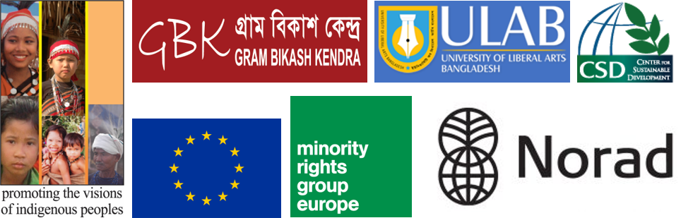

For more information about Indigenous Peoples in Bangladesh, please contact Sanjeeb Drong at sanjeebdrong@gmail.com.

For specific technical queries about the study, please contact Anitta Mankhin at an182mankhin@gmail.com or Oliver Scanlan at oliver.scanlan@ulab.edu.bd.

Appendix B: Study Methodology

This rapid study on impact of Covid-19 on indigenous people was conducted using mixed method meaning a quantitative survey was deployed and qualitative information was collected from different layers of the society. In order to capture more specific and detailed information as well as more sensitive issues we complemented the household survey with 20 Key Informant Interviews and six micronarratives from a range of respondents including community leaders and leaders of indigenous-led or indigenous friendly organizations. KIIs and households stories were collected either by phone interview or by email.
In the dynamics of Covid-19, the indigenous and minority groups are suffering the most, which in principle, indigenous friendly and indigenous-led organizations or advocacy networks talk about. However, because of not having desegregated statistics about the indigenous people in the country, it has been highly challenging to advocate and influence policymakers, and to take informed decision by NGOs. As an attempt to fill the gap of data insufficiency and rhetoric power and persuasion in advocacy, we conducted a quantitative survey on plainland indigenous people, which not only is representative to the population but has exhibited the general characteristics of disconnected people. When welfare governments formulate and deploy policies to leave no one behind, the identification of underlying socio-economic characteristics of disconnected people, per se, indigenous people is necessary.
We have been able to collect 1205 responses from 28 out of 64 districts in the country. The survey was administered in two ways: (1) respondents answered the survey semi-structured questionnaire developed on Google forms by themselves (2) responses collected by the volunteers using the same questionnaire developed on Google forms. To keep the sample representative, volunteers connected to the team were from different indigenous communities across the plainland in the country. As this rapid study was an initiative by the volunteers, the selection of volunteers played an instrumental role in making the sample representative to the population.
In the case of self-administered survey, we limit a single submission from a respondent, per se, an email ID. We sent the link of the Google form through email, social-networking sites and other messaging apps. Around 40 volunteers involved in the collecting data from the field, were trained by conducting online webinars, supervised by 6 volunteers. Volunteers collected information from the respondents either by calling them over the phone or visiting households while maintaining physical distance. In most cases in rural set-up, volunteers collected information from the households when they were conduct relief activities e.g., listing vulnerable families, distribute reliefs, or mere visiting the families. In the urban setup, volunteers collected information by calling themselves. In both cases, the volunteers submitted responses by signing their names listed as volunteers.
Vulnerable people likely try to keep connected among them to protect themselves even if they have limited access to resources i.e., information, political power, or money. Amid Covid-19, different indigenous communities form community response teams which were the major resources of this study.

Appendix C: Indigenous Groups Covered by the Study

Table 3: List of Indigenous Groups covered in the rapid study
SL | Ethnicity | Freq. | Percent | Included in the Govt. list*
1 | Banai | 1 | 0.08 | No
2 | Barman | 3 | 0.25 | Yes
3 | Bediya Mahato | 9 | 0.75 | No
4 | Bhuia (Rai) | 16 | 1.33 | No
5 | Bhumij | 2 | 0.17 | No
6 | Chakma | 1 | 0.08 | Yes
7 | Dalu | 1 | 0.08 | No
8 | Ganju | 1 | 0.08 | Yes
9 | Garo | 409 | 33.94 | Yes
10 | Gorait | 10 | 0.83 | No
11 | Hajong | 1 | 0.08 | Yes
12 | Kadar | 14 | 1.16 | No
13 | Khasi | 5 | 0.41 | Yes
14 | Koch | 6 | 0.5 | Yes
15 | Koch Rajbangshi | 2 | 0.17 | No
16 | Kole | 10 | 0.83 | Yes
17 | Kora | 10 | 0.83 | No
18 | Kormokar | 2 | 0.17 | No
19 | Kurmi Mahato | 2 | 0.17 | No
20 | Lohar | 1 | 0.08 | No
21 | Mahali | 37 | 3.07 | No
22 | Mal Pahariya | 10 | 0.83 | Yes
23 | Malo | 16 | 1.33 | No
24 | Manipuri | 81 | 6.72 | Yes
25 | Munda | 67 | 5.56 | Yes
26 | Mushohor | 6 | 0.5 | No
27 | Oraon | 119 | 9.88 | Yes
28 | Pahan | 4 | 0.33 | No
29 | Pahariya | 9 | 0.75 | Yes
30 | Patro | 2 | 0.17 | No
31 | Rabidas | 14 | 1.16 | No
32 | Rakhine | 54 | 4.48 | Yes
33 | Santal | 263 | 21.83 | Yes
34 | Teli | 1 | 0.08 | No
35 | Turi | 16 | 1.33 | No

Note: 20 Indigenous groups are missing from the list prepared by the Government, available here: http://plainlandethnic.portal.gov.bd/site/page/0fa2c59c-c5ba-44f2-bd27-c8d192d90036/-

Appendix D: Responses by District

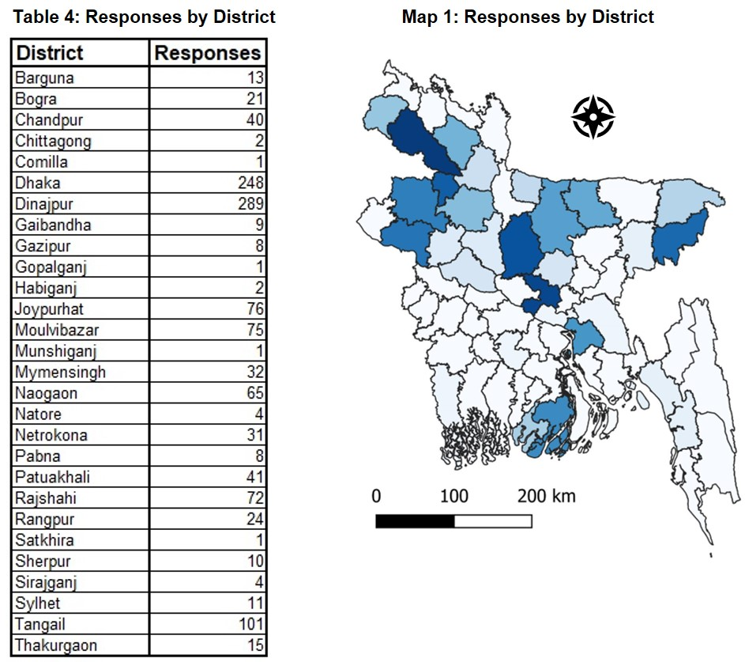

Appendix E: About IPDS

Indigenous Peoples Development Services – IPDS is a voluntary and non-profit indigenous peoples’ organisation led by indigenous peoples. It was established in 2001 with the vision of protecting and promoting the fundamental human rights of indigenous peoples in Bangladesh. It has also registered with the Social Welfare Ministry of Bangladesh for social work in 2004. IPDS has a General Body (GB) consisting 13 members and an Executive Committee (EC) with 7 members. Its main focus is on indigenous peoples’ rights, livelihood, land issues, capacity building of indigenous elders, women and youth on human rights issues and advocacy. IPDS has working experience with EU (EIDHR), UNDP, ILO, Danida, Oxfam GB, the Asia Foundation, Misereor, Manusher Jonno Foundation, VU University Amsterdam, Action Aid etc.

In response to COVDI 19, IPDS has made awareness building campaign among indigenous community and made educational leaflet in indigenous languages. Some emergency relief supports have been distributed to 350 indigenous families in Moulvibazar and Mymensingh region.

IPDS’ Executive Director, Sanjeeb Drong, also serves as General Secretary of Bangladesh Indigenous Peoples’ Forum, the apex body representing all Indigenous Peoples in Bangladesh.

Indigenous Navigator, ‘Factsheet Bangladesh’, Indigenous Navigator (2020) http://www.nav.indigenousnavigator.com/images/Documents/Factsheets/Bangladesh_Factsheet_Final.pdf, (last accessed 19th June 2020).
GoB, ‘Development Assistance for the Minor Ethnic Communities’, Government of Bangladesh (2016), http://plainlandethnic.portal.gov.bd/site/page/0fa2c59c-c5ba-44f2-bd27-c8d192d90036/-?fbclid=IwAR1-B1EfzKRLxjinciZ7xVmOJZ3s-p-P3g4DaT1ddv0rd1-KiW9IIIuX5Ps, (last accessed 19th June 2020).
Databank, ‘World Development Indicators’, The World Bank (2020) https://databank.worldbank.org/home.aspx (last accessed 18th June 2020).
Staff correspondent, ‘Mother, daughters assaulted by landlord ‘over rent’, The Daily Star (19th May 2020) https://www.thedailystar.net/city/news/mother-daughters-assaulted-landlord-over-rent-1903915, (last accessed 18th June 2020).
Formerly known as the “Special Affairs Division”, see Indigenous Navigator, op. cit..
Eva Gerharz, ‘What is in a Name? Indigenous Identity and the Politics of Denial in Bangladesh’, South Asia Chronicle 4 (2014) 115 - 137.
Abul Barkat, Political Economy of Unpeopling of Indigenous Peoples, the Case of Bangladesh (Dhaka: MuktoBuddhi Prokasana, 2016).
Indigneous Navigator, op. cit..

