***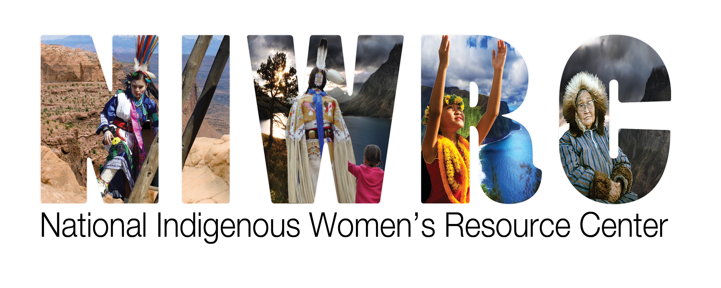*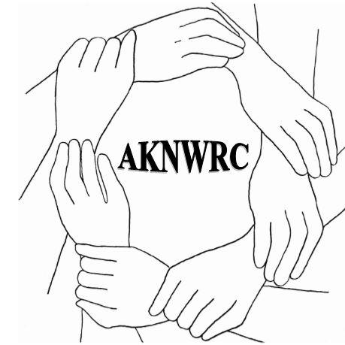**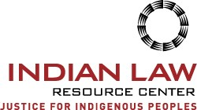

**Violence Against Indigenous Women in the United States,**

**Particularly Alaska Native Women,**

**in the Context of the Covid-19 Pandemic**

**June 18, 2020**

Input to the Report of the UN Special Rapporteur on the rights of indigenous peoples ̶

Impact of Covid-19 on indigenous peoples

The Alaska Native Women’s Resource Center, the Indian Law Resource Center, and National Indigenous Women’s Resource Centeroffer this submission on violence against indigenous women in the United States, particularly Alaska Native women, in the context of the Covid-19 pandemic as input to the report of the UN Special Rapporteur on the rights of indigenous peoples to the General Assembly on the Impact of Covid-19 on indigenous peoples.[1]

Indigenous women often suffer multiple forms of discrimination and higher rates of violence. They are battered, raped, murdered, and disappear at extraordinary rates because of their gender and because they are indigenous.[2]

The UN has recognized that indigenous peoples are particularly vulnerable to the global pandemic,[3] and that a shadow pandemic of violence against women is growing.[4] Clearly some measures like curfews, quarantines, lockdowns, and travel restrictions being used to limit outbreaks of the virus also restrict survivors of abuse from getting help, reaching shelters, and distancing themselves from abusers. However, in the case of indigenous women in the United States, the Covid-19 pandemic has magnified pre-existing pervasive human rights abuses, turning a high beam on dangerous gaps in U.S. law and the significant disparities faced by indigenous peoples before Covid-19. These include, but are not limited to disparities in the availability of critical resources and services such as law enforcement, safe housing, indigenous women’s shelters, health care, victim services, internet, cellular, and equitable federal funding.

Many Alaska Native villages are in remote rural areas that are not accessible by roads. Since the pandemic arose Alaska’s main rural air carrier abruptly shut down. Without such a lifeline, it is difficult if not impossible to move an abuse survivor to a regional shelter or to ensure villages have adequate food, medicine, personal protective equipment, and other essential items, or to receive mail and freight. Similar issues were raised with the shutdown of certain ferry services. The pandemic has left women and children with fewer options for safety than ever before. In rural Alaska, geographic isolation, limited and often overcrowded housing, a lack of domestic violence shelters, limited law enforcement and inconsistent prosecution of crimes are always facts of life. But the pandemic has worsened all of these problems. Social distancing and quarantine requirements cut deeply into the availability of shelter beds. The risk of contracting or spreading COVID-19 make even leaving the house to visit or stay with relatives or friends a potentially dangerous choice. Travel restrictions and the economic fallout of the pandemic that led to the collapse of local air service now leave many women and children with no consistent travel options out of their communities. Law enforcement response protocols that have shifted to limit police exposure to coronavirus leave women with even less access to protection than before.

The Covid-19 health crisis reveals the terrible disparities in health and government services, especially including justice services, that Alaska Native and American Indian women face daily. In the United States, a discriminatory legal system limits the authority of the 574 federally recognized Indian and Alaska Native nations to protect their women and children, and fails to prevent and respond to crimes of violence. As a result, violence against American Indian and Alaska Native women and girls has reached extreme and unprecedented levels on tribal lands and in Alaska Native villages.[5] According to the United States’ latest statistics, more than 4 in 5 American Indian and Alaska Native women (84.3%) have experienced violence in their lifetimes, including:

* 56.1% who have experienced sexual violence;
* 55.5% who have experienced physical violence by an intimate partner and 90% of these victims report being victimized by a non-Indian perpetrator, while only 18% report being victimized by an Indian;
* 48.8% who have experienced stalking; and
* 66.4% who have experienced psychological aggression by an intimate partner.[6]

American Indian and Alaska Native women are 2.5 times more likely to be sexually assaulted or raped[7] and more than twice as likely to be stalked[8] than other women in the United States.

The murder rate for American Indian women is ten times the national average on some reservations.[9]

The situation for Alaska Native women raises unique concerns and is even more dire. They are subjected to the highest rate of forcible sexual assault in the United States.[10] One in two Alaska Native women will experience sexual or physical violence, and "an Alaska Native woman is sexually assaulted every 18 hours."[11] The vast majority have experienced that violence by an interracial perpetrator over whom tribes lack full criminal jurisdiction.[12] At least 75 Alaska Native communities are without any law enforcement presence whatsoever.[13]

These disproportionately high rates of violence against American Indian and Alaska Native women are directly linked to a discriminatory system of federal laws and court decisions governing Indian country and Alaska Native lands, and to the United States’ persistent failure to respond adequately to the violence against indigenous women in Indian country and on Alaska Native lands. The United States took an affirmative step forward in 2013 with the passage of legislation (VAWA 2013) restoring partial criminal jurisdiction to Indian nations over certain non-Indian perpetrators who commit domestic and dating violence against American Indian and Alaska Native women in Indian country or who criminally violate protection orders.[14] Unfortunately, dangerous gaps remain in the law. Perhaps the most glaring one is that the law excludes all but one of the 229 federally-recognized Indian tribes in Alaska from using the new protections to ensure safety for Alaska Native women. Further, the law recognizes tribal jurisdiction only over a limited set of crimes and a limited class of offenders, doing nothing to ensure that non-Indians who commit sexual assault, stalking, trafficking, or child abuse crimes in Indian country are held accountable.

By restricting the restored special domestic violence jurisdiction to Indian country, VAWA 2013 denies Alaska Natives the full benefit of the law and treats them differently than other women, including other non-Alaskan Native women. In 2013, a statutorily authorized commission, the Indian Law and Order Commission, completed its comprehensive report to the United States President and Congress−*A Roadmap for Making Native America Safer (Nov. 2013)*. The Commission found that the exclusion of Alaska Native villages from the definition of Indian country in VAWA 2013 separates the villages from other federally recognized tribes and places them at a severe disadvantage regarding public safety. The Commission recommended that local control and criminal authority be restored to Alaska Native villages. These and many other recommendations by the Commission have yet to be implemented.

In the light of the foregoing and in the context of the Covid-19 pandemic, we urge that the Special Rapporteur on the rights of indigenous peoples include in his report recommendations that the Human Rights Council:

1. During its annual discussions on women’s human rights and on indigenous peoples, regularly address the elimination of all forms of violence against indigenous women and girls;
2. Direct the Expert Mechanism on the Rights of Indigenous Peoples to pay particular attention to the rights and special needs of indigenous women and children in the context of the Covid-19 pandemic and monitor states’ measures to ensure they enjoy protection against all forms of violence and discrimination;
3. Enhance the ability of relevant special procedures to address the multiple and intersecting forms of discrimination experienced by indigenous women in the context of Covid-19 by requesting special, and perhaps joint, reports on the topic; and
4. Request that the Secretary-General:

a. Issue a report on violence against indigenous women in the context of the Covid-19 pandemic with recommendations for future actions, and

b. Convene a high-level panel in 2021 on intensifying efforts, in collaboration with indigenous peoples, to prevent and eliminate violence and discrimination against indigenous women in the context of the Covid-19 pandemic.

1. Founded in 1978 by American Indians, the ***Indian Law Resource Center*** (ILRC) is a non-profit organization that provides legal assistance to indigenous peoples of the Americas to combat racism and oppression, to protect their lands and environment, to protect their cultures, to achieve sustainable economic development and genuine self-government, and to realize their other human rights. Its Safe Women, Strong Nations project works with indigenous women’s organizations and Native nations to end violence against indigenous women. ILRC is in consultative status with the UN Economic and Social Council. ([www.indianlaw.org](http://www.indianlaw.org)). The ***National Indigenous Women's Resource Center, Inc.***(NIWRC) is a nonprofit organization whose mission is to ensure the safety of Native women by protecting and preserving the inherent sovereign authority of American Indian and Alaska Native nations to respond to domestic violence and sexual assault. NIWRC’s Board consists of Native women leaders from American Indian and Alaska Native nations across the United States. NIWRC is a national resource center for Indian nations providing technical assistance, policy development, training, materials, resource information, and the development of tribal strategies and responses to end the violence. In 2015, NIWRC launched the Violence Against Women Act (VAWA) Sovereignty Initiative to defend the constitutionality and functionality of all VAWA tribal provisions. ([www.niwrc.org](http://www.niwrc.org)). Organized in 2015, the ***Alaska Native Women’s Resource Center*** (AKNWRC) is a tribal nonprofit organization dedicated to ending violence against women with Alaska’s 229 tribes and allied organizations. AKNWRC board members are Alaska Native women raised in Alaska Native Villages and have 141 years of combined experience in tribal governments, nonprofit management, domestic violence, and sexual assault advocacy (both individual crisis and systems and grassroots social change advocacy at the local, statewide, regional, national and international levels), and other social service experience. AKNWRC’s philosophy is that violence against women is rooted in the colonization of indigenous nations. ([www.aknwrc.org](http://www.aknwrc.org)).
2. A/HRC/RES/26/15 (11 July 2014), 2.
3. See <https://www.un.org/development/desa/indigenouspeoples/covid-19.html.>
4. See <https://www.unwomen.org/en/news/stories/2020/4/statement-ed-phumzile-violence-against-women-during-pandemic>.
5. For additional discussion of available crime statistics, see the Center’s 2019 submission to the Inter-American Commission on Human Rights, available at <https://indianlaw.org/sites/default/files/Supplemental%20Response%20to%20Questions%20from%20Thematic%20Hearing%20October%202018%20(final).pdf>.
6. Andre B. Rosay, Ph.D., National Institute of Justice Research Report, *Violence Against Indian and Alaska Native Women and Men, 2010 Findings From the National Intimate Partner and Sexual Violence Survey* (May 2016).
7. *See, e.g.*, Steven W. Perry, U.S. Dep’t of Justice, *American Indians and Crime, A BJS Statistical Profile 1992-2002,* 5 (2004).
8. *See, e.g.*, U.S. Dep’t of Justice, *Stalking and Domestic Violence, The Third Annual Report to Congress Under the Violence Against Women Act,* 8 (1998).
9. *See* U.S. Government Accountability Office, *Indian Country Criminal Justice: Departments of the Interior and Justice Should Strengthen Coordination to Support Tribal Courts,* Report No. GAO-11-252, 5 (Feb. 2011).
10. S. 1474, the Alaska Safe Families and Villages Act of 2013, § 2(a)(3).
11. S. 1474, the Alaska Safe Families and Villages Act of 2013, § 2(a)(3), (4).
12. Rosay, André, PhD, *National Institute of Justice Research Report: Violence Against Indian and Alaska Native Women and Men 2010 Findings from the National Intimate Partner and Sexual Violence Survey*, p. 46 (May 2016), U.S. Dept. of Justice, available at: <https://www.ncjrs.gov/pdffiles1/nij/249736.pdf>.
13. *SeeRoadmap for Making Native America Safer*, a report to the President and Congress of the United States from the Indian Law and Order Commission (November 2013), Chapter Two – Reforming Justice for Alaska Natives: The Time is Now, at 39, available at <https://www.aisc.ucla.edu/iloc/report/>.
14. Violence Against Women Reauthorization Act of 2013, Pub. L. No. 113-4, 127 Stat. 126 § 904.