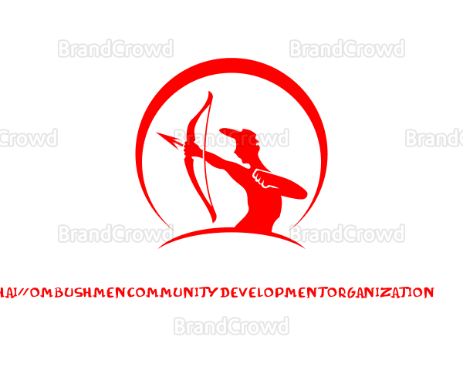
HAI //OM BUSHMEN COMMUNITY DEVELOPMENT ORGANISATION -------------------------------------------------------------------------------------------------------------------------------------- Office of the Director Reg No : W O 185 Email : hbcdo77745@yahoo.com P O BOX 116 Mobile: +264 81 3526327 Outjo 27 October 2020 Namibia --------------------------------------------------------------------------------------------------------------------------------------
UN Expert Mechanism Email : expertmechanism@ohchr Geneva Switzerland
RE: THE STATEMENT OF HAI //OM SAN INDIGENOUS PEOPLES IN NAMIBIA.
The Hai //om San ever since Independence of Namibia is excluded from all development programmes of the Namibian Government.
The land of Namibian Hai //om San Indigenous people’s , was dispossessed . Ever since this peoples are landless . Namibian Government discriminating the Hai //om San ever since Independence and up to now . During the time of Covid -19 , Government has put no measures in place , Which could have assist and enable us to sustain this serious and dangerous disease . No International or UN declarations are protected or respected on behalf of Hai //om San of Namibia.
Hai //om San are not assisted by Government in following developmental needs. Land , Education , Health and Health care , ration , UN Human right are not respected . Namibian Government have impoverished the Namibian Hai //om San Indigenous peoples. Therefore , HBCDO , Would like to make a serious and urgent call , to UN to intervene and negotiate the next .
1: Protection of Health and Health care of Indigenous Peoples Right , 2: Returning of dispossessed land Etosha National Game Park. 3: Respect and promotion of all Indigenous Peoples Rights rations as serious and Immediate need for Hai //om San of Namibia by Namibian Government . 3: Fair compensation of Germans to Hai //om San on Genocide. 4: Namibian Government not to take the compensation funds of Hai //om San for Genocide. 5: Namibia Government Discriminates against Hai //om San , And should be requested to comply with International standards of Un Declarations on Indigenous Peoples HBCDO needs UN to encourage the donor agencies to funding the Indigenous peoples NGO . H.B.C.D.O than only Hai //om San will be self reliance.

Finally H.B.C.D.O would like to request Expert Machanism to place H.B.C.D.O statement on UN Web , As a need of urgency.
Best Regards HBCDO Director Mr willem Aib

