Hawai’I Institute for Human Rights
United Nations Expert Mechanism on the Rights of Indigenous Peoples
Land Rights in Ka Pae Aina Hawai’I
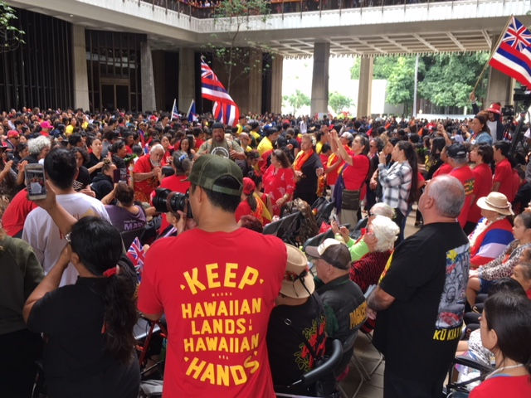

Hawai’I Institute for Human Rights
Honolulu, Hawai’I
joshuacooperhawaii@gmail.com

Hawai’I Institute for Human Rights (HIHR) conducted meetings with civil society and community associations actively involved in two land struggles on Maui and Hawai’I islands. HIHR shared about human rights enshrined in the Universal Declaration of Human Rights and the UN Declaration on the Rights of Indigenous Peoples as well as core UN human rights treaty bodies ratified by the United States of America.

Land rights in Hawai’I need greater attention and must include international human rights law in its analysis and jurisprudence to address the historical harms and current continuation of commercialization under the current colonial construct and capitalism systems dominating land use in Hawai’i.

At the time of contact, over 1 million Kanaka Maoli inhabited the current islands of Hawai’i. Since then merchants, missionaries and military waves colonized Hawai’I denying the people of Hawai’I their right to self-determination. During the following centuries, Kanaka Maoli spiritual relationship to the land remains strong in the core identity of Kanaka Maoli and communities across the Hawai’I archipelago. However, Kanaka Maoli must engage in direct action and use the courts to defend and protect the sacred aina.

The study will concentrate on two case studies – Mauna Kea on Hawai’I and Burial Grounds on Maui.

Mauna Kea has received a great deal of attention. For decades, Kanaka have challenged the development on Mauna Kea in the name of science. Kanaka Maoli continuously practice cultural and spiritual ceremonies on the summit of Mauna Kea, the highest mountain in Oceania. Unfortunately, the rights enshrined in the UN DRIP have been constantly ignored and cultural practices have been criminalized. Recently, the announcement of a 30 meter telescope was the step too far. Kanaka Maoli rose up to exercise their right to self-determination and organized peaceful protection of the sacred mountain from desecration of a telescope on the sacred summit. The state responded with arrest of elderly kupuna putting their bodies on the legal lines to ensure construction didn’t begin. The act of protection sacred ignited a movement for indigenous rights with Kanaka Maoli uniting as defenders of the sacred.
The government responses followed patterns around the world of criminalization and militarization of the conflict. Kanaka Maoli have remained vigilant committed to a culture of Kapu Aloha. The people remain committed to peace and living own values of caring for the land. After over half a year, Kanaka Maoli have been able to halt any construction. More important, a movement has been born where people have assumed their inherent right to care for and protect the natural environment.
Upon consultations and conversations, Kanaka Maoli demand recognition of inherent dignity and rights. At one meeting the solution was shared in three words around the land question, “Give it back.” In a more indepth discussion, the recommendation connected with Hawaii commitments to the Paris Agreement and the UN 2030 Agenda. There was focus on the
Recommendations
There must be a Truth and Reconciliation Commission centered around the land rights question rooted in a human rights based approach with voice of Kanaka Maoli being at the center of the Commission mandate.

All earth rights defenders and protectors of the sacred must have all legal charges dropped and there must be human rights training for police forces and assurances of no military from the neighboring bases to be involved.

Access to the summit must be recognized and secured for cultural practicioners and all Kanaka Maoli including allies desiring to exercise their fundamental freedoms on Mauna Kea.

Mauna Kea must be granted rights of nature as recognizing and emerging around the world such as in states like New Zealand and India. Mauna Kea should be recognized with rights of Nature with a fair commission of Kanaka Maoli and experts in human rights and sustainability .

The other main area of concern is burial grounds on every island. However, for the sake of the expert report we will focus on case study of Maui. Direct descendents have utilized the country, state and national laws to exercise religious freedoms and cultural rights to continue access to the burial mounds.

Kanaka Maoli face condition similar to indigenous peoples around their planet. Due to racism, their ancestors remains are continuously disturbed in the name of progress, development and profit. Ancestors bones are constantly disturbed and removed. In the case of Maui, homes are being proposed and land cleared even though remains have been recognized.

HIHR was able to accompany cultural practitioners visiting the burial grounds and witness firsthand the harassment from nearby home owners even facing actions of local police authorities called on to apprehend. The Kanaka Maoli remained nonviolent and explained calmly the reason behind visiting and the actions were legal and guaranteed in law.

Cultural practicioners have are mobilizing at all levels of government to guarantee basic core human rights enshrined in the UNDRIP.

Recommendations

The burial grounds must be recognized and demarcated. There must be legal protection to ensure Kanaka Maoli can exercise their rights in the UDHR and UNDRIP as well as the ICCPR and CERD.

All proposed construction must not be allowed and cultural ceremonies must be defended on a continuous basis establishing spaces so cultural and spiritual practices can thrive ensuring ability to duly honor ones ancestors.

There must be a local process rooted in the historical and cultural practices of Hawai’I. A place based approach rooted in international human rights law is the only way forward to ensure peace and mutual respect.

Hawai’I should be recognized as a member of the Pacific Islands Forum. Hawai’I should be able to utilize international human rights law, specifically the UN DRIP articles Recognition of a right to land/establishment of processes to adjudicate land rights/involvement of indigenous peoples (articles 25, 26, 27, 30, 32 of the UNDRIP)

Conclusion

The State of Hawai’I adopted the UN DRIP at the state legislature. Also, the UN Paris Agreement and the UN 2030 Agenda have also been adopted when the national administration has abdicated its relationship.
Hawai’I as part of the Pacific Islands State should continuously examine and explore way forward that recognized land rights in the historical Pacific context. Hawai’I land rights are similar to other states in Pacific and there are lessons to be learned that provide way forward to protect and preserve the sacred connection to the land.
Indigenous lands must be guaranteed in indigenous hands. All over the planet, the only way to guarantee the biodiversity and perpetuation of a sustainable ecosystem is to ensure right to land for indigenous peoples.

