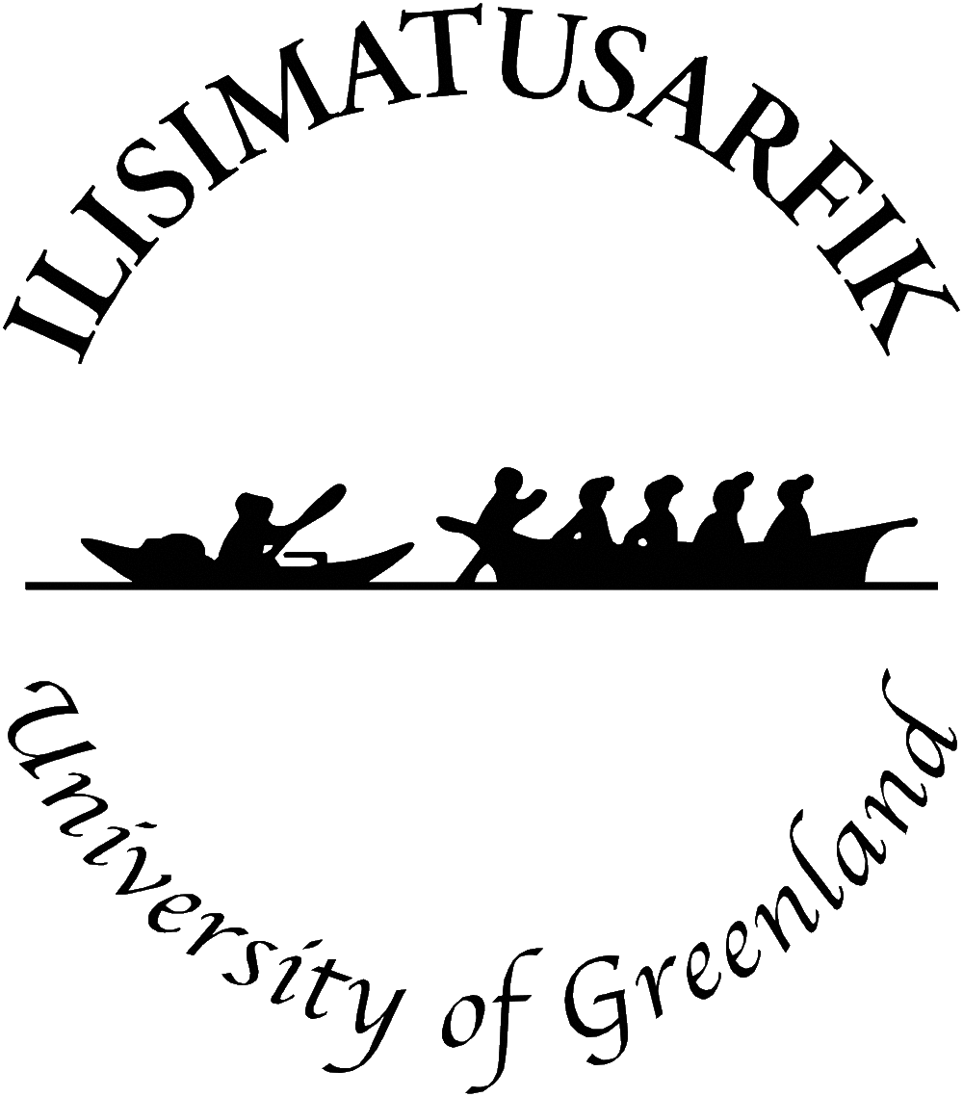

Expert Mechanism on the Rights of Indigenous Peoples Study on
“The rights of the indigenous child under the UN Declaration on the Rights of Indigenous Peoples”

Concept Note

Background

1. Established by the United Nations Human Rights Council in 2007, the Expert Mechanism on the Rights of Indigenous Peoples is a subsidiary body composed of seven independent members that provides the Council with expertise and advice on the rights of indigenous peoples as set out in the United Nations Declaration on the Rights of Indigenous Peoples (the Declaration). The seven members serve in their individual capacities.

2. In September 2016, the Human Rights Council amended the mandate of the Expert Mechanism, to include inter alia the preparation of an annual study on the status of the rights of indigenous peoples worldwide in the achievement of the ends of the Declaration, focusing on one or more interrelated articles of the Declaration.

3. In this framework, the Expert Mechanism held a virtual seminar on 16 and 17 November 2020, on the theme of its next annual study: The rights of the indigenous child under the United Nations Declaration on the Rights of Indigenous Peoples UNDRIP.

4. The studies and advice of the Expert Mechanism provide a better understanding of the provisions of the Declaration and propose concrete actions that States, indigenous peoples,
civil society, national human rights institutions, international organizations, businesses and others can take in order to further its implementation. The Office of the United Nations High Commissioner for Human Rights (OHCHR) provides technical and substantive support to the Expert Mechanism.

5. The Expert Mechanism has traditionally collaborated with academic institutions. While the seminar could not take place in Greenland as planned due to the COVID-19 crisis, it took place virtually with the collaboration of the Centre for Children, Youth and Family Research, University of Greenland, Nuuk, Greenland.

Focus of study

6. To assist all parties in contributing to this seminar, the EMRIP sets out below some of the elements it intends to focus on in its study. Article 3 on self-determination is the overarching right, inextricably linked to the way in which the rights contained in UNDRIP are implemented and in the case of children’s rights as well supports the notion of community control.

SECTION 1 – the right to a nationality, the rights to life, physical and mental integrity, liberty and security of person, violence, access to justice (preamble, and articles, 6, 7, 8, 22 and 43)

Could consider but not limited to:
- The right to a nationality, birth registration and avoidance of statelessness.
- Threats to the right to life of indigenous children, including child mortality, extreme poverty, and malnutrition. Action taken following EMRIP’s Advice in its Study on Health, in 2016, to reduce the high rate of indigenous suicide worldwide, in particular among children.
- Threats to the right to life of indigenous children by organs of the State, and non-State armed groups, including targeted arrests, detention, imprisonment, killing, torture and execution by law enforcement authorities.
- The impact of climate change and environmental harm on the right to life of indigenous children, including the right to a dignified life.
- Measures taken to protect the cultural, as opposed to physical, survival of indigenous peoples and individuals, to prevent forced assimilation or destruction of their culture.
- The inter-play between collective and individual rights of the child within the context of the principle of the best interests of the child.
- The physical abuse, sexual abuse and exploitation, and trafficking of indigenous children.
- Indigenous children’s access to justice and high disproportionate rates of incarceration.
- Follow-up action taken since EMRIP’s Advice in its Study on Health, on the steps taken to address the far-reaching health effects of intergenerational trauma attributable to the forced removal of indigenous children.
- The extent to which indigenous childern continue to be removed from their homes and communities through fostering and adoption and its consequences.
- The extent to which support services are provided for victims of domestic violence in consultation with indigenous peoples, including indigenous children.
- The extent to which indigenous children are made aware of their rights: how and whether this is done in a child friendly manner.

SECTION 2 – Non-discrimination, health, housing (as part of the right to an adequate standard of living and non-discrimination), employment, labour, culture; education. (articles 14, 17 and 21)

Could consider but not limited to:
- Action taken by States to follow-up on EMRIP’s Advice in its Study on Health, to establish action plans on health and access to health-care facilities for indigenous peoples. Measures taken to ensure that indigenous children, including children with disabilities, enjoy the highest attainable standard of health and have access to health-care services.
- Measures taken and good practices on addressing harmful practices, such as early marriage and female genital mutilation.
- The impact of environmental harm, mining, development, and displacement on indigenous children’s physical and mental health. Action taken as a follow-up to the Advice in EMRIP’s Study on Health, to protect indigenous peoples from environmental damage caused by third parties (such as private companies) by minimizing, through legislative and practical measures, the impact that extractive industries in particular have on the physical and mental health of indigenous peoples.
- Measures taken to ensure access to proper information in indigenous languages, including on health and reproductive health issues.

- Measures taken to ensure the provision of housing to indigenous peoples without discrimination, particularly in light of the Special Rapporteur on Housing’s overview in 2019 that, “Indigenous peoples face significant barriers to their enjoyment of the right to housing compared with non-indigenous peoples ... and are more likely to suffer inadequate housing and negative health outcomes..».
- Examples of special measures taken to ensure that indigenous children have access to culturally appropriate services in the areas of health, nutrition, education, social services, housing, and sanitation.
- Measures taken to improve economic and social conditions of indigenous children and to tackle the overrepresentation of indigneous children in care populations.
- Measures taken to ensure consultation, indiviudally and collectively, with indigenous children, including disabled children on the issues that affect them.
- Measures taken to combat discrimination, including through public information and educational measures.
- Measures taken to protect indigenous children from economic exploitation.
- Action taken as a follow-up to the Study on Education undertaken by the EMRIP in 2009 (https://undocs.org/A/HRC/12/33) Such action may include information on: (1) action taken to ensure that indigenous peoples have control over their own educational systems and that they can provide education in their own languages and with regard to their culture. (2) action taken to ensure that indigenous children, including those living outside their communities, have access to education at all levels in their own language and culture. In this regard, does the education of indigenous children exhibit the essential features of availability, accessibility, acceptability and adaptability as outlined be the Committee on Economic Social and Cultural Rights?

………………………………………………………………………………………..

For the purposes of this Study, as the UNDRIP does not include a definition of the “child”, the EMRIP will apply the same definition as under article 1 of the Convention on the Rights of the Child “a child means every human being below the age of eighteen years unless under the law applicable to the child, majority is attained earlier”, as defined by the Committee in it General Comments 4, 20 and 24 and its concluding observations.
To date, the Expert Mechanism has carried out studies on themes including indigenous peoples’ rights with respect to their cultural heritage; access to justice for indigenous peoples; the right to health and indigenous peoples; right to participate in decision-making; the right of indigenous peoples to education; free, prior and informed consent; migration and land rights; and on recognition, reparations and reconciliation.
Many of the issues raised here were highlighted by the UN Committee on the Rights of the Child, in its concluding observations following its reviews of States periodic reports in the last five years and in its General Comment No. 11 on Indigenous Children.
The introduction and legal framework to the Study will include the link between self-determination (UNDRIP preamble paras. 6, 10, 11 and 12 and articles 3, 4 and 5) and lands, territories and natural resources.
A/HRC/33/57
Abid
Abid.
Abid
A/74/183
A/74/183
A/HRC/39/62
CESCR, General Comment 13 para 6.

