Call for inputs
Report of the Special Rapporteur on the human rights of internally displaced persons
Protection of Internally Displaced Persons with Disabilities
Deadline: 15 February 2020

The International Foundation for Electoral Systems (IFES), an international nonprofit organization that works to empower every person to have a voice in political processes, has worked on disability-inclusive elections and political life in about 60 countries worldwide. IFES works with a variety of electoral stakeholders, such as election management bodies (EMBs), government ministries, civil society, and media to ensure all people have access to the political process. Based on its experience integrating persons with disabilities into democracy and governance programming and conducting targeted activities to empower persons with disabilities as voters, election officials, candidates, observers, and others, IFES submits the following inputs to the upcoming report of the Special Rapporteur on the protection of internally displaced persons (IDPs) with disabilities.
IFES Inputs on Questionnaire
5. Describe efforts undertaken to ensure the active coordination, participation and meaningful consultation with internally displaced persons with disabilities and their organisations in decisions affecting them during all phases of displacement. Information about the outcomes achieved and the remaining gaps would also be welcome.
Ukraine
In Ukraine, IFES has worked closely with the Central Election Commission (CEC) and disabled people’s organizations (DPOs), such as the National Assembly of Persons with Disabilities (NAPD) and Fight for Right, to make progress on adopting provisions in the UN Convention on the Rights of Persons with Disabilities (CRPD) and to ensure that all citizens, including IDPs with disabilities, have access to their electoral rights. IFES and the CEC collaborated on the development of voter education campaigns targeting IDPs which mainstream people with disabilities. These voter education initiatives highlighted below contribute to ensuring the meaningful participation of IDPs with disabilities in decision-making processes and political life.
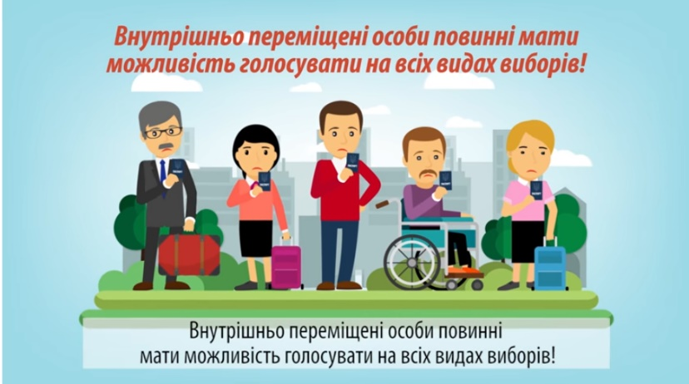
Video 1: Voting for Internally Displaced Persons
A television spot on the rights of internally displaced persons (IDPs) to vote included persons with disabilities.
In 2017, IFES produced a video on the right of IDPs to vote. This video mainstreams disability by including images of persons with disabilities alongside other citizens. In the image on the left, a television spot on the rights of IDPs to take part in political life, including casting a ballot, integrated images of persons with disabilities alongside other voters.

Video 2: How to Change your Voting Place
A television spot on voting procedures targeting IDPs which mainstreams disability.
This video was produced ahead of Ukraine’s early parliamentary elections in July 2019. It encourages IDPs, including IDPs with disabilities, to consider where they plan to vote on election day and whether they will need to temporarily change their voting place in order to exercise their voting rights. The video also provides detailed instructions for voters on how to change their voting places.
Video 3: How to Apply for a Temporary Change of the Voting Place

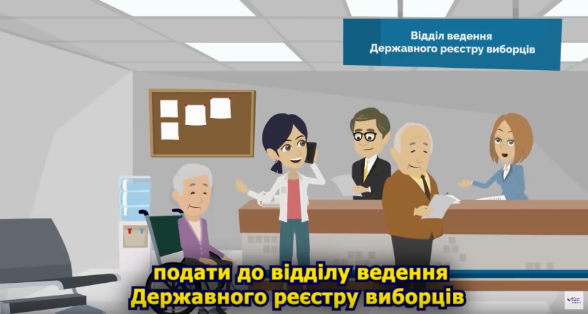
This video was produced ahead of Ukraine’s second-round presidential election in April 2019. It reaffirms the voting rights of all Ukrainians, including IDPs with disabilities. The video also describes the procedure for Ukrainians to temporarily change their voting place before the elections, where to submit their applications for a change of voting place, and what documents are required for this procedure.
A television spot on voting procedures targeting IDPs which includes images of people with disabilities.

Myanmar

The General Election Network for Disability Access (AGENDA), a creative partnership of DPOs and election-focused civil society organizations in Southeast Asia founded by IFES, is engaging policymakers to implement a new disability rights action platform of the Association of Southeast Asian Nations (ASEAN) Community. Building on the ratification of the CRPD by all ten ASEAN member states, the ASEAN Intergovernmental Commission on Human Rights (AICHR) launched the ASEAN Enabling Masterplan 2025: Mainstreaming the Rights of Persons with Disabilities in December 2018 to ensure disability rights in the region. The AGENDA network, which has promoted equal access to rights since 2011, is playing a significant role advocating for implementation and enforcement of this plan with national governments.

In Myanmar, IFES’ AGENDA partner, the Myanmar Independent Living Initiative (MILI), contributed recommendations to ASEAN to improve the inclusion of persons with disabilities, including IDPs with disabilities. One of the key recommended actions related to strengthening ASEAN cooperation on disaster management and emergency responses, including addressing vulnerabilities for persons with disabilities from natural disaster and conflict and situations leading to internally displaced persons. MILI also recommended ASEAN member states take necessary measures to protect persons with disabilities belonging to other groups as well, such as internally displaced people.

These recommendations contribute to ensuring the meaningful participation of IDPs with disabilities in political and public life in Myanmar and throughout the region.

7. Describe actions considered or planned for 2020 to provide IDPs with disabilities with inclusive and accessible humanitarian assistance during displacement, to promote durable solutions and to foster their active participation and meaningful consultation in decisions affecting them during all phases of displacement.

Myanmar

To address the intersection of disability and conflict in the context of civic engagement, particularly in regard to refugees and internally displaced persons (IDPs), IFES is developing a program to highlight the role of persons with disabilities in conflict and transitioning societies. This initiative, which is being piloted in Myanmar, capitalizes on IFES’ disability rights programming and on IFES’ training programs to build complementary efforts in a post-conflict setting with a focus on citizen engagement.

To collect data on disability, conflict, and participation in Myanmar, IFES is implementing focus group discussions and key informant interviews. The objective of this research is to identify barriers to inclusion of men and women with disabilities in conflict settings, particularly refugees and IDPs with disabilities. IFES intends to utilize input from the focus group discussions to guide post-conflict recommendations for government officials, CSOs and other stakeholders, with a focus on building and rebuilding community engagement.

As part of this initiative, IFES also intends to develop an interactive training module to target CSOs, DPOs, and other advocates with disabilities to increase their capacity to conduct specialized outreach within a conflict or post-conflict society. The module will include strategies for cultivating networks, coaching on how to initiate conversations and potential negotiations with stakeholders, and an increased knowledge of mechanisms for peaceful civic participation. Cultivating civic and community engagement among stakeholders, the module will build long-term participation capacity while targeting persons with disabilities, including IDPs with disabilities.

This programming aims to foster meaningful participation of IDPs with disabilities in public life and in decisions affecting them during all phases of displacement.

