Introduction

National Shelter is the peak non-government organisation representing the interests of low-income housing consumers, and has been in operation since 1976. It comprises representatives of Shelter bodies in all states and territories, and also includes national bodies Homelessness Australia, the Community Housing Federation of Australia and the National Association of Tenant Organisations. National Shelter cooperates closely with other national organisations such as the Australian Council of Social Service, and is a member of the National Affordable Housing Summit Group, the Community Organisations Housing Alliance and the campaign group Australians for Affordable Housing.
National Shelter advocates the development of a national housing policy based around the following principles:
- Housing is affordable. People on low and moderate incomes should not have to pay more than 30% of their income on housing costs.
- Housing is adequate. Everybody is entitled to housing that meets acceptable community standards of decency and their own needs.
- Housing is secure. People should not live under threat of loss of home and shelter. A secure base enables people to form constructive relationships, grow families and seek employment and community engagement.
- Housing is accessible. People should be informed about available housing options and access to these should be free from discrimination. Most housing should be built to Universal Design principles.
- Housing is in the right place. It should be located close to services and support networks, to job opportunities, to transport networks and to social and leisure activities.
- Housing meets people's life-cycle needs. People have different housing needs at different stages of their lives, and housing should be available to match these changing needs.

Australia’s Housing Challenges
Australia faces a number of housing challenges, which could be summarised as follows.

Housing is unaffordable for ordinary Australians
The long-term trend is for housing prices to rise faster than incomes. This has led to housing becoming increasingly unaffordable for Australian households, particularly younger people who are trying to enter the housing market.
Figure 1: House Prices and Incomes, 1960-2010
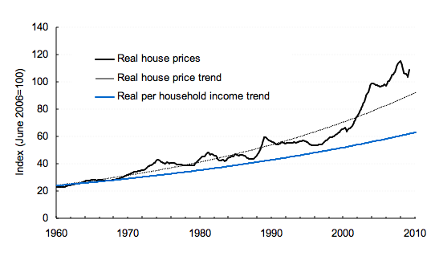
This long-term affordability problem goes hand in hand with a problem of supply, as documented by the National Housing Supply Council. In 2012 the Council estimated a shortfall of approximately 228,000 dwellings, with this shortfall projected to increase to 369,000 in 2016-17 if nothing changes in our housing market. However for low income renters the situation is worse, with a shortfall of 539,000 rental properties affordable and available to low income renters.

Australia’s private rental market does not meet the needs of a large proportion of its tenants
With the price of home ownership so high, many Australians will spend long periods, even their whole lives, as tenants in the private rental market. However, the rental market is not currently set up to meet the needs of long term tenants. Its investors are mainly small household investors, and their attachment to the rental market is marginal. This means they are unable to provide any level of security to their tenants, and the regulation of the industry is based around short-term tenancies and short notice periods for eviction, even where there is no breach of tenancy conditions.
In addition, the private rental market is not affordable for many households. In 2009-10, approximately 513,000 lower income renters (in the lowest 40% of the income scale) were paying over 30% of their income in rent – this represents almost half of all lower income renters. 211,000 of these households were paying over 50% of their income in rent.

Australia’s social housing system is overburdened
Despite population growth and decreasing housing affordability, Australia’s supply of social housing (housing owned by governments or not-for-profit organisations and rented at affordable rents to low income households) remained static in the decade to 2010, with funding for new housing struggling to keep pace with the disposal of stock that reached the end of its useful life.
In the face of strong demand for public housing, most housing authorities have tightened eligibility criteria and culled their waiting lists, as well as changing allocation processes so that only the most disadvantaged get housed. Nonetheless, waiting lists for social housing remain long.
The Social Housing Initiative from 2009-12 provided a much-needed boost to the supply of social housing. However, there is no long-term funding strategy for social housing in Australia and “business as usual” will see a steady, ongoing decline in the stock of social housing as State and Territory Housing Departments are forced to sell housing to meet operational and maintenance costs.
For example, in June 2012 the Queensland Department of Housing and Public Works estimated it had an underlying deficit of $54m in 2011-12, projected to increase to $140m by 2015-16. This underlying deficit is largely the result of the need to subsidise the rents of the low income tenants who make up the vast majority of social housing tenants – in Queensland the average rental subsidy per tenant was over $7,000 in 2009-10. In 2013 the NSW Auditor-General found an even more difficult situation for the NSW public housing system, with an expected operating deficit of $490m in 2012-13 and an extra $100m needing to spent on top of this to maintain housing at an appropriate standard. The extremely low incomes of the majority of NSW public housing tenants meant that the expected rental income for the NSW public housing portfolio was on 42% of its market rental value.
This data points to a social housing system that is not sustainable in its current form, and urgent reform is needed to put this system back on a sustainable footing.

Too many Australians are homeless or in inadequate housing
One result of these pressures is that many Australians continue to be homeless. Over 105,000 were counted as homeless on census night in 2011, up from just over 89,000 in 2006. This figure probably underestimates the number of people affected by homelessness by a large margin – the Australian Institute of Health and Welfare reports that 244,000 people sought help from specialist homelessness services in 2012-13.
Despite recent injections of funds to improve homelessness services, these services are still struggling to meet the needs. On an average day in 2009-10, over half the people who asked for crisis accommodation were not able to be accommodated, with an average of over 350 people per day turned away.

Meeting the Challenges
Australians face a wide variety of individual housing circumstances and each of these requires a different kind of response. For most Australians, the current market provides a reasonable quality of housing at a price they can afford. However, the substantial minority in housing stress need some form of support. The type of support will vary according to their particular circumstances. This is illustrated in Figure 2 below.
Figure 2 – Matching Assistance to Need
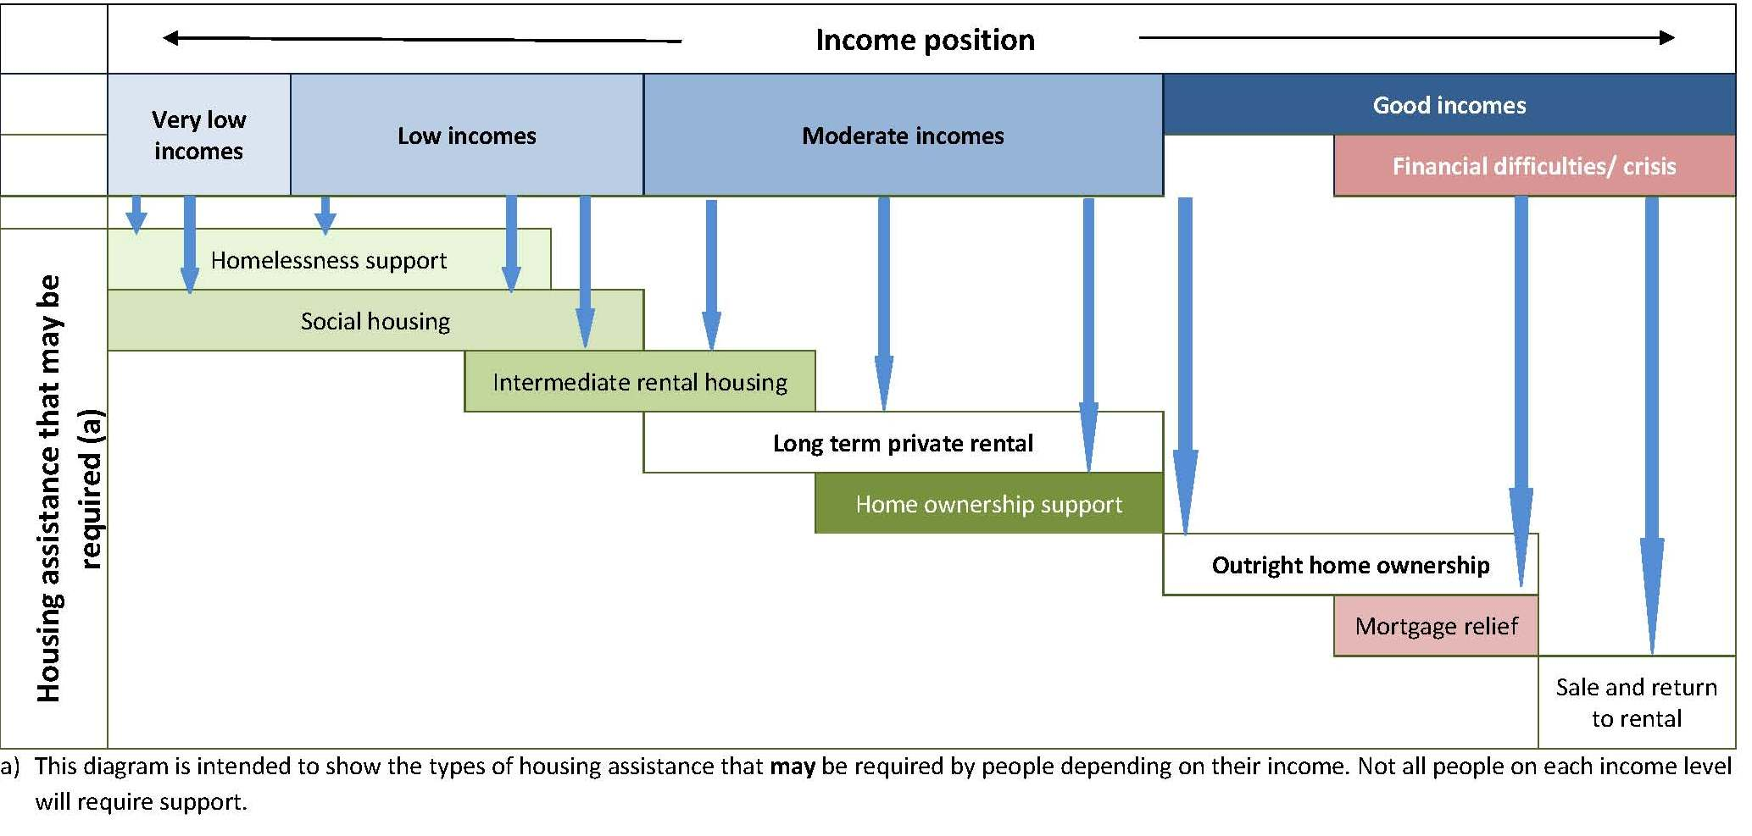
Meeting Australia’s housing challenges requires a concerted effort on a number of fronts, including taxation, social security, housing assistance, homelessness and urban planning. This complex set of policies is represented in Figure 3.

Figure 3 – Meeting the Challenges

Meeting the challenges

Making housing more affordable:

tax reform

urban planning improvements

assistance for home purchasers

Reforming the private rental market:

changed investment mix

improved consumer protection

enhanced rent assistance

intermediate rental housing

Combatting homelessness:

homelessness services reform

improved marginal housing

Revitalising social housing:

increased supply

sustainable funding

increased diversity of provision

improved ATSI social housing

improved management

A. Distribution of responsibilities related to the right to adequate housing:

- Please identify the levels of government (national, provincial/state, municipal) primarily responsible for the following: (where primary responsibility is shared please check more than one):

 | National/ Federal | Provincial/  state | Municipal | Explanatory Notes
Housing programme |  |  |  | The Commonwealth of Australia provides funding for the National Affordable Housing Agreement which is administered by State and Territory Governments.
Income support (eg: transfer payments to individuals, welfare, social security and/or rent subsidies/supplements) |  |  |  | The Commonwealth of Australia provides the social security payments including Commonwealth Rent Assistance (CRA is an income support supplement which helps but does not meet affordability benchmarks for recipients)  States also provide some assistance for low income tenants to secure private rental.
Tenancy and security of tenure legislation
Infrastructure (eg: Water/sanitation, electricity) |  |  |  | Funding is provided by the Commonwealth but administered by States and Territories
Prohibition of discrimination in housing |  |  |  | Some State legislation prohibits discrimination but is difficult to police. The Commonwealth provides the Racial Discrimination Act which prohibits discrimination on the basis of race.

2. What are the primary bases for the allocation of responsibilities among different levels of government? Please identify the appropriate provision(s) and provide a copy or link if possible:

§ Constitutional

The Australian Constitution has no specific clause giving the Commonwealth responsibility for housing.

§ National framework legislation or housing strategy

The Commonwealth Government has though, since 1945 following a Commission of Inquiry, dedicated funding programs to housing and homelessness provision. Initially the Commonwealth State Housing Agreement (CSHA) since 2008 the National Affordable Housing Agreement.
http://www.aph.gov.au/About_Parliament/Parliamentary_Departments/Parliamentary_Library/Publications_Archive/archive/StateHouseAgree

https://www.dss.gov.au/our-responsibilities/housing-support/programs-services/housing-affordability/national-affordable-housing-agreement

The major difference between the CSHA and the NAHA is the inclusion of both housing and homelessness program funding and that the NAHA is a broader agreement with additional partnership agreements attached to it including on Remote Indigenous Housing, Homelessness and Social Housing, all of which are time limited. The NAHA is an in perpetuity agreement which may be adjusted with the agreement of the Commonwealth and States and Territories

§ Sub-national level legislation or housing strategy

Most State Governments have State Housing Acts which govern the operation of their housing provision. For example The Queensland Housing Act 2003
https://www.legislation.qld.gov.au/LEGISLTN/CURRENT/H/HousingA03.pdf

http://www.slp.wa.gov.au/legislation/statutes.nsf/main_mrtitle_427_homepage.html

http://www.austlii.edu.au/au/legis/nsw/consol_act/ha2001107/

§ Inter-governmental agreement (see above re NAHA)

§ Other – Please explain

- What role does the national level government play in relation to housing and related programs? How is compliance with the right to adequate housing structured between the national and sub-national levels? If possible please kindly provide concrete examples of how these roles and compliance mechanisms are operationalized.

The national government’s role in housing is largely as a funder of States and Territories via the NAHA, the National Rental Affordability Scheme and the National Partnership Agreements on Homelessness and Remote Indigenous Housing.
The Commonwealth of Australia is the signatory to the U.N. conventions including the right to housing but the States have jurisdictional responsibility for housing programs.

This means Australia has a National Government with responsibility for compliance but without jurisdictional responsibility and States with Jurisdictional responsibility but without compliance requirements in place.

Our housing acts contain provisions aligned with a right to housing but never confer a right to housing. They generally describe the provision of programs, the administration of programs etc without providing legal recourse if citizens fail to secure adequate housing.

- Where sub-national governments hold key responsibilities in relation to the right to adequate housing, please describe how programs and policies are co-ordinated nationally and what responsibilities remain with national level institutions.

Australia has no civil rights Act and does not provide a right to adequate housing despite being a signatory to the U.N. conventions. State and Territory Governments administer housing programs, tenancy legislation, planning Acts and schemes and have jurisdictional responsibility for land and housing related legal frameworks.

Australia is about to embark on a process examining the nature of our federal system and which has the potential to redraw the various responsibilities between the Commonwealth and States and Territories. This is most likely to mean a withdrawal of responsibility by the Commonwealth from areas it is not specifically required to legislate for or provide for, housing may be an area where the Commonwealth withdraws from capital and other programs with the exception of Commonwealth rent Assistance which is a social security provision which is the direct responsibility of the Commonwealth.

- Where housing and related programs are administered by sub-national level governments, by whom and how are these programs funded? Are conditions attached to the funding which seek to ensure the resources are spent in a way that protects the right to adequate housing? How is this monitored?

The Commonwealth is the primary funder of housing and homelessness programs excepting those relating to tenancy law. The CSHA used to have matching funding provisions requiring State Governments to provide matched funding. The NAHA does not contain matching requirements instead requiring the States and Territories to meet outcomes (which are not well established or measurable) and which allows Sub national jurisdictions to forge their own funding if they meet outcome indicators which as previously indicated are difficult to measure. see http://www.coagreformcouncil.gov.au/reports/housing.html

B. Accountability of Sub-National Governments

1. Are sub-national governments legally accountable to the right to adequate housing on the basis of any of the following?

§ International human rights law? (No)

§ Constitution/National Bill of Rights (No)

§ National or sub-national legislation (No)

§ State level or municipal level Bills of Rights/Charters (No)

§ Inter-governmental agreements (No)

§ Conditional financing (eg: budget transfers from national level to sub-national) (No)

2. With respect to the above and where applicable, please identify:

- the relevant provision.

- the sub-national levels of government to which the legal provision applies.

- the means of enforcement (eg: courts, tribunals, national human rights institution, including ombudsmen, administrative mechanisms, etc.) and examples of how these means have been applied.

- Are sub-national governments involved in State reporting to international human rights monitoring mechanisms and in implementing recommendations? (eg, UN treaty monitoring body, Universal Periodic Review). If so, how? Please kindly provide an example.
No

- Apart from the legal and international accountability described above, what political or institutional accountability mechanisms are in place in your country through which sub-national governments are held accountable to standards or requirements linked to the implementation of the right to adequate housing (eg, Government review procedures, ombudsman/national human rights institutions, local human rights councils). Please provide any useful examples of how these have been used and, if possible, assess the outcome.
As previously indicated there are no legally binding requirements for sub national governments to meet legal responsibilities associated with International conventions or Treaties.
We do have a Human Rights and Equal Opportunity Commission, but without power to coerce, we do have strict health and safety legislative requirements providing for standards of housing to be met in State and Territory jurisdictions. We do have legislation in many jurisdictions covering the operation of tenancies, boarding houses and in some states caravan parks and our local governments have responsibility for monitoring the safety of housing through fire and other safety regulations and legislation.

- Please kindly identify what in your view may be the three most significant challenges in your country to effective accountability of sub-national governments to the right to adequate housing as guaranteed under international human rights law and identify key strategies or ideas for addressing these challenges.

- There is no requirement to meet international obligations within State and Territory legislation. Australian sub national jurisdictions are not required to house all their citizens adequately. Most Australian households are well housed but we have a growing shortfall of affordable and available housing for our lowest income households, estimated by the National Housing Supply Council as 539,000 properties. This creates a big level of housing stress for low income households. The previous Rudd and Gillard governments developed a new National Affordable Housing Agreement which was broader in scope but retained a narrow focus on welfare housing and did not address historic concerns over transparency and accountability and which does not deliver sufficient funding to States and Territories to address the long term supply shortfall. They did however provide significant additional funding in the areas of social housing provision, a new National Rental Affordability Scheme and new national partnership agreements on homelessness and remote Indigenous housing.

- Our most pressing housing challenges exist around remote Indigenous Communities but also for the majority Indigenous urban population. Approximately 25% of Indigenous Australians live in remote areas with 75% living in urban settings. Aboriginal and Torres Strait Islander (ATSI) Australians still suffer high levels of discrimination in obtaining and retaining housing. ATSI Australians live in highly overcrowded conditions in discreet communities and at much higher levels of overcrowding in general compared to the non Indigenous population.

- There is inadequate accountability between the Commonwealth and States for meeting the housing shortfall and for spending the money allocated by the Commonwealth for these purposes. It creates a continual mistrust between levels of government in Australia about the transparency and accountability of our housing and homelessness programs.

Taken from Dr Judith Yates, Housing Affordability – Who Is the Most Affected?, adapted from Australia’s Housing Affordability Crisis, in The Australian Economic Review, vol. 41, no. 2, pp. 200–14, 2008. Figures from Productivity Commission (2004) to 2003, updated by ABS Cat no. 6416.0 to 2009
National Housing Supply Council, Housing Supply and Affordability – Key Indicators, 2012, p22-27
Ibid, p47. The figure of 539,000 is arrived at as follows. In 2009-10 there were 857,000 renter households in the bottom 40% of the income distribution, and 1,256,000 dwellings rented at an affordable price for these households. However, 937,000 of these dwellings were rented by households in higher income groups, leaving only 319,000 available for rent by low income households – a shortfall of 539,000.
Ibid, p43
Queensland figures taken from Queensland Department of Housing and Public Works, Social Housing: Factors affecting sustainable delivery in Queensland, June 2012, pp4-5
NSW Figures taken from NSW Auditor-General’s Report, Performance Audit: Making Better Use of Public Housing, July 2013, pp18-21
Australian Bureau of Statistics, Estimating Homelessness 2011, p5
Australian Institute of Health and Welfare, Specialist Hoemlessness Services 2012-13, pvii
Adapted from a diagram in Delivering places where people live and achieving meaningful customer choice, presentation by David Cowans, Group Chief Executive, People for Places UK at the International Social Housing Summit 2010

