REPORTS ON DISCRIMINATION, SEGREGATION AND THE RIGHT TO ADEQUATE HOUSING

QUESTIONNAIRE

Background and Objective of the report

2021 thematic reporting of the Special Rapporteur on the right to adequate housing on:

- discrimination in relation to the right to adequate housing
- impact of spatial segregation in urban or rural-urban environments on the enjoyment of human rights.

Objectives:

- to identify contemporary and historical forms of discrimination and segregation that affect the right to adequate housing
- to highlight good practices in the prevention of discrimination and segregation
- to provide guidance to States on how they can ensure their human rights obligations in relation to non-discrimination and the right to adequate housing.

BASIC INFORMATION

1. Name of Individual, Organization, Institution, Agency or State: Participation and the Practice of Rights

Type of Entity*
☒ Community-based NGO

2. Categorization of your Work
☒Other: human rights based organising so people can access their economic and social rights

3. City/Town: Belfast

4. State/Province: County Antrim

5. Country (please indicate your region or “international” if focus the work of your organization covers multiple countries); Northern Ireland

6. Contact e-mail (will remain confidential) in case we have questions:
HOUSING DISCRIMINATION

7. What specific forms of de facto or legal discrimination or barriers towards equal enjoyment of the right to adequate housing do the following groups face in your country (please provide evidence with examples, studies, reports and relevant statistical information):

- People of African Descent, or Roma
- Racial, caste, ethnic, religious groups/minorities or other groups
- Migrants, foreigners, refugees, internally displaced persons
- Women, children or older persons
- Indigenous peoples
- Persons with disabilities
- LGBTQ persons
- Low income persons, including people living in poverty
- Residents of informal settlements; persons experiencing homelessness
- Other social groups, please specify

1. Low income persons, including people living in poverty

Northern Ireland has nearly 808,000 homes in its housing stock. Of these, 43% are owned outright and 27% are owner-occupied with an outstanding mortgage.

Half of the remaining 30% rent socially at "affordable rents", either from the Northern Ireland Housing Executive (NIHE) or from housing associations. In 2019-20, 64% of NIHE tenants received Housing Benefit -- a means-tested state benefit that "helps people on a low income who have to pay housing costs for the property they live in" -- a decrease on the 80% of NIHE tenants who received the benefit in 2003-04.

Finally, 14% of NI households rent their homes from private landlords.

These proportions are a product, in part, of policies such as the House Sales Scheme which encouraged home ownership amongst eligible social tenants, allowing those who met criteria to purchase their homes at a discount. Figures obtained from NIHE through Freedom of Information request indicate that as of end January 2019, 120,562 former Housing Executive homes -- equivalent today to roughly 15% of the total housing stock in NI -- had been sold under the scheme.

Some of those homes were bought by people who continue to live in them as owner-occupiers; others however have ended up in the hands of landlords who, living elsewhere themselves, rent them out privately. NIHE data obtained through FOI indicates that since 2012 roughly four times as much public money has been spent annually in paying needs-based housing benefit to private landlords than has been spent on building new social homes for lower income families in need of housing.

Meanwhile, housing need has continued to outstrip supply. The table below shows how the number of Northern Ireland households on the waiting list for social housing has continued to grow.

Recent local press reports have highlighted the social housing shortage affecting lower-income households, often in deprived areas, and have revealed that at the current rate of new social housing growth, it will take 20 years to clear the waiting list.

The NIHE allocates social homes on a points-based system; households on the waiting list with over 30 points are recognised to be in "housing stress". Some of those households have also been recognised by NIHE as 'Full Duty Applicant' homeless. The table below shows that both housing stress and homelessness are endemic in the NI housing system. In recent years around half of all waiting list households have formally been recognised as homeless, and over two thirds of waiting list households have been considered to be in housing stress:

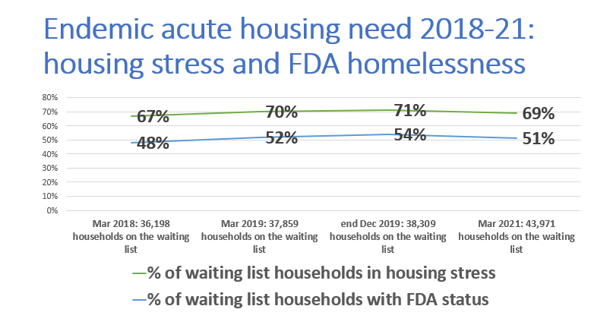

Policy priorities
In 2019, NI's Department for Communities proposed changing the definition of 'affordable housing'. Rather than directing policy change to where need was most acute -- homelessness and housing stress -- the aim of the proposed re-definition was "to provide a framework for the development of a broader range of intermediate products" to benefit first time buyers, active older people and, explicitly, those on the waiting list with less than 30 points. A revised definition has since been suggested but it is not clear what its impact will be.

Meanwhile, as in many areas, the Covid-19 pandemic has made inequalities more acute. In one example, NI press reported in February that the social housing waiting list had grown by 10% between the start of the pandemic and end 2020.

In October 2020 the Communities Minister proposed fundamental changes to the housing system here that she said would increase social housing supply and target it to areas of high demand. The plan included strengthening the NIHE in order to help improve access to social housing, widening access to co-ownership and protecting private renters.

However, the Department backtracked in early 2021 in response to a 'static' budget allocation from Westminster for the 2021-22 fiscal year, saying the lack of additional money for housing transformation meant that its ability to "reconfigure services and introduce new services or policy initiatives will also be reduced".

Children in social housing waiting list households
It is important to note the people behind the statistics. When PPR first requested information on the number of children under the age of 18 living in households on the waiting list, in housing stress and/or with homeless status, the NIHE said that the information was not available. We asked for the household composition data and put together 'at least' figures ourselves, based on NIHE family categories:

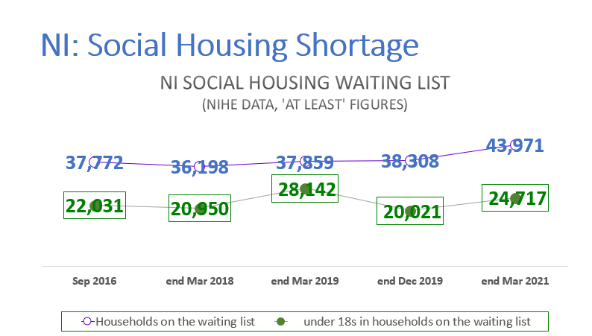

Housing stress and/or homelessness are detrimental to anyone; but the particularly harmful impacts on these types of trauma on the mental, physical and social development of children is increasingly well documented. The current figures for children living in households designated as in housing stress or homeless are:

The impact of growing up in temporary accommodation, overcrowded conditions, hostel life, sofa surfing and homelessness all have a heavy impact on children and young people here, as recent press coverage reveals. Their physical and mental health and that of their families, their ability to learn, to make friends and to play are all affected.

Under-18s from the #BuildHomesNow housing rights group in Belfast have undertaken a number of actions to tell duty bearers and the public about the impact their living conditions have on them.

Again, this is an area where Covid-19 has deepened existing inequalities. NI press sources reported Department for Communities figures showing that the number of young people placed in temporary bed and breakfast accommodation in 2020 was 1,481 -- over four and a half times greater than in 2019, when the figure was 320. Requests for Housing Executive temporary accommodation more than doubled, from 3,500 to 7,500. These were believed to be people unable to make the deposits and monthly payments required to rent privately, many of whom would have been living with family or friends until lockdown pressures made those arrangements untenable.

2. Racial, caste, ethnic, religious groups/minorities or other groups

Northern Ireland’s Multiple Deprivation Measures take factors like employment, health, education, access to services and living environment into account in addition to income in assessing deprivation. Analysis of overall NIMDM rankings against 2011 NI census data on religion reveals that fifteen of the twenty most deprived areas (out of Northern Ireland’s 890 "super output areas", each with around 2,000 people) are over 80% Catholic while four are over 80% Protestant. In NIMDM rankings from 2010, 16 of the 20 most deprived areas were predominately Catholic.

Deprivation affects people from both communities here; but given that the population is divided nearly equally between the two groups, its impact is disproportionately prevalent amongst people in predominately Catholic areas. This is an enduring reality with roots deep in the past.

A closer look at some of the factors in deprivation paints a similar picture. With regard to the availability of social housing, Catholic and Protestant families – even those living in adjacent areas -- can face starkly different prospects.

West Belfast
The Equality Commission NI reported analysis over time showing that Catholic-headed households continue to experience the longest waiting times for a social home. Press reporting of Northern Ireland Housing Executive (NIHE) data showed that people in West Belfast are waiting on average 23 months for a home - the longest waiting time of any area in the north and half again as long as waiting times (around 15 months) in north and east Belfast. Nearly 3,000 households were considered to be in housing stress against only 401 social homes allocated to new tenants during the previous year. An NIHE spokesperson said "it has been well recognised that there is a supply issue for available land in west Belfast for new social housing".

Analysis of NIHE's measure of demand of housing is even more revealing. As mentioned above, NIHE allocates housing to people on the waiting list using a points-based system: someone recognised as homeless, for instance, automatically receives 70 points, while anyone with 30 points or more is considered to be in “housing stress”. The number of people in housing stress in a given area, minus the average number of relets of social homes each year in that area, gives the NIHE measure of “residual housing need” .

NIHE data for 2017/18 reveals that the three predominately Catholic areas of Inner, Middle and Outer West Belfast have a cumulative residual need for 2,137 social homes. Meanwhile, two of the five surrounding areas have a surplus of social homes; taken jointly, the five have a shortfall of just 94 social homes, according to NIHE figures for the same year.

Otherwise, NIHE statistics obtained by Freedom of Information request show that as of the end of year 2019, there were 3,829 households on the waiting list in West Belfast -- by end March 2021 this had risen by over 9%, to 4,186. At end 2019 83% of them in the predominately Catholic areas of Inner, Middle and Outer West Belfast; by end March 2021 this had risen to 84%.

Alarmingly, in December 2019 87% of the 3,062 West Belfast households in housing stress were in these predominately Catholic areas, as were 89% of the 2,515 households with FDA status. (By end March 2021, the number of West Belfast households considered to be in 'housing stress' had risen to 3,221; 89% of them were in predominately Catholic areas. The number of households with FDA homeless status had risen to 2,625; 90% of them were in predominately Catholic areas). Graphically, that looks like this:

With regard to the impact of the housing shortage on children under the age of 16, the data looks like this, with need clearly concentrated in predominately Catholic areas. The acute need in these areas has noticeably increased during the time of the pandemic:

Another way of visualising this data, to see the differential between areas of different predominate religious community as well as over time:

North Belfast
In terms of 'residual need' as described above, in predominately Catholic North Belfast 1 in 2017/18 there was “residual need” for 883 homes, while in adjacent but predominately Protestant North Belfast 2, only 20 homes were needed.

With regard to numbers of households on the waiting list, in housing stress and with homelessness status, the breakdown is as follows. At end of year 2019, there were 2,586 households on the waiting list in North Belfast -- over three quarters of them in predominately Catholic North Belfast 1 HNA area. (By end March 2021 this had risen to 2,818, with the same proportions.) With regard to housing stress, in December 2019 79% of North Belfast households experiencing it lived in North Belfast 1, as did 82% of Full Duty Applicant homeless households. By March 2021, 80% of households in housing stress were in North Belfast 1 as were 83% of homeless households:

With regard to the impact of the housing shortage on children under 16, the data looks like this, with need clearly concentrated in predominately Catholic areas. As in West Belfast, the acute need in these areas has noticeably increased during the time of the pandemic:

Again, social housing need is concentrated in predominately Catholic areas.

Another way of visualising this data, to see the differential between areas of different predominate religious community as well as over time:

3. Migrants, foreigners, refugees, internally displaced persons

The NI Department of Justice published the report of an independent review into hate crime legislation here. It found that hate crime and discrimination against minorities has been "a persistent and recurrent problem across Northern Ireland for the past two decades". Since 2016, racist hate motivated incidents are more prevalent each year than sectarian motivated incidents, meaning "in practical terms, there is approximately a one in 31 chance of being the victim of a reported racial hate incident compared to an approximately one in 1777 chance of being a victim of a reported sectarian hate incident".

The Equality Commission NI's 'key inequalities' research includes tracking of NI crime statistics regarding the number of ‘criminal damage to a dwelling crimes’ that had a racist motivation. Around the same time as the DOJ report was issued, press reports showed that the PSNI were investigating a hate incident in which racist and sectarian graffiti was painted on walls in North Belfast to deter potential residents from moving there. Over the past three years PPR have logged numerous similar reports of perceived 'foreigners' being intimidated out of their homes, indicating that discrimination against this group impacts their access to their right to adequate housing.

Moreover, in terms of the Covid-19 pandemic, local press highlighted cases of migrants excluded from the Northern Ireland Housing Executive's implementation of the 'Everyone In' policy to house all rough sleepers during the pandemic in the interest of public safety, meant to be accessible to all regardless of nationality or immigration status.

PPR have worked extensively with some of the Syrian families resettled in Northern Ireland under the UK's Vulnerable Persons Resettlement Scheme (see for instance the 2018 'We Came Here for Sanctuary' report, documenting substandard housing conditions and other issues). This work continues, both in Belfast and in the city of Derry, where numerous families have been placed.

In Belfast, FOI requests have revealed that the NIHE has chosen to place a large percentage of Syrian families in areas of high demand and clear shortage of social handing -- including, mainly, predominately Catholic areas. The top four areas of placement listed below (with their residual need - or shortfall - figures) are predominately Catholic:

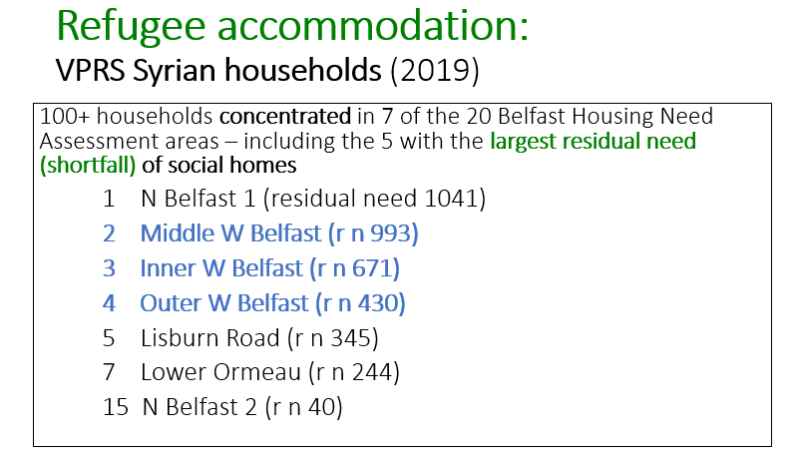

The deliberate placing of vulnerable refugee families in private rental accommodation in deprived areas with high housing demand -- in which deprivation also manifests in severe housing shortage, housing stress and homelessness -- places additional stress on them and potentially impedes their integration.

Finally, with regard to asylum seekers, the asylum UK system imposes enforced destitution on people whose claims have been initially rejected and who have yet to file an appeal. They are forced out of asylum accommodation and designated as having 'No Recourse to Public Funds', meaning they cannot access homeless shelters. Research has demonstrated that a given asylum seeker can be made destitute numerous times in the typical asylum process before eventually having their claim accepted. PPR have worked for the last three years in a pilot project with a local housing association to provide accommodation to destitute women asylum seekers who might otherwise be forced into rough sleeping or other situations that could jeopardise their safety, health and well-being.

8. Discrimination in housing can affect various dimensions of the right to adequate housing and other human rights. Could you provide more details regarding the specific areas in which housing discrimination is experienced? Below are examples of various forms of discrimination that can be experienced in relation to different dimensions of the right to adequate housing:

Accessibility

The income based discrimination described above impedes accessibility -- the main issue is shortage of social housing, particularly in areas of high demand, high housing stress and high levels of homelessness.

Similarly, the discrimination on the basis of perceived religious community is largely a question of accessibility, in that there is a shortage of social homes in the predominately Catholic areas described.

The enforced destitution of asylum seekers includes a 'No Recourse to Public Funds' designation which denies them access to state-funded homeless shelters.

Habitability
With regard to the discrimination against Syrian refugees and other migrants, there are real issues of substandard conditions and/or conditions inappropriate for residents' physical and medical needs as described in the We Came Here for Sanctuary report. New reporting on the same issues, based on 2021 research, will be forthcoming in the next few months.

Affordability

Security of tenure

Availability of services, materials, facilities and infrastructure

Location

Cultural adequacy

9. Are there any particular current laws, policies or practices in your country, region or town/community that contribute to or exacerbate discrimination in relation to the right to adequate housing?

Current asylum procedures clearly discriminate through the denial of asylum accommodation and the No Recourse to Public Funds designation.

10. Can you explain exemptions in national law that allow (certain) public, private or religious housing providers to give preferential or exclusive access to housing to members of a particular group, for example based on membership, employment contract, public service, age, disability, civil status, sex, gender, religion, income or other criteria?
n/a

11. In case there may be differential treatment of particular groups in relation to housing, please explain why such treatment could be justifiable according to international human rights standards - for example positive measures benefiting a particular group to overcome systematic discrimination or disadvantage-or if it would amount to discrimination?
n/a

SPATIAL AND RESIDENTIAL SEGREGATION

12. What forms of spatial segregation along racial, caste, ethnicity, religion, nationality, migration status, heritage, economic status/income or other social grounds can be observed in urban and urban-rural contexts in your country?

NIHE describes Northern Ireland's social housing segregation as follows:
The extent of self-segregation grew rapidly with the outbreak of the Troubles, and in 1969, 69% of Protestants and 56 % of Catholics lived in streets where they were in their own majority. As the result of large-scale flight from mixed areas between 1969 and 1971, following outbreaks of violence, the respective proportions had by 1972 increased to 99% of Protestants and 75% of Catholics.
Analysis of 2011-based figures indicates that residential segregation in estates constructed by the Housing Executive reduced slightly between 2001 and 2011, but remained widespread. In 2011 more than 80% of households in these areas were living in segregated communities, rising to around 94% in Belfast.

13. What impacts do these forms of spatial and residential segregation have on affected communities? Please point to indicators such as rates of poverty, un-employment and under-employment; prevalence rates of malnutrition; disparities in access to services and facilities (such as access to schooling, health care or other public benefits); disparities in access to infrastructure (lack of and/or poor quality provision of water, sanitation, transportation, energy, waste collection and other utility services); rates of exposure to environmental health risks (poor air quality, flooding, toxic ground exposure, etc).

See above.

14. Have any particular historical or current laws, policies or practices in your country, region or town/community caused or exacerbated segregation?

See above.

15. In your view, what factors (current or historical) are the principal drivers of spatial and residential segregation in urban and urban-rural contexts in your country?

See above.

16. Are there examples in your country of where spatial and residential clustering has been a result of voluntary choices of residence by members of particular groups?

See above.

17. The preservation of cultural identity, the right to self-determination of indigenous peoples and the protection of minority rights are examples of grounds for which groups may choose to live separately. Can you comment on how these forms spatial/territorial separation are evidenced in your country, if these communities they are subject to discrimination and suffer adverse consequences from spatial segregation such as through disparities in access to services, infrastructure, living conditions, etc.?
n/a

18. In your view, are certain forms of observed residential separation/voluntary clustering compatible with human rights law and if so why? (for example to protect rights of minorities or to respect the freedom of choice of individuals to decide with whom to live together).
n/a

19. Are there any laws or policies requiring certain individuals (and their families) to live in particular housing provided to them or in a particular geographical area (e.g. asylum seekers, migrants, IDPs, refugees, ethnic, religious, linguistic or other minorities, indigenous peoples, persons with disabilities, public service and military personnel)?
See above.

20. In your view, what are the principal barriers to diminishing spatial, including residential segregation?
See above.

MEASURES AND GOOD PRACTICES TO CURB DISCRIMINATION AND REDUCE SEGREGATION

21. What laws, policies or measures exist at national or local level to prevent or prohibit discrimination in relation to the right to adequate housing?

Section 75 of the Northern Ireland Act 1998 states:

Statutory duty on public authorities.

(1) A public authority shall in carrying out its functions relating to Northern Ireland have due regard to the need to promote equality of opportunity—

(a) between persons of different religious belief, political opinion, racial group, age, marital status or sexual orientation;

(b) between men and women generally;

(c) between persons with a disability and persons without;

and

(d) between persons with dependants and persons without.

(2) Without prejudice to its obligations under subsection (1), a public authority shall in carrying out its functions relating to Northern Ireland have regard to the desirability of promoting good relations between persons of different religious belief, political opinion or racial group.

22. Have your State, regional or local Government adopted any positive measures, such as measures of affirmative action, to reduce discrimination, segregation or structural inequality in relation to housing? To what extent have such initiatives been successful to address housing discrimination and segregation?

The NIHE has in the past used a policy of 'ringfencing' to attempt to increase the supply of social housing in areas of high demand; however it did not redress the issues and was discontinued. There is discussion of bringing the practice back but this has not happened as of this writing.

23. Have any particular laws, policies or measures been implemented to limit or reduce residential segregation? To what extent have such policies raised human rights concerns?
There have been some official 'shared community' social housing schemes; press reports indicate some of them have seen cases of people being intimidated out of their homes.

Discrimination is understood as any formal or substantive distinction, exclusion, restriction, preference or other differential treatment that is directly or indirectly based on the prohibited grounds of discrimination as to race, colour, sex, language, religion, national or social origin, political or other opinion, property, birth or other status - including disability, age, nationality, marital and family status, sexual orientation and gender identity, health status, place of residence, economic and social status - which has the intention or effect of nullifying or impairing the recognition, enjoyment or exercise, on an equal footing, of human rights (see article 2.1 of International Covenant on Economic, Social and Cultural Rights and the related General Comment No. 20 of the Committee on Economic, Social and Cultural Rights)
Spatial segregation can be understood as the imposed or preferred separation of groups of people in a particular territory by lines of race, caste, ethnicity, language, religion or income status. Spatial, including residential segregation can have different forms depending on the territorial, cultural or historical context and is often characterized by forms of economic and social exclusion, inequity and spatial disparity in access to infrastructure, services and livelihood opportunities.
https://www.communities-ni.gov.uk/system/files/publications/communities/ni-housing-stats-19-20-full-copy.pdf, p. 1.
"Social rented housing is housing provided at an affordable rent by a Registered Housing Association; that is one which is registered and regulated by the Department for Social Development as a social housing provider. Social rented accommodation should be available to households in housing need and is offered in accordance with the Common Selection Scheme, administered by the Northern Ireland Housing Executive, which prioritises households who are living in unsuitable or insecure accommodation". NI Strategic Planning Policy Statement, https://www.infrastructure-ni.gov.uk/sites/default/files/publications/infrastructure/SPPS.pdf p. 114.
https://www.nihe.gov.uk/Housing-Help/Housing-Benefit/About-Housing-Benefit
https://www.communities-ni.gov.uk/publications/northern-ireland-housing-statistics-2019-20 section 3 tables.
https://www.nidirect.gov.uk/articles/house-sales-scheme
https://www.belfasttelegraph.co.uk/news/northern-ireland/belfast/housing-queue-will-last-for-20-more-years-40301098.html
https://www.communities-ni.gov.uk/sites/default/files/consultations/communities/dfc-consultation-paper-affordable%20Housing.pdf paras. 4.6 and 8.7.
https://www.thedetail.tv/articles/social-housing-waiting-list-10-higher-since-start-of-pandemic?utm_source=mailinglist&utm_medium=email&utm_campaign=832-social-housing-waiting-list-10-higher-si
https://www.communities-ni.gov.uk/news/right-home
https://www.communities-ni.gov.uk/sites/default/files/consultations/communities/DfC%20Draft%20Budget%2020212022%20Equality%20Impact%20Assessment.pdf
These figures are 'at least' because of the way the data is shared by NIHE. When there are less than 10 households in a given category NIHE does not specify a number. To avoid any risk of overinflating, we calculated these at the lowest possible value of '1'. Similarly, for families in the NIHE category of '4+ children', for instance, we used the lowest possible value of 4, again to avoid any over-inflation.
https://www.belfasttelegraph.co.uk/sunday-life/news/young-homeless-figures-in-northern-ireland-soar-40268790.html
For instance see https://www.youtube.com/watch?v=Sj2wMoy4LQo
https://www.belfasttelegraph.co.uk/sunday-life/news/young-homeless-figures-in-northern-ireland-soar-40268790.html
https://www.nisra.gov.uk/statistics/deprivation/northern-ireland-multiple-deprivation-measure-2017-nimdm2017
2017 NIMDM rankings obtained at https://www.nisra.gov.uk/sites/nisra.gov.uk/files/publications/Top%20100%20SOAs.pdf
2011 census data obtained by SOA via https://www.ninis2.nisra.gov.uk/public/AreaProfile.aspx?sk=
2010 NIMDM rankings downloaded from https://www.nisra.gov.uk/statistics/deprivation/northern-ireland-multiple-deprivation-measure-2010-nimdm2010
http://www.equalityni.org/ECNI/media/ECNI/Publications/Delivering%20Equality/HousingCommunities-KeyInequalitiesStatement.pdf, para. 1.9; see also https://www.equalityni.org/KeyInequalities-Housing#hideHR20.
https://www.belfasttelegraph.co.uk/news/northern-ireland/belfast/call-to-build-up-housing-stock-in-west-belfast-as-3727-await-homes-40222930.html
Review of Housing Need Assessment Formula for the Northern Ireland Housing Executive at https://touch.nihe.gov.uk/review_of_housing_need_assessment_formula_for_the_northern_ireland_housing_executive__published_november_2010_.pdf
Figures obtained by Freedom of Information request; copies available on request.
Figures obtained by Freedom of Information request; copies available on request.
https://www.justice-ni.gov.uk/sites/default/files/publications/justice/hate-crime-review.pdf
https://www.equalityni.org/KeyInequalities-Housing#hideHR20
https://www.belfasttelegraph.co.uk/news/northern-ireland/police-investigating-hate-incident-after-graffiti-painted-outside-belfast-home-ahead-of-viewings-39767072.html
https://www.thedetail.tv/articles/concern-over-covid-19-s-effect-on-migrants-in-need-of-housing-support-in-northern-ireland?utm_source=mailinglist&utm_medium=email&utm_campaign=837-homeless-migrants-missing-out-despite-ev
https://issuu.com/ppr-org/docs/we_came_here_for_sanctuary_report_-
See for instance A Prison without Walls: asylum, migration and human rights, PPR/Housing4All, June 2019 at https://issuu.com/ppr-org/docs/h4all_report_june_2019_final_17.06.
https://issuu.com/ppr-org/docs/we_came_here_for_sanctuary_report_-
https://www.nihe.gov.uk/Community/Community-Cohesion/Shared-Neighbourhood-Programme
https://www.legislation.gov.uk/ukpga/1998/47/section/75

