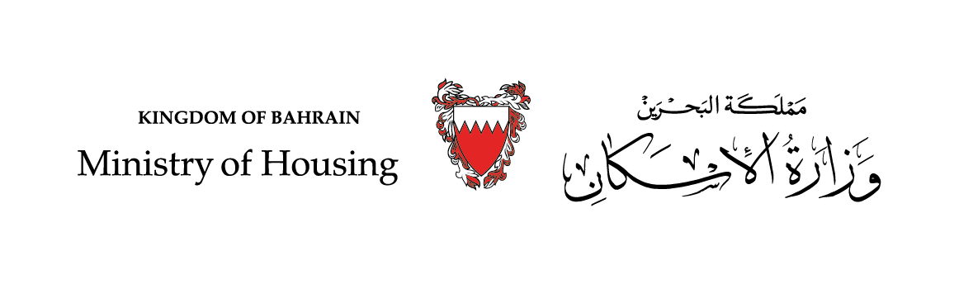

Response to Discrimination, Spatial Segregation & the Right to Adequate Housing
Quesstionnaire

Housing Policies & Strategic Planning Directorate

April 2021

Despite the challenges imposed by the nature and size of its land, the Kingdom of Bahrain was able, represented by its Ministry of Housing, to provide low-cost housing units for its citizens; a great challenge that only a limited number of countries have been able to accomplish worldwide.

During nearly half a century of providing housing services, the government of the Kingdom of Bahrain has managed to invest more than 3 billion Bahraini dinars to provide more than 130,000 housing services, from which nearly 60% of Bahraini citizens have benefited over a period of 45 years, during which Bahrain provided distinguished housing services. This reflects the vision of Bahrain's wise leadership in achieving the aspirations and needs of the Bahraini citizen; The main driver of the development process in the Kingdom and the primary beneficiary of social development and economic well-being.

Due to the constant interest and boundless support of the government for the housing file, the Kingdom of Bahrain was able to achieve great progress in reducing poverty rates and social marginalization. Bahrain is also characterized by the absence of slums, achieved by facilitating the means for low standard of living citizens to obtain adequate shelter while preserving the cultural heritage in the Kingdom.

It is worth noting that the housing axis included in Bahrain's vision is closely linked to the social support programmess, included in the National Economic Strategy, most notably the United Nations Human Settlements Programme (UN-Habitat) and the United Nations Development Programme (UNDP), which aim to promote social and environmental development.

Providing citizens with decent housing in harmony with the standard of living and striving to reduce housing crises comes in line with the aim of bringing about an urban transformation in the future of the Kingdom of Bahrain and ensuring the sustainability of the provision of adequate housing in the Kingdom of Bahrain.

The Kingdom of Bahrain fulfills its obligations to provide shelter to citizens, improve housing and neighbourhoods, and is committed to its responsibility to provide legal protection to ensure aquisition and equality in the right to land aquisition, including the right of inheritance and ownership for all citizens, in order to address the reduction of homelessness for Bahraini citizens.

The Constitution of the Kingdom of Bahrain forms the basis for guaranteeing all rights related to housing and adequate housing, as it guarantees the principle of equality and equal opportunities and prohibits discrimination related to housing, as stipulated in Article 9, Paragraph “F” of the Bahraini Constitution: “ The State shall endeavour to provide housing for citizens with limited income”. The Ministry is also working to implement the various controls and provisions that govern the provision of this service in accordance with the provisions of Legislative Decree No.(10) of 1976 with respect to Housing and Ministerial Order No. (909) of 2015 with respect to housing.

Perhaps the entirety of these legislations, published in accordance with the applicable systems - are characterized by a great deal of justice that ensures access to housing services to citizens in accordance with clear controls and standards applied among all citizens without discrimination on the basis of ethnic, national, lineage, cultural, or any other grounds.
In addition, the Ministry follows multiple internal supervisory administrative systems that work to monitor the implementation of these controls, and the follow-up and review imposed on the Ministry by other oversight bodies- like other government departments in accordance with the laws - ensures that the Ministry is not deviated from these systems and that the required legal goals are achieved.

The Kingdom of Bahrain provides modern housing, safe infrastructure services, and advanced public facilities to meet the residents' requirements for a decent living, in accordance with international best practices, in terms of water availability for various uses, wastewater treatment, availability and efficient use of energy, introduction of renewable energies, broad transformation of cities into smart clusters that attract technology, adopt low-carbon performance and more. The road network has also been developed and public transportation modernised, as well as the provision of public facilities such as schools, educational, social and health centers. Furthermore, the development of parks, public parks, popular and central markets, and urban and village development projects. This will positively affect the living, health and social standards of the population in various areas of the country, in a way that enhances the Kingdom's efforts to achieve a healthy environment for smart, healthy and sustainable cities.

The Kingdom of Bahrain represented by the Ministry of Housing also offers a variety of housing services Bahraini citizen can choose from according to personal preference and suitability, which includes the service of housing units; houses or apartments, in addition to land plots and housing loans of all kinds.

Moreover, to develop more options for housing services and expedite serving applicants on the waiting lists, in recent years the Government of Bahrain, represented by the Ministry of Housing, has introduced a number of new housing financial solutions, in partnership with the private sector. The Ministry of Housing regulates the process between the beneficiaries, banks & developers, to provide social housing services. One of these housing financial solutions is the “Mazaya” Programme, which enables the beneficiaries to choose the suitable housing units in the area they desire, provided they obtain financing to purchase it from one of the certified local banks in cooperation with the Ministry in accordance with certain controls. The ministry also provides a monthly housing allowance to applicants on the waiting lists as financial support to enable them to obtain suitable temporary housing upto the time they benefit from the housing units service.

The Kingdom of Bahrain also pays great attention to the construction of housing projects, and perhaps the most important of which is the modern and integrated housing cities, which has amounted to five new housing cities that meet the diverse societal needs by containing all basic facilities and services in addition to infrastructure, green spaces, schools and hospitals, which all citizens, wishing to obtain the housing unit service, are entitled to benefit from.

The Ministry of Housing is keen on ensuring that all housing projects meet all basic needs, including the availability of comprehensive infrastructure that provides different main services related to water, electricity and sanitation, and even surpassed that, as the new housing cities meet the requirements of sustainable green cities that provide green spaces, bicycle paths, waterfronts, in addition to public coasts, public transport stations and others.

Recently, it was considered to include private and government shelters as part of future housing projects in preparation to meet any future conditions, and implement safety and protection measures.

In addition to the services provided by the ministry, it also gave special attention to applicants with special needs and special groups in the society such as single women, widows, abandoned and divorced women who are without children and have no shelter. For that “Masaken”, a unique housing project, in cooperation with the Supreme Council for Women, was designated to provide adequate housing for women in this category to ensure a feeling of safety and stability among them.

As for the people of determination and special needs category, a number of housing units are allocated in the various housing projects that are equipped with the special requirements that the owners of this category need in their homes. These units are allocated to them in order to assist them to achieve a sense of equality and non-discrimination.

In the interest of preserving the societal and cultural heritage in the old neighbourhoods, the Kingdom of Bahrain, through the Dilapidated Homes Rehabilitation and Restoration Project, has provided Bahraini citizens the right to have their old homes restored or rebuilt in order to ensure adequate housing and to create healthy and appropriate residential conditions for its citizens of all categories.

